CAREER GUIDANCE 2024-25
TABLE OF CONTENTS
1. | MAX AHEAD – 02 Aug 2024
2. | TRIO SOFTWARE EDUCATION – 25 Sept 2024
3. | PLACEMENT DRIVE – R-SHELL INFO SERVICES – 21 Oct 2024
4. | PLACEMENT DRIVE – START UP JOB FAIR – DISTRICT COLLECTORATE OFFICE, Nagercoil – 18 JAN 2025
5. | AWARENESS PROGRAM - DISTRICT EMPLOYMENT OFFICE – 24 JAN 2025
6. | PLACEMENT DRIVE - SRV SCHOOL, NAMAKKAL – 27 JAN 2025
7. | PLACEMENT DRIVE – MICHAEL’S ACADEMY OF COMMUNICATIVE ENGLISH, SALEM – 10 JANUARY, 2025
8. | CAREER EXHIBITION – DISTRICT EMPLOYMENT OFFICE, NAGERCOIL – 19 FEB 2025
9. | PLACEMENT DRIVE - TVS MOTOR COMPANY, HOSUR – 21 FEB 2025
10. | AWARENESS PROGRAM – 17 MAR, 2025
11. | ALO INFOR TECH – 19 MAR, 2025
12. | PLACEMENT DRIVE – ICICI, HDFC & AXIS BANK – 20 MAR 2025
13. | PLACEMENT DRIVE – VIRTUAL SOLUTIONS – FOXCONN HON HAI TECHNOLOGY INDIA MEGA DEVELOPMENT PVT LTD – 01 APRIL 2025

AWARENESS PROGRAM

NAME OF THE ACTIVITY : AWARENESS PROGRAM
RESOURCE PERSON : Mr.Shiva Balan, TTR, Southern Railway, Nagercoil
DATE AND DURATION : 17 Mar, 2025 & 2.30PM to 3.30PM
NUMBER OF PARTICIPANTS : 157
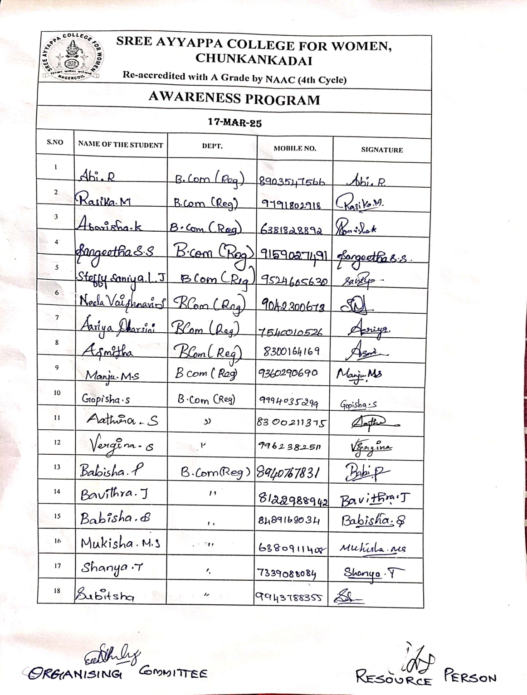
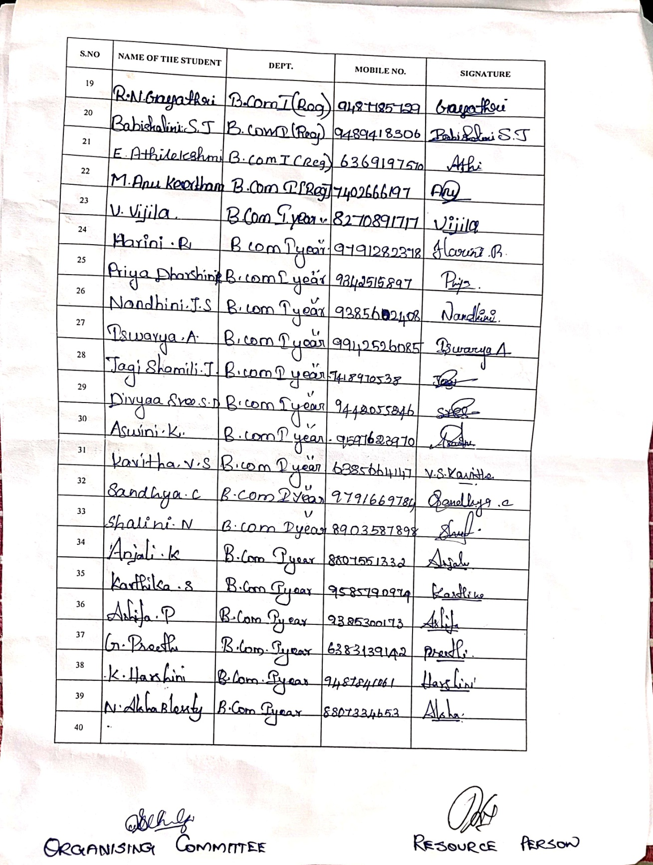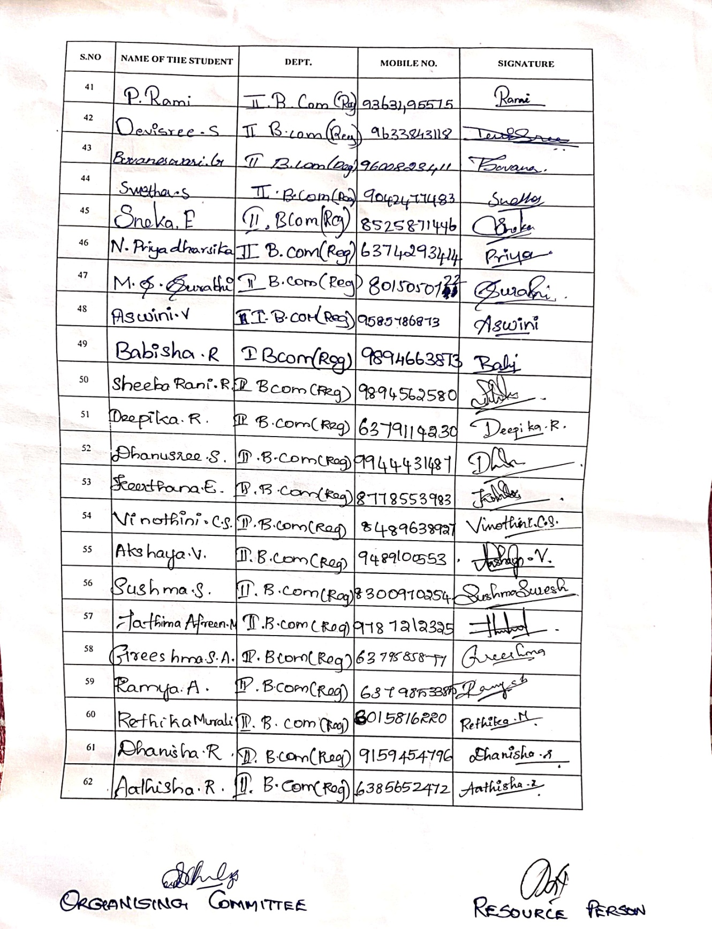
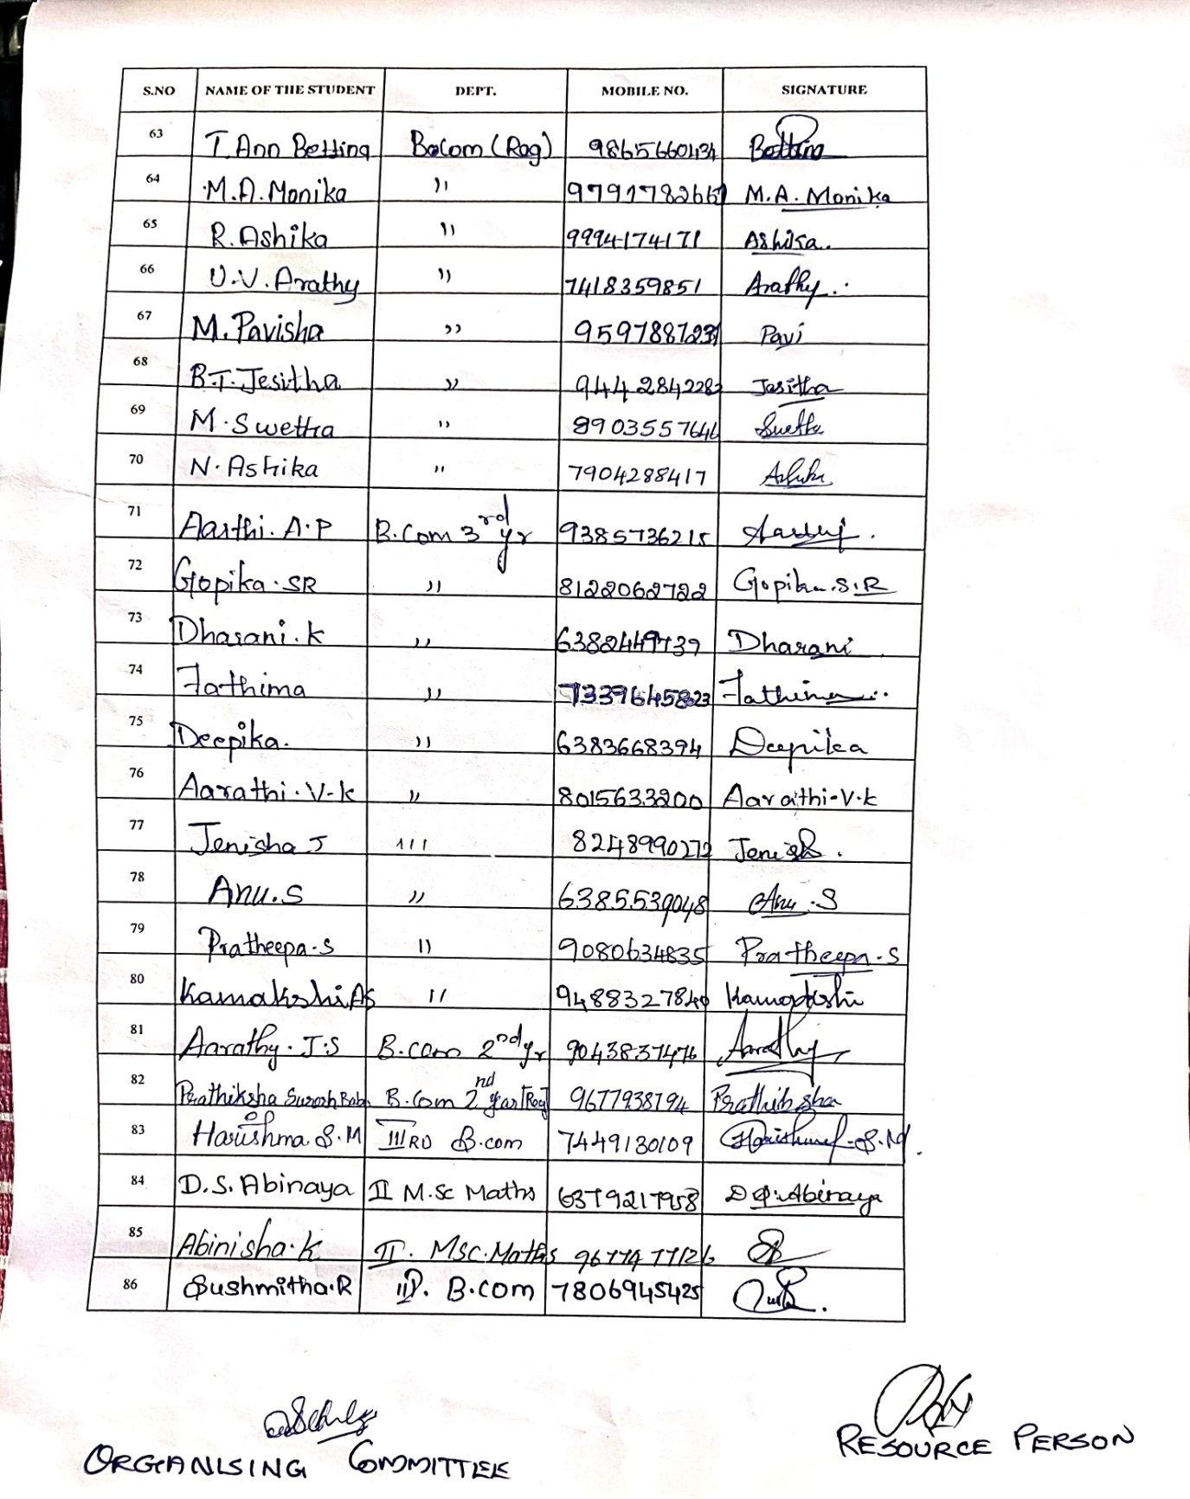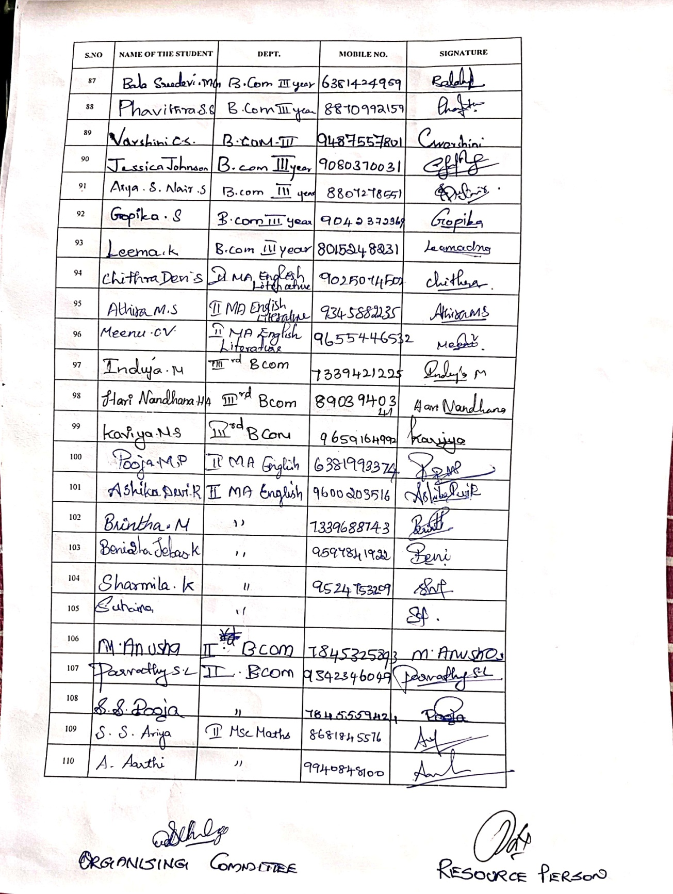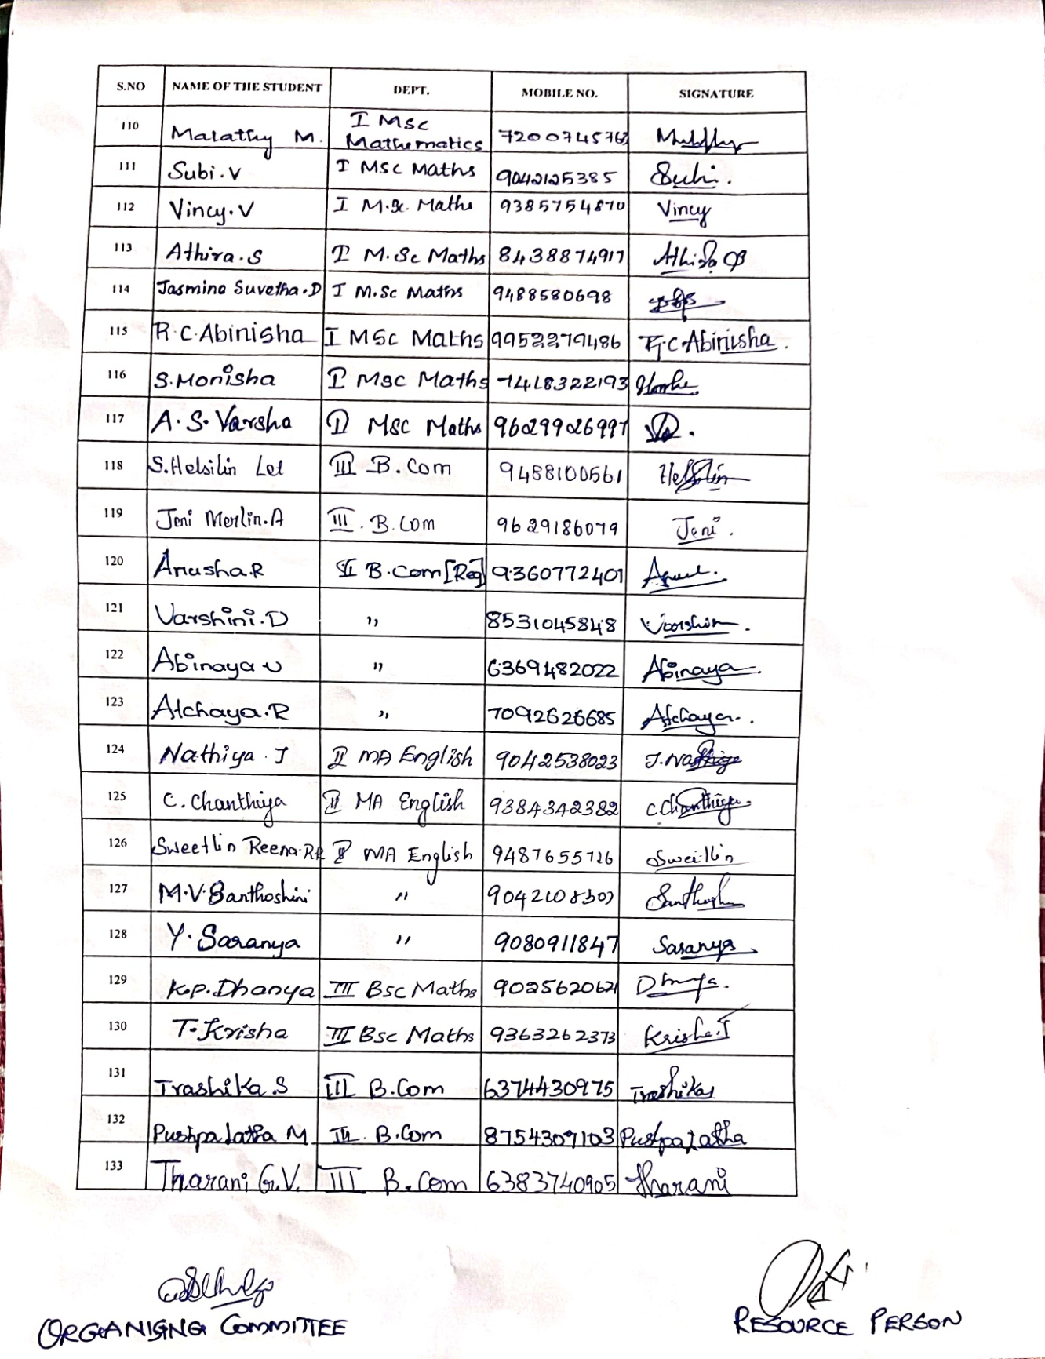

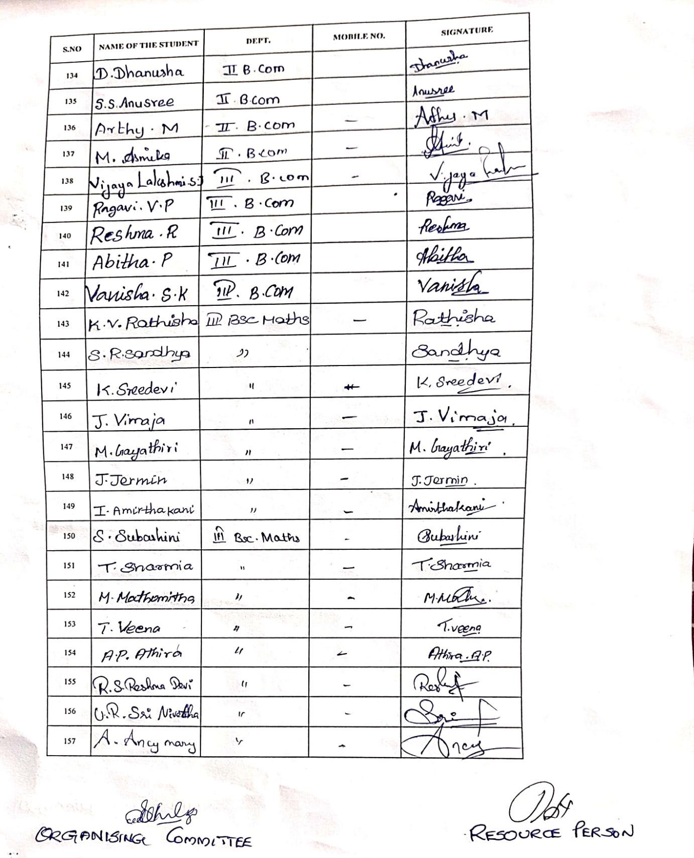

OBJECTIVE OF PROGRAMME : Providing detailed information about TNPSC and SSC CGL, including eligibility, exam pattern and section process. Guiding students on effective study techniques. Highlighting the government job roles, benefits and career growth associated with these programs.

OUTCOME OF PROGRAMME : The students gained a clear understanding of the exams. Students became aware of the career opportunities in government sectors. The Resource Person circulated a Questionnaire to students and a test was conducted. 2 of our students who secured good score were awarded with a Book.

PHOTOS OF THE PROGRAMME :

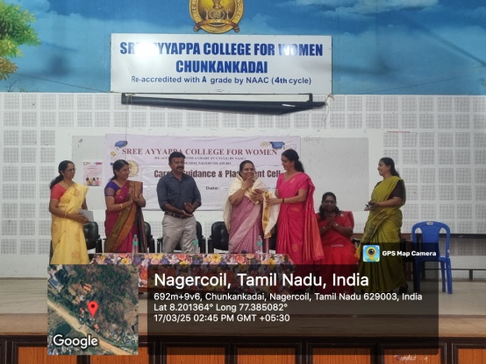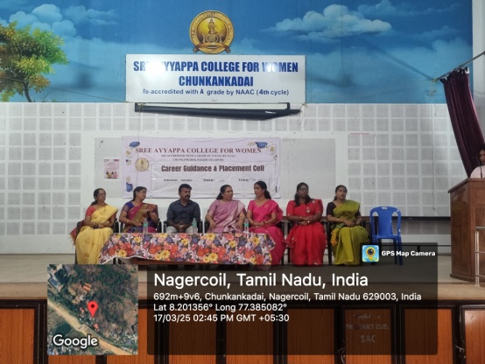

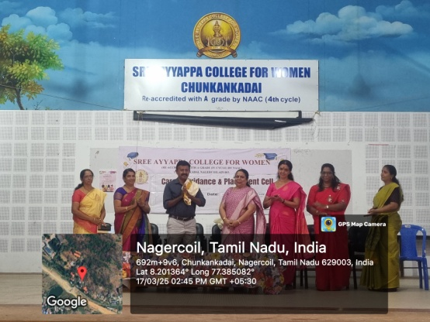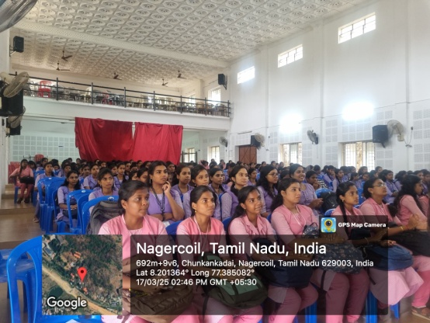

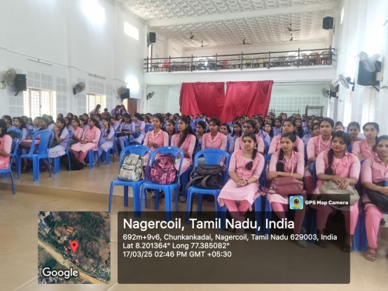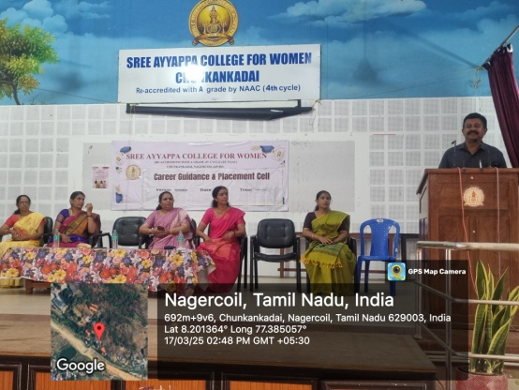

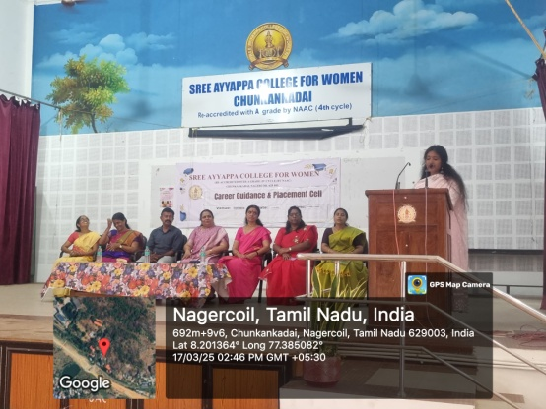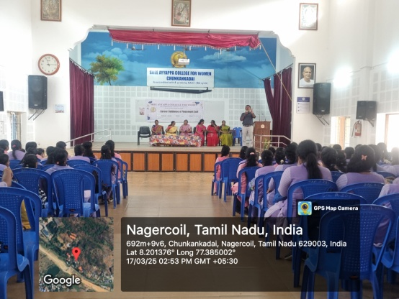

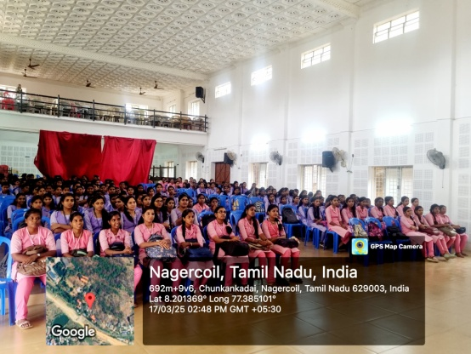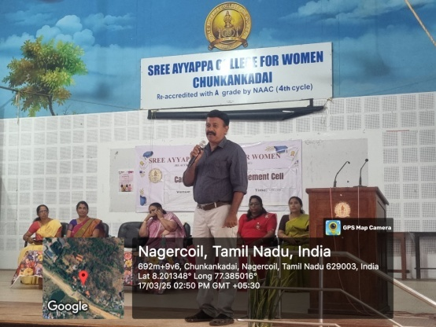

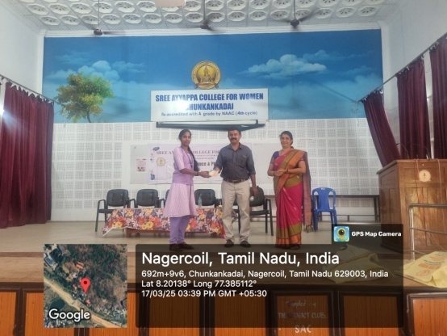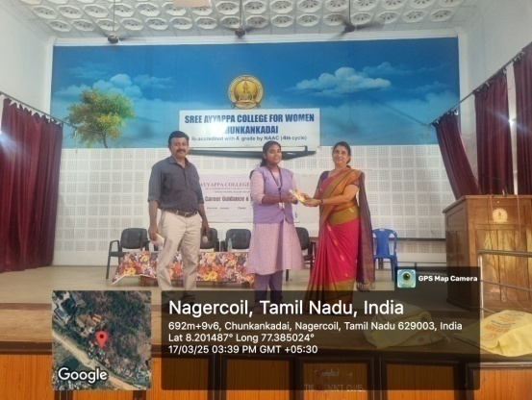

BROCHURE :

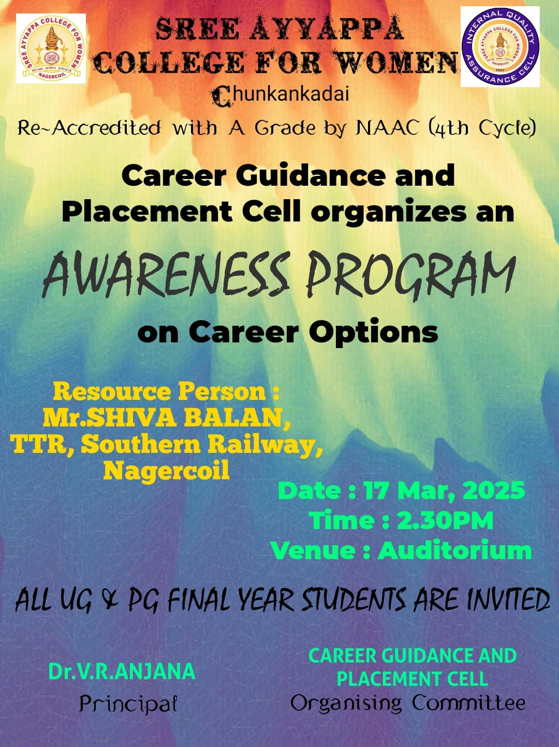

NAME OF THE ORGANIZING COMMITTEE : Career Guidance and Placement Cell.

ALO INFO TECH
NAME OF THE ACTIVITY : ALO INFO TECH – The Future of UI / UX Design: Trends and Innovations
RESOURCE PERSON : 1. Mr. ESAI KUMAR.P, Senior UI-UX Designer, 2. Mr. LIFNI GIFSHAN PAUL, Junior UI-UX Designer, 3. Mr. AHIN.PM, Business Development Analyst.
DATE AND DURATION : 19/03/2025 & 10.50AM to 11.40AM
NUMBER OF PARTICIPANTS : 66

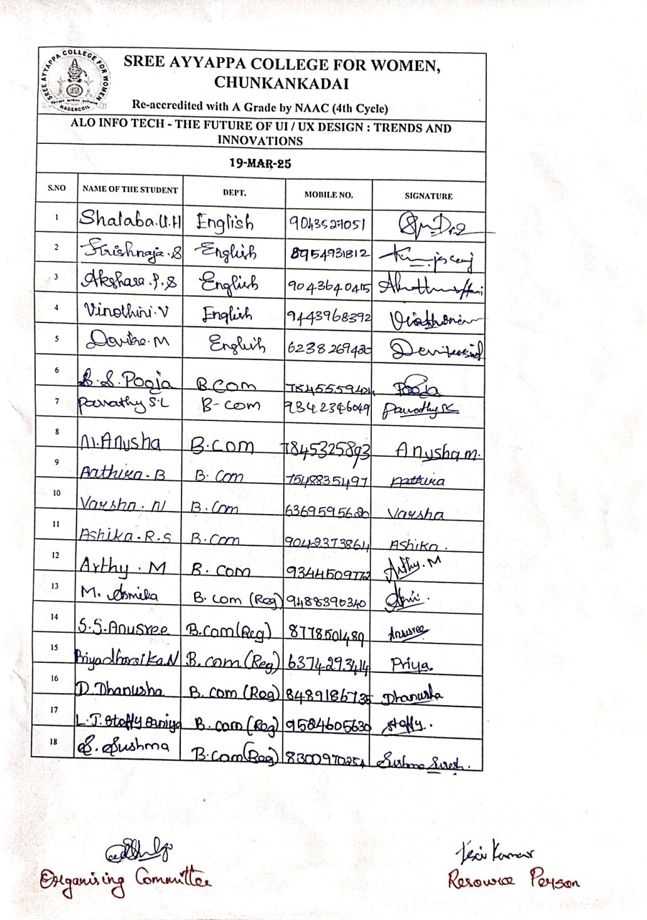
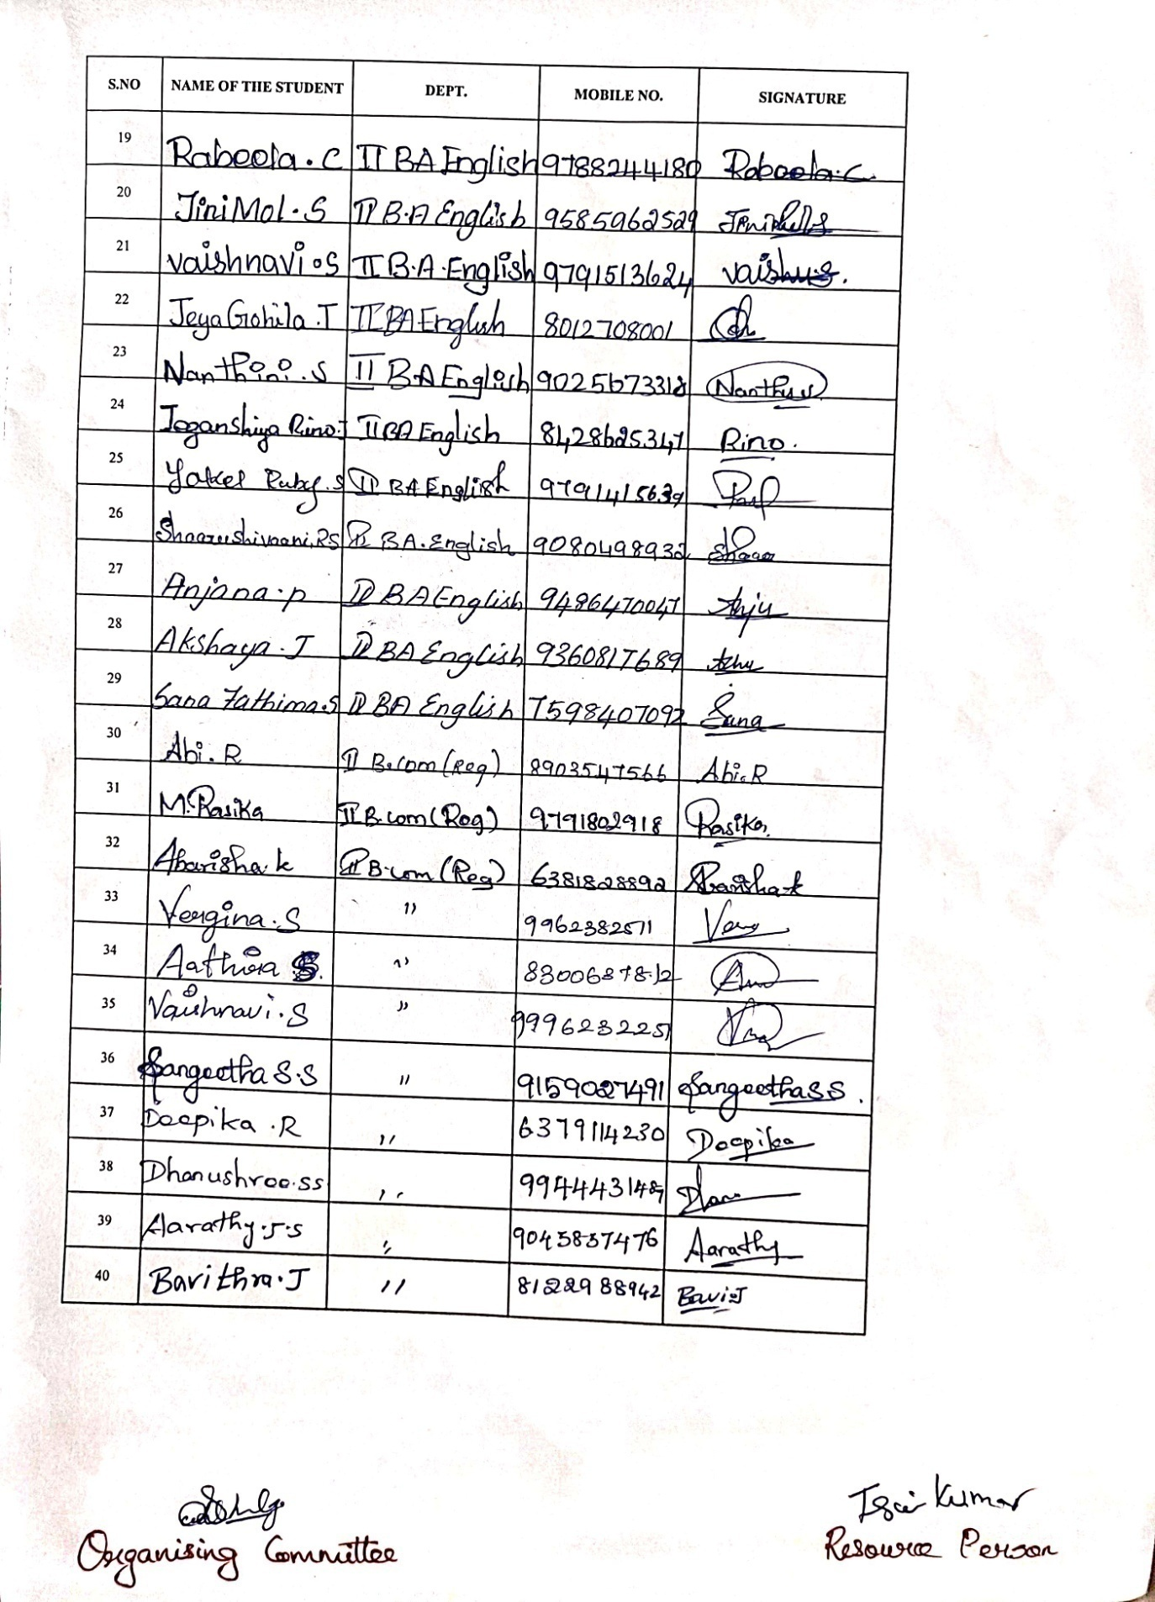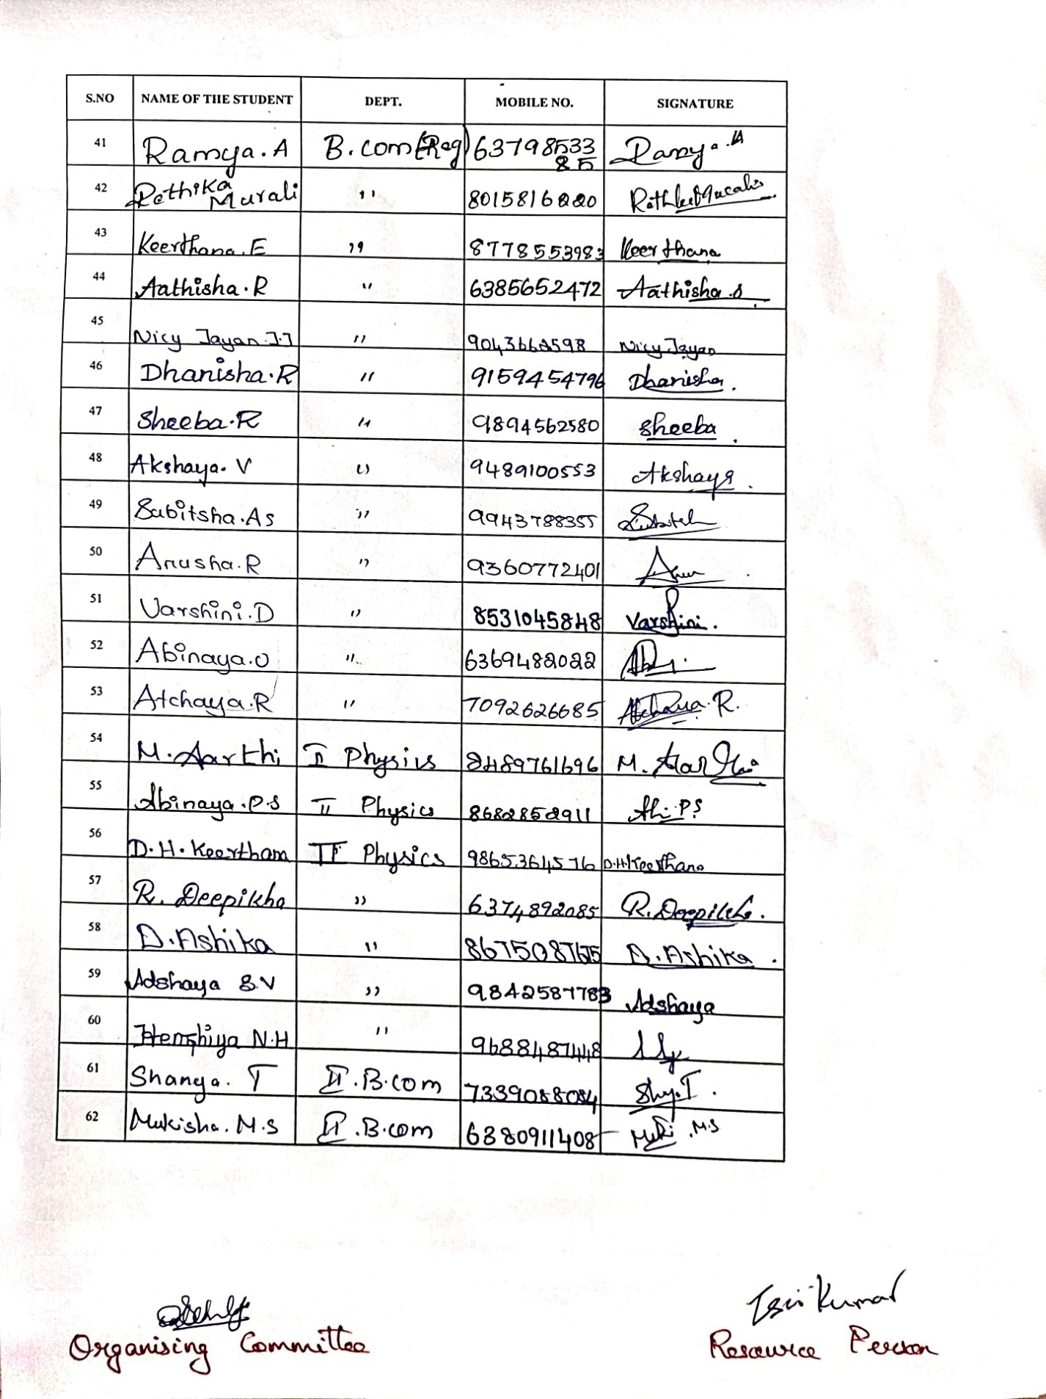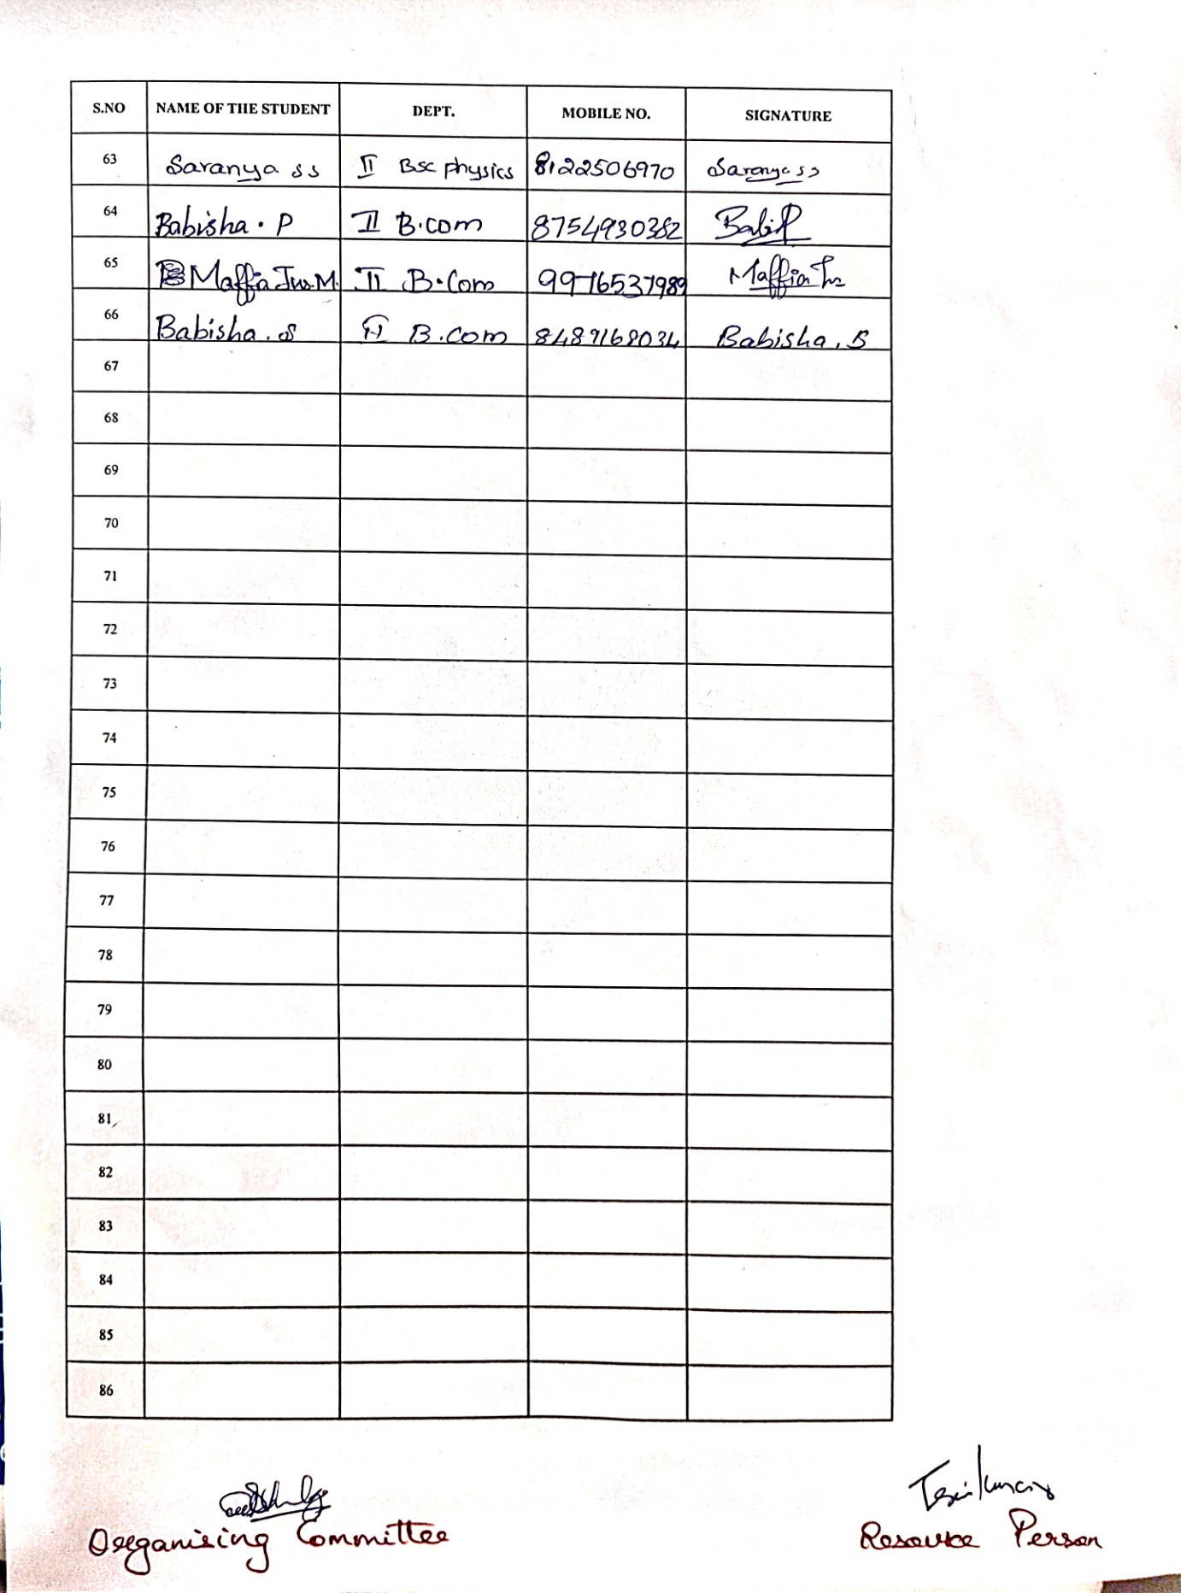

OBJECTIVE OF PROGRAMME : Building strong UI/ UX Foundations among students. Designing interfaces that work effortlessly across mobile, desktop and emerging devices. Creating eco-friendly digital products.

OUTCOME OF PROGRAMME : Focus on accessibility, ensuring apps work for people of all abilities. The students were eager about learning UI / UX Design.

PHOTOS OF THE PROGRAMME :
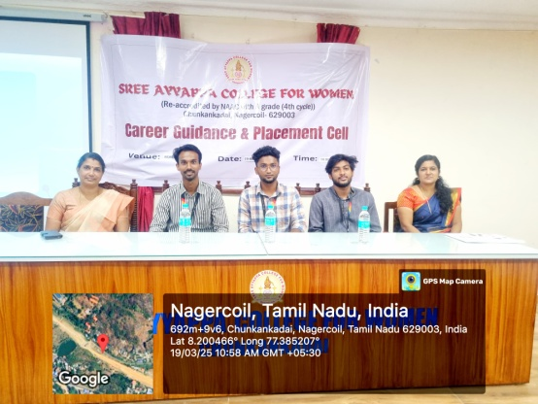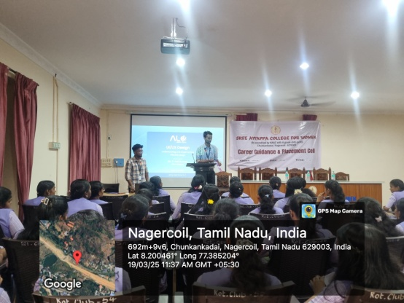

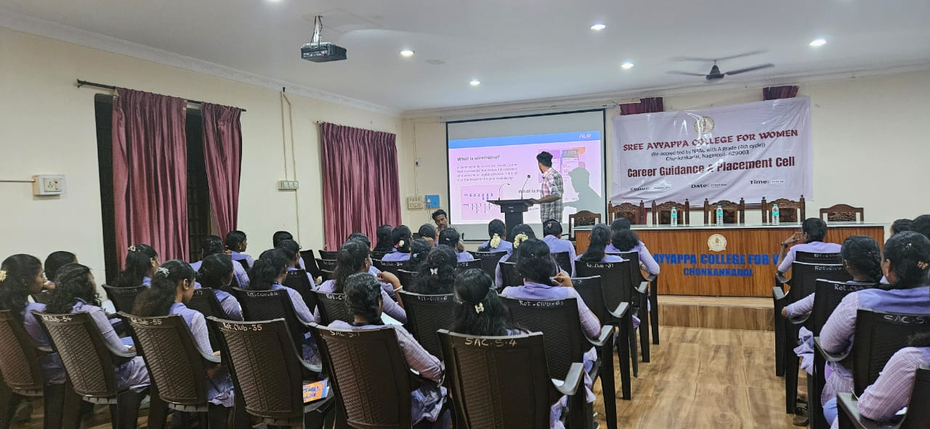

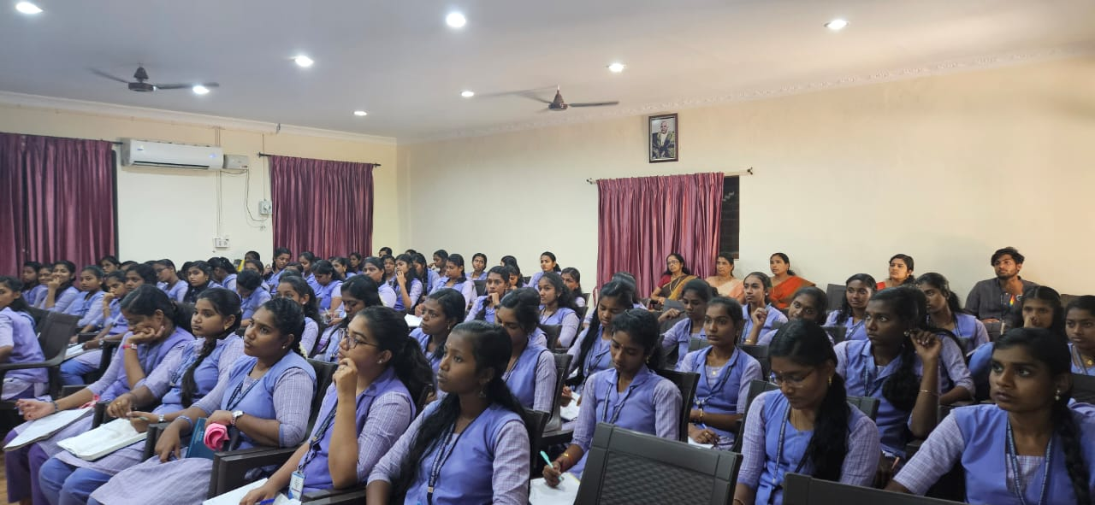
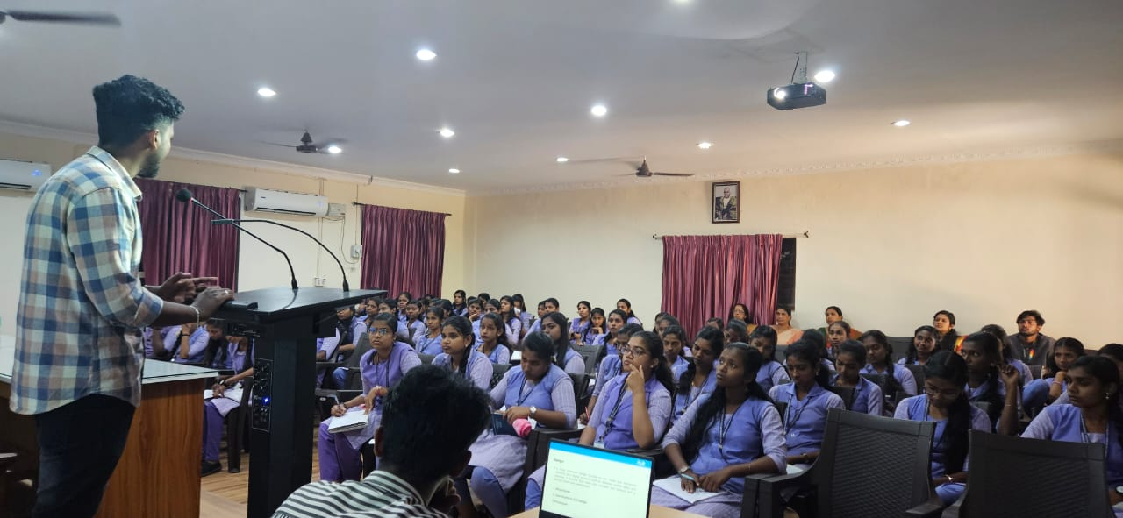

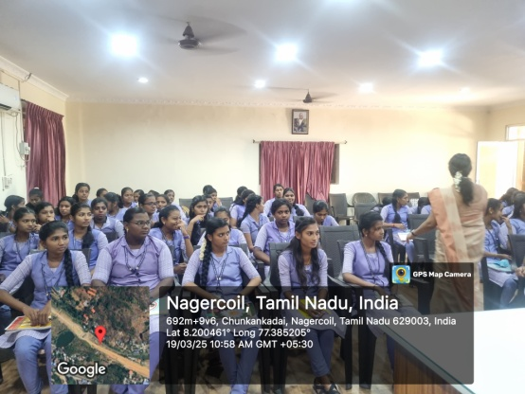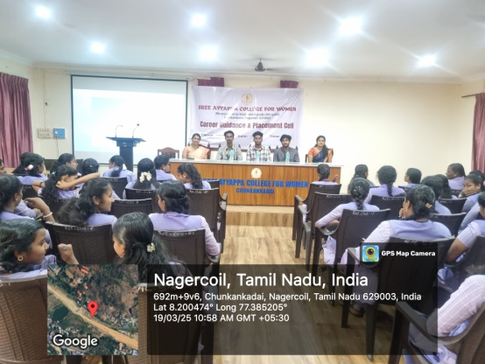
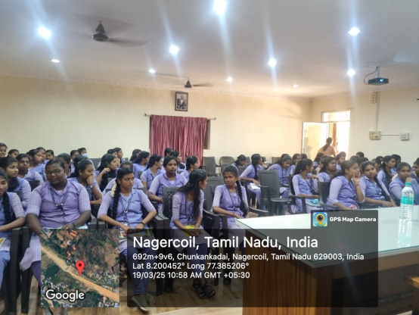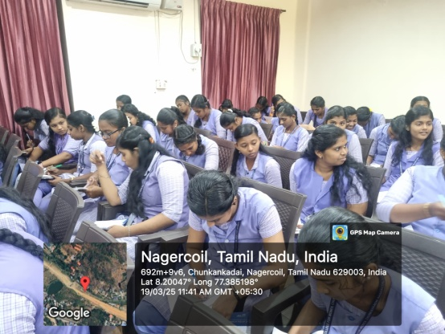
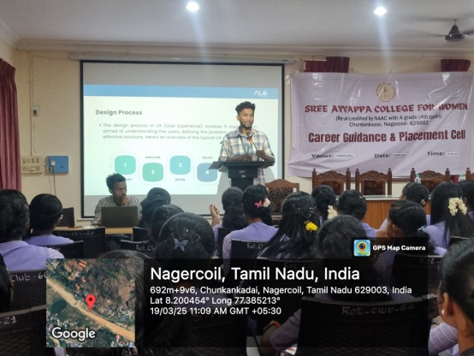

BROCHURE :

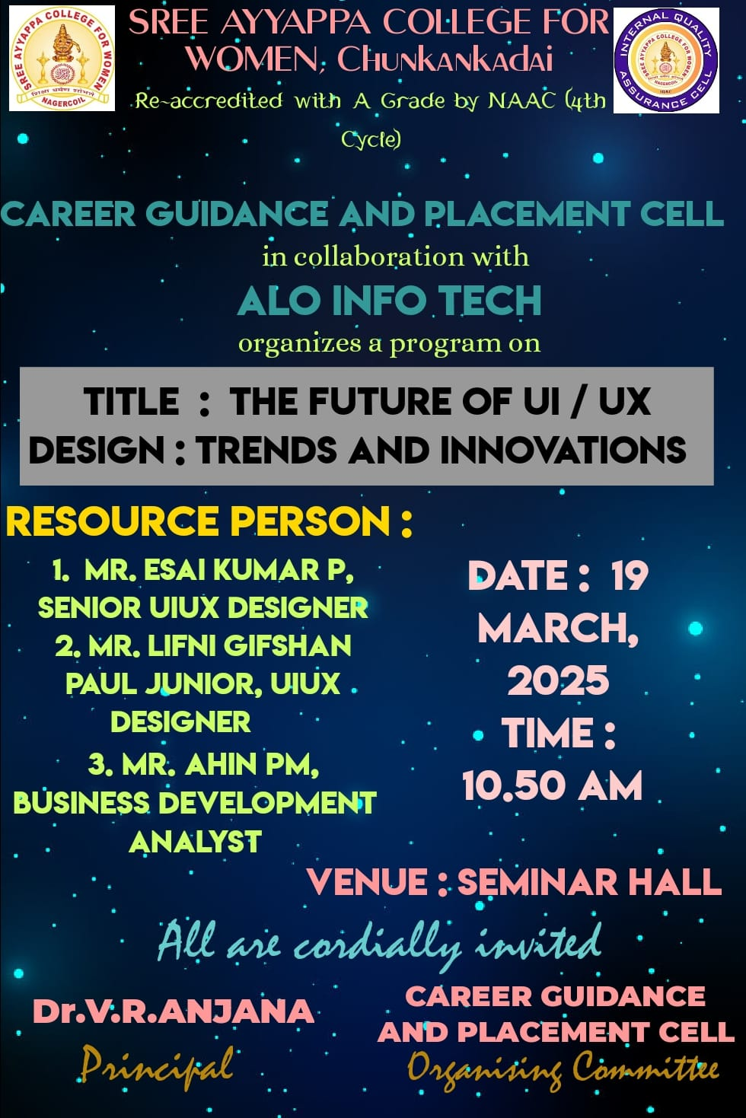

NAME OF THE ORGANIZING COMMITTEE : Career Guidance and Placement Cell in collaboration with Alo Info Tech.

PLACEMENT DRIVE 2024-25
NAME OF THE ACTIVITY : Placement Drive 2024-25
RESOURCE PERSON : Mr.Dhanashekar, TVS Training and Services
DATE AND DURATION : 20/03/2025 & 10.00AM to 3.30PM
NUMBER OF PARTICIPANTS : 148 – Out of which 8 are Outsiders remaining 140 for Sree Ayyappa College for Women.

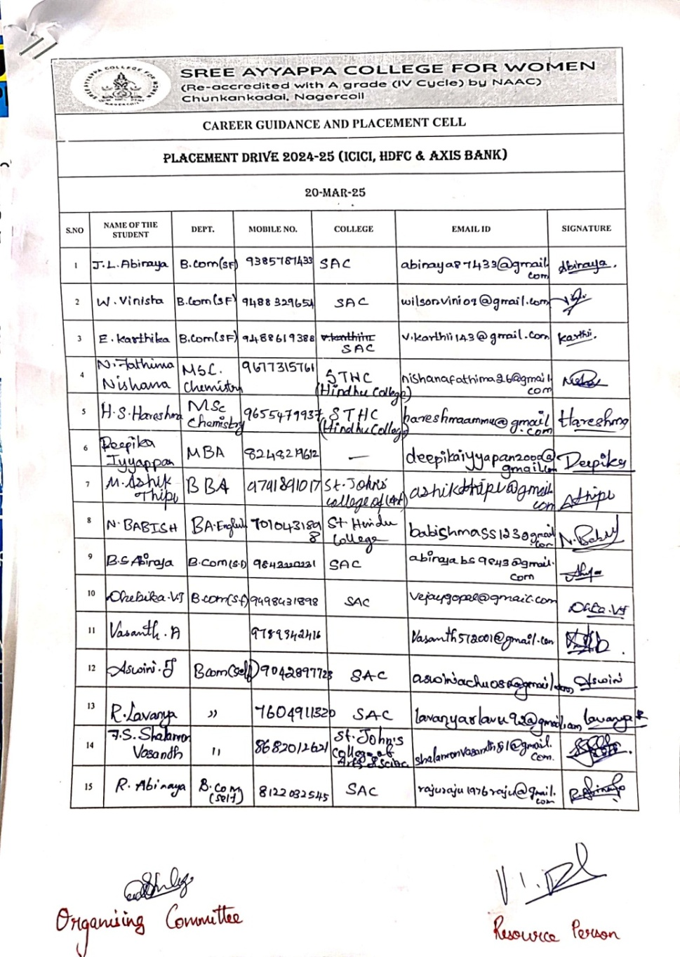
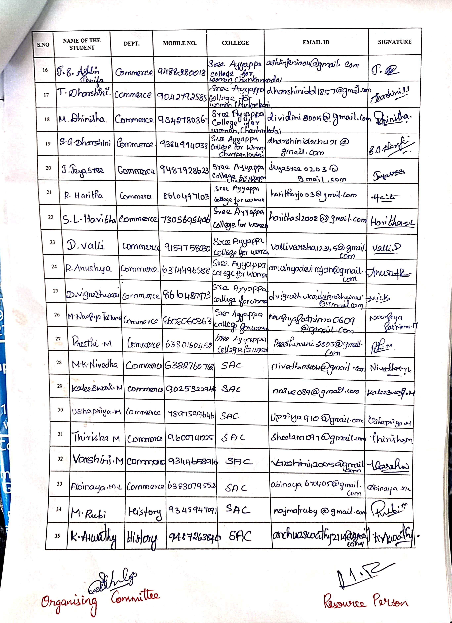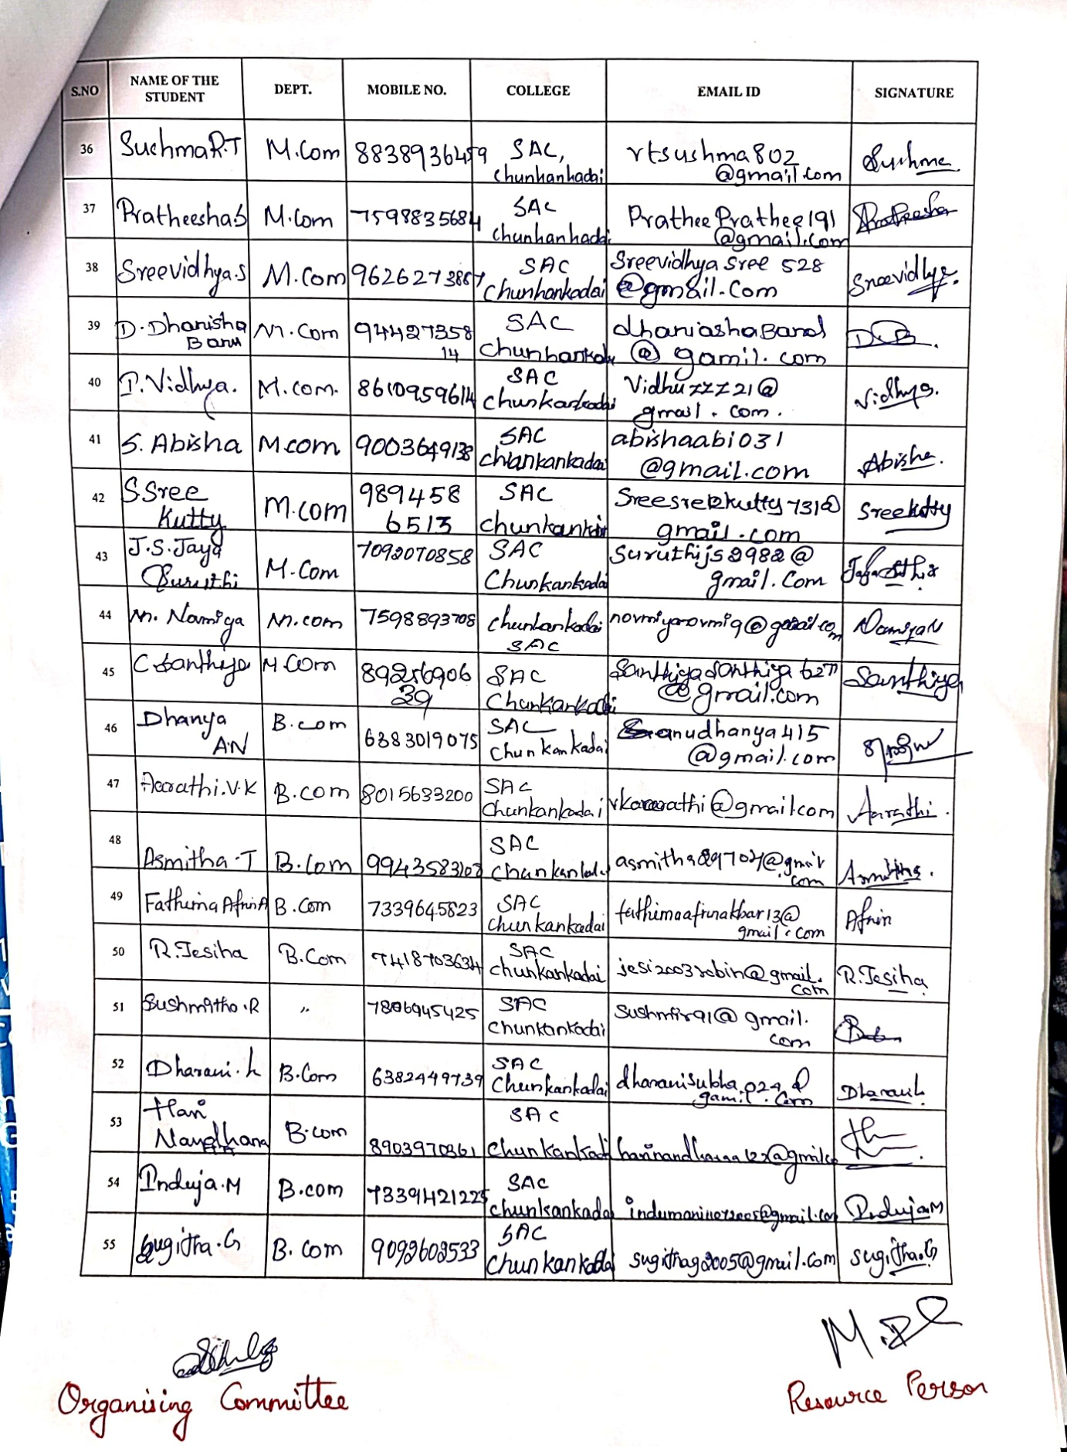
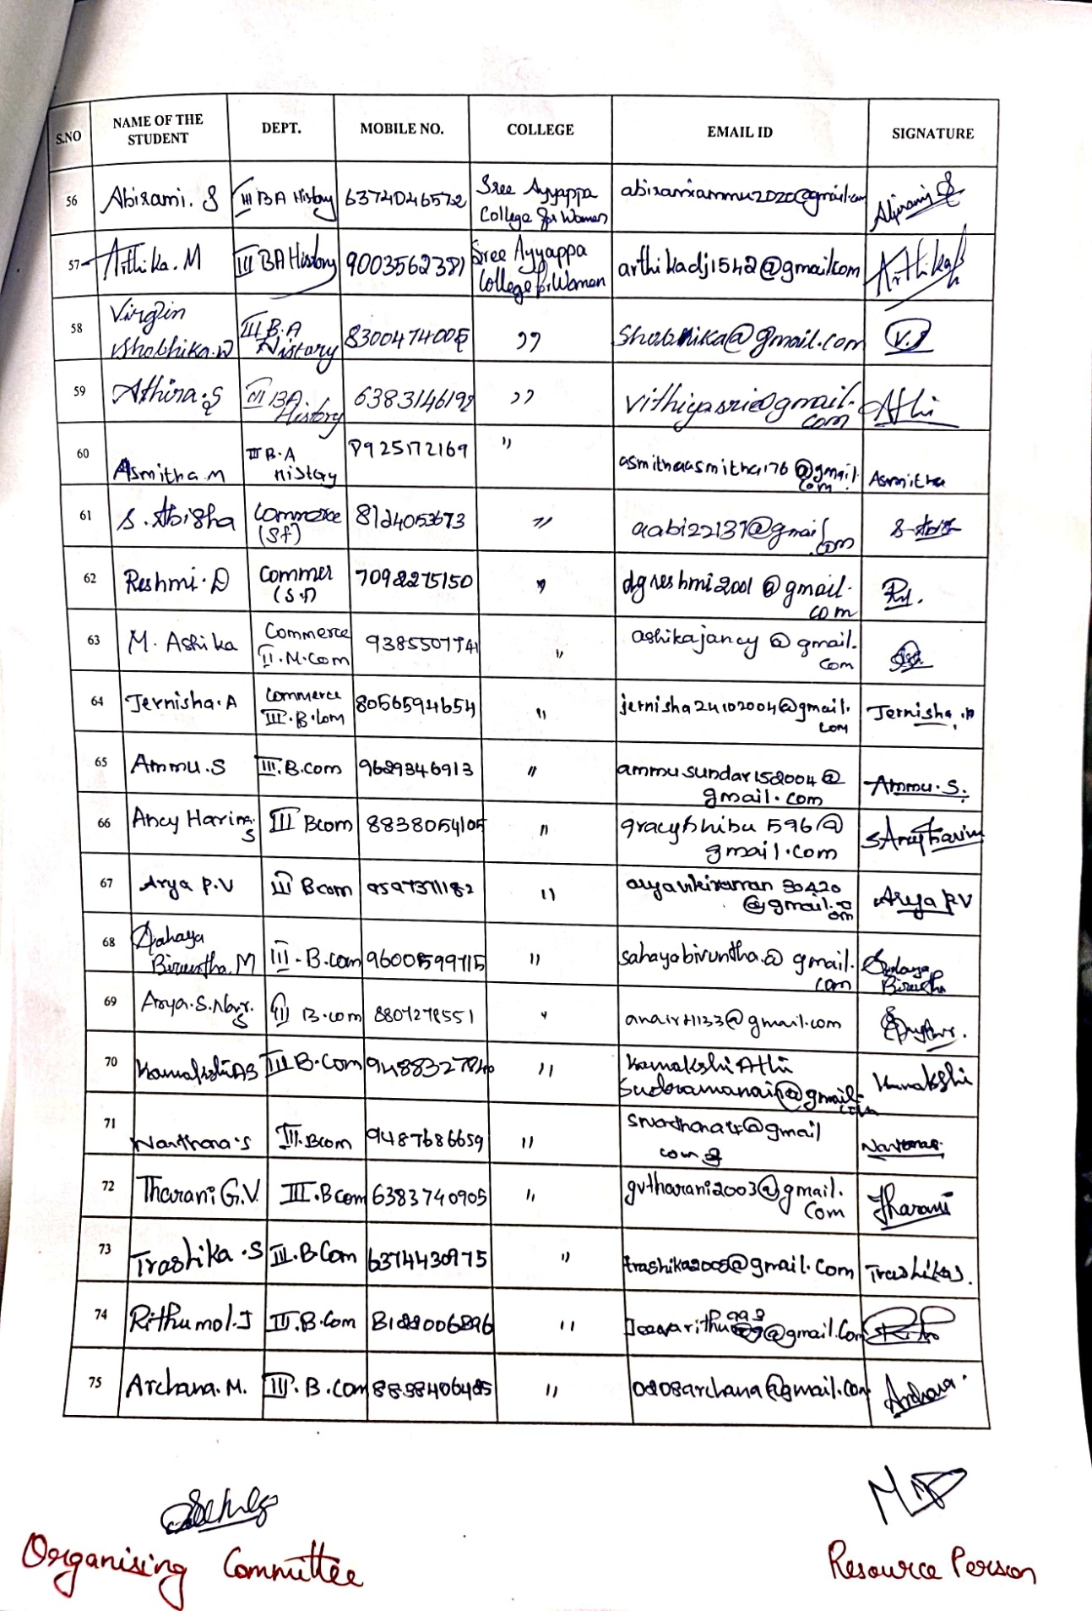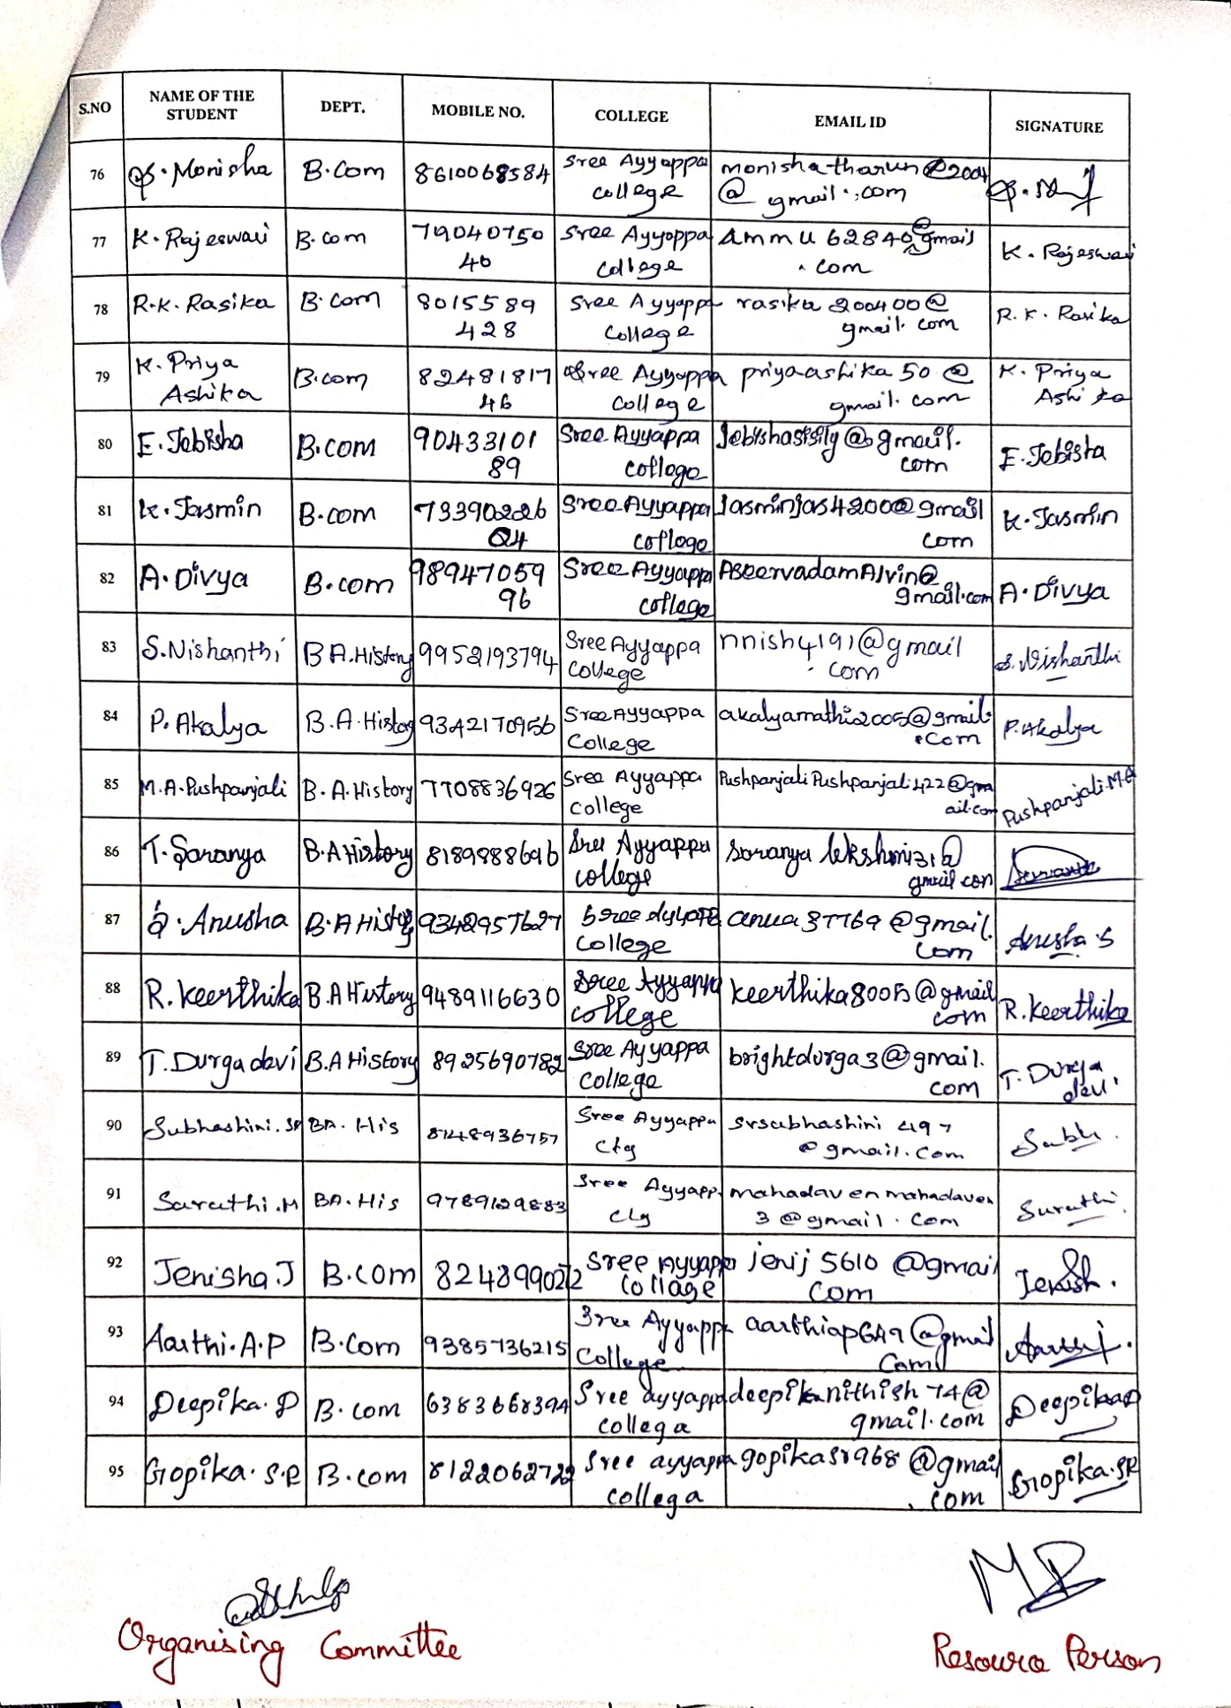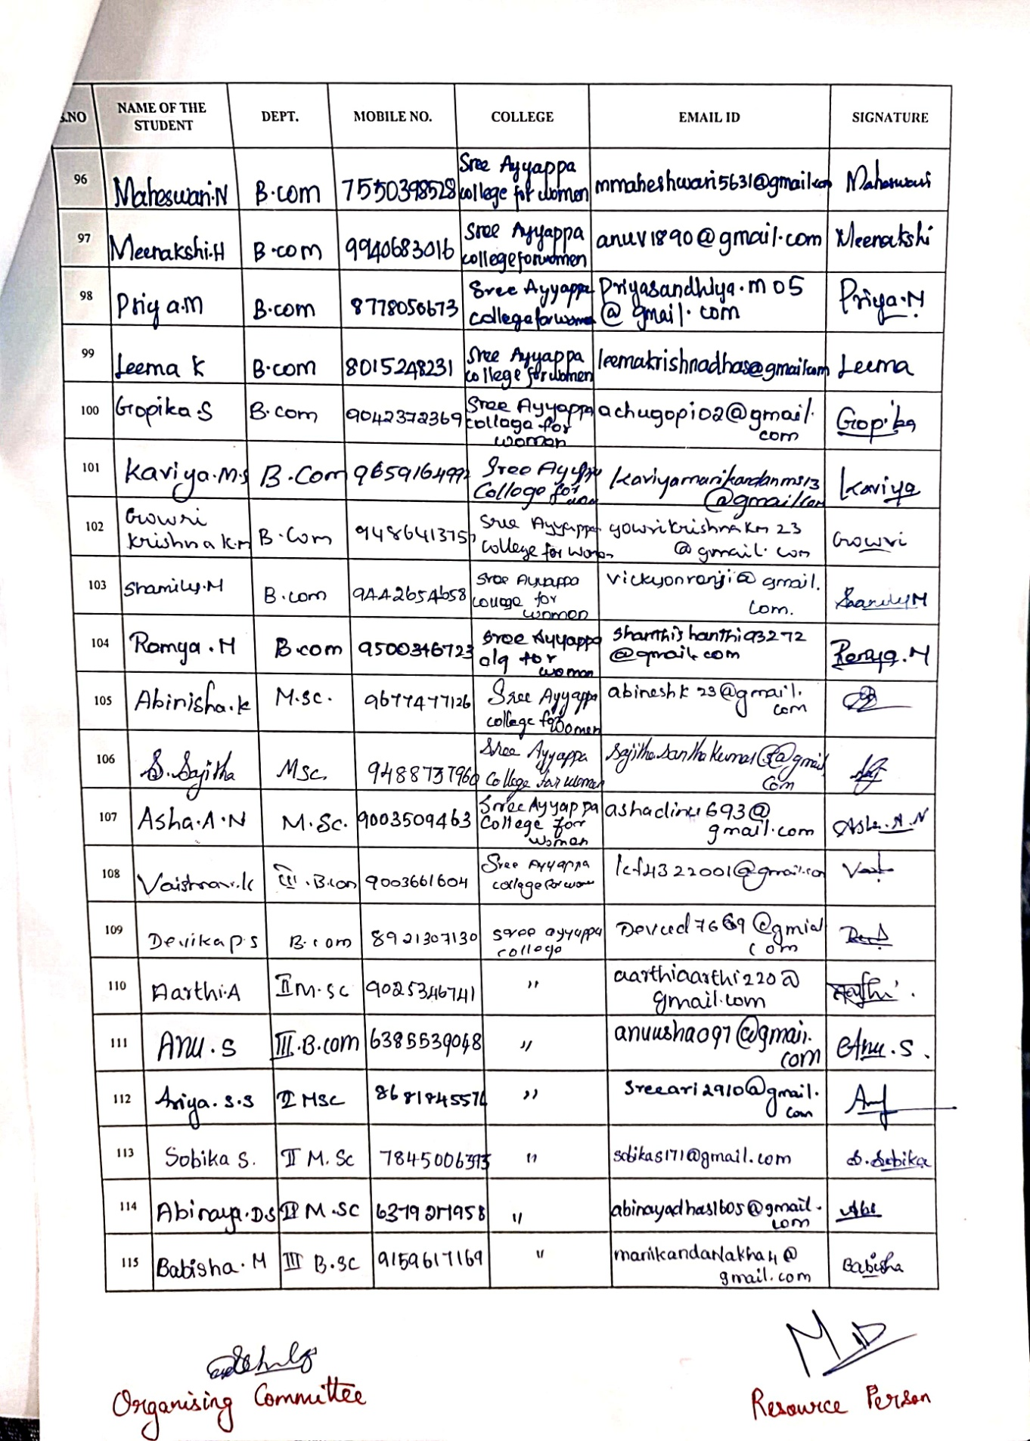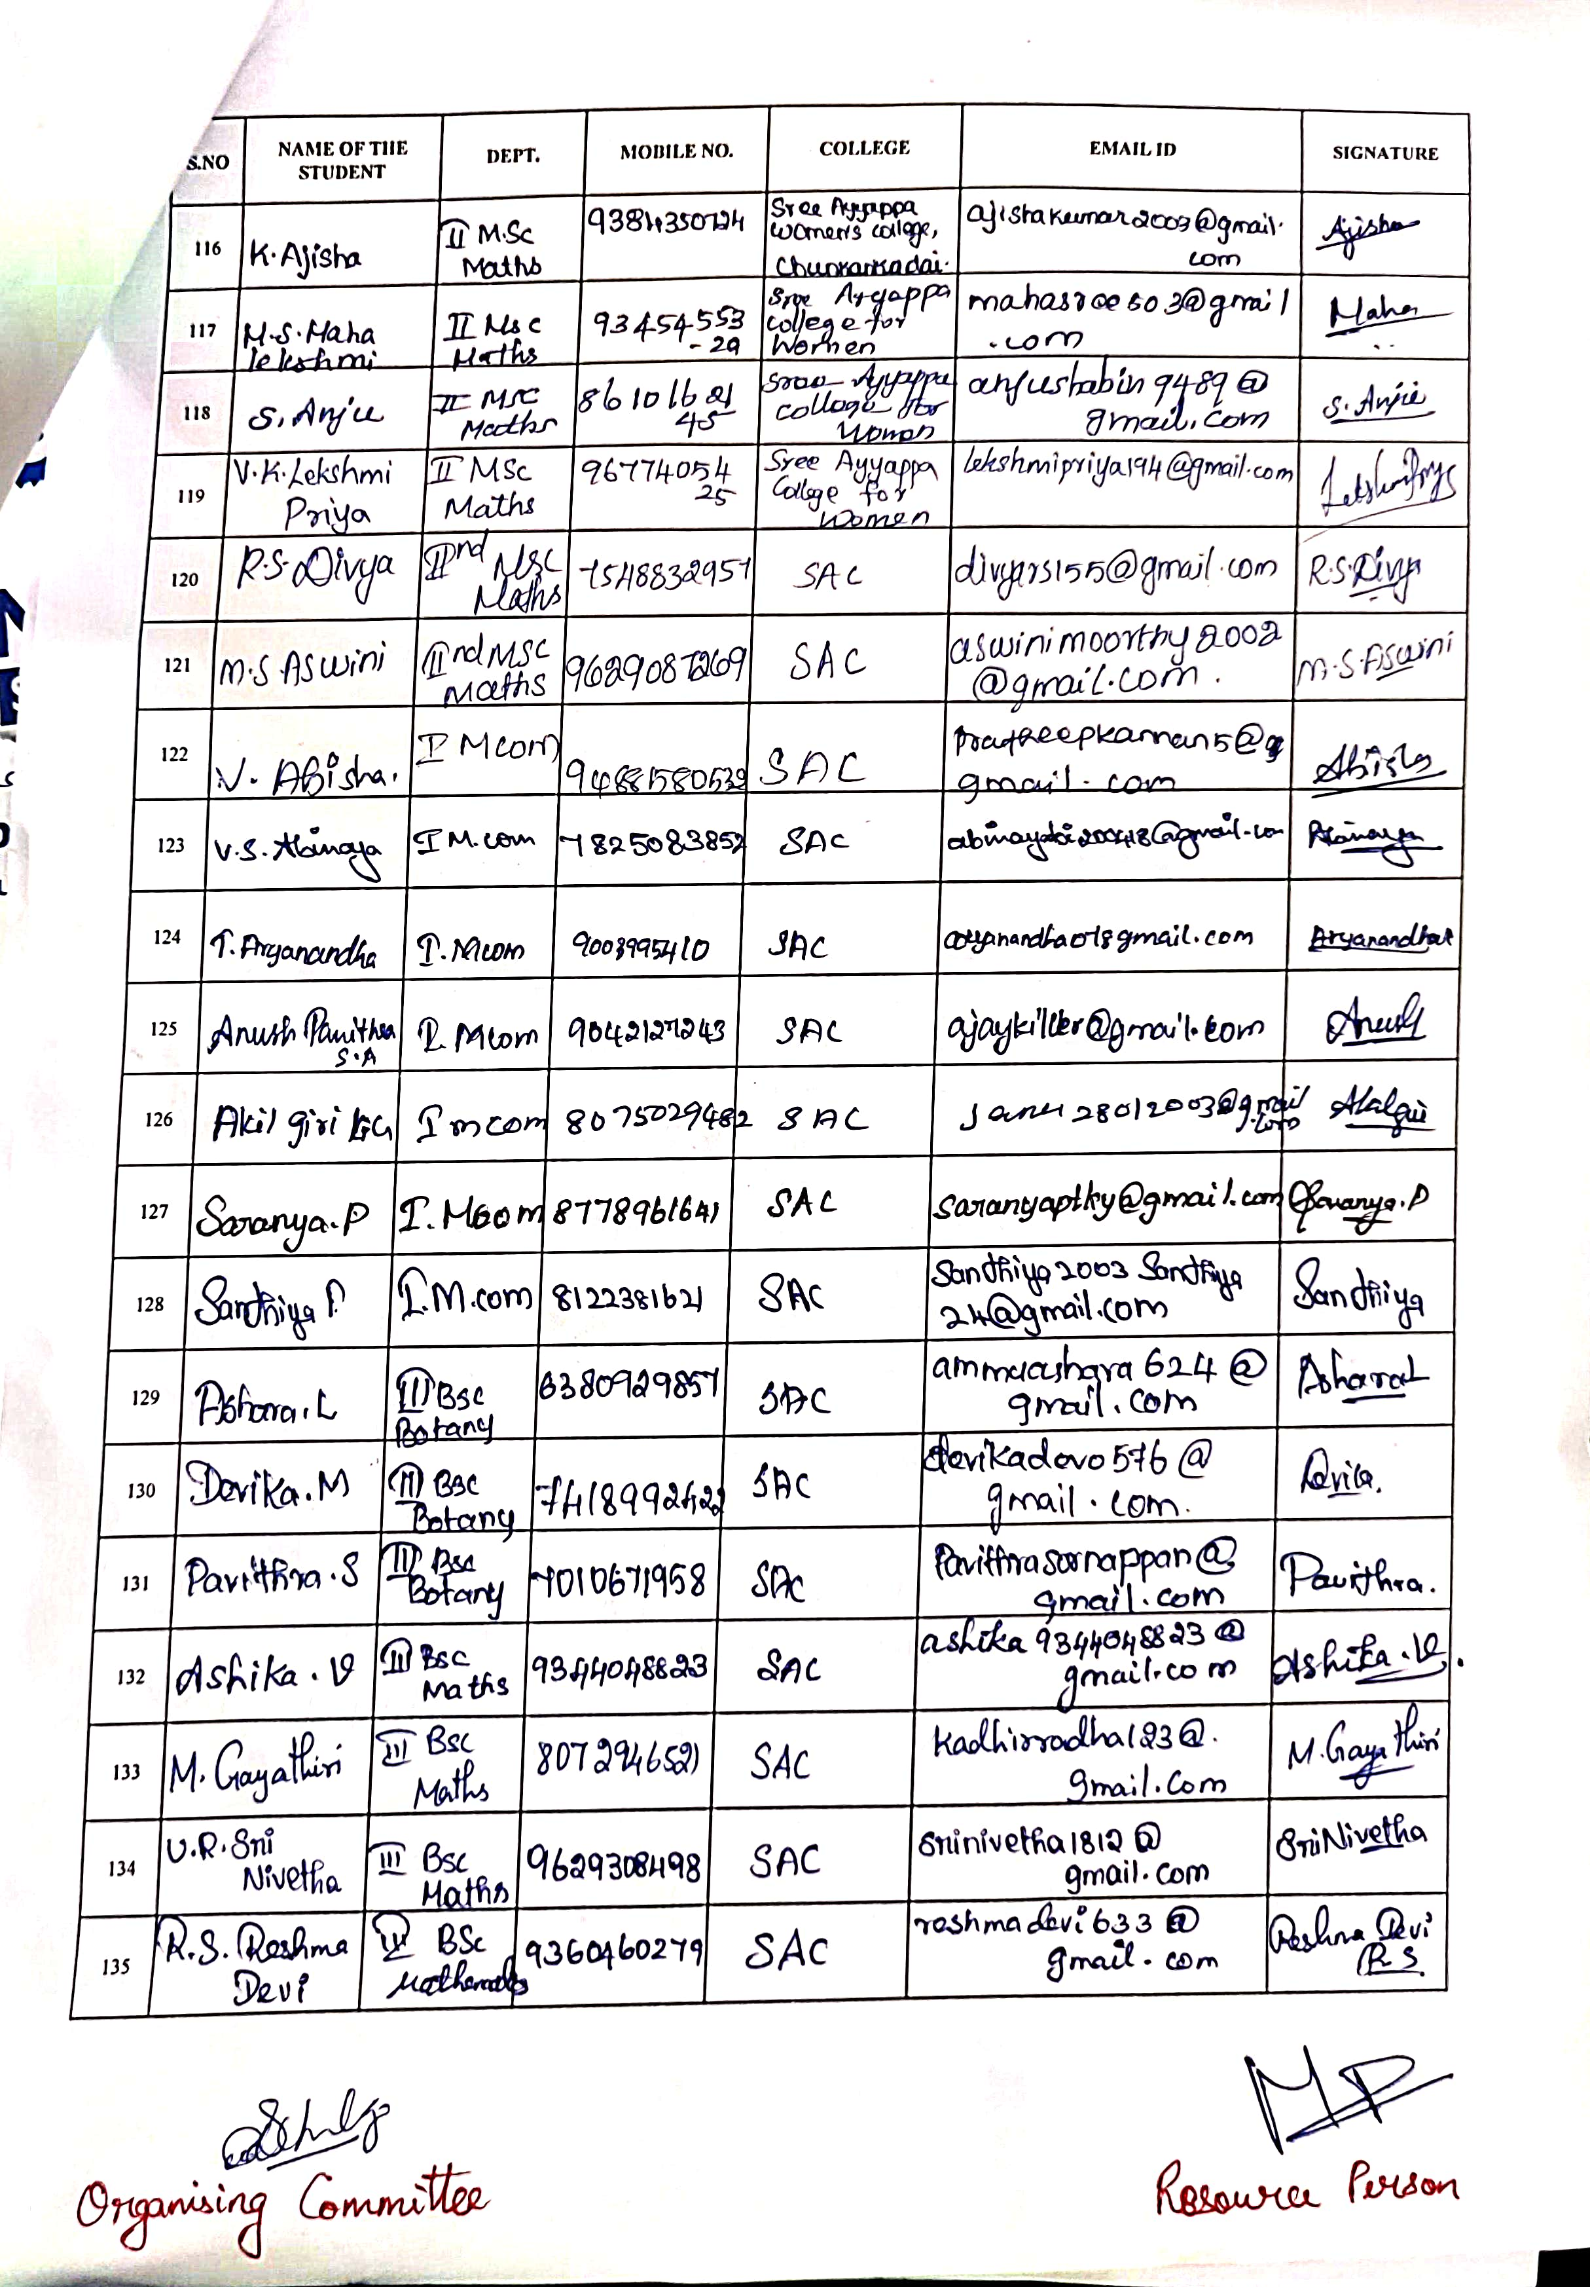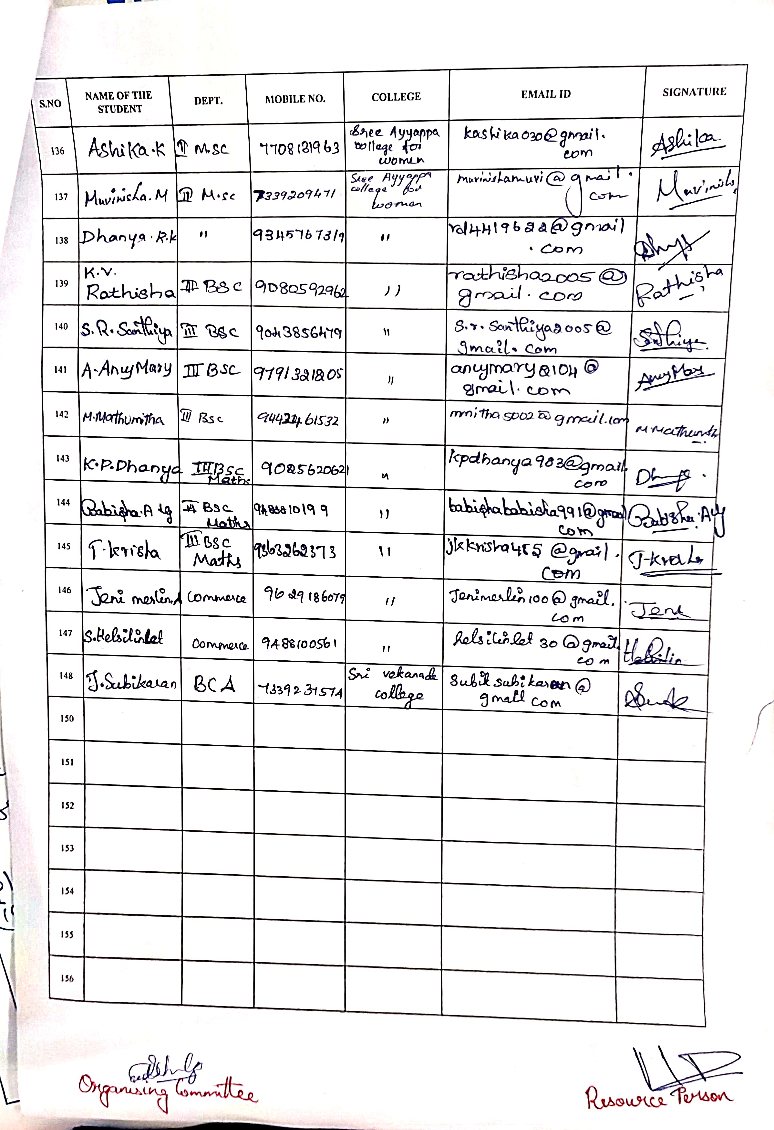

OBJECTIVE OF PROGRAMME : Recruitment was conducted for the Final Year students for the HDFC Bank, ICICI Bank and AXIS Bank. Students were given complete details on the work.

OUTCOME OF PROGRAMME : Online registration was done for the students and was informed that the students will be called for interview once the exams are completed.

PHOTOS OF THE PROGRAMME :

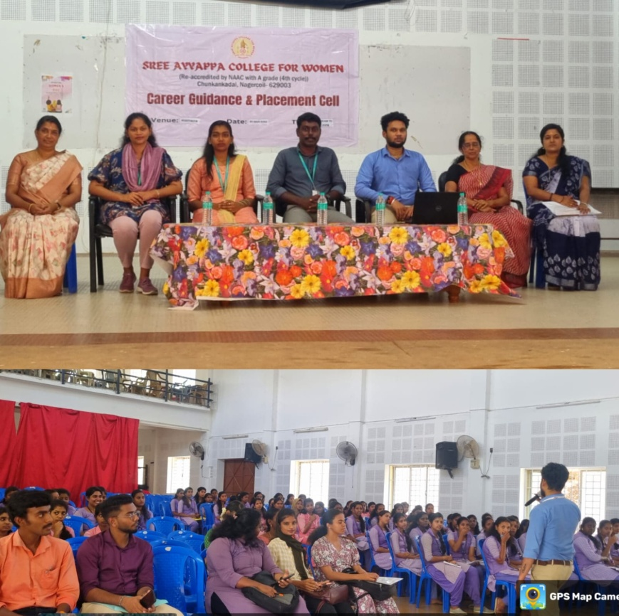
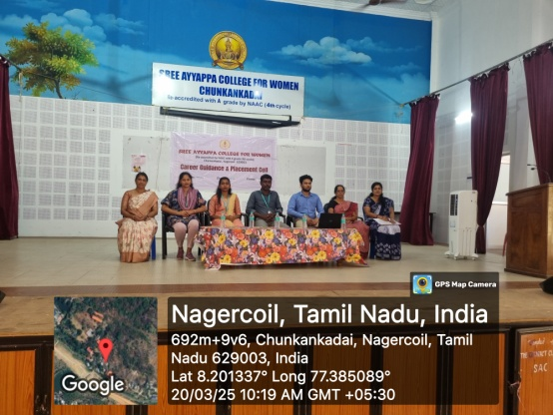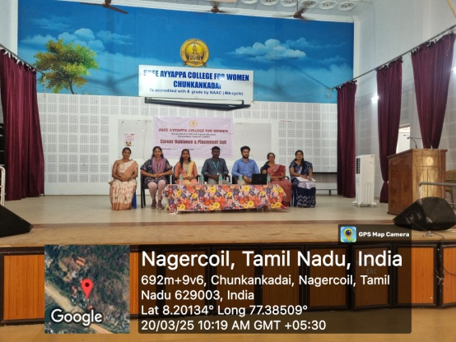
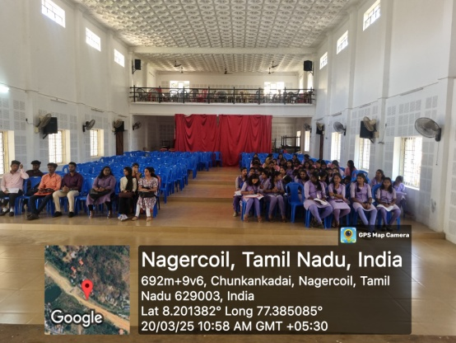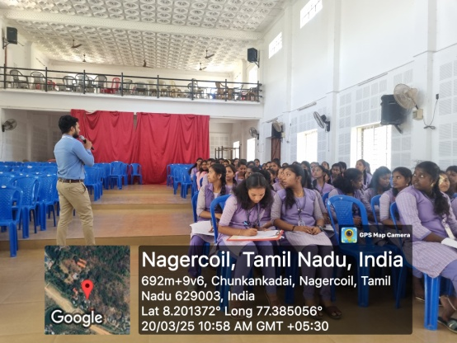
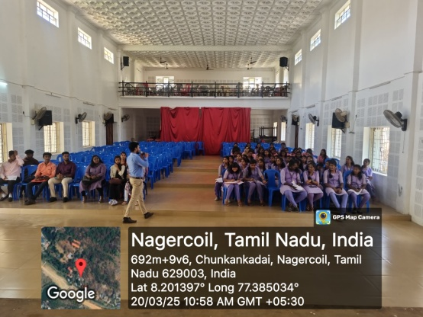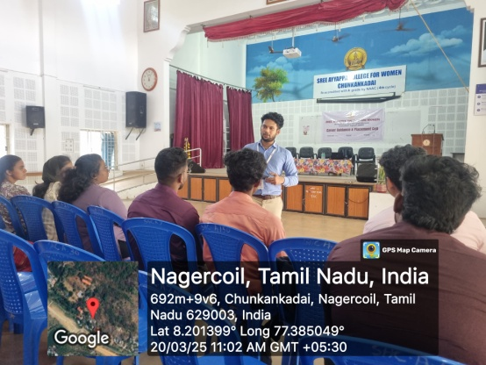
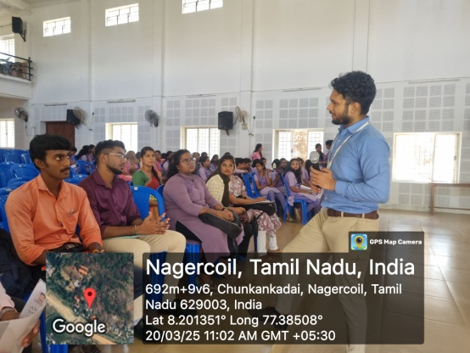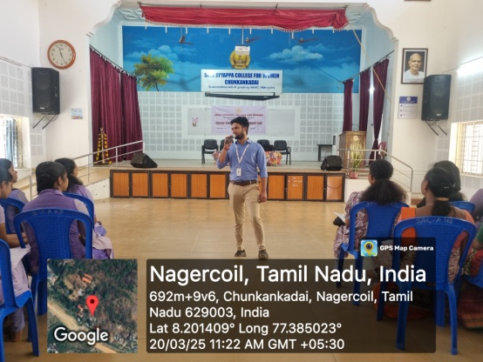
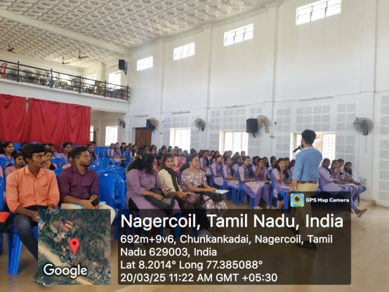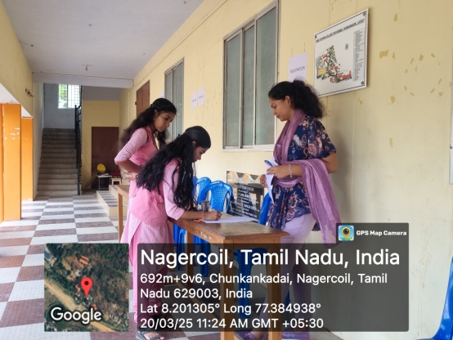
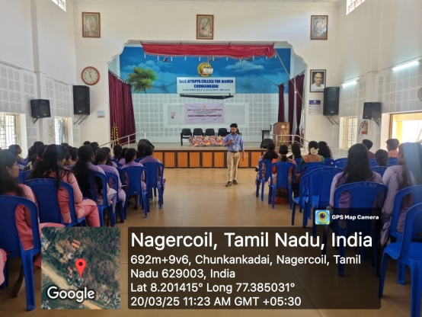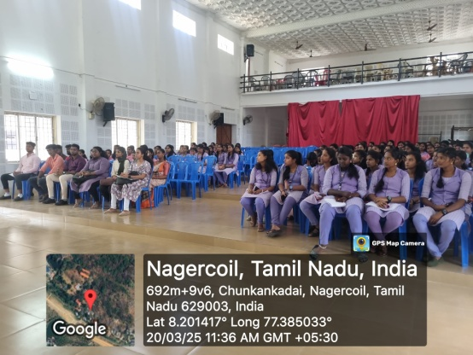

BROCHURE :
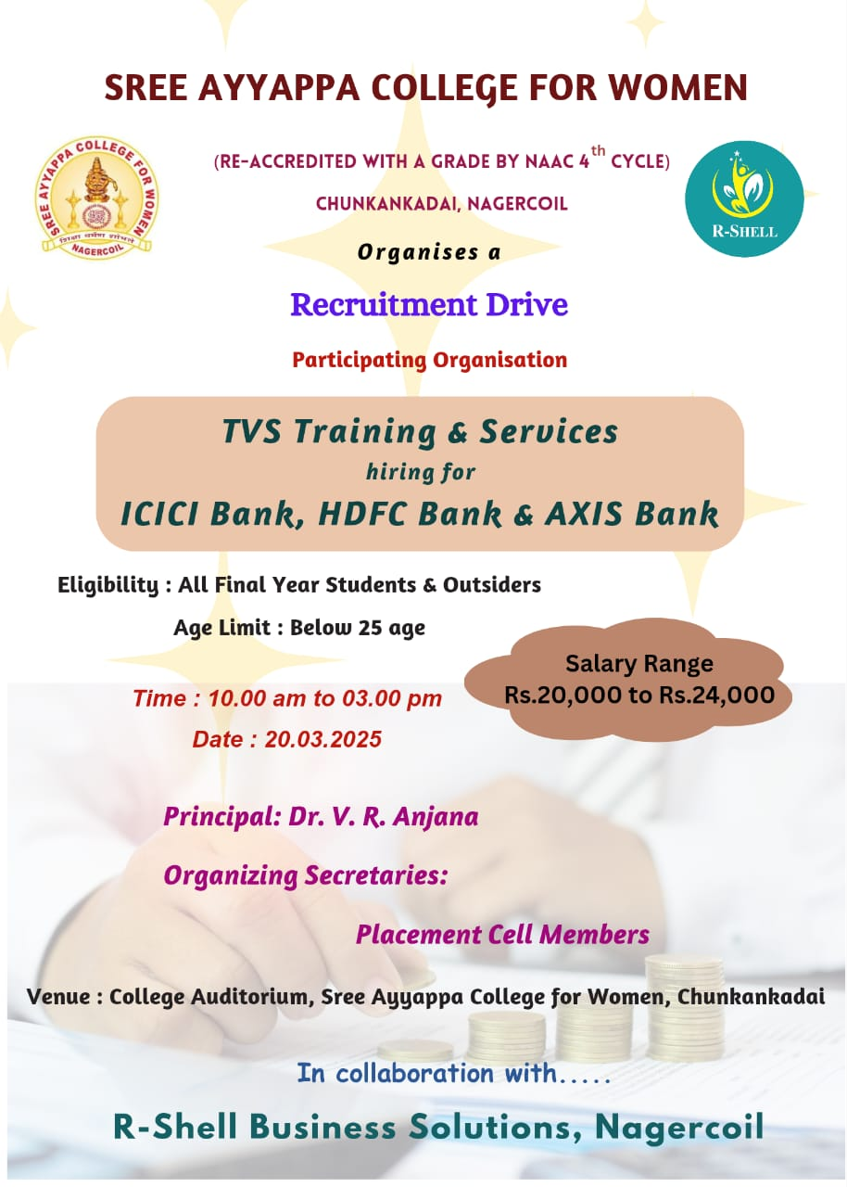

NAME OF THE ORGANIZING COMMITTEE : Career Guidance and Placement Cell in collaboration with R-Shell Info Services.
PLACEMENT DRIVE 2024-25

NAME OF THE ACTIVITY : Placement Drive 2024-25 VIRTUAL SOLUTIONS under FOXCONN HON HAI TECHNOLOGY INDIA MEGA DEVELOPMENT PRIVATE LTD

RESOURCE PERSON : 1. Mr. M.PRASANTH, HR Executive, Virtual Solutions under FOXCONN Company, Chennai
2. Mr. S.FERMIN PAUL, HR Executive, KM Foundation Research and Development, Kanyakumari.
3. Mr. V.P.GLASTON YESUDAS, Project Coordinator-KMF
4. Mr. Er.J.JOHNLY, Vice-President - KMF

DATE AND DURATION : 01 April 2025 and 11.30AM to 3.00PM
NUMBER OF PARTICIPANTS : 70
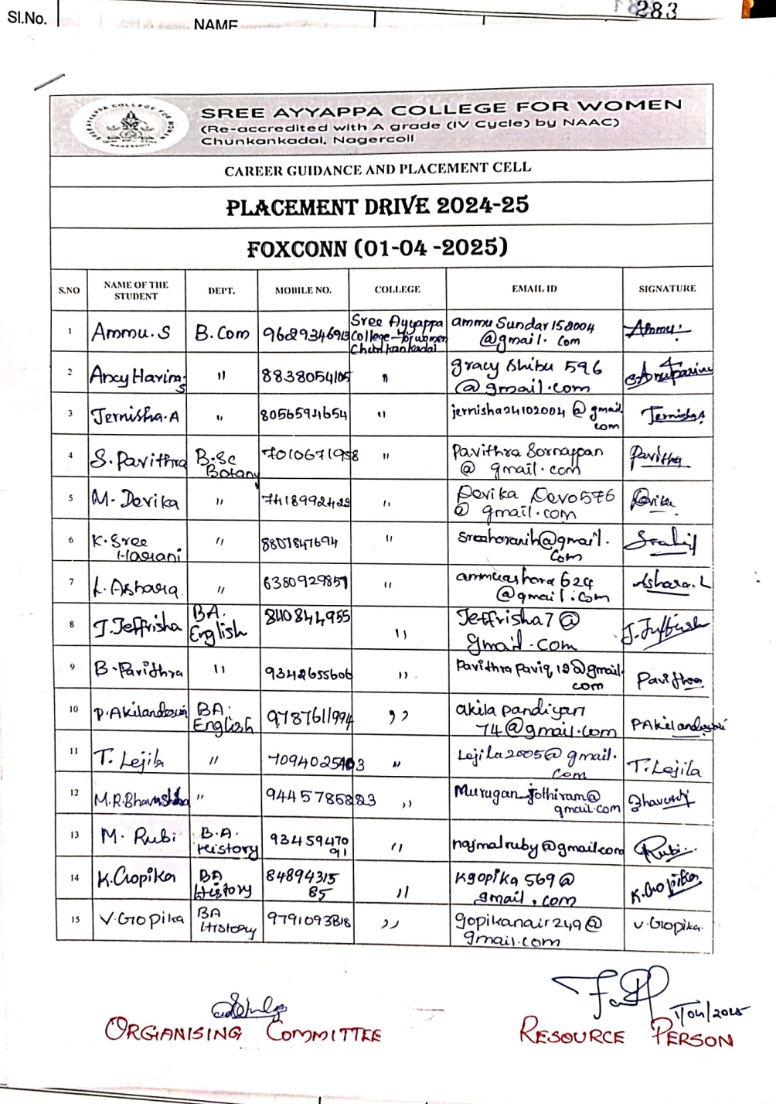
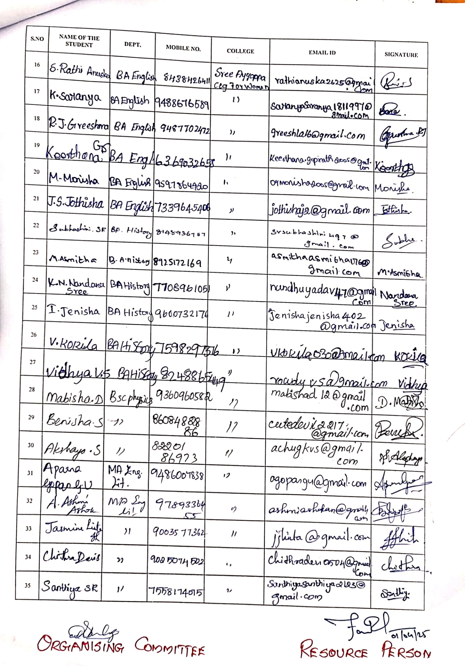

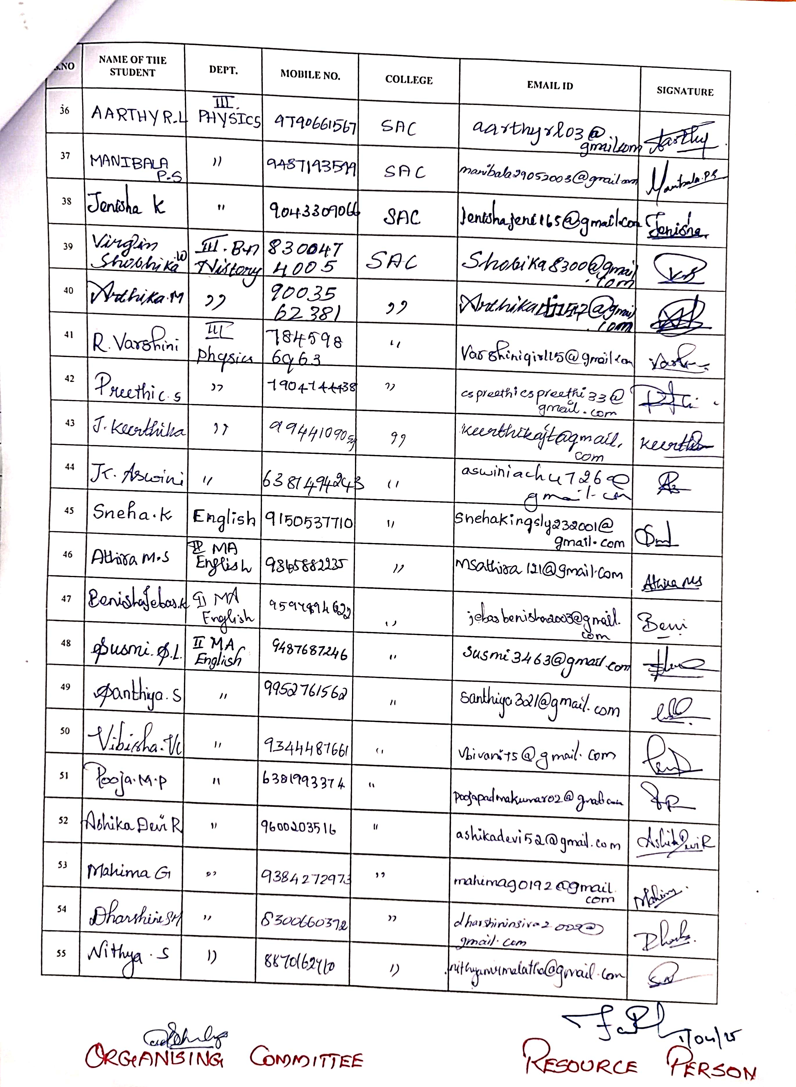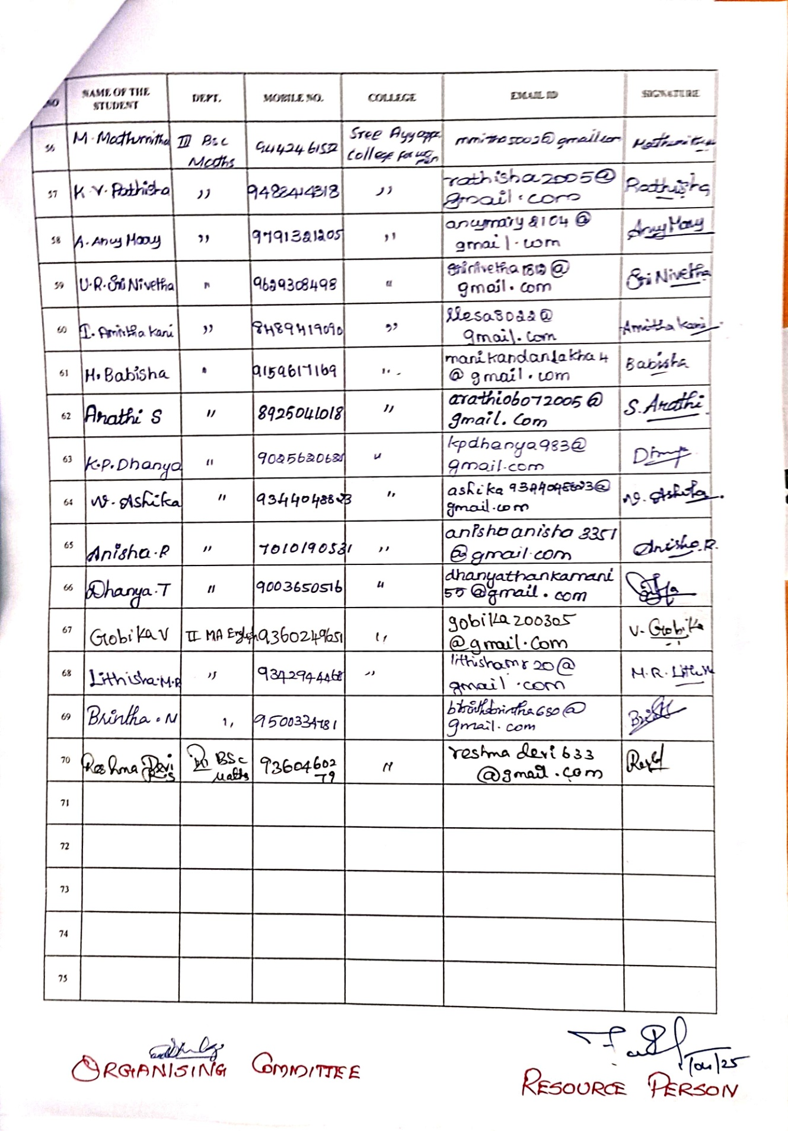

OBJECTIVE OF PROGRAMME : Placement Drive 2024-25 was conducted for Final Year UG and PG students by VIRTUAL SOLUTIONS under FOXCONN HON HOI INDIA MEGA DEVELOPMENT PVT LTD situated at Sriperumbudur, Chennai.

OUTCOME OF PROGRAMME : 37 Students were selected as Assembly Line Operator for Iphone with a Pay of Rs.17, 000/m for first 6months followed by Rs.19, 000/m after 6months. After 1year they will be assigned as Quality Analyst with Rs.21, 000/m and after 18months they will assigned as TECHNICIAN with a pay of Rs.25, 000/m.

LIST OF SELECTED STUDENTS
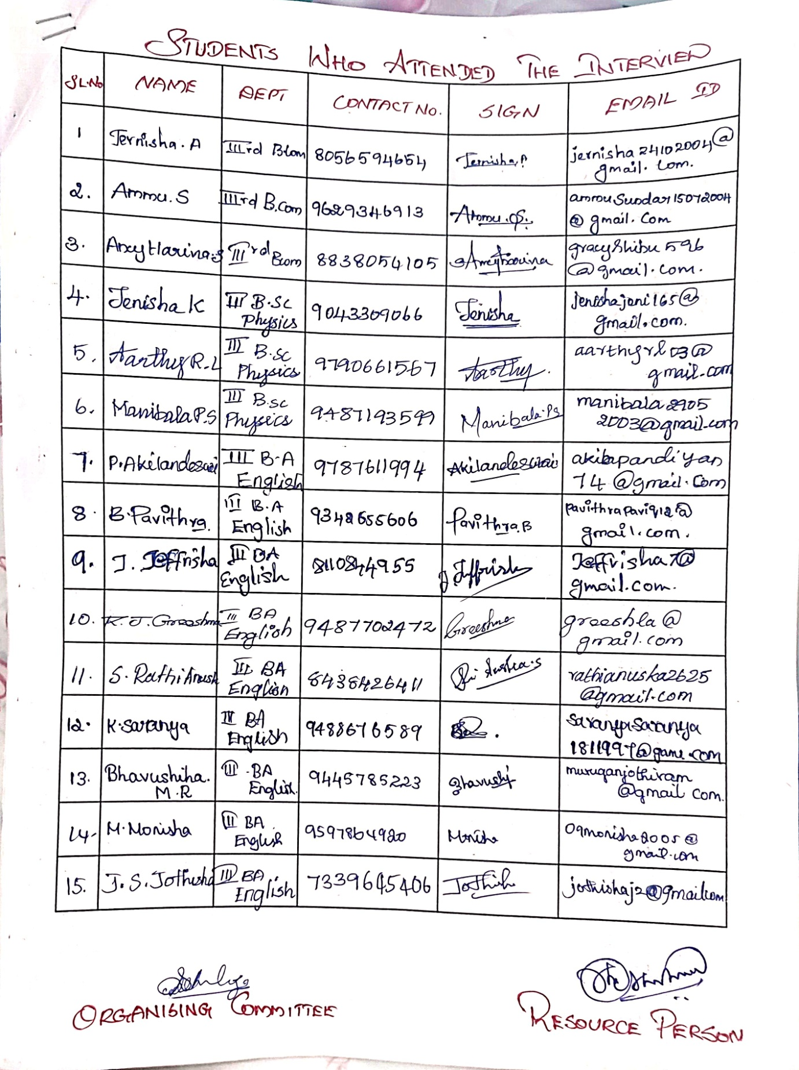
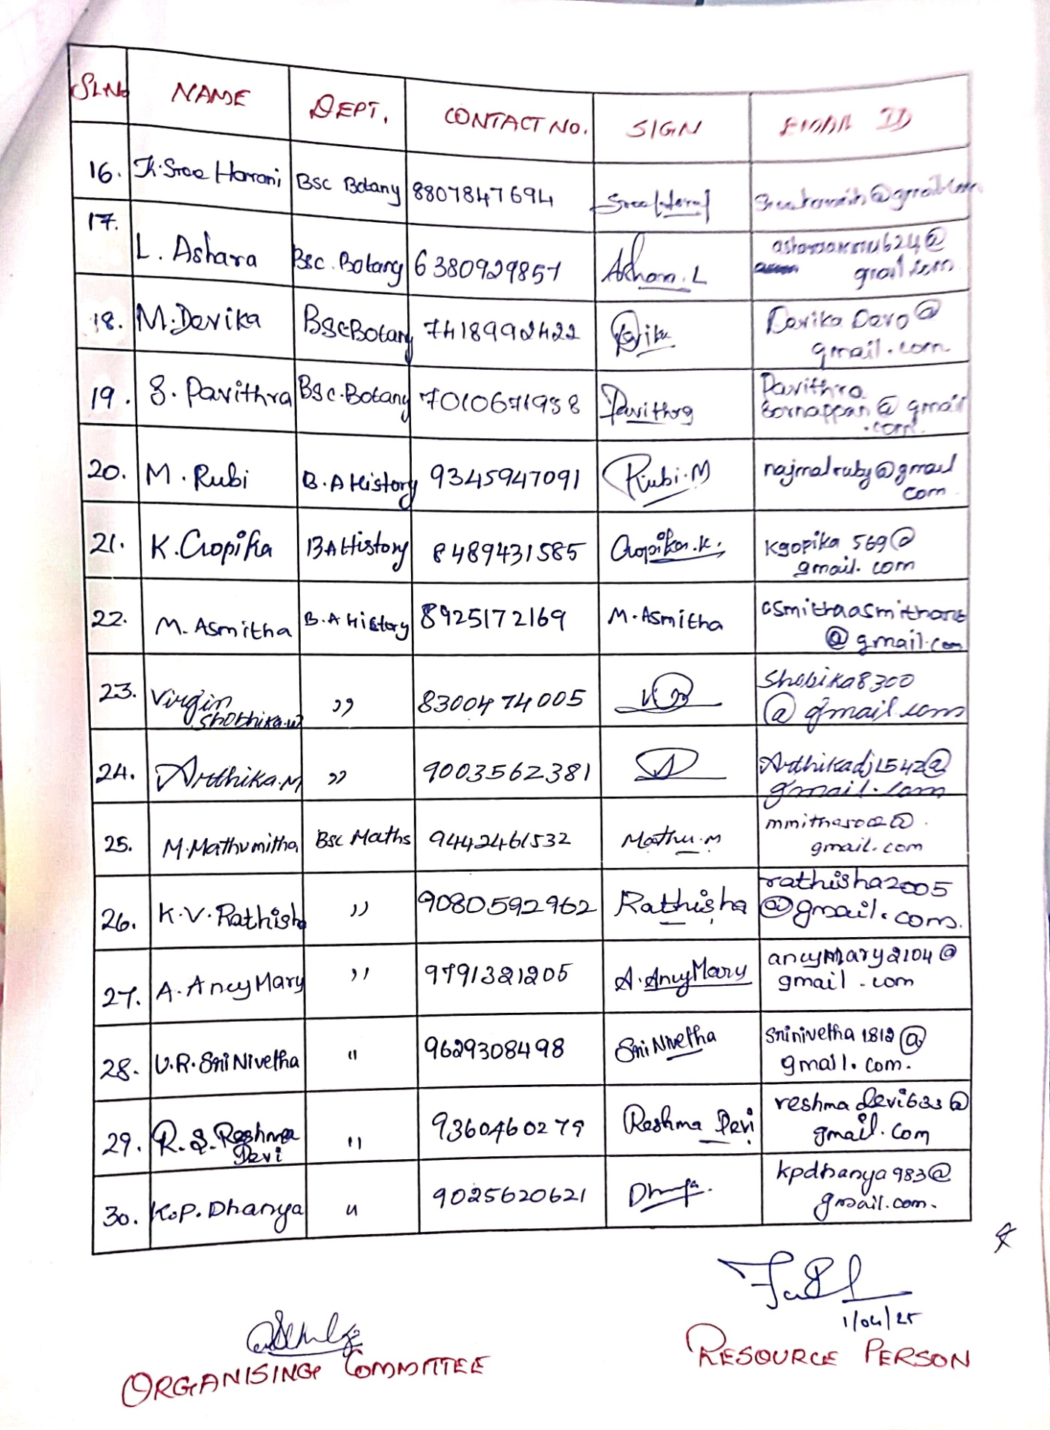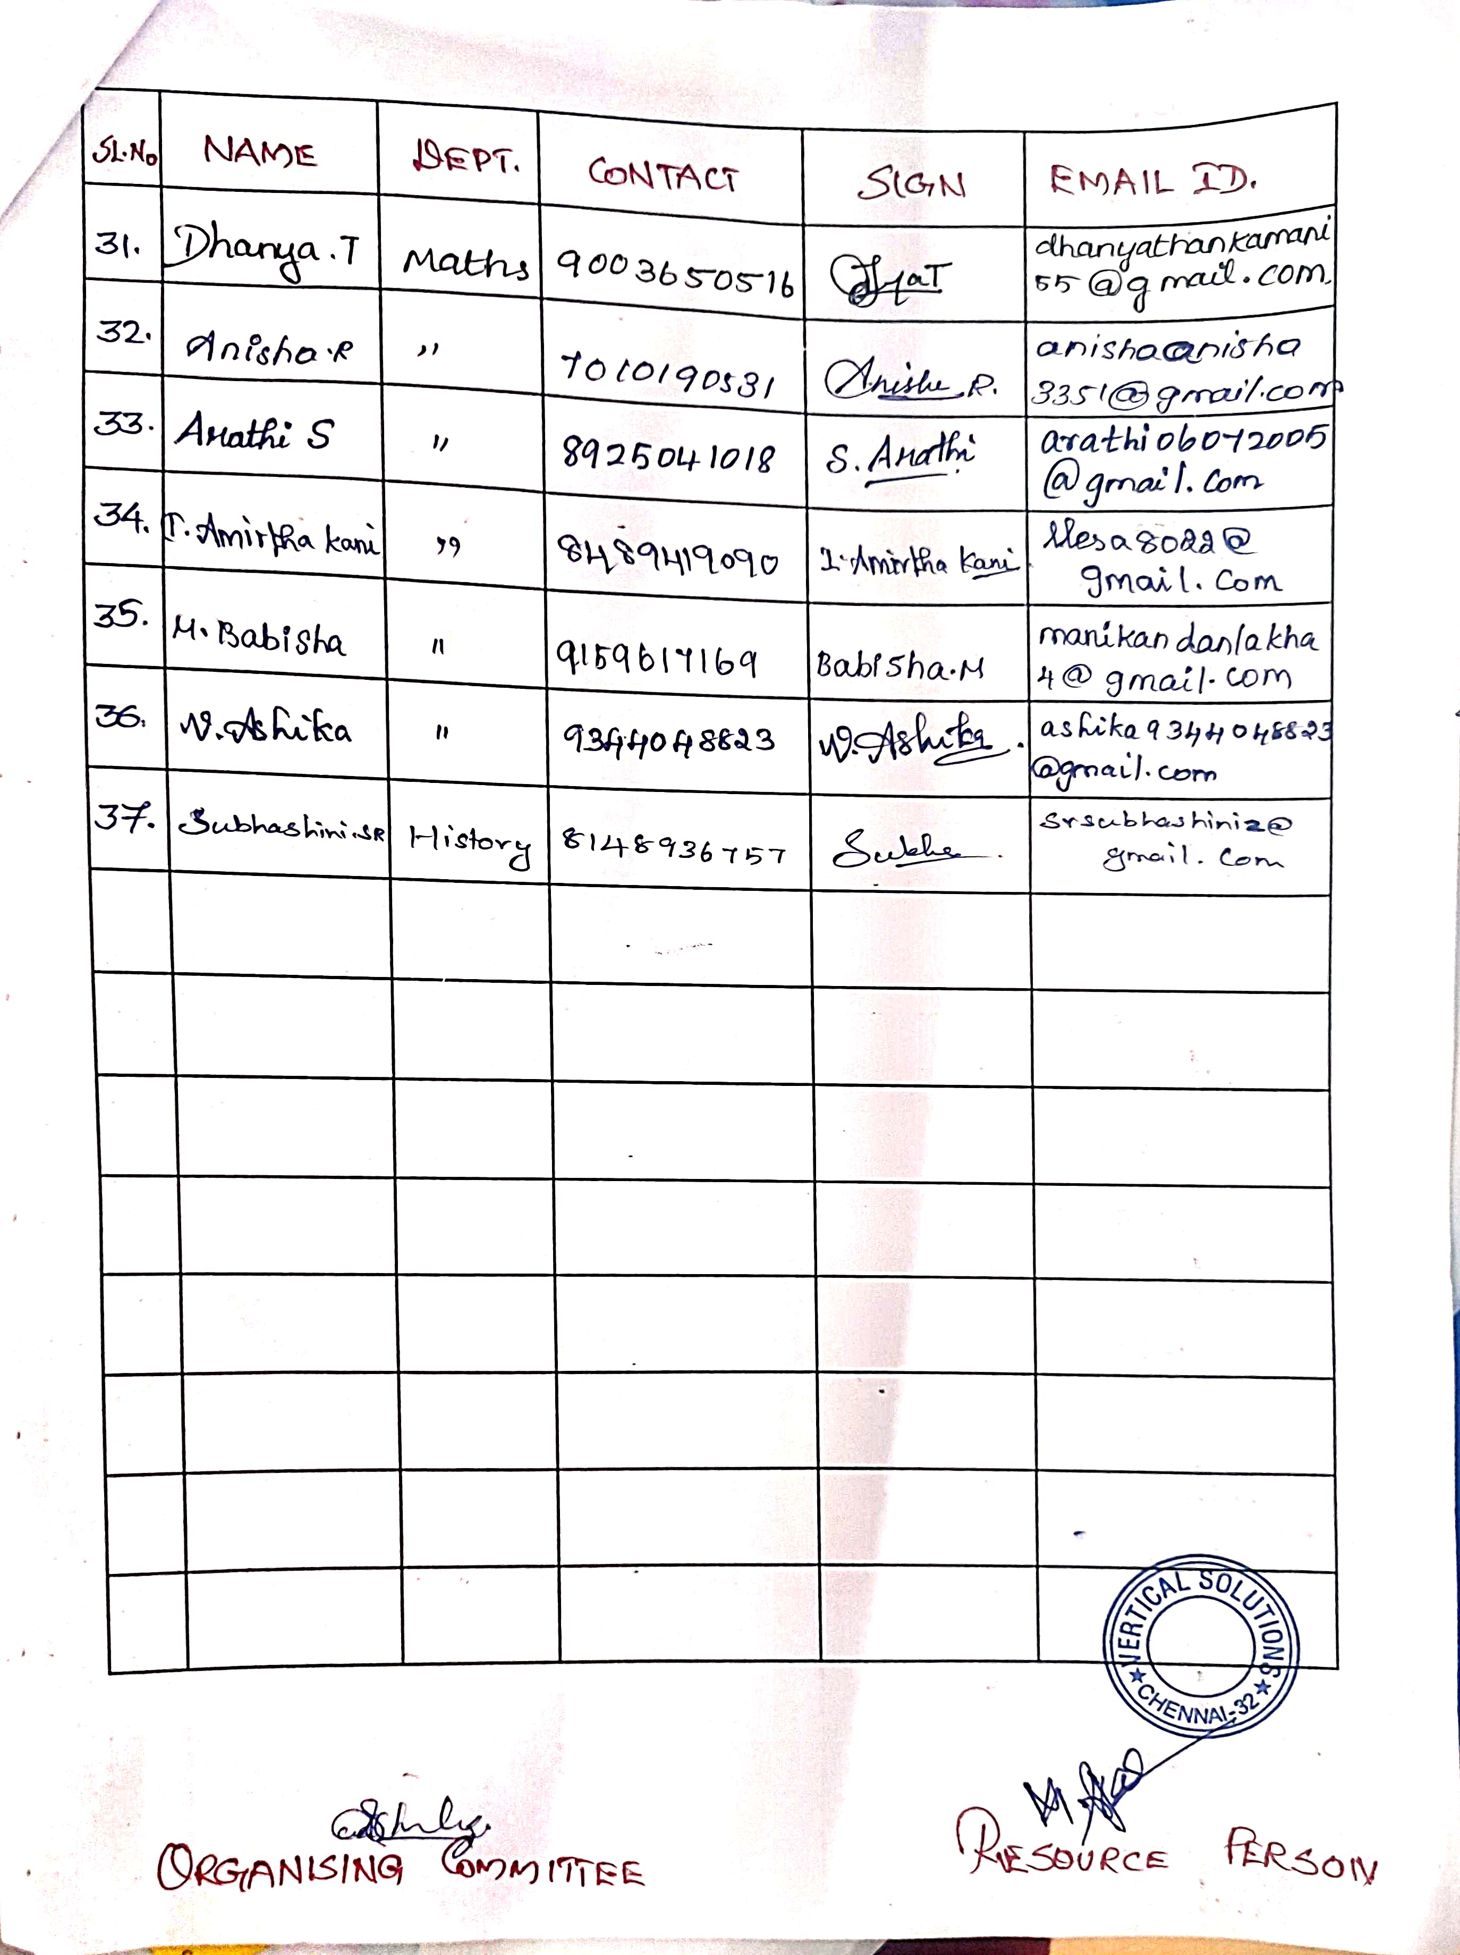

FOXCONN HON HAI TECHNOLOGY INDIA MEGA DEVELOPMENT PVT. LTD.

APPOINTMENT ORDERS

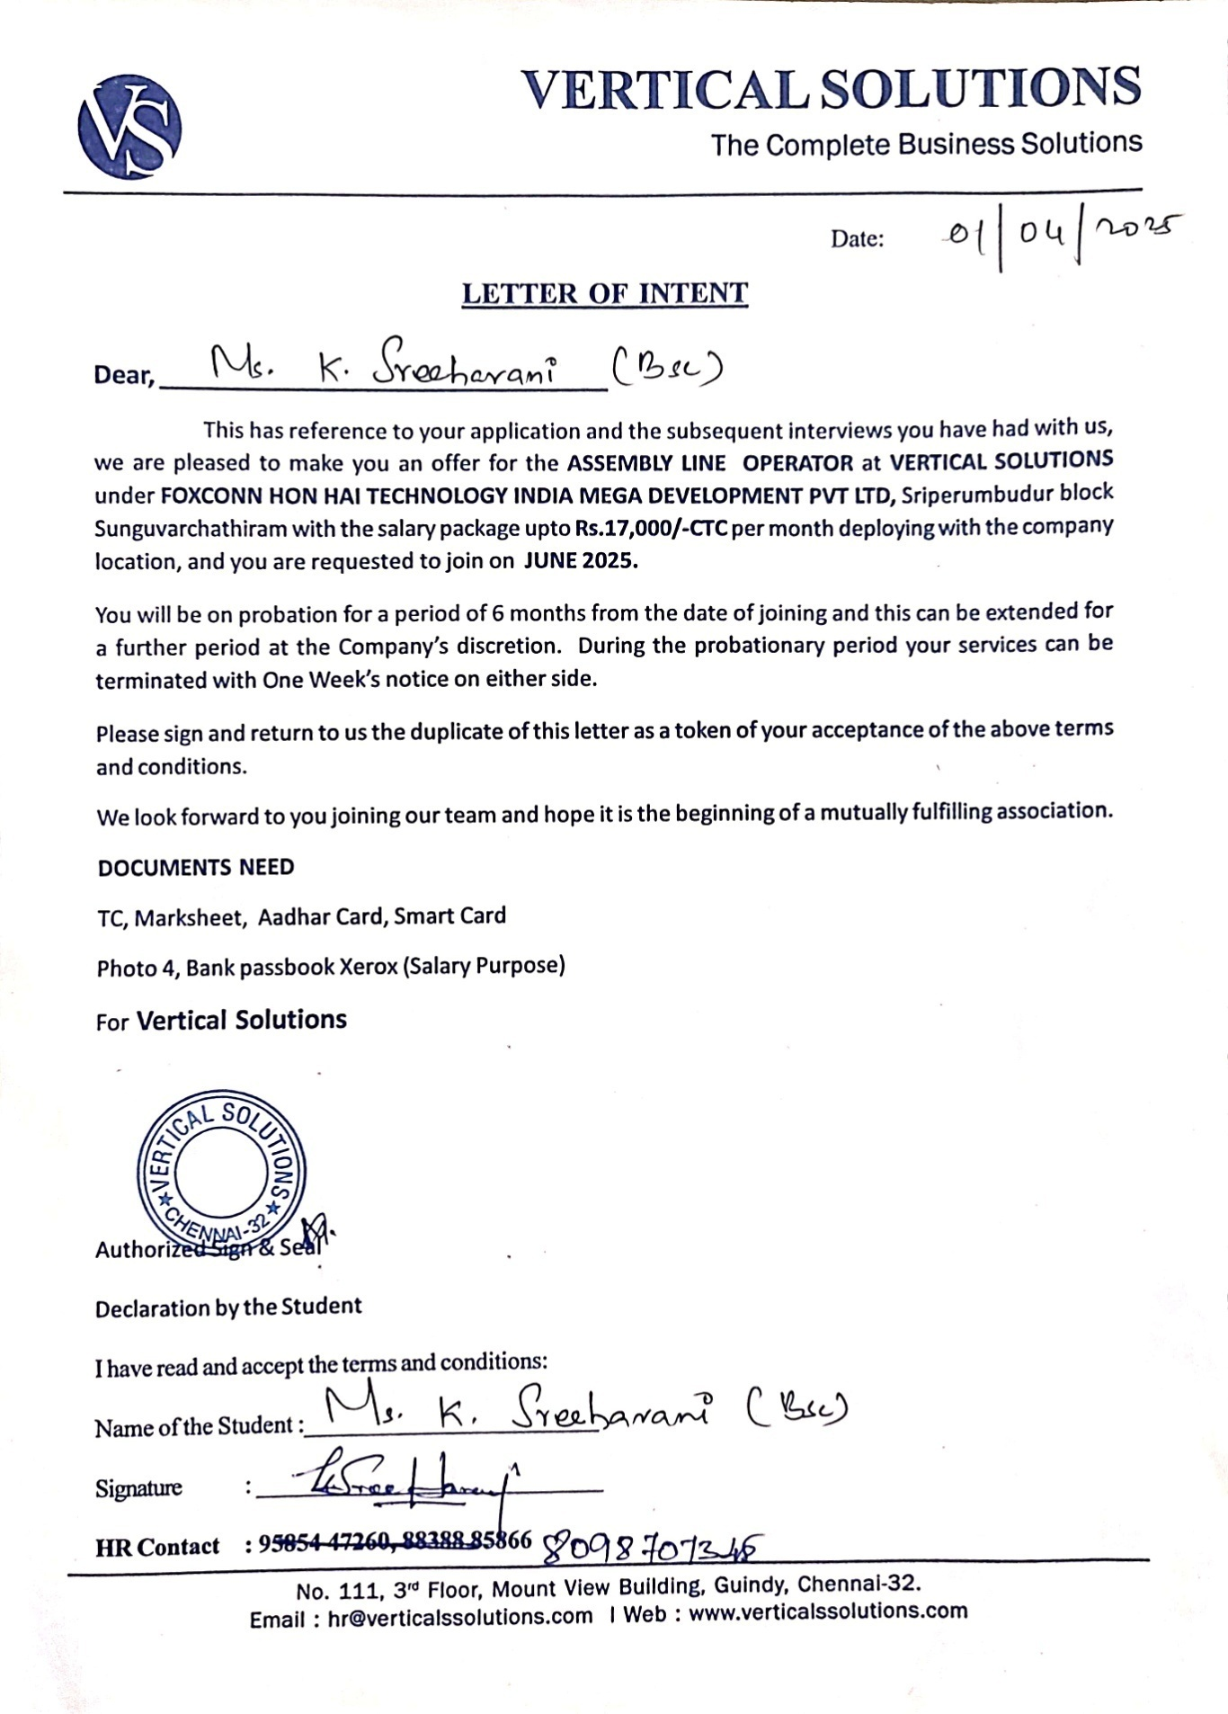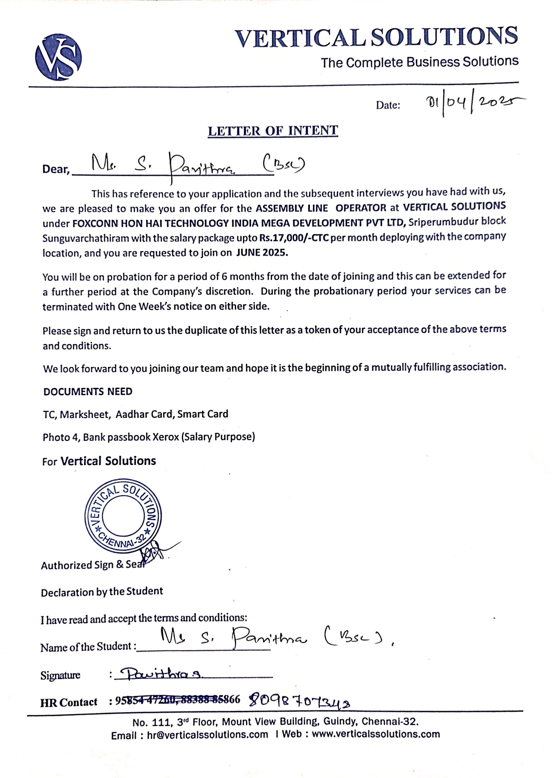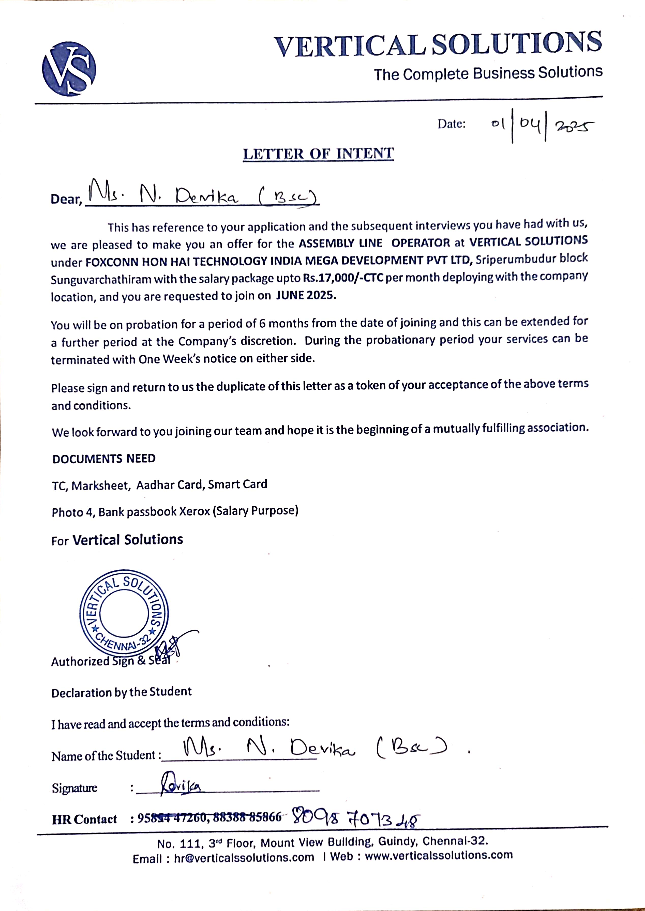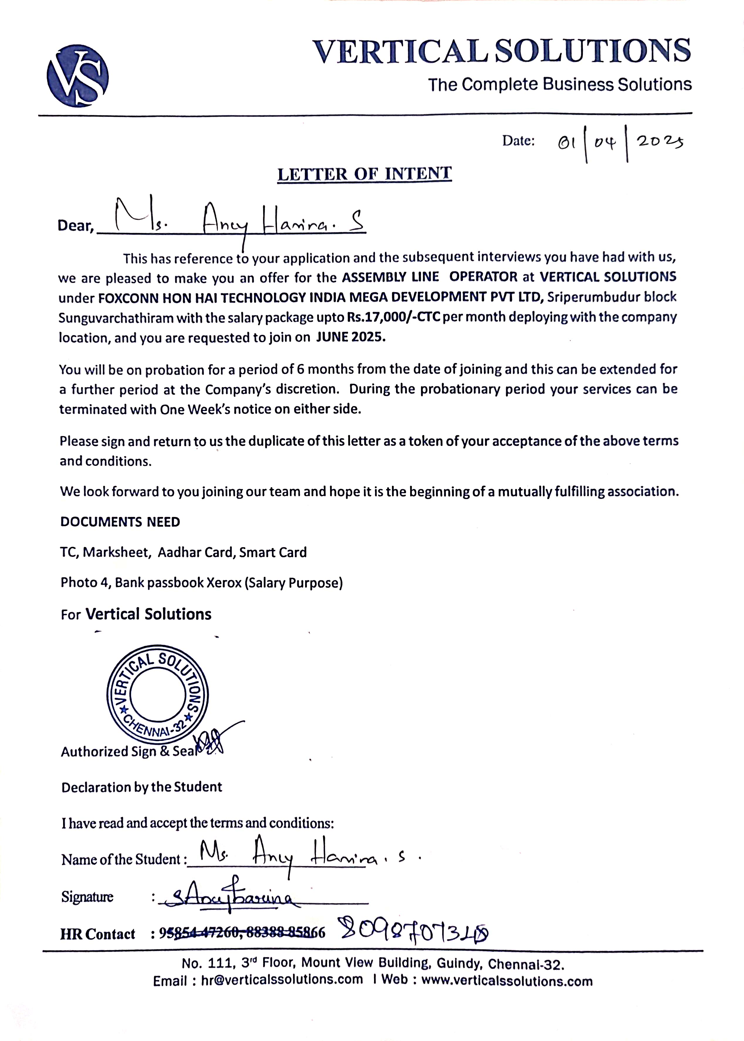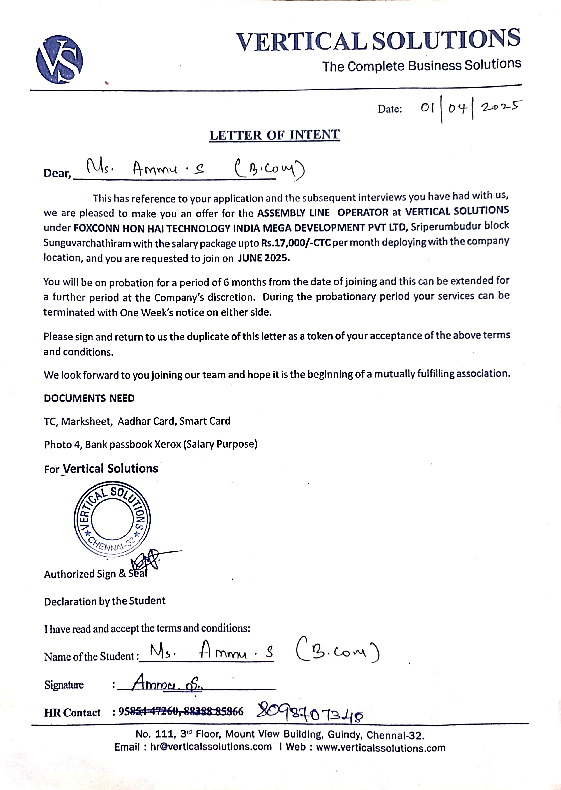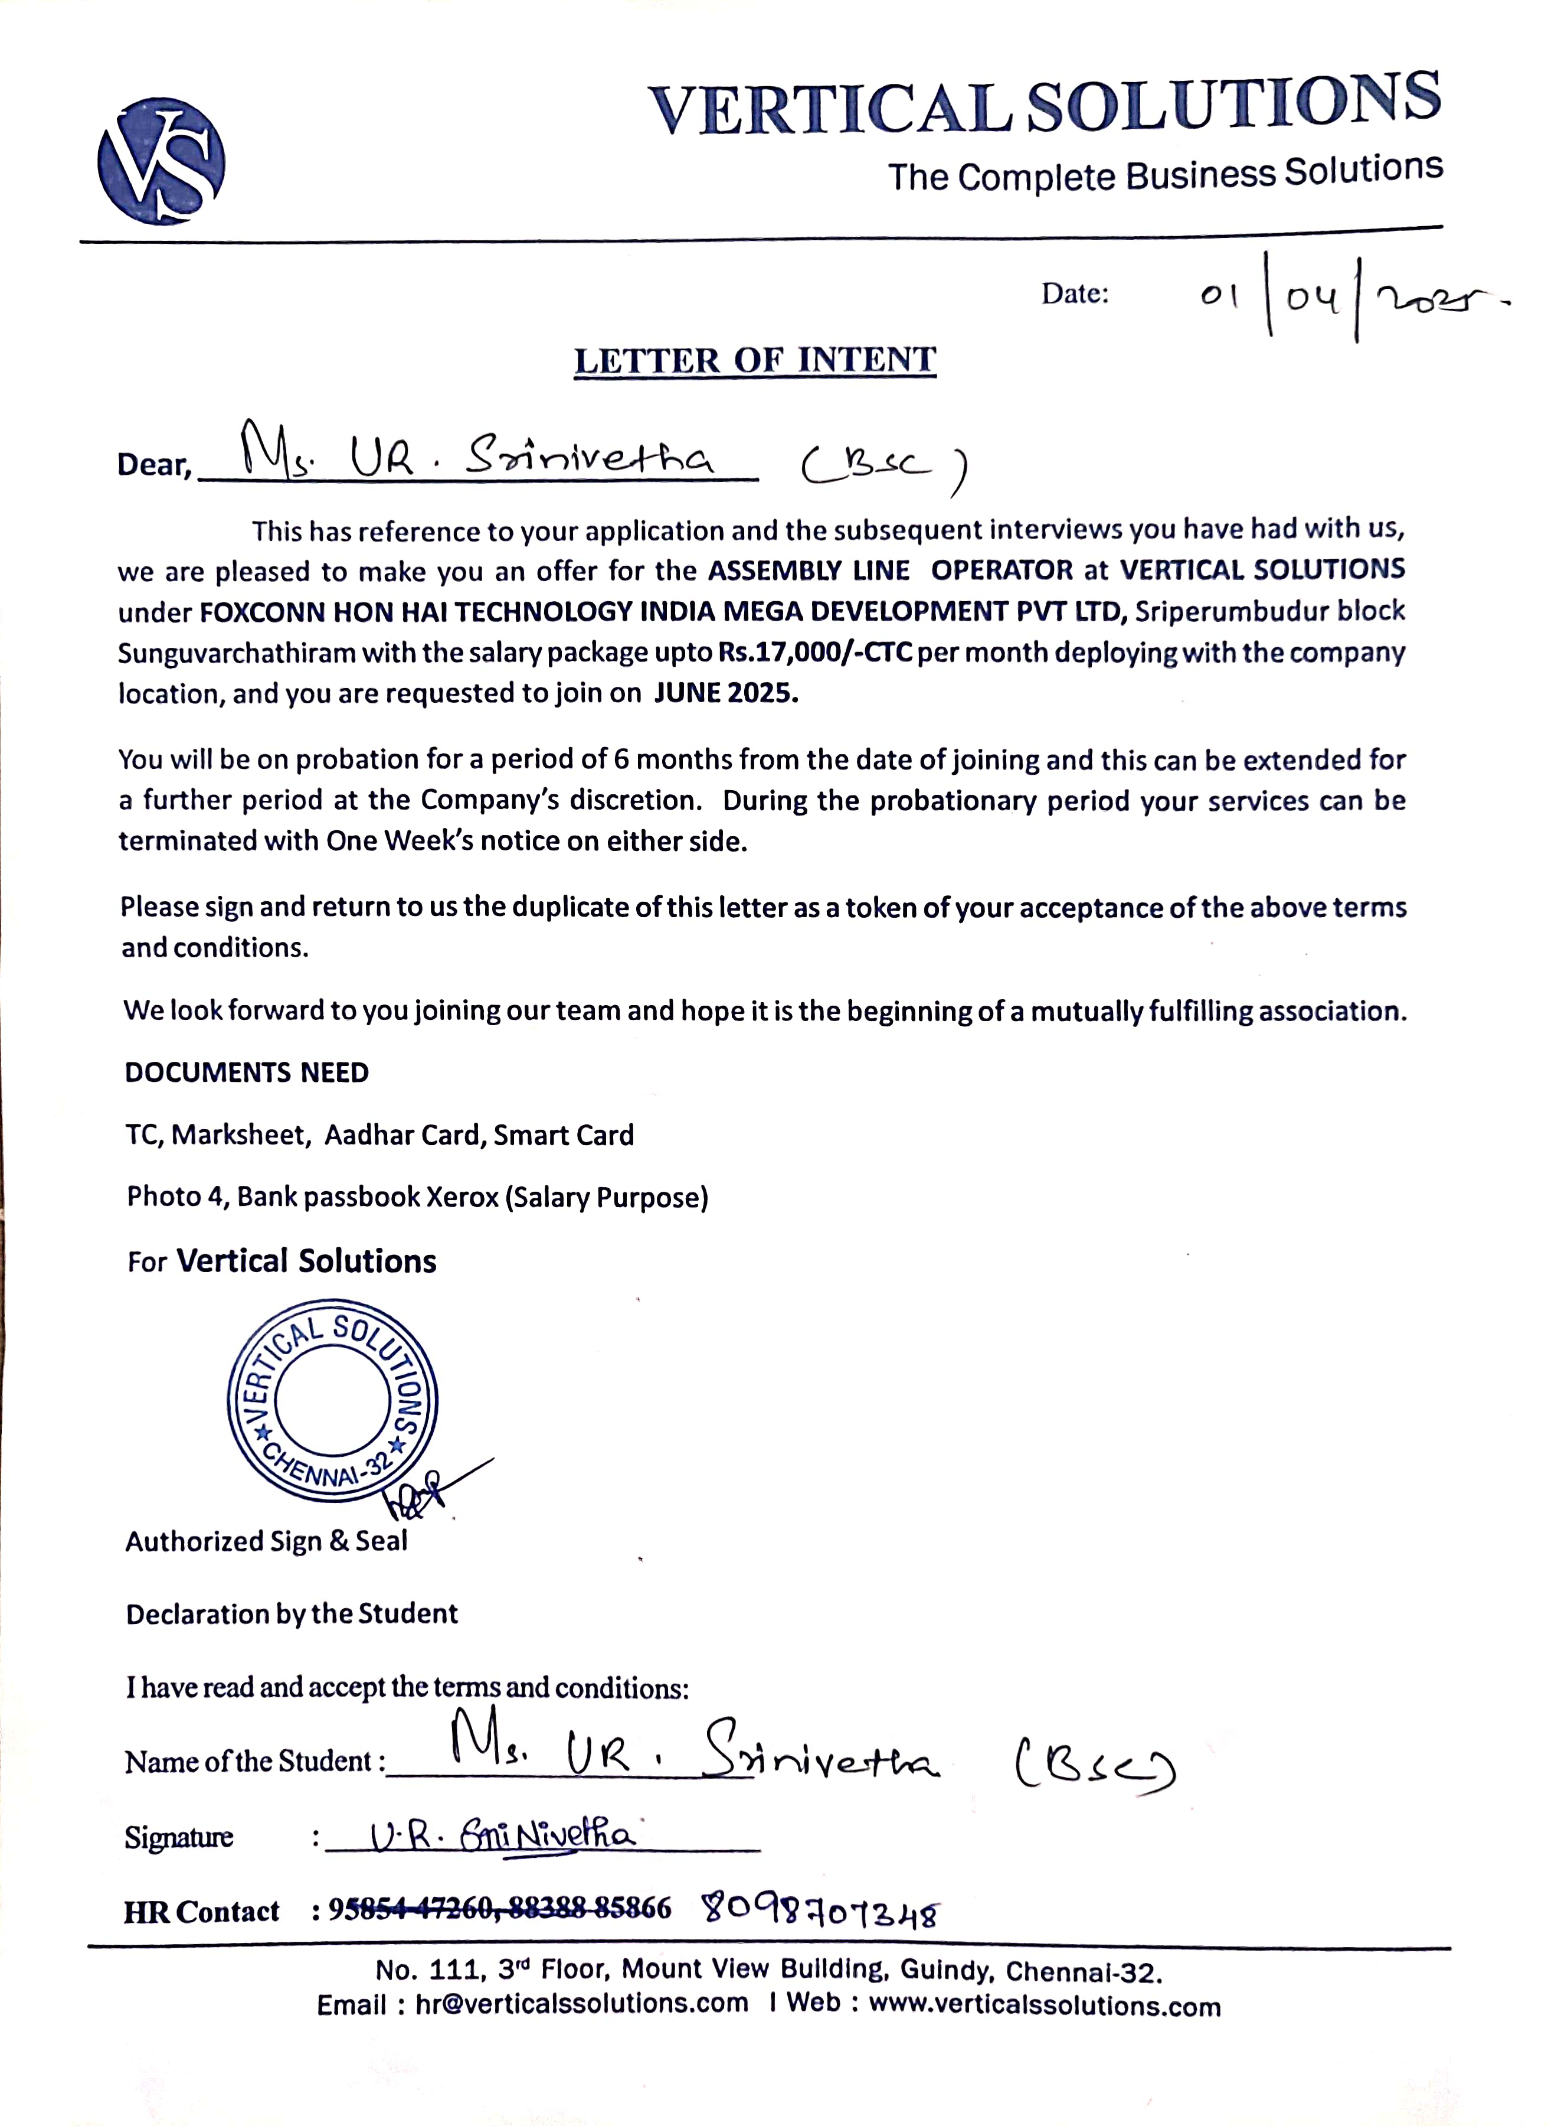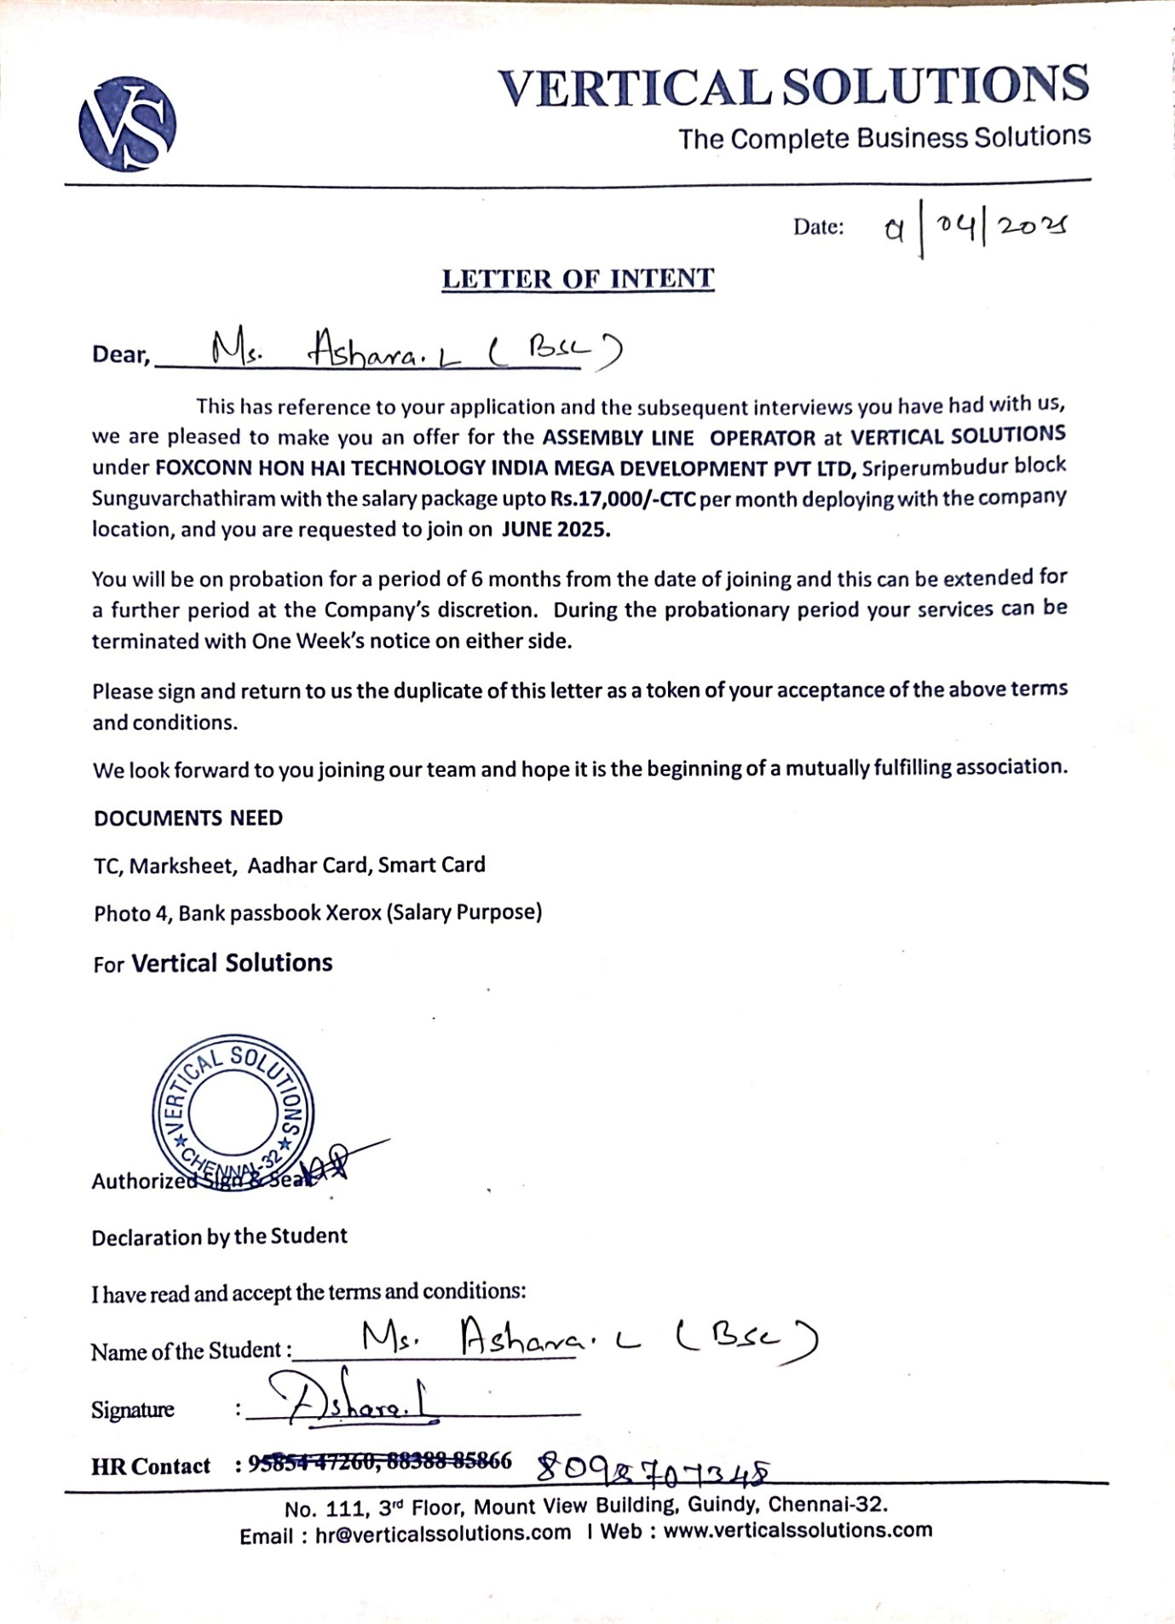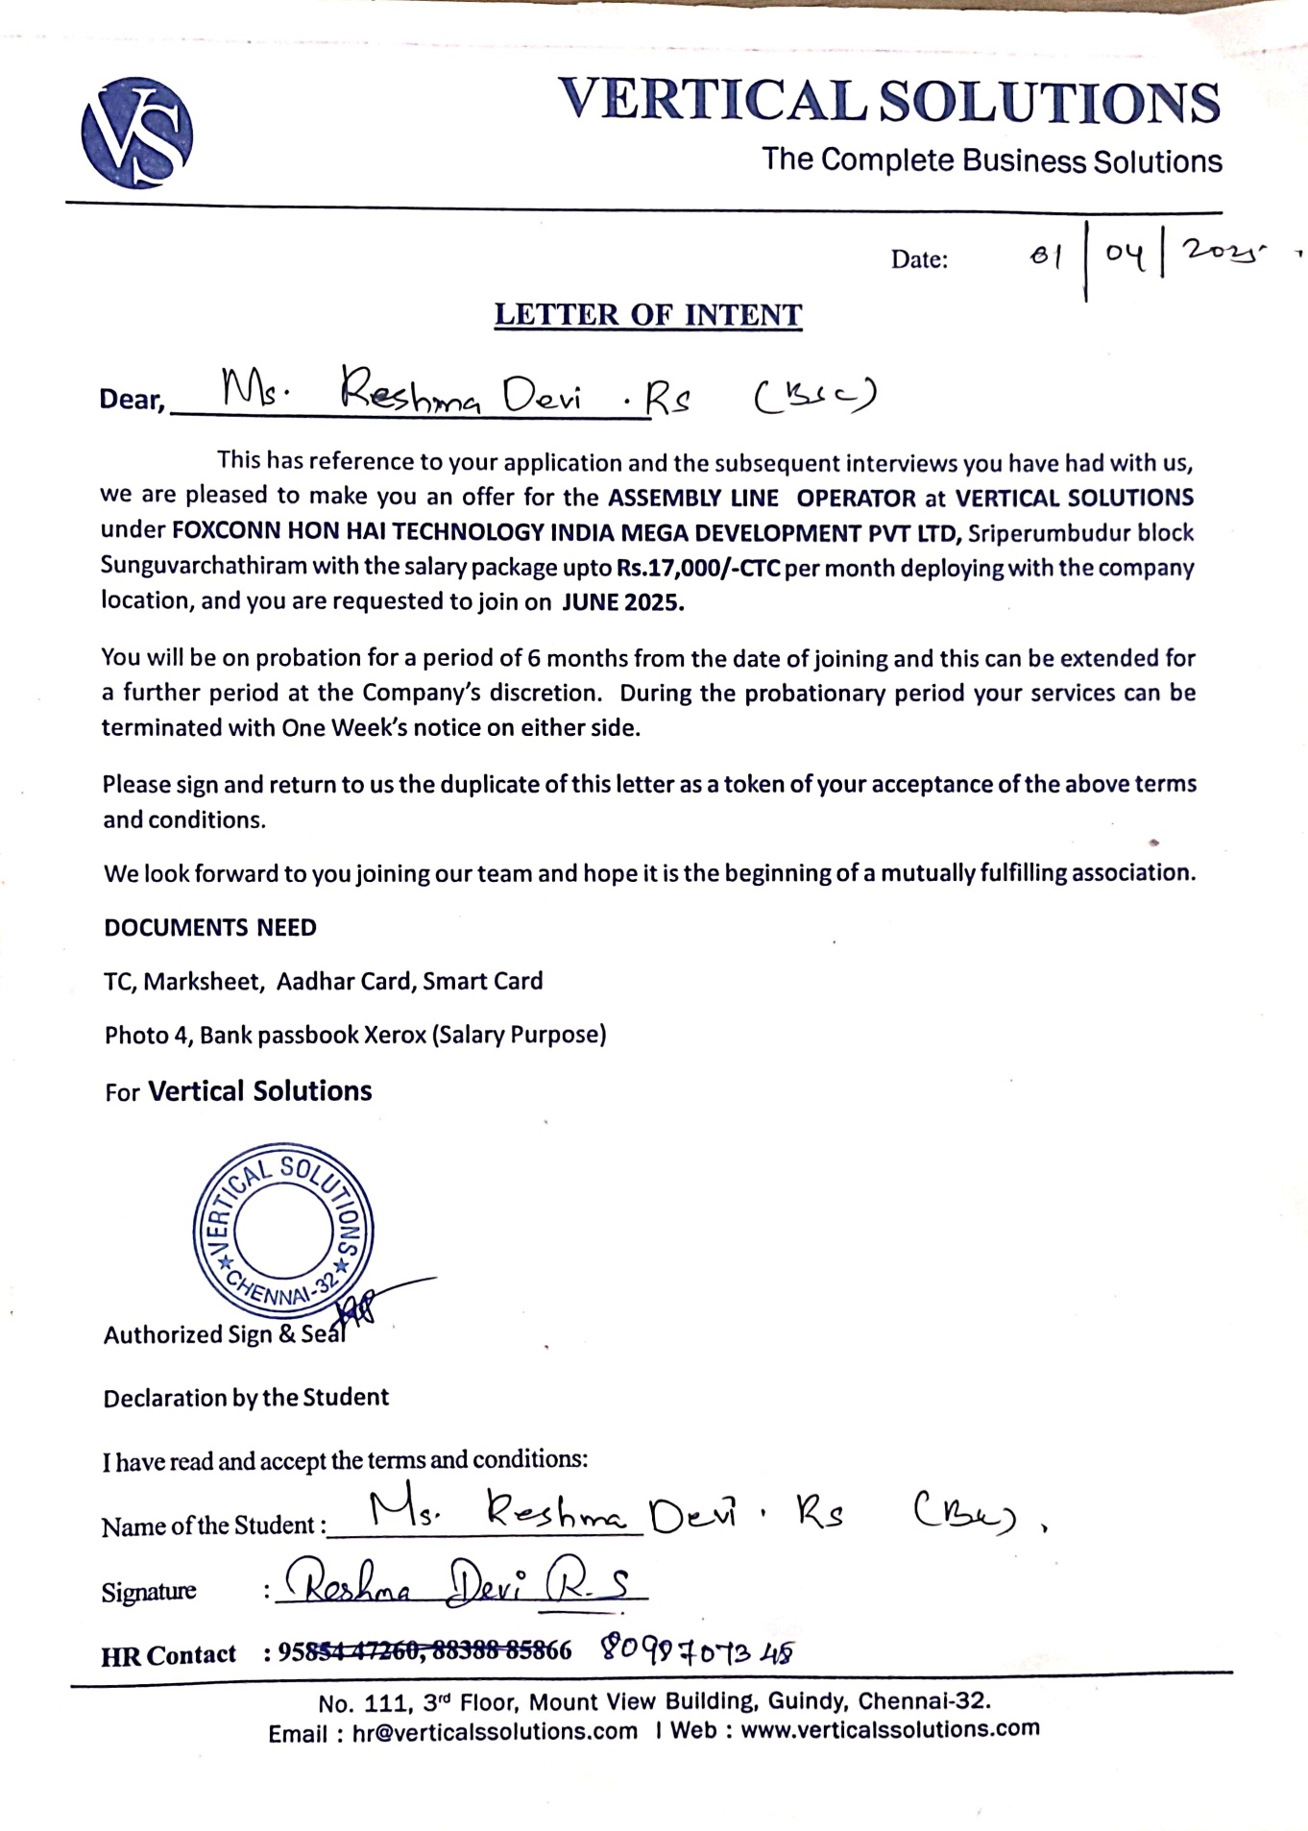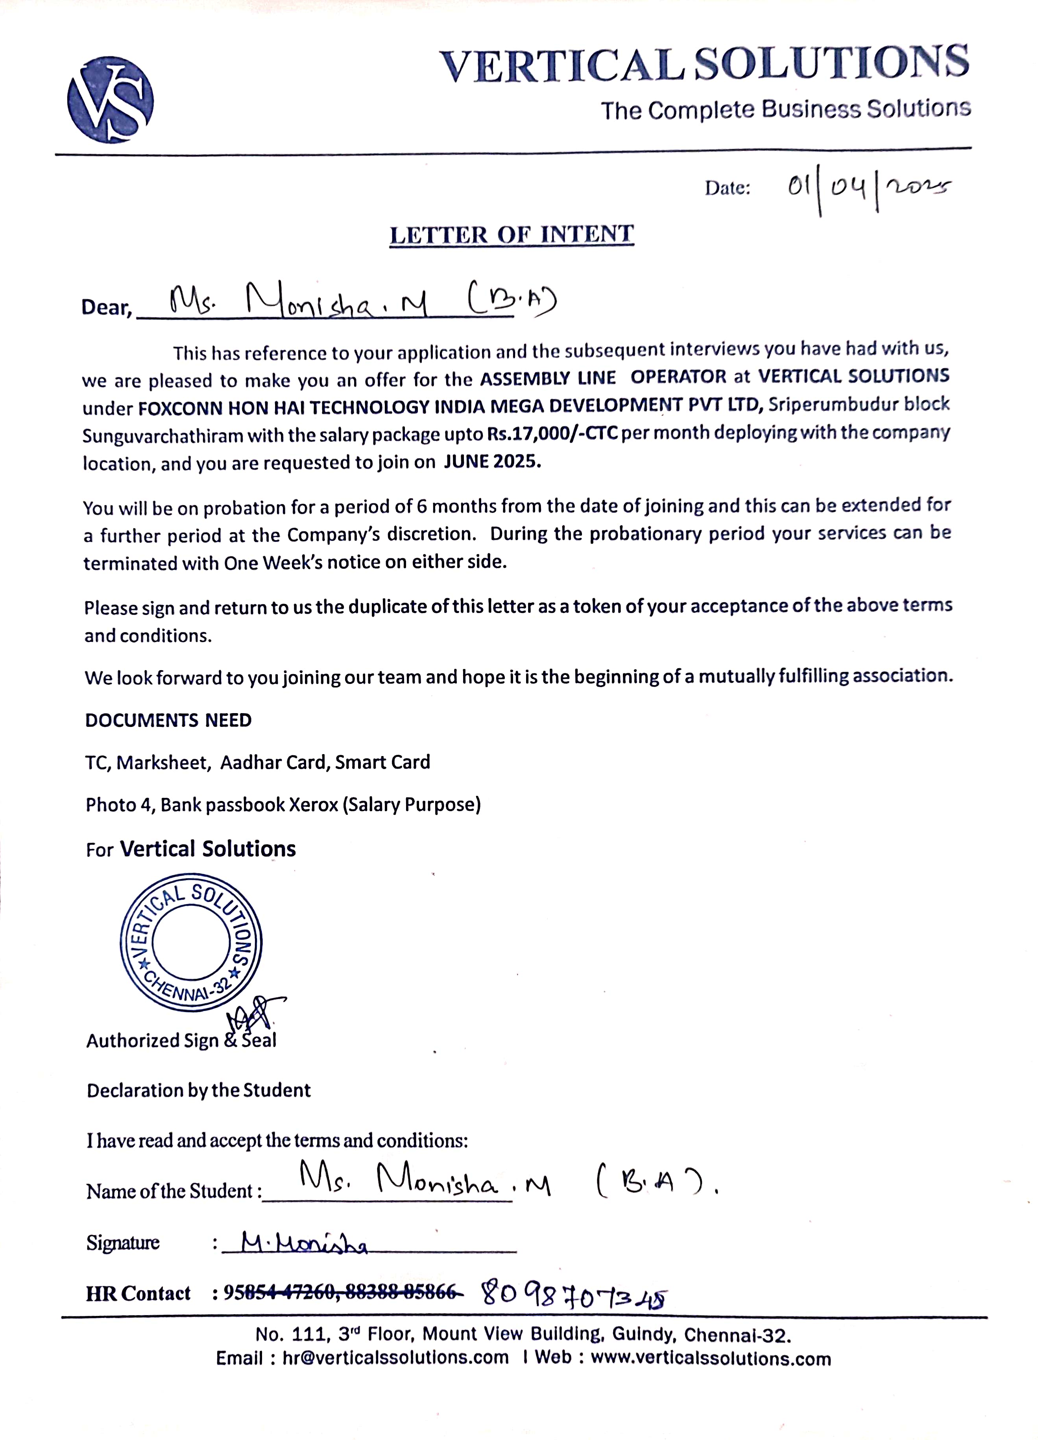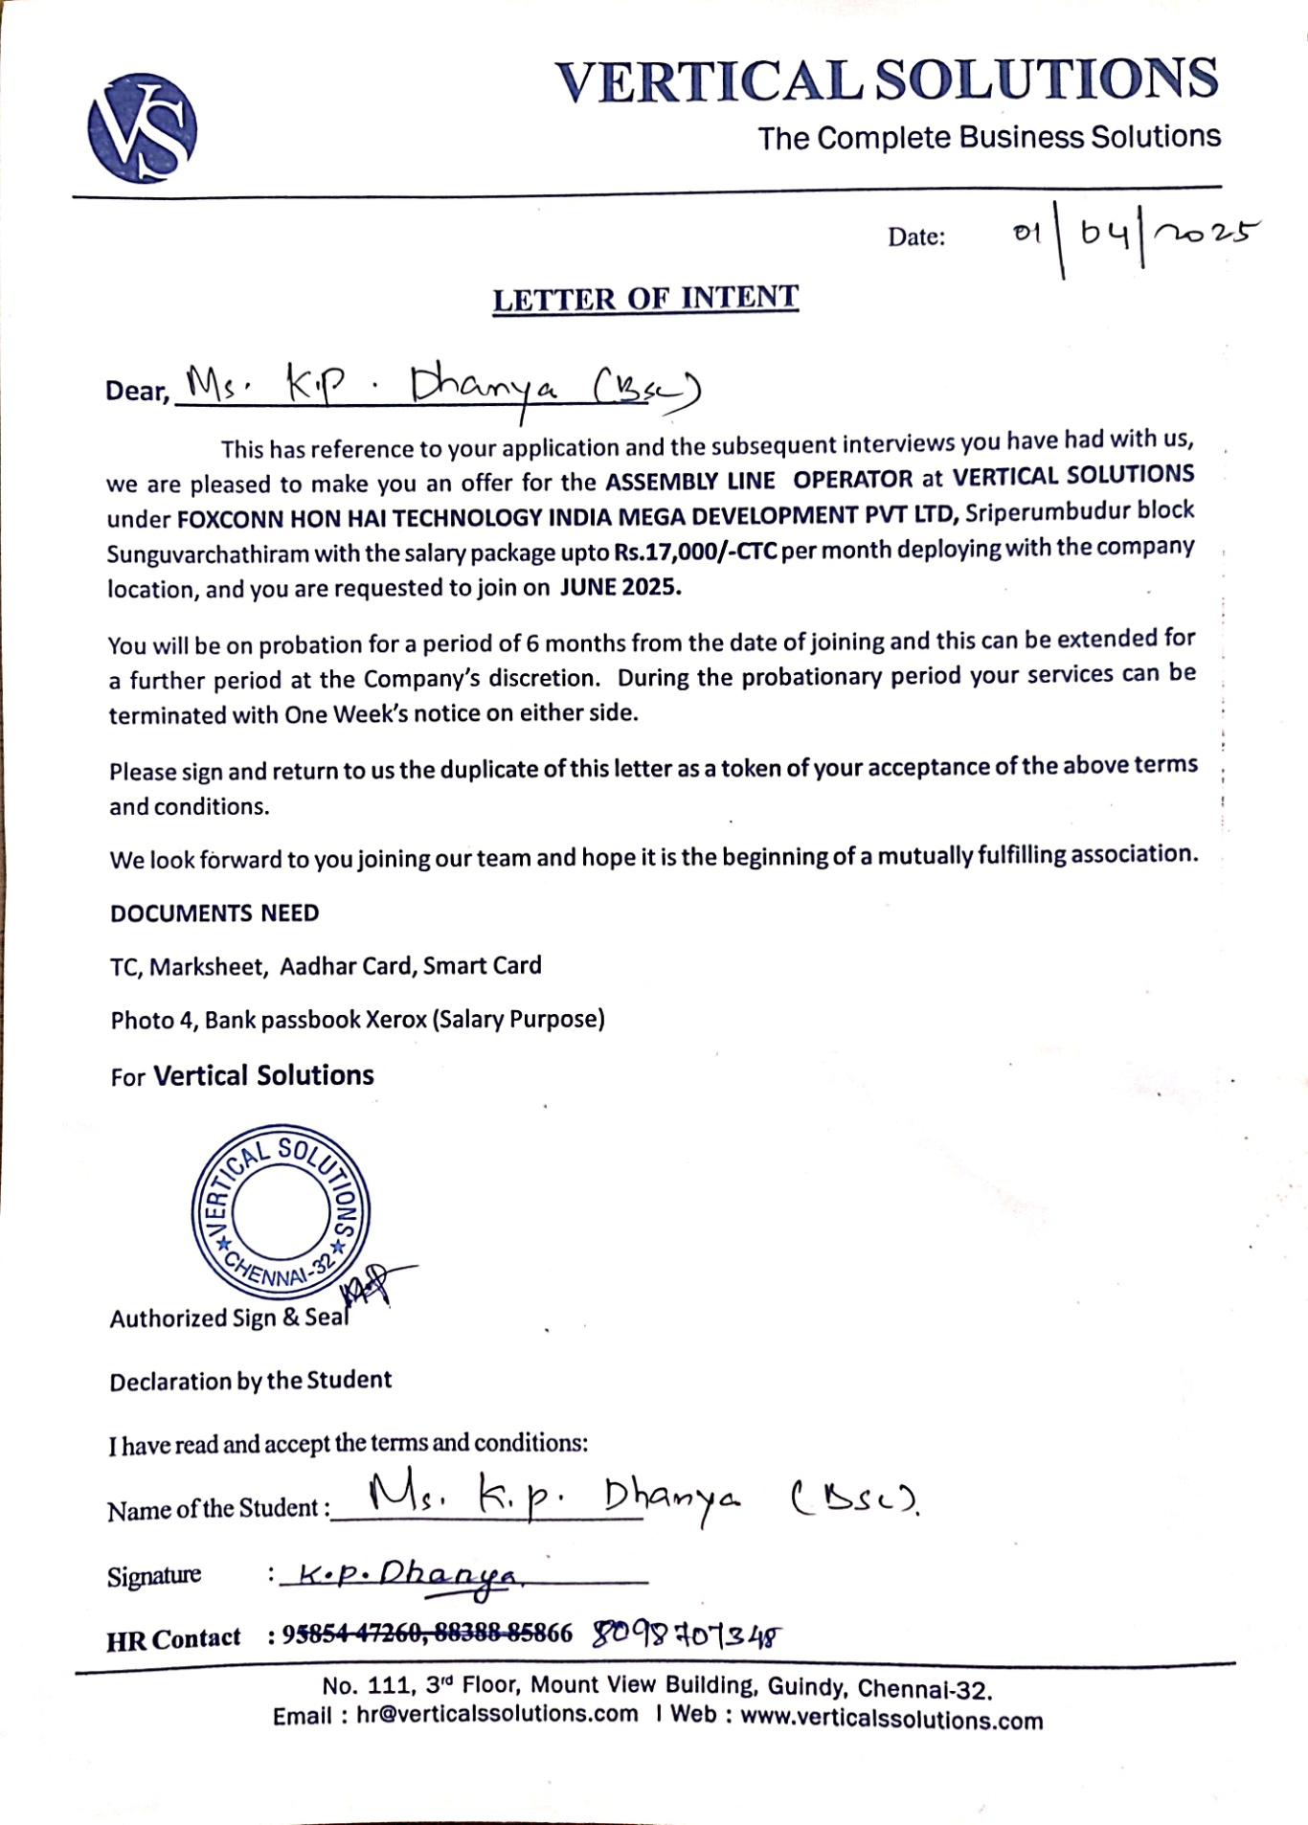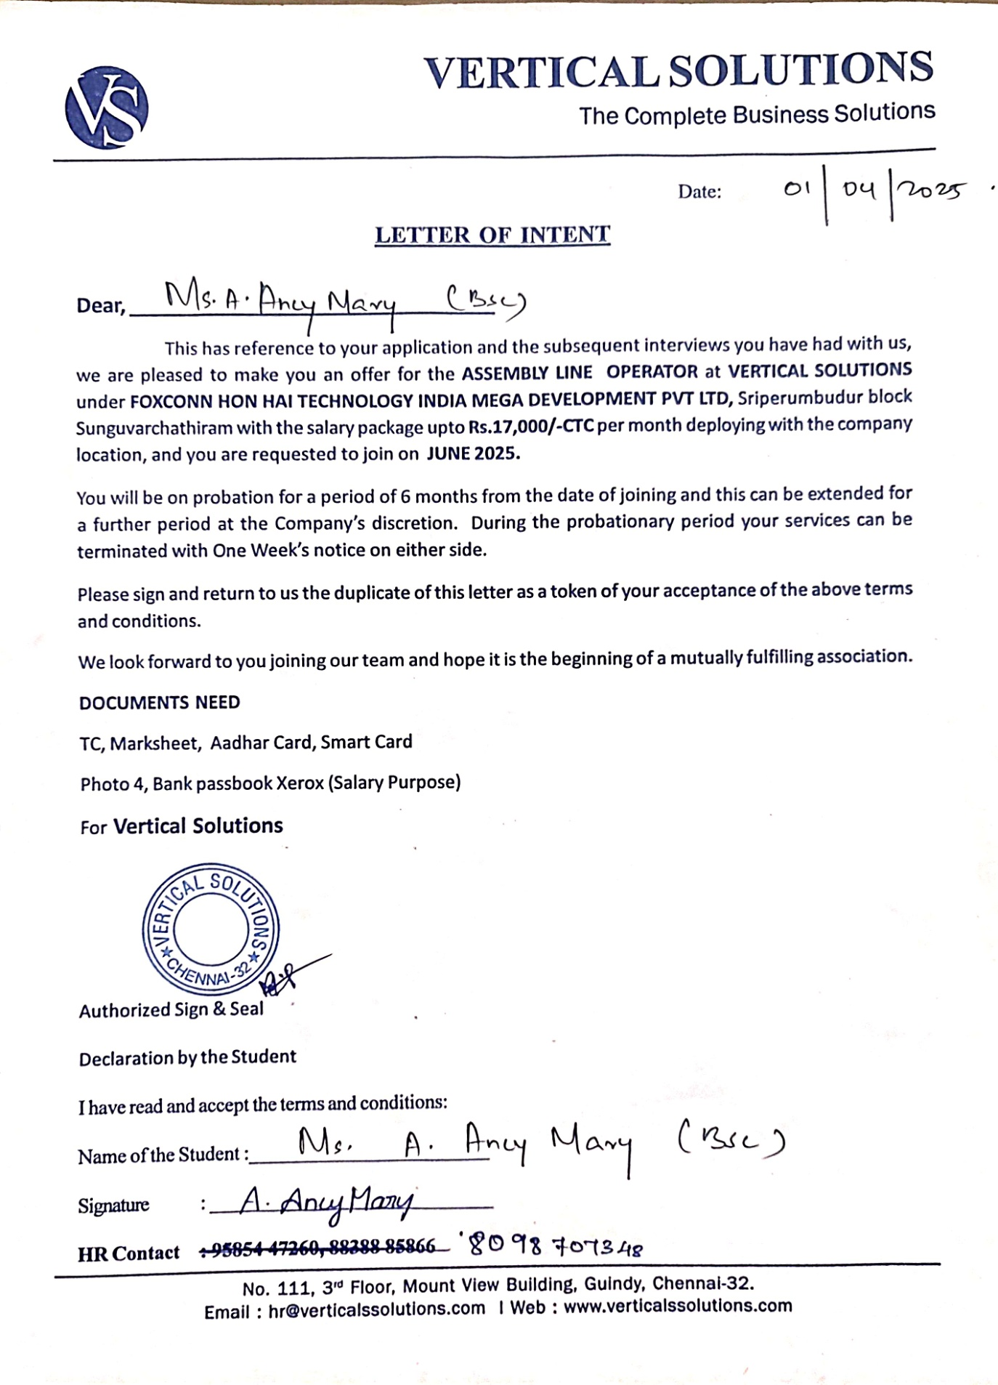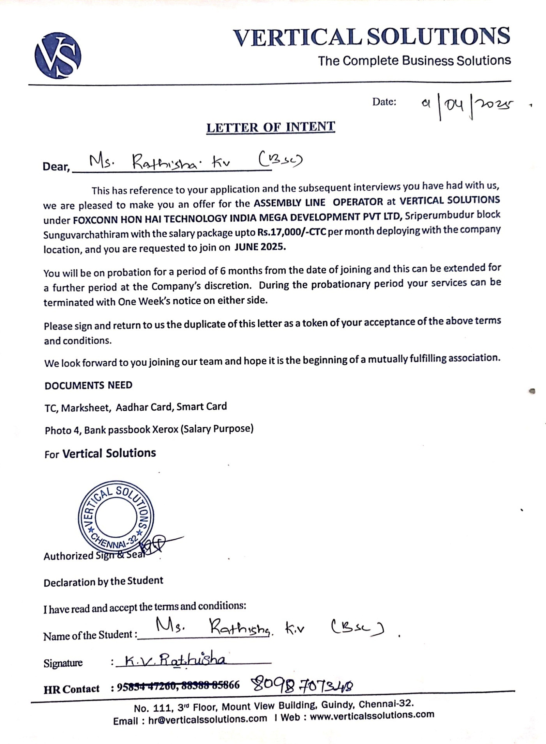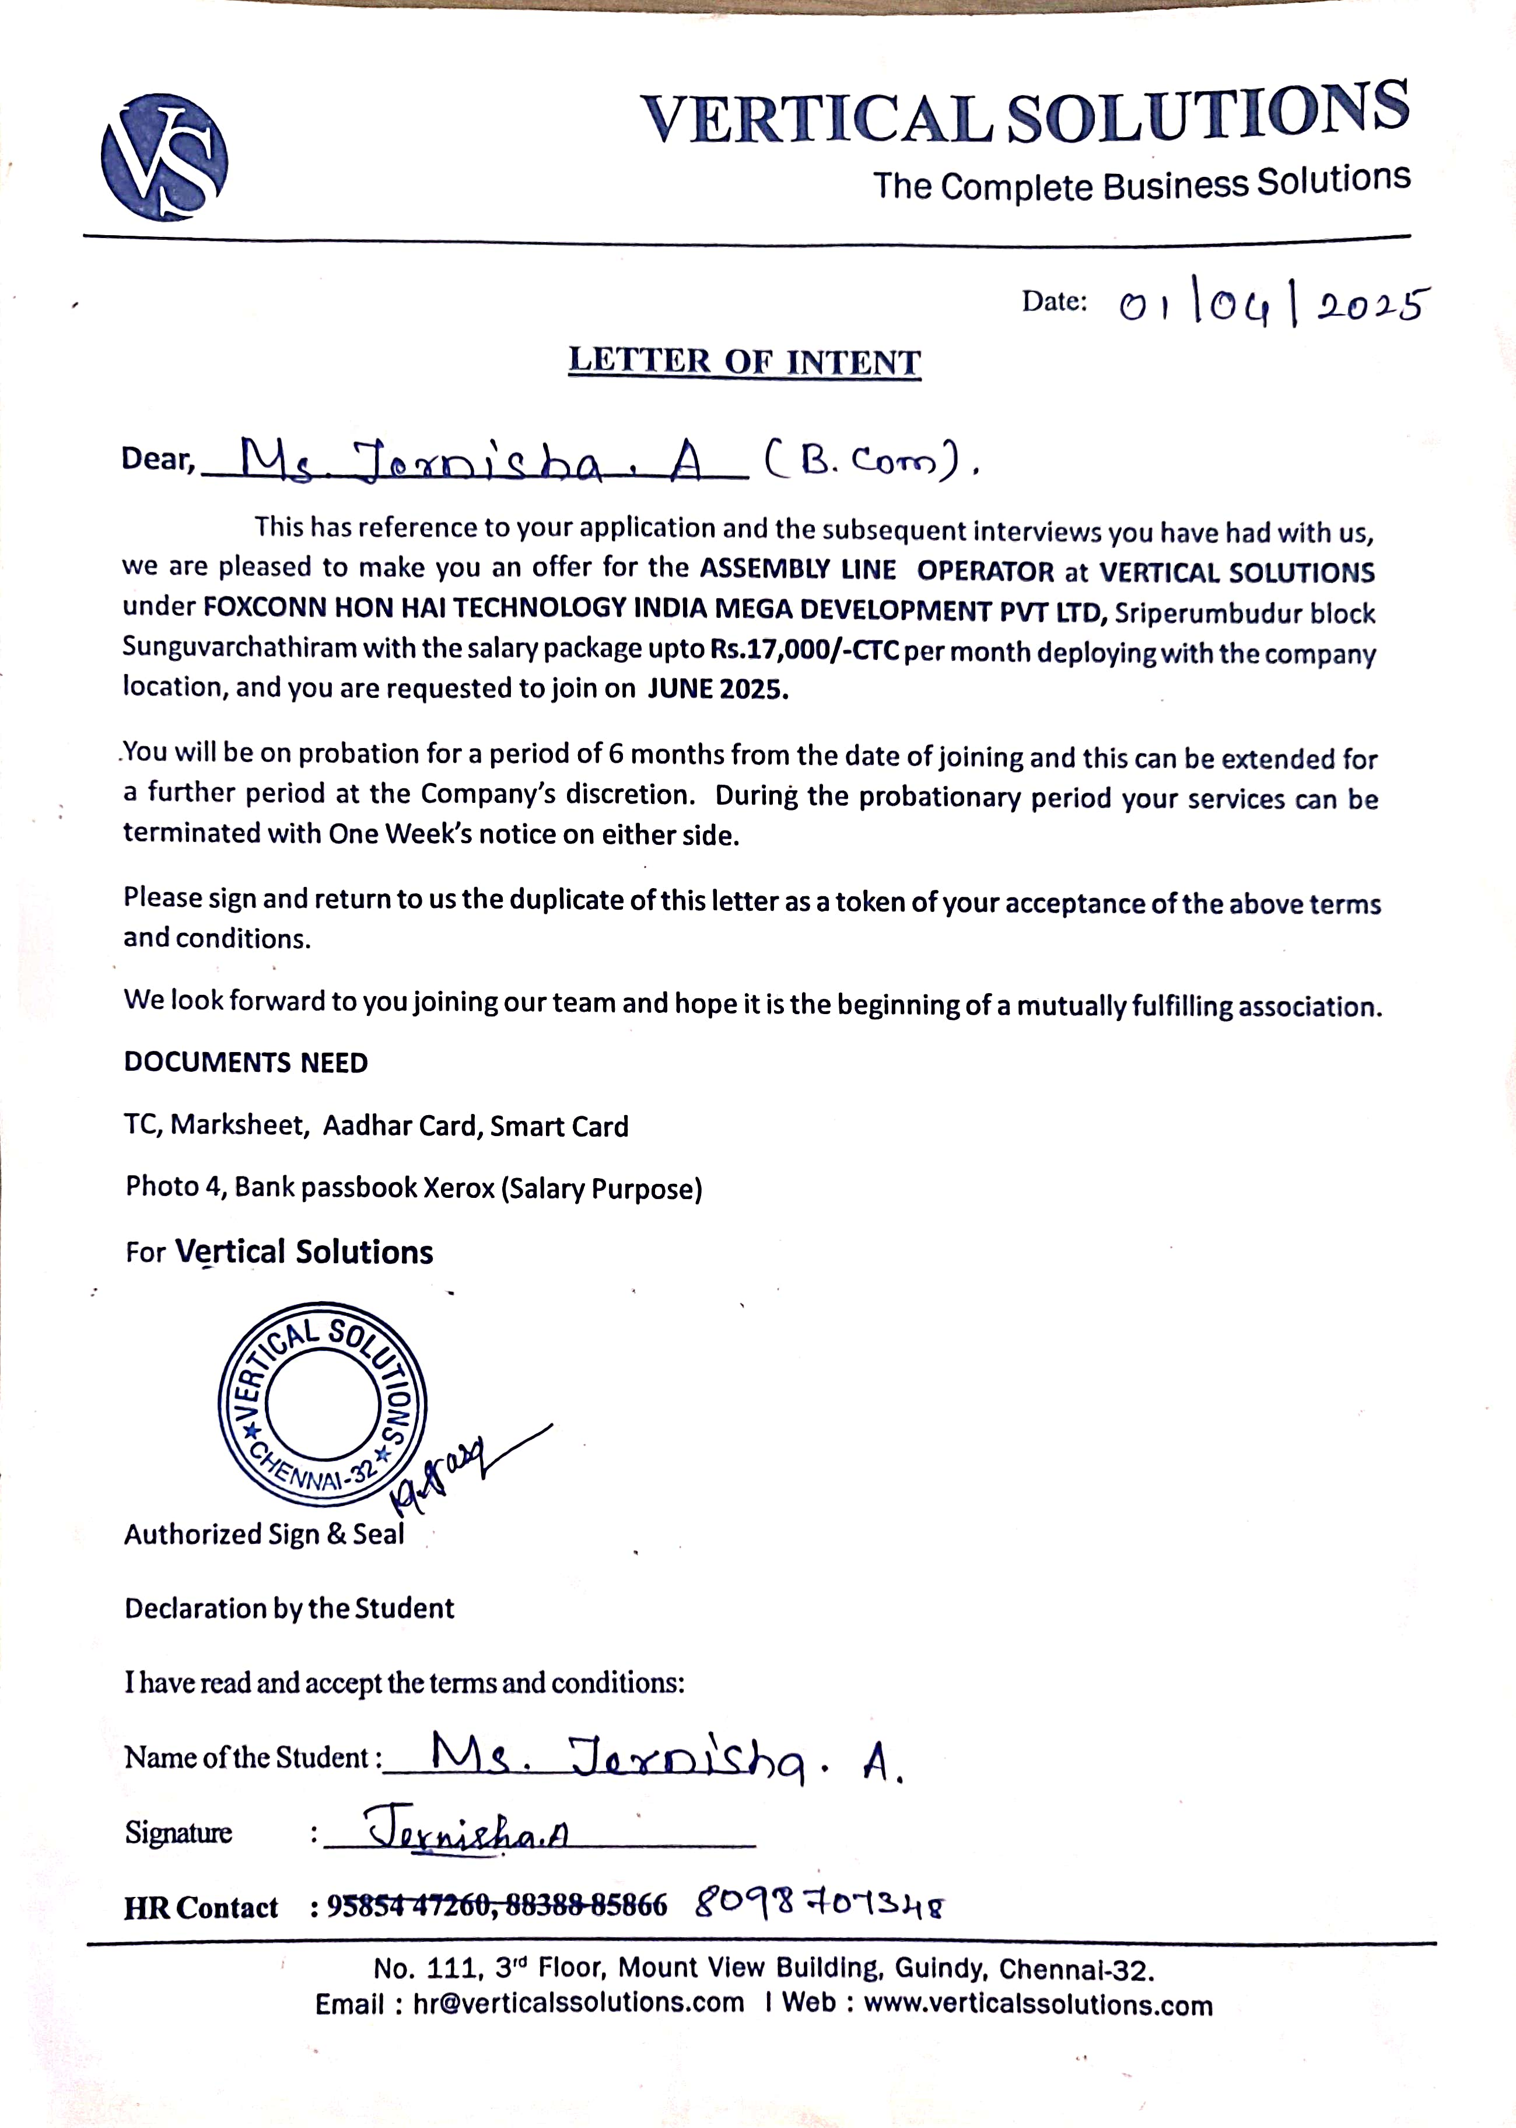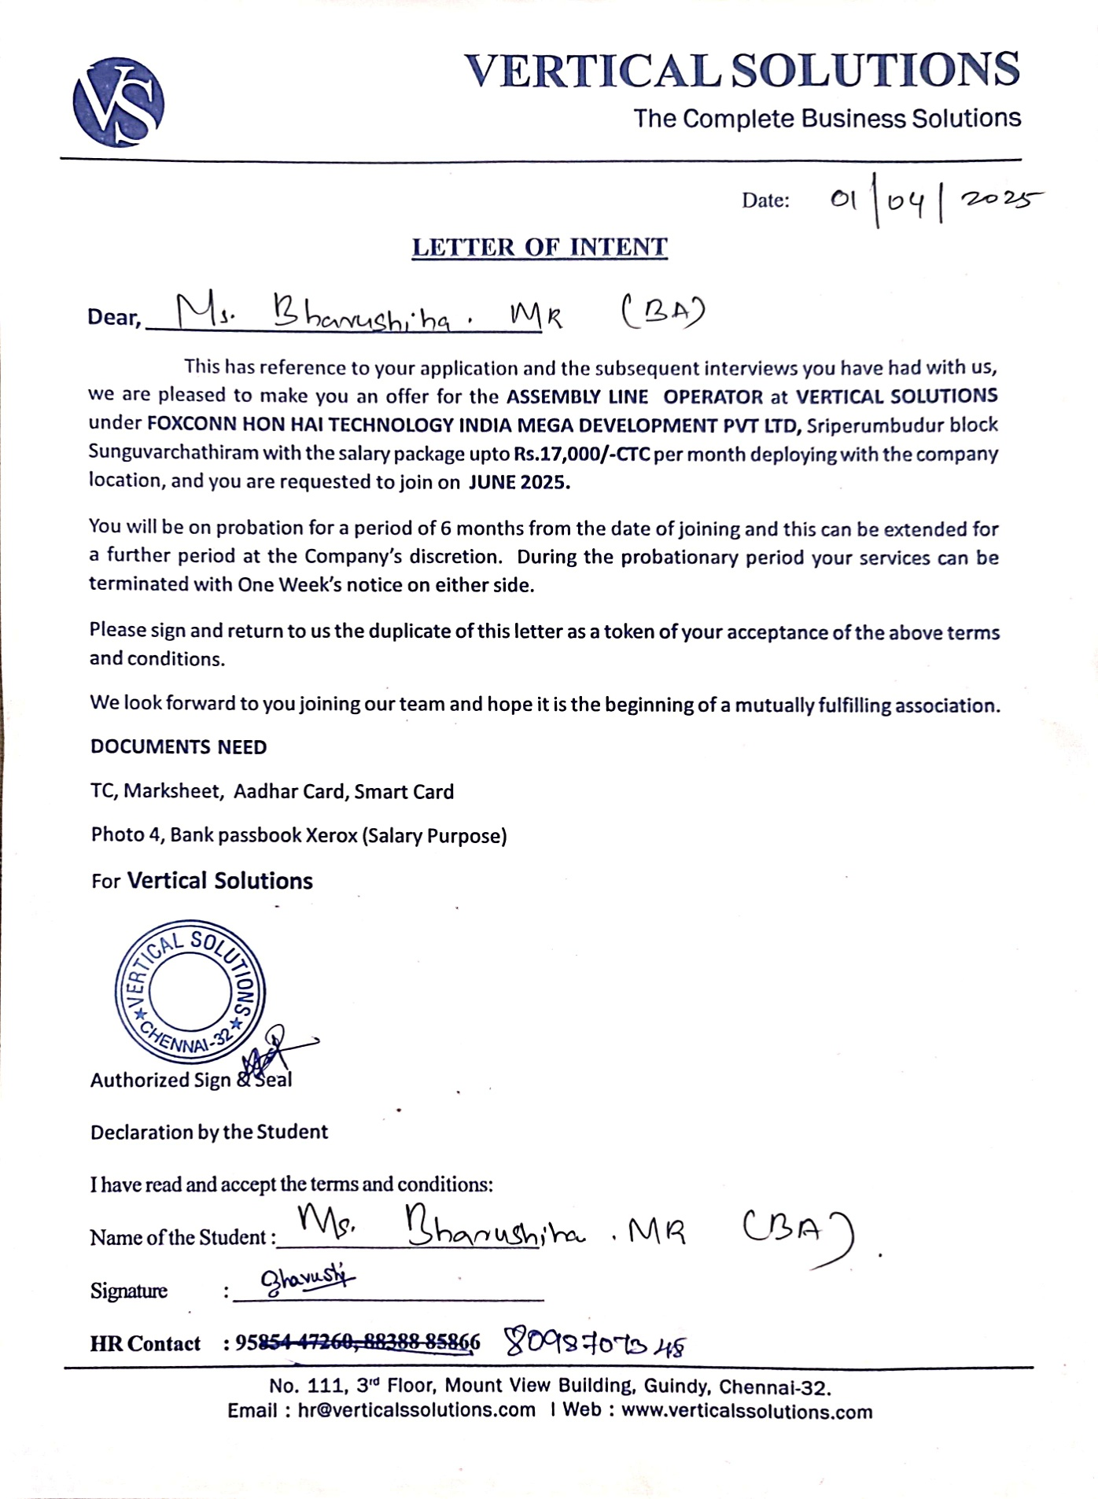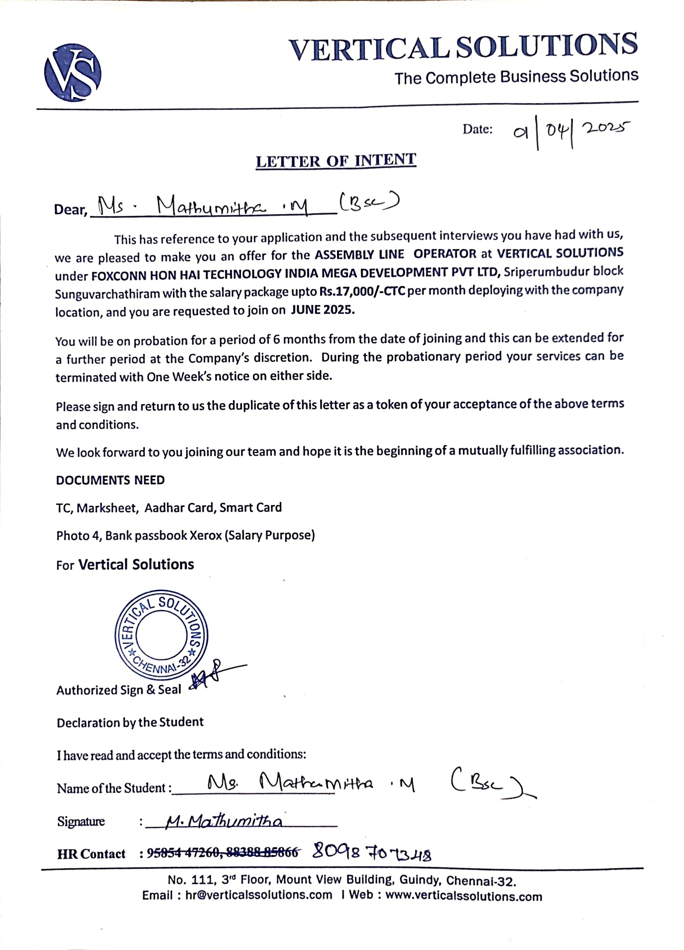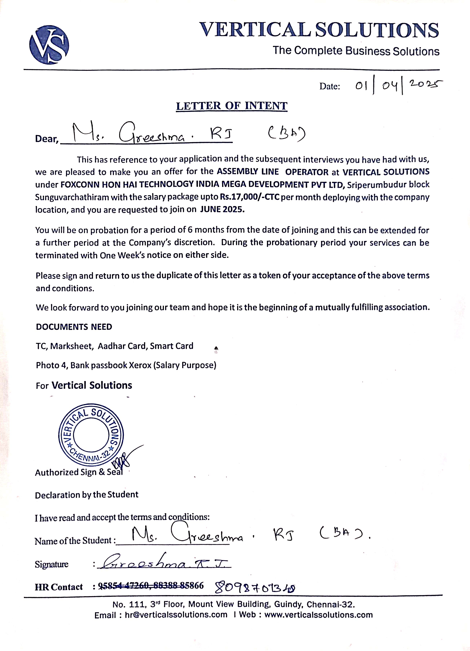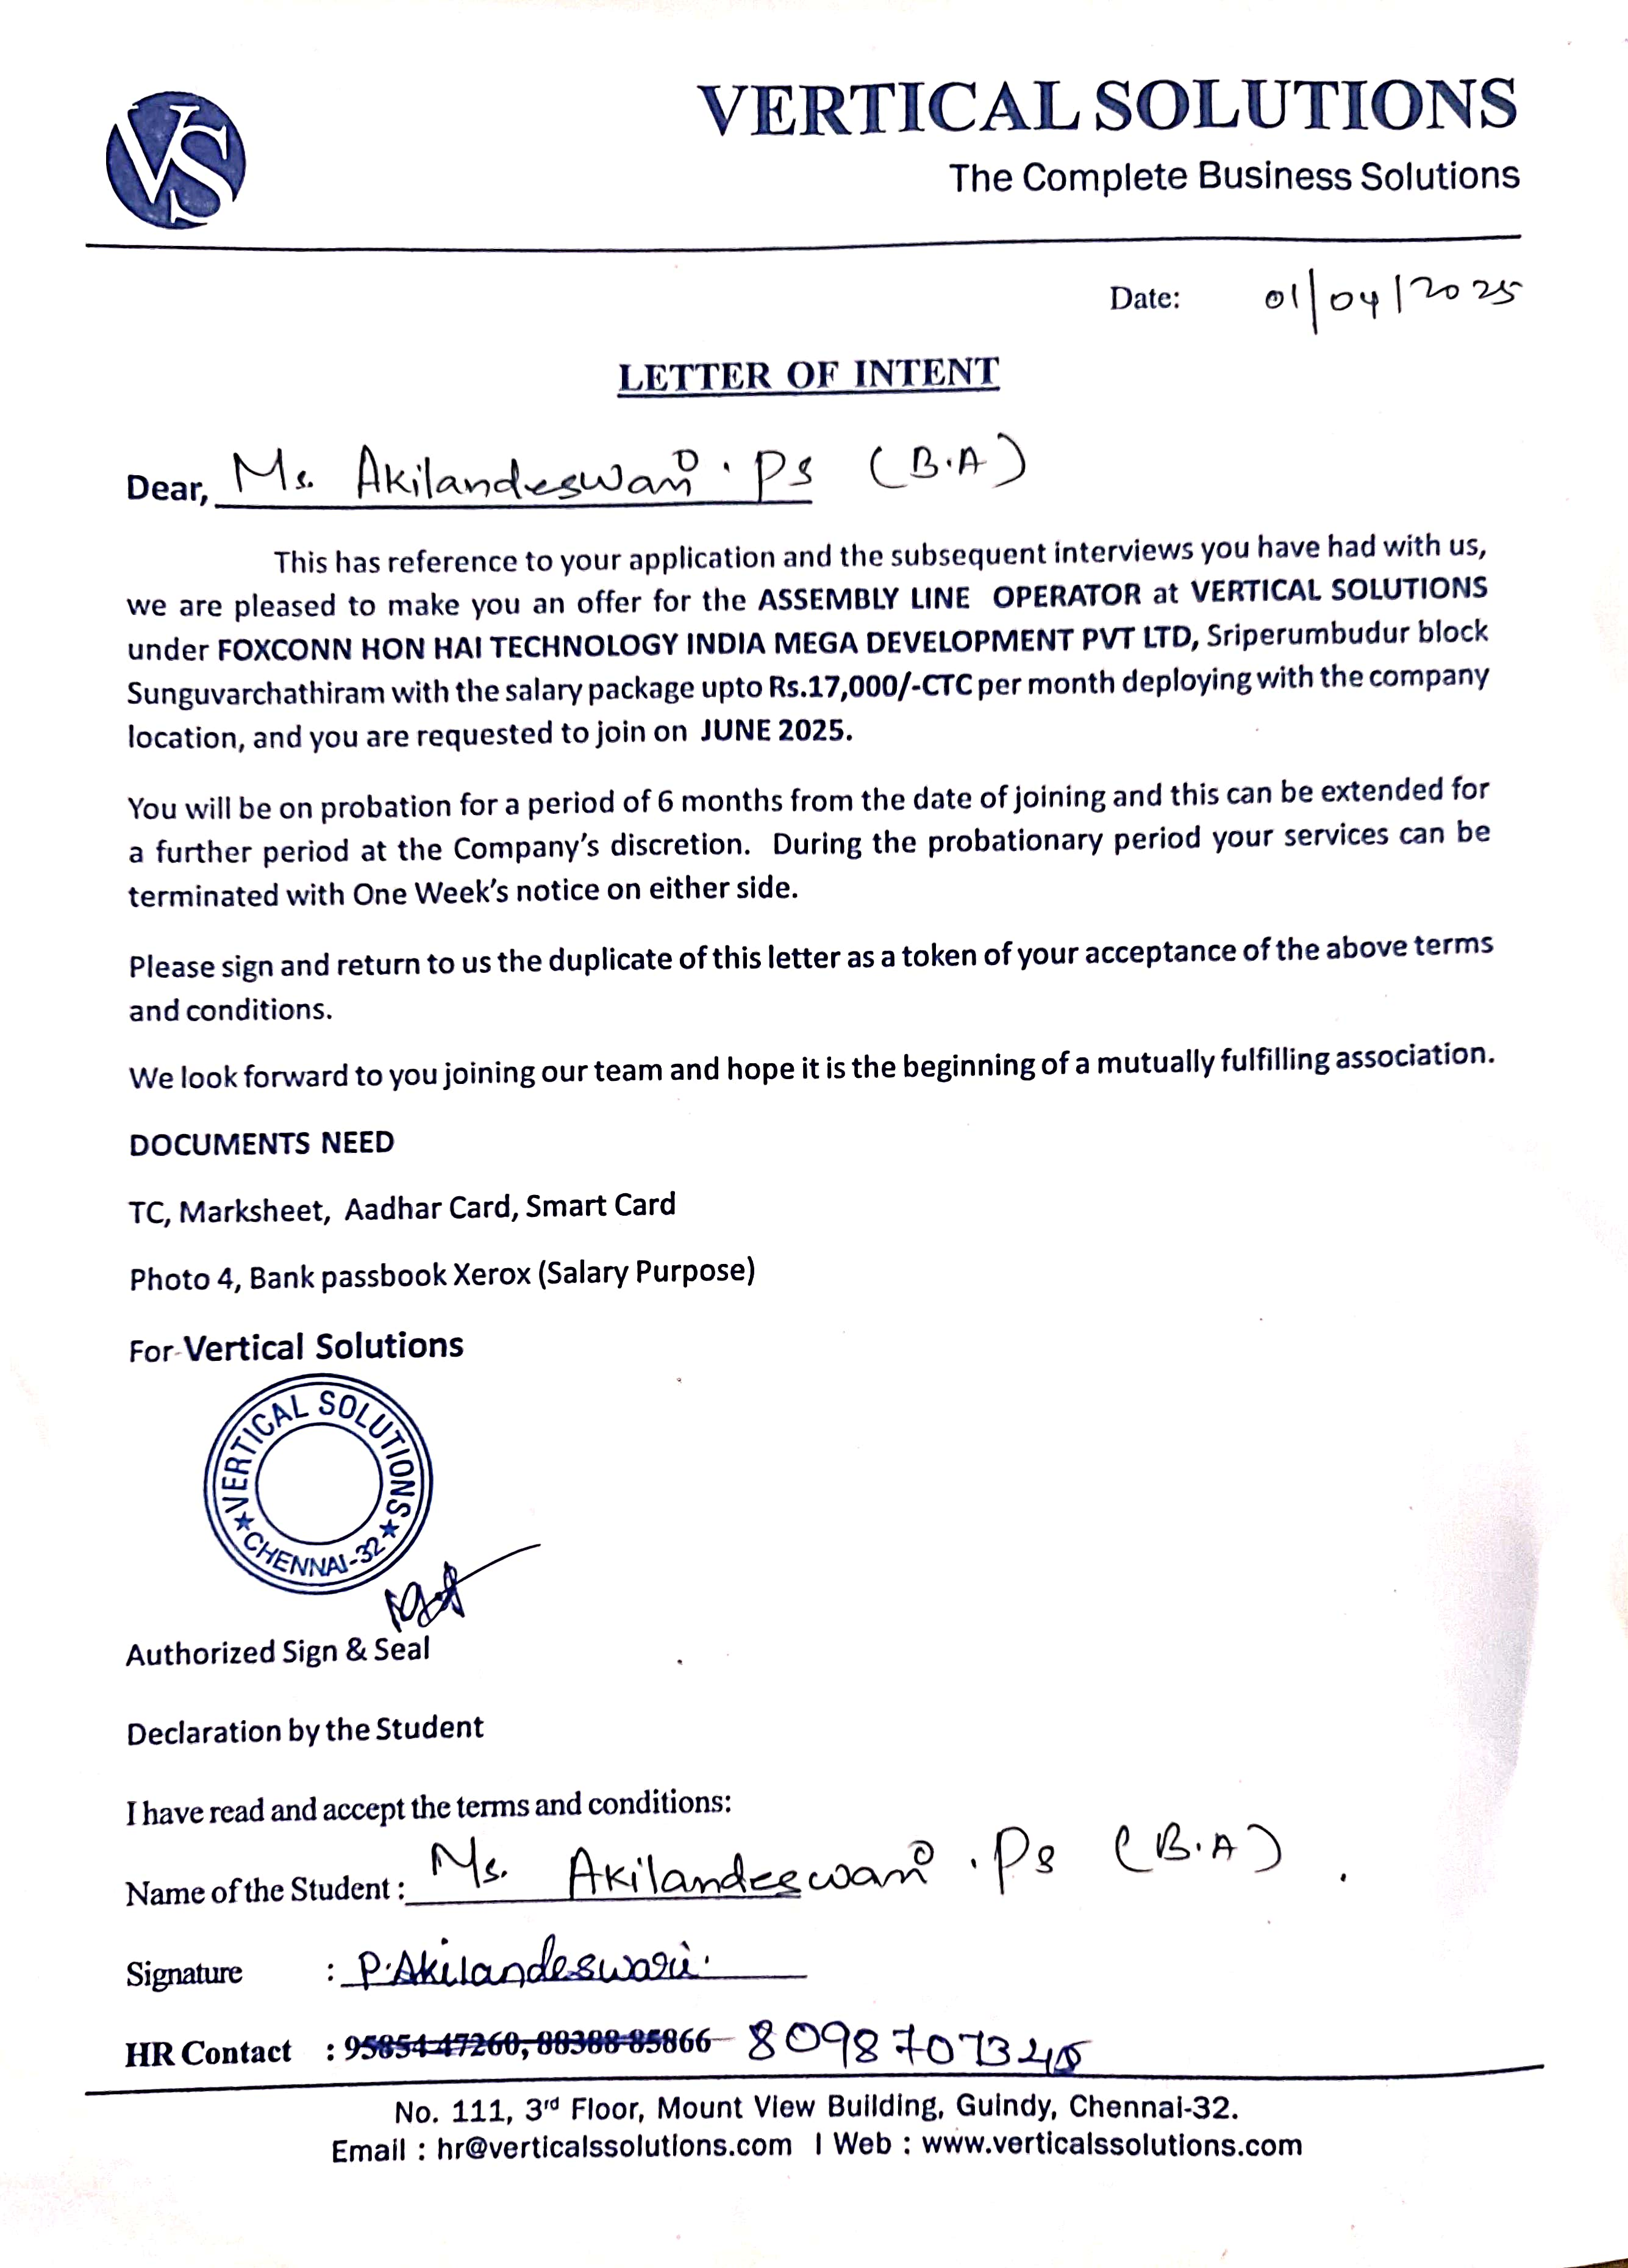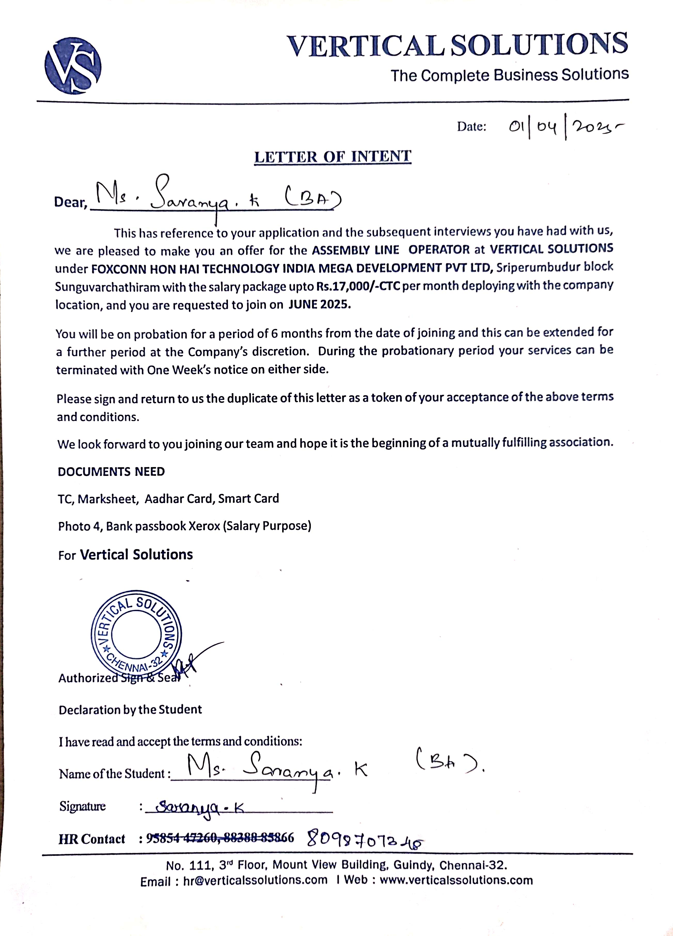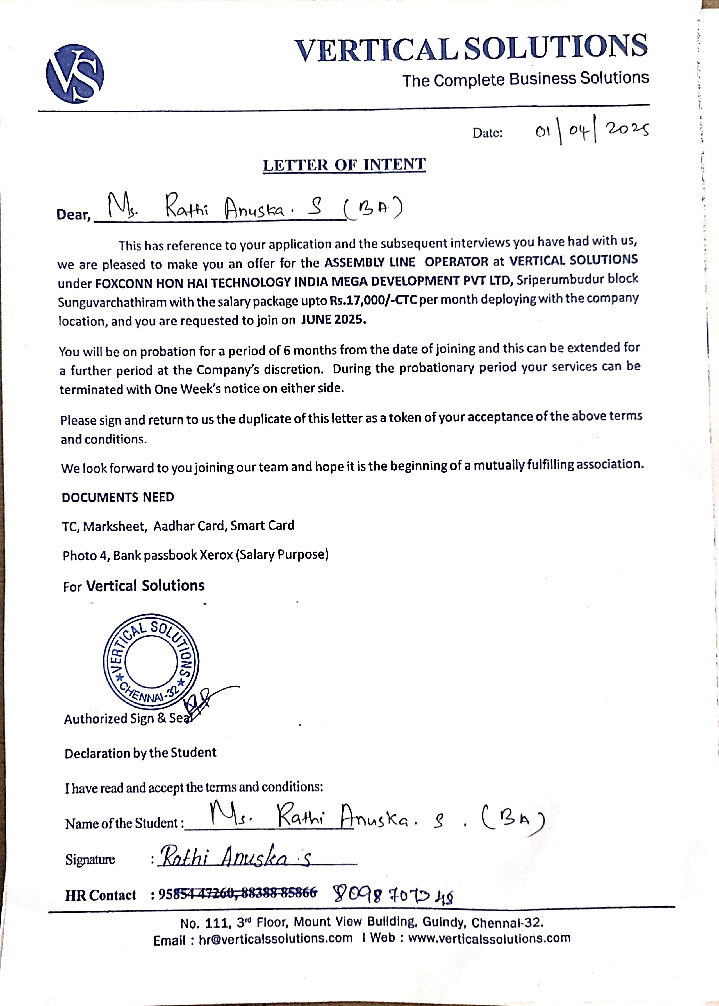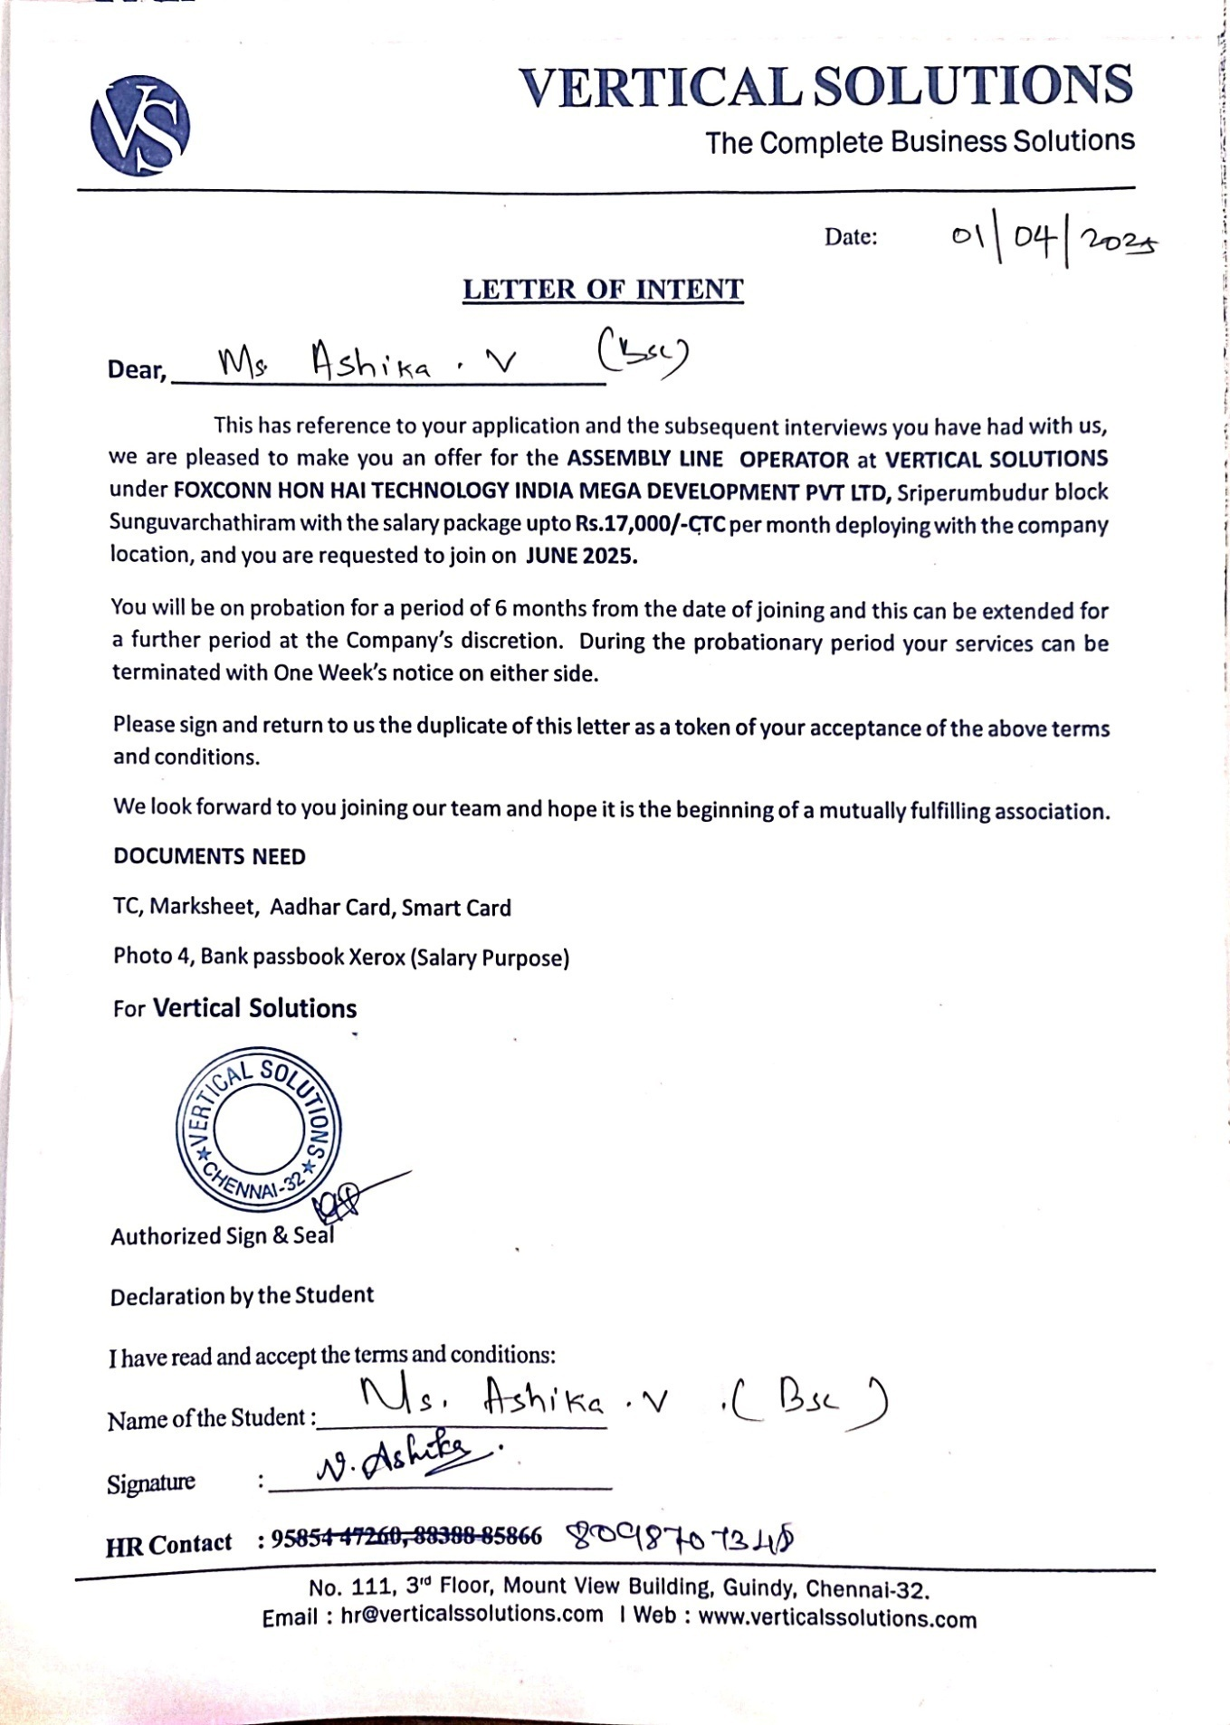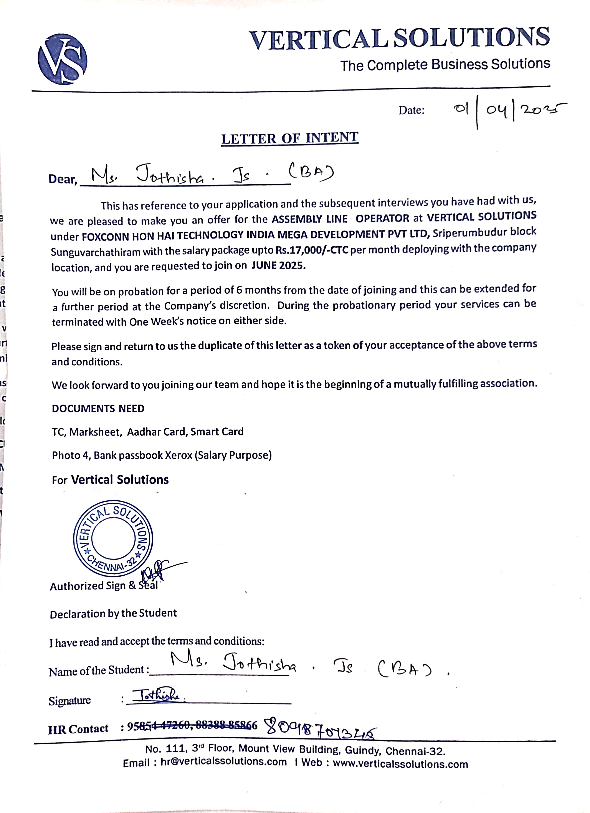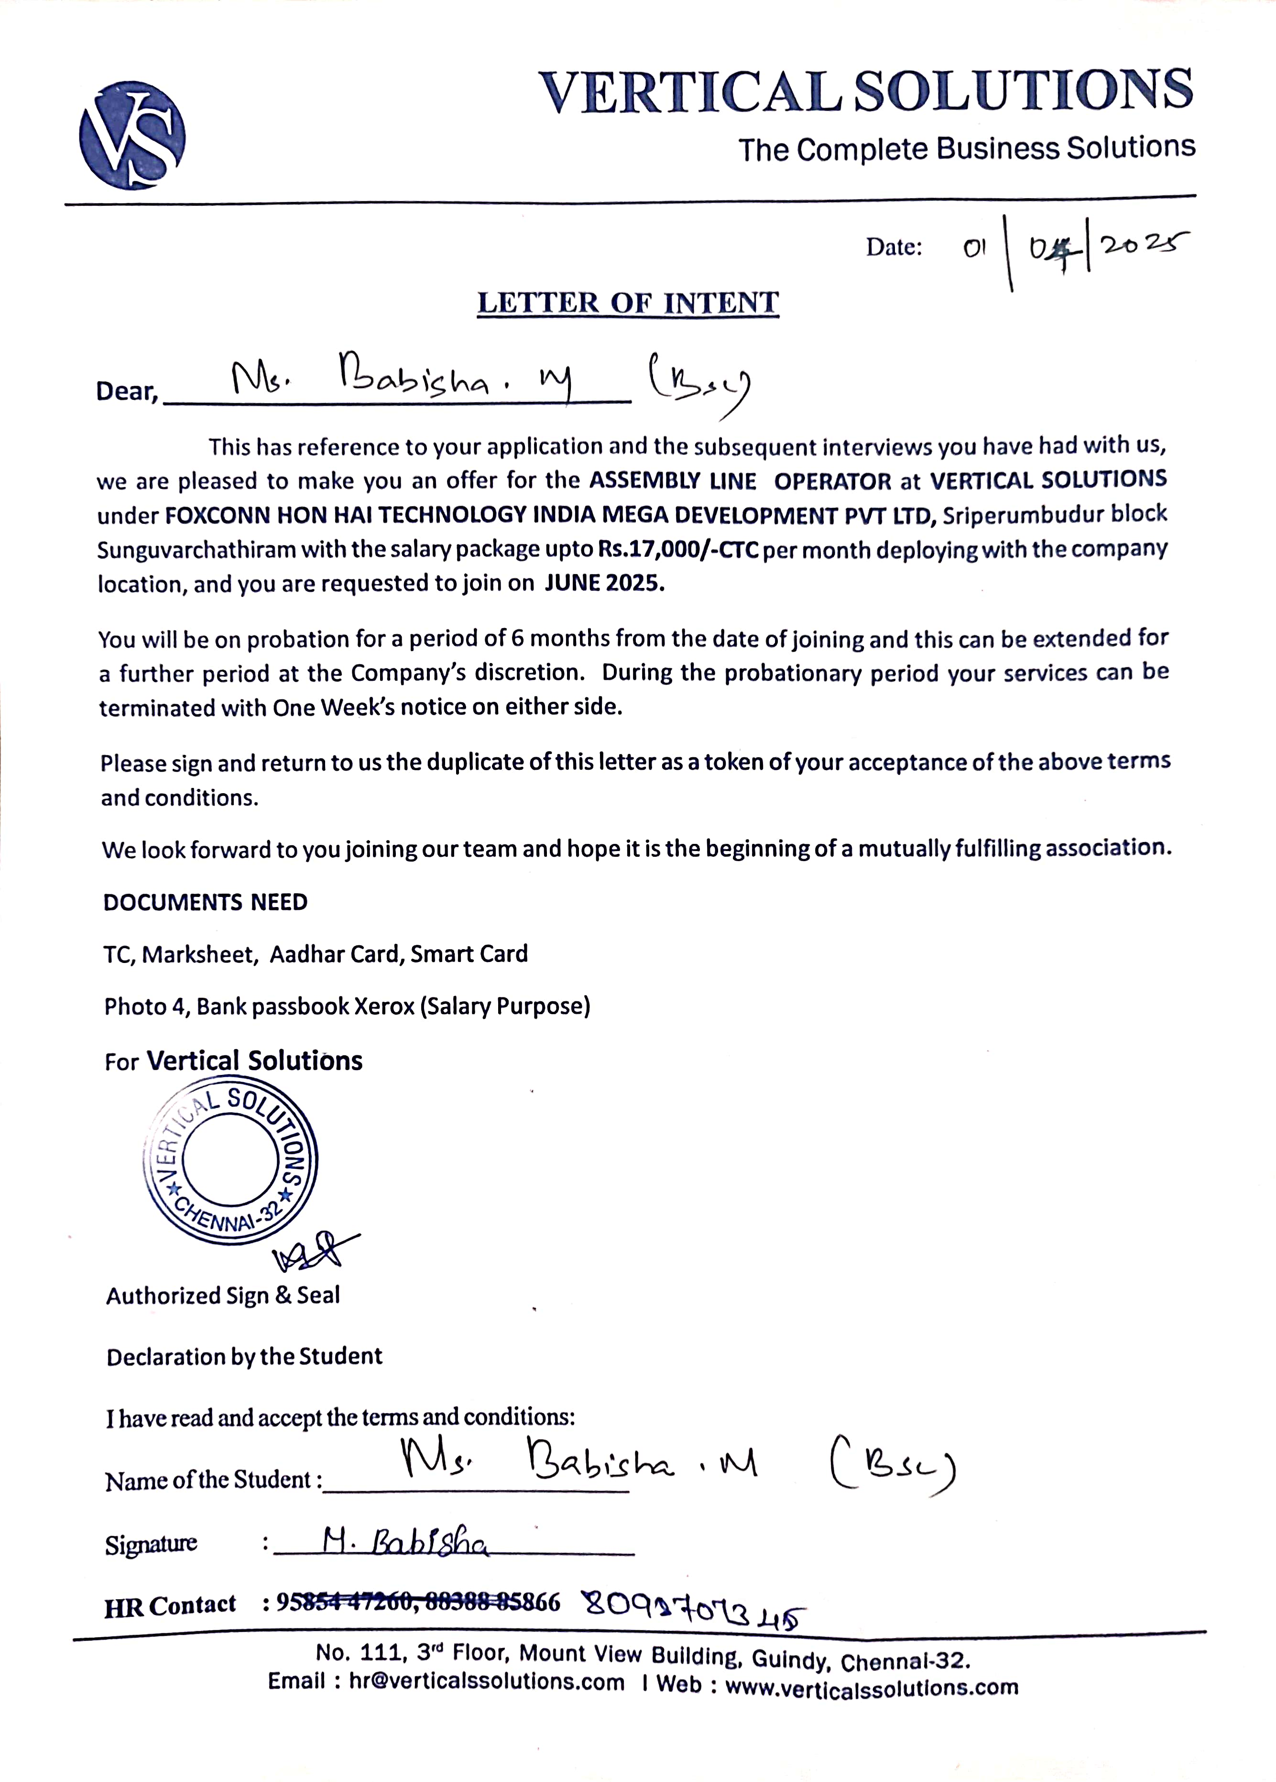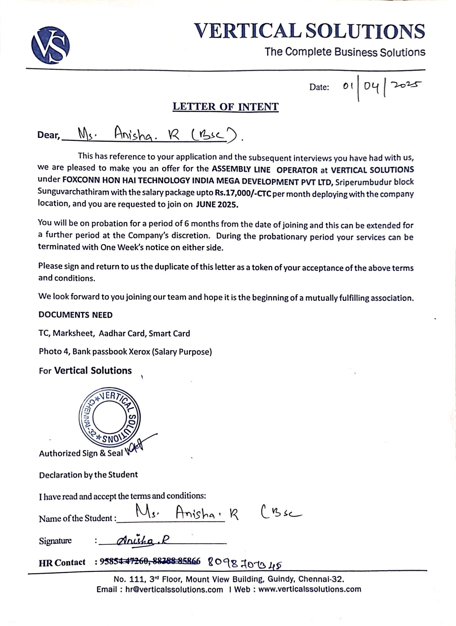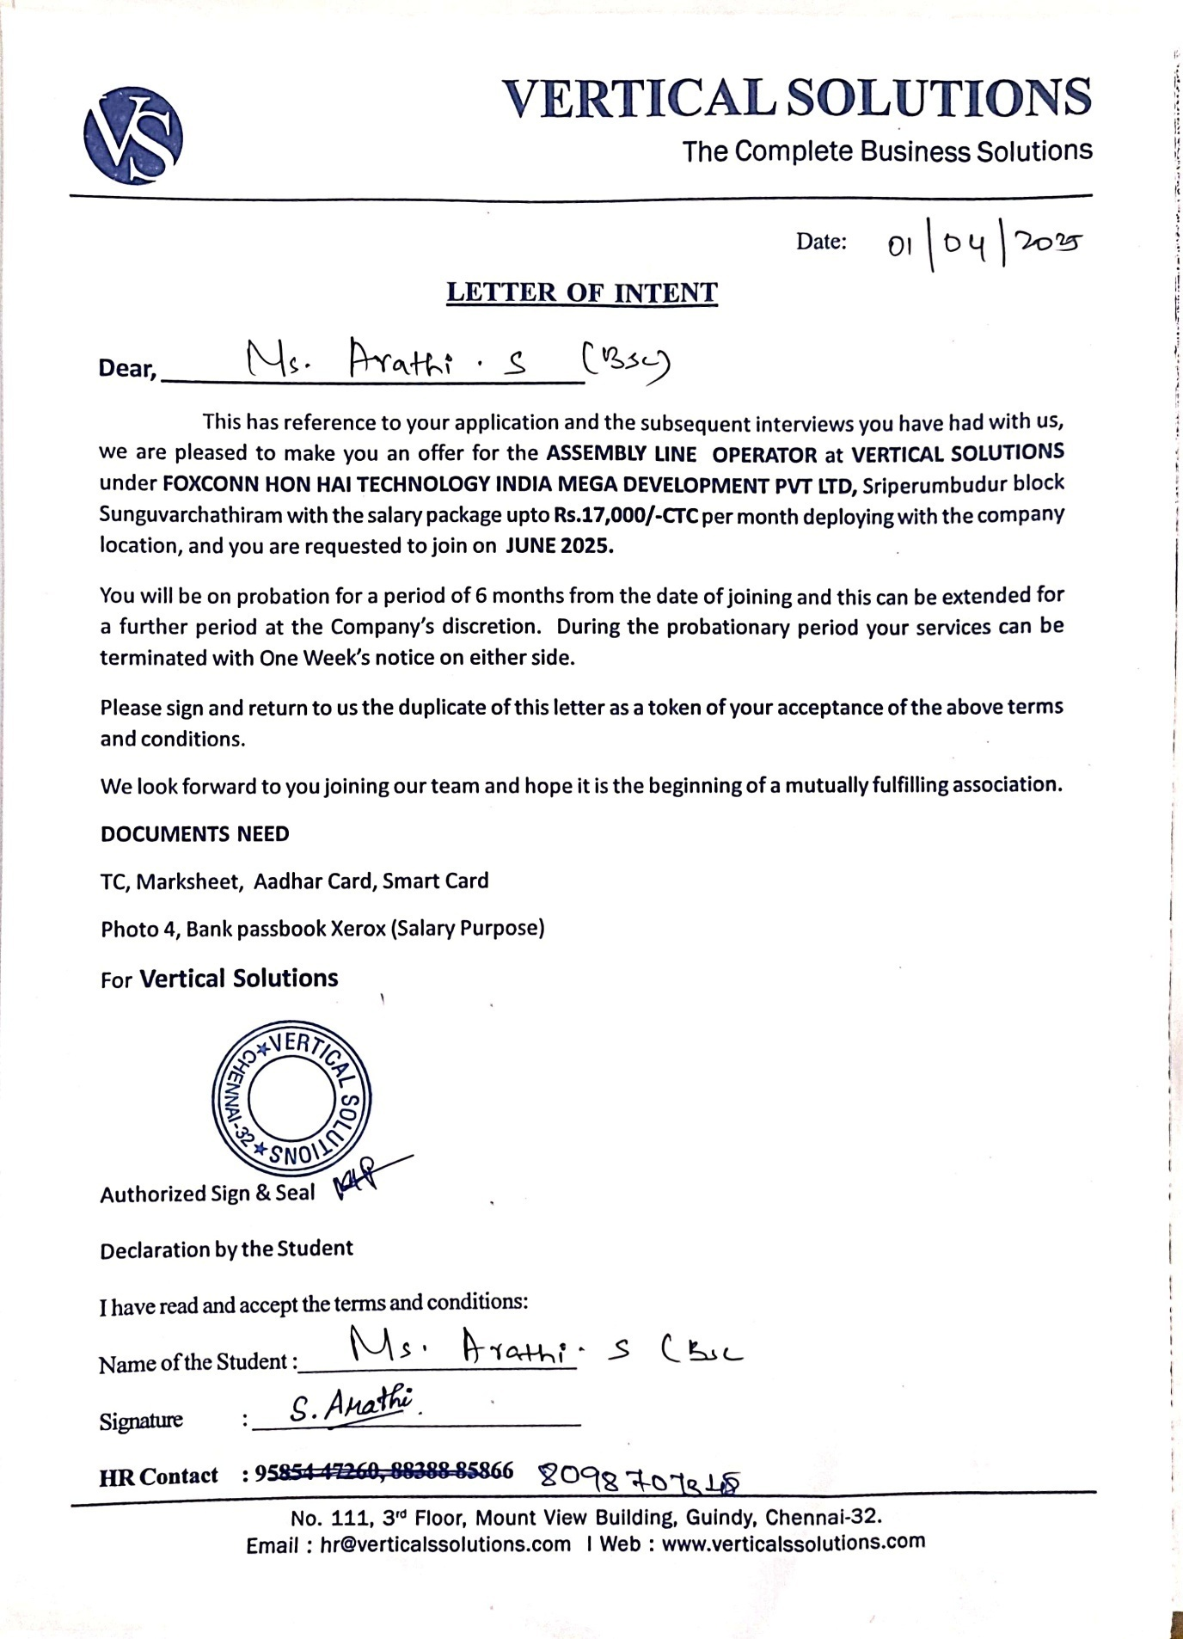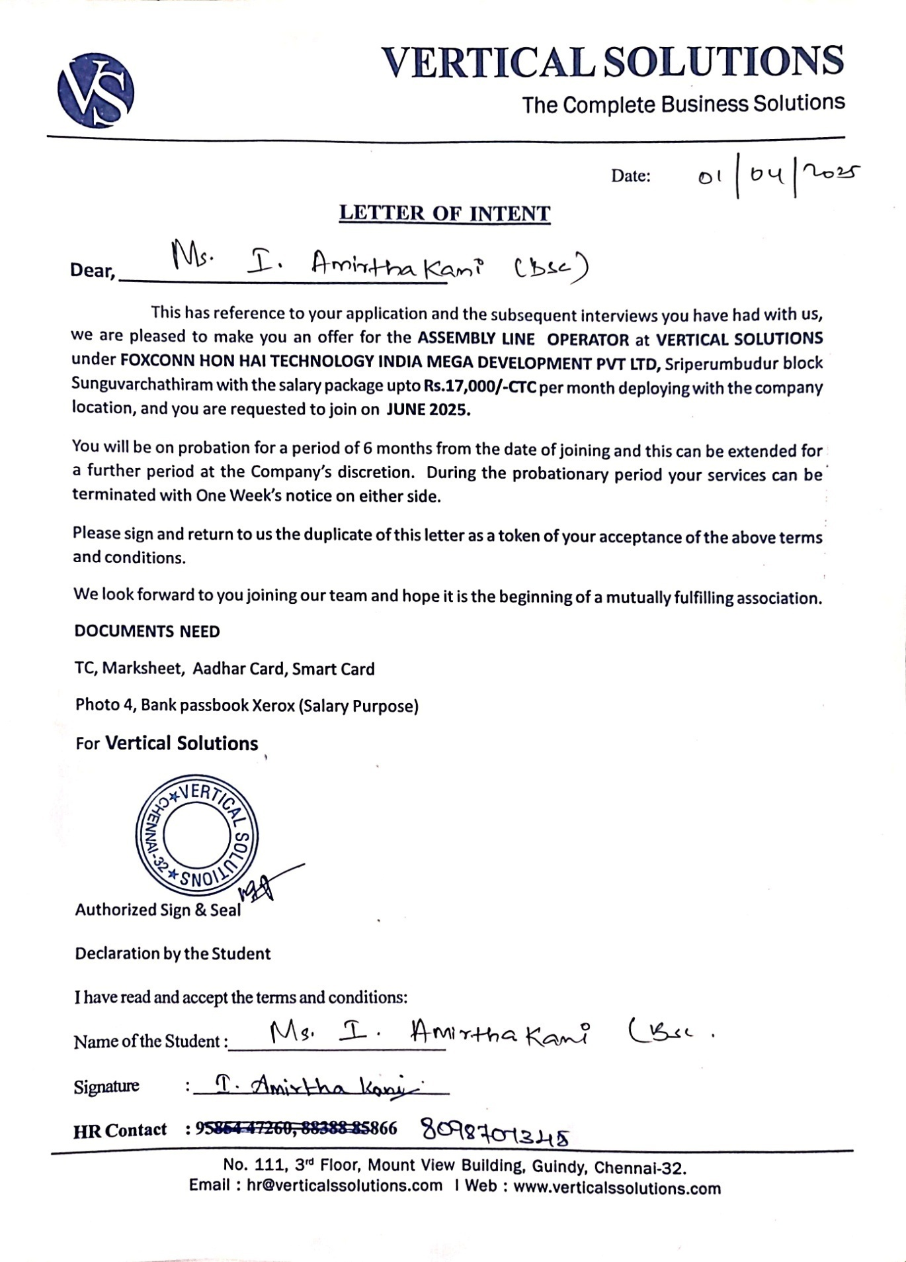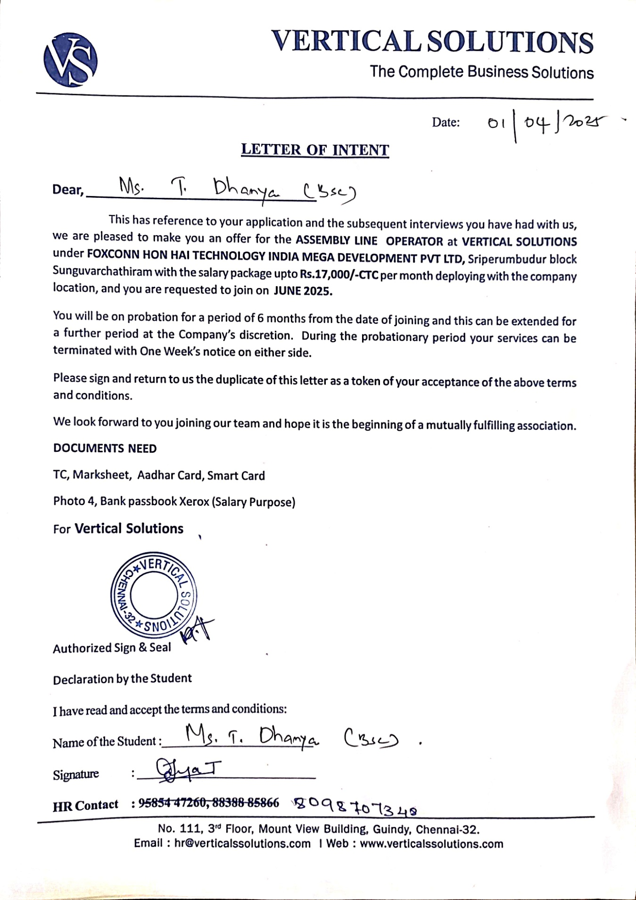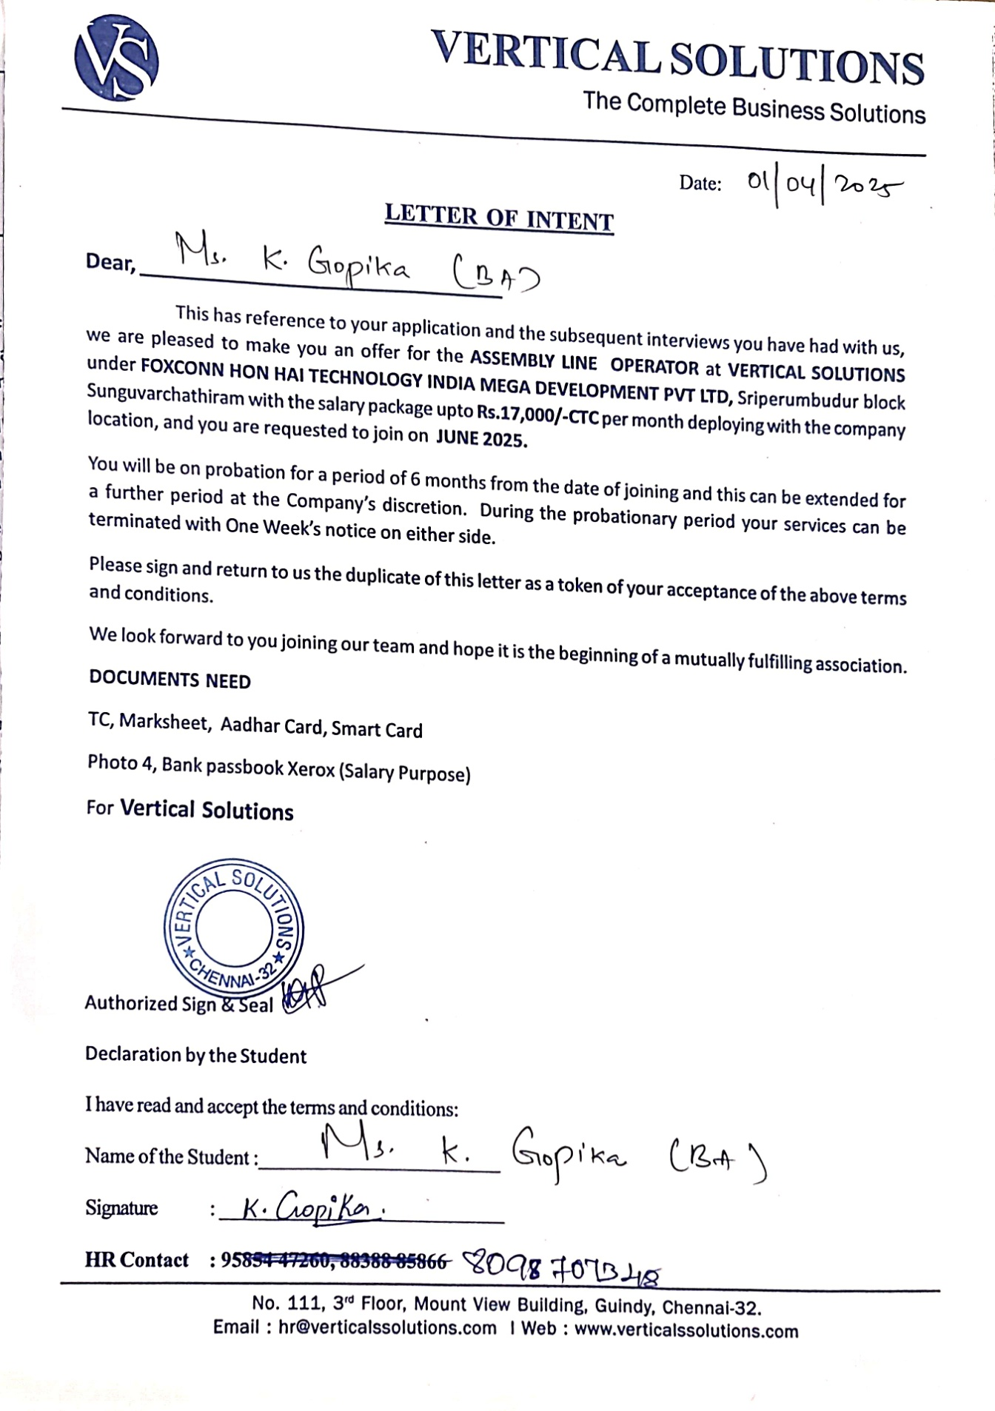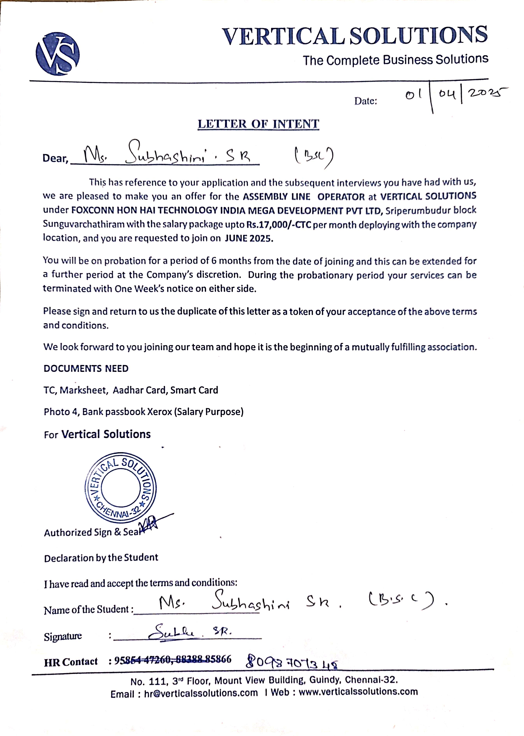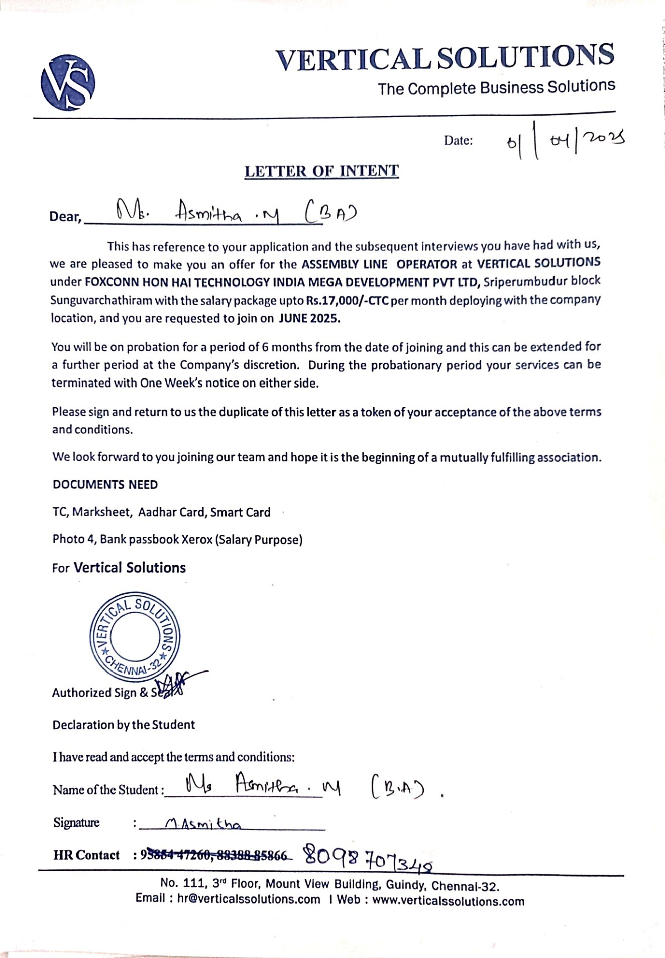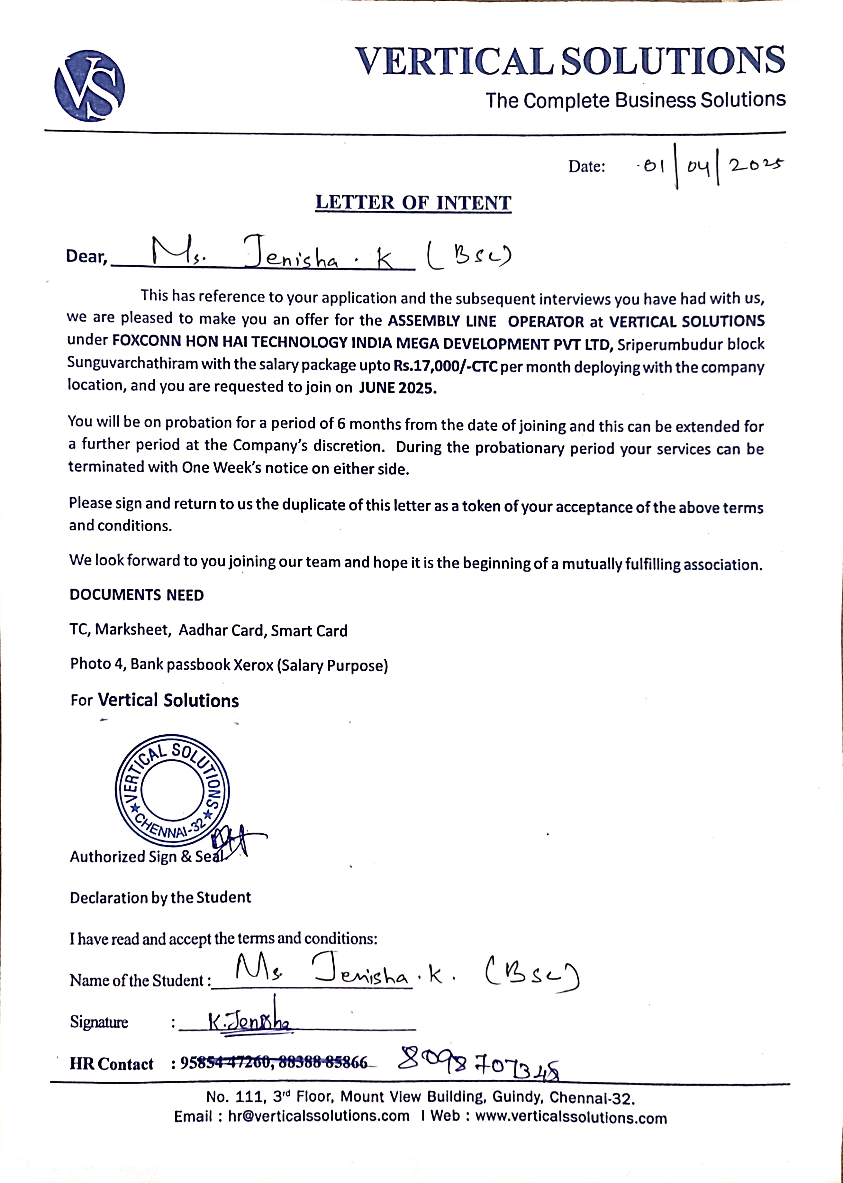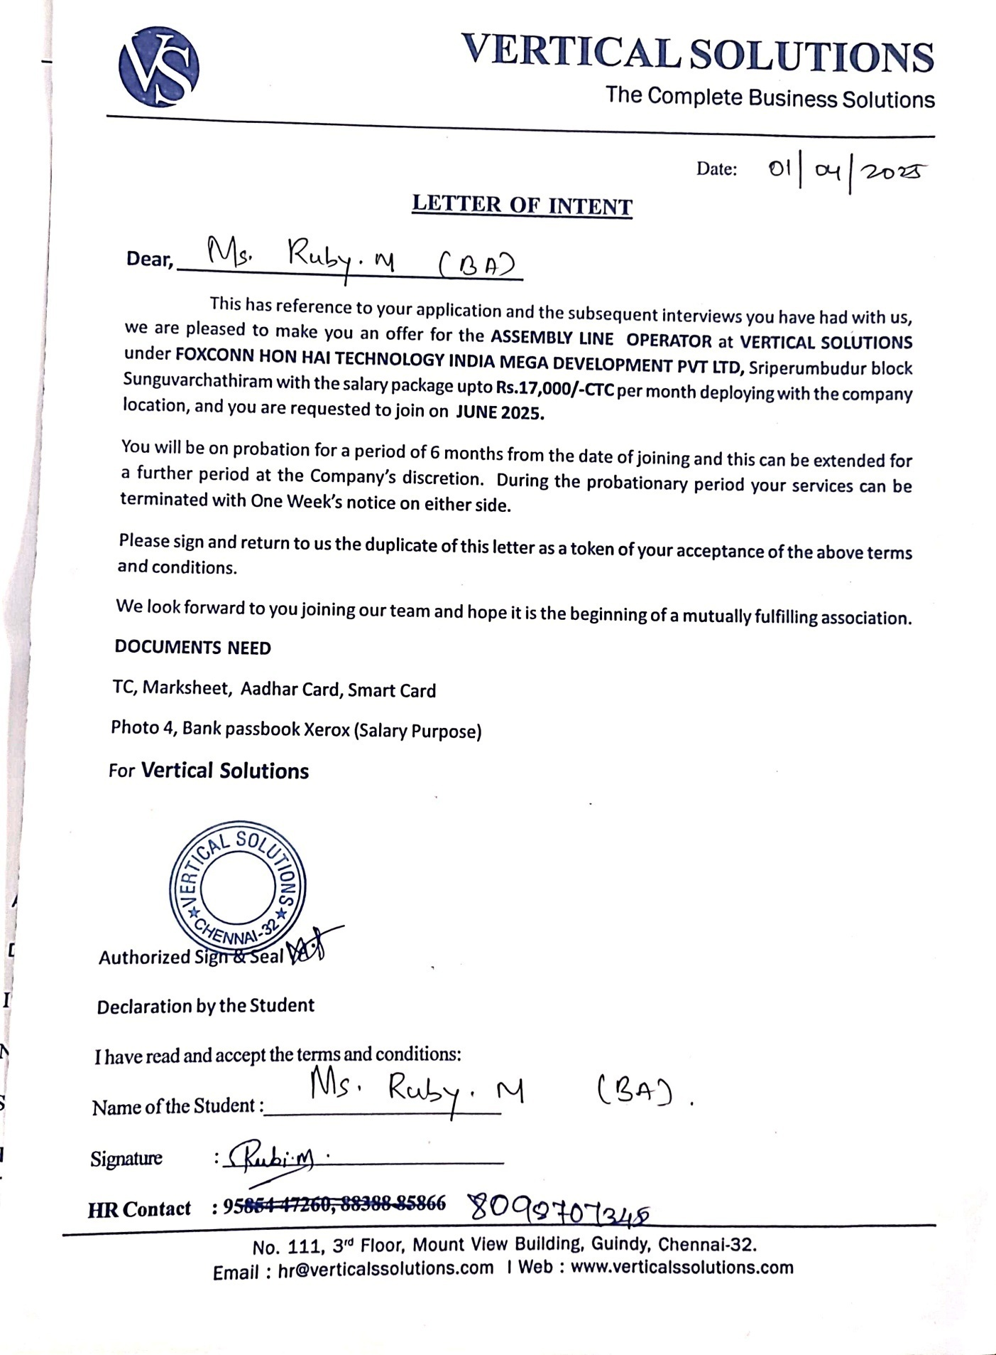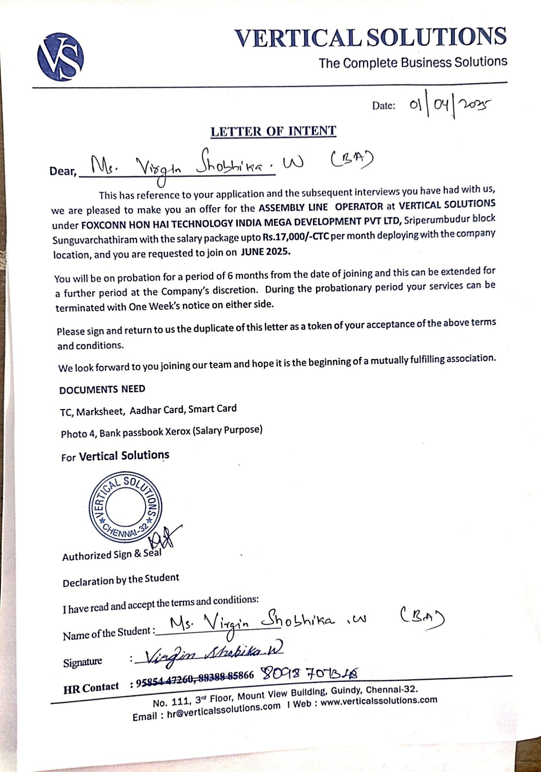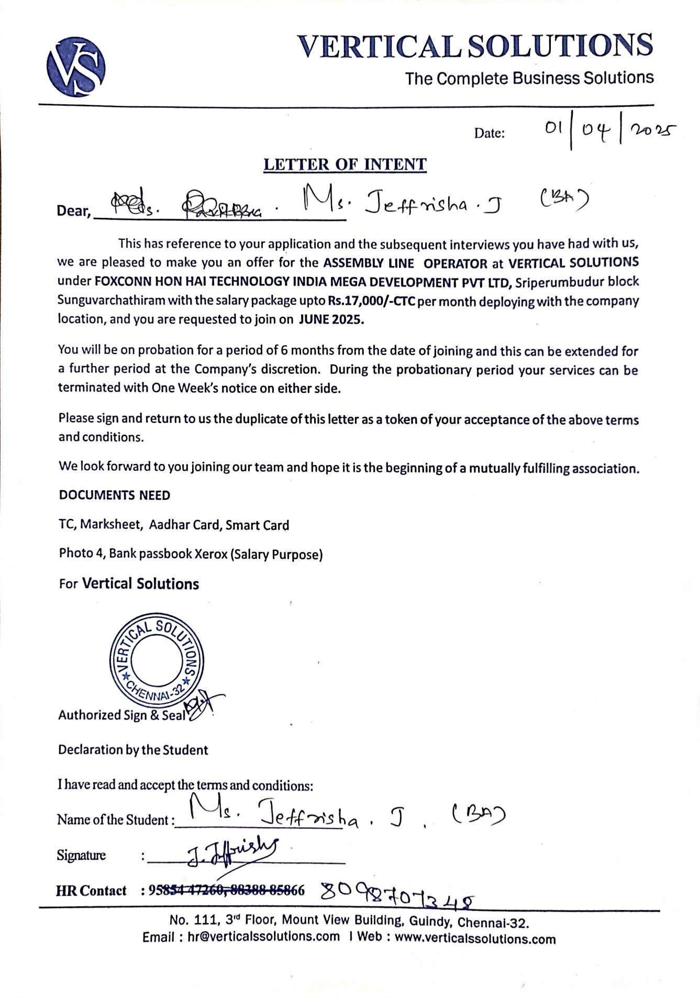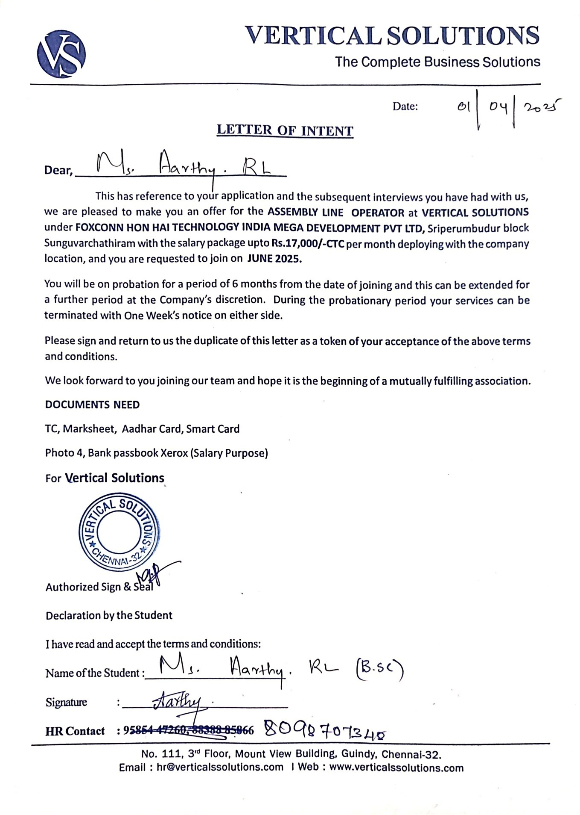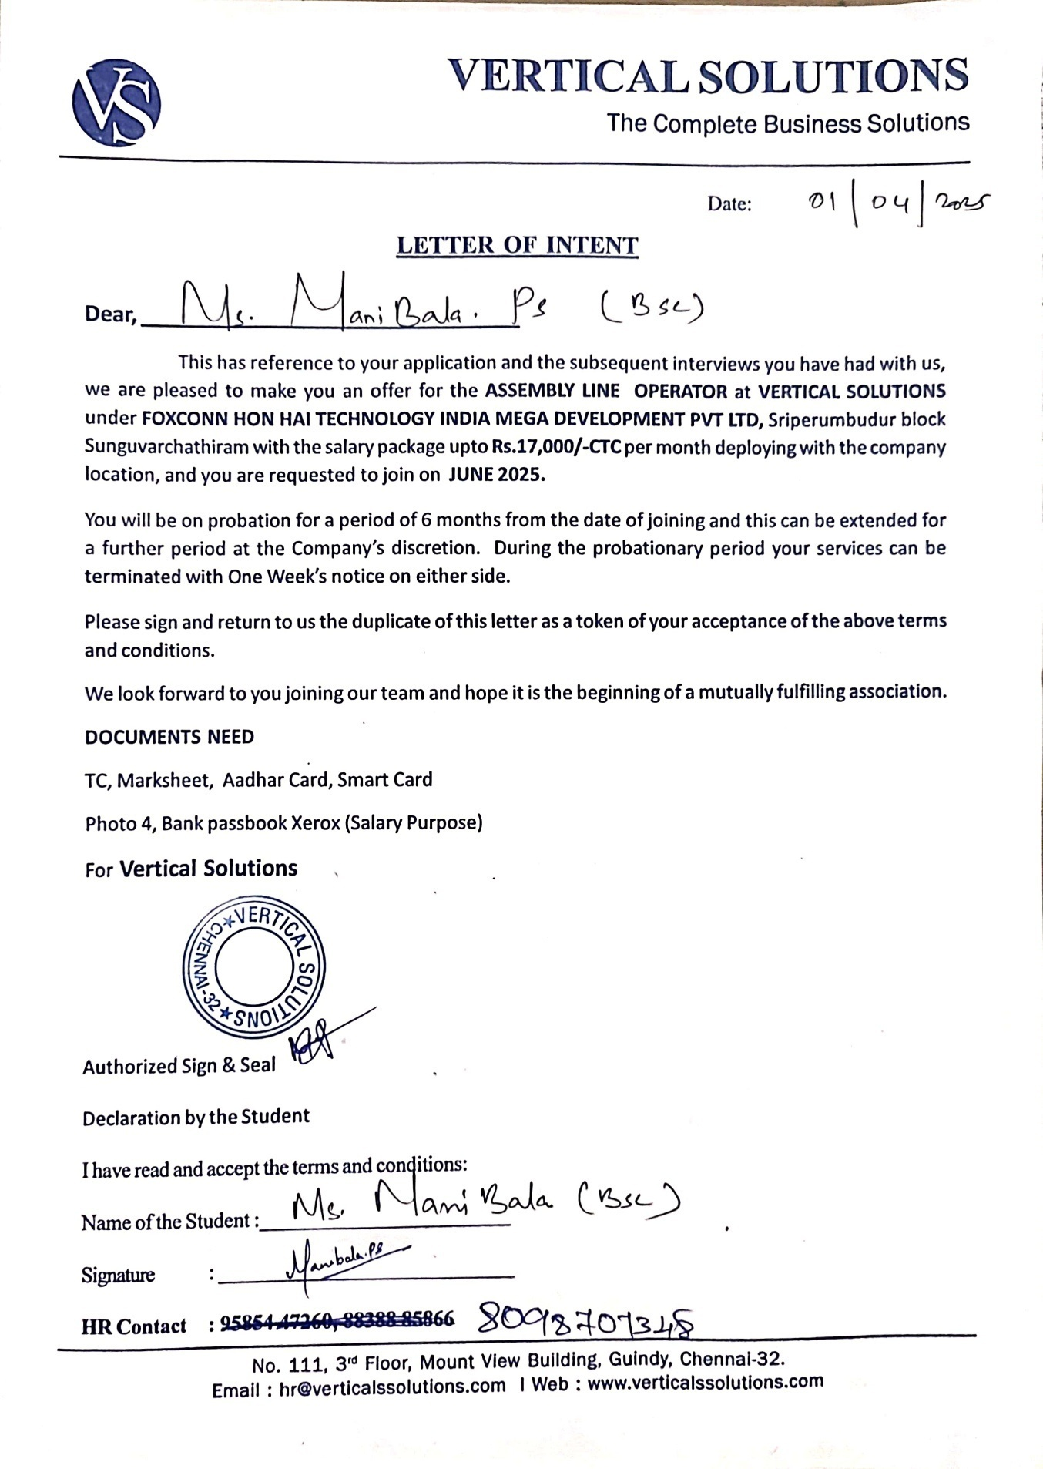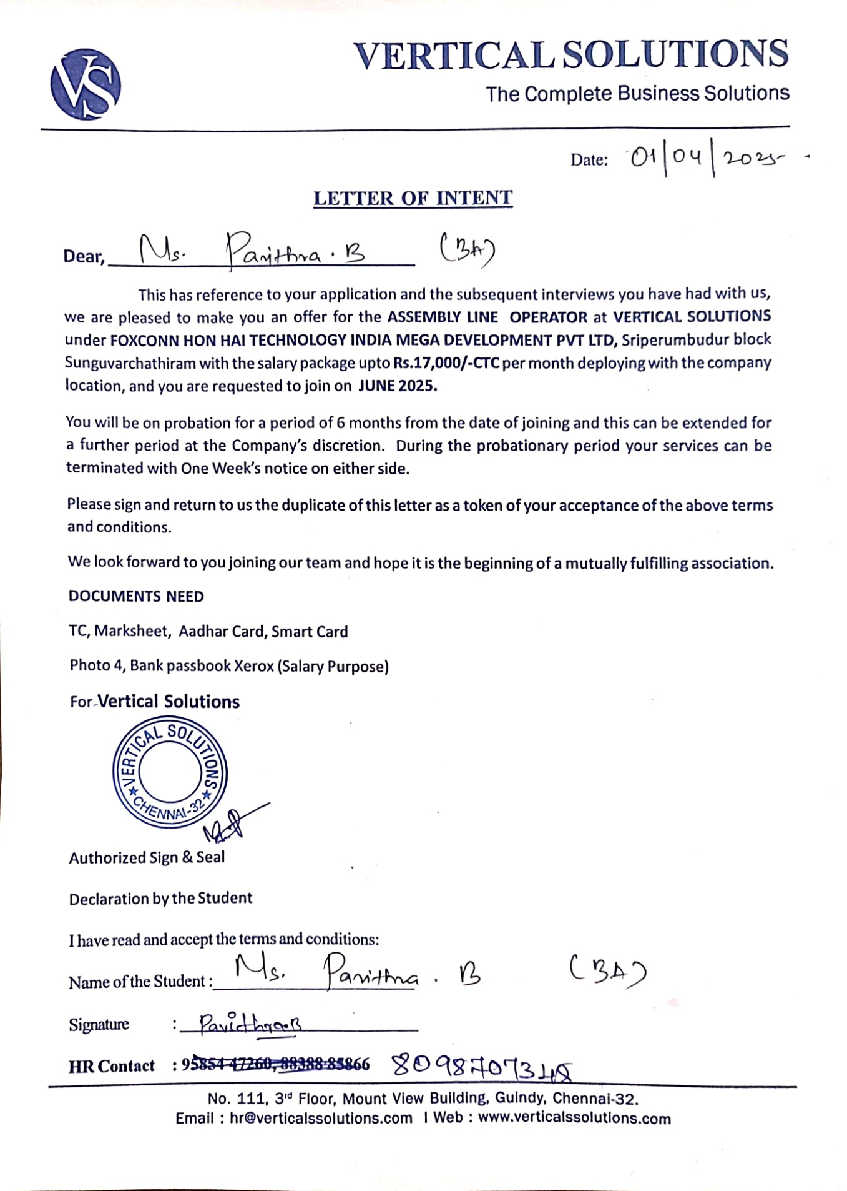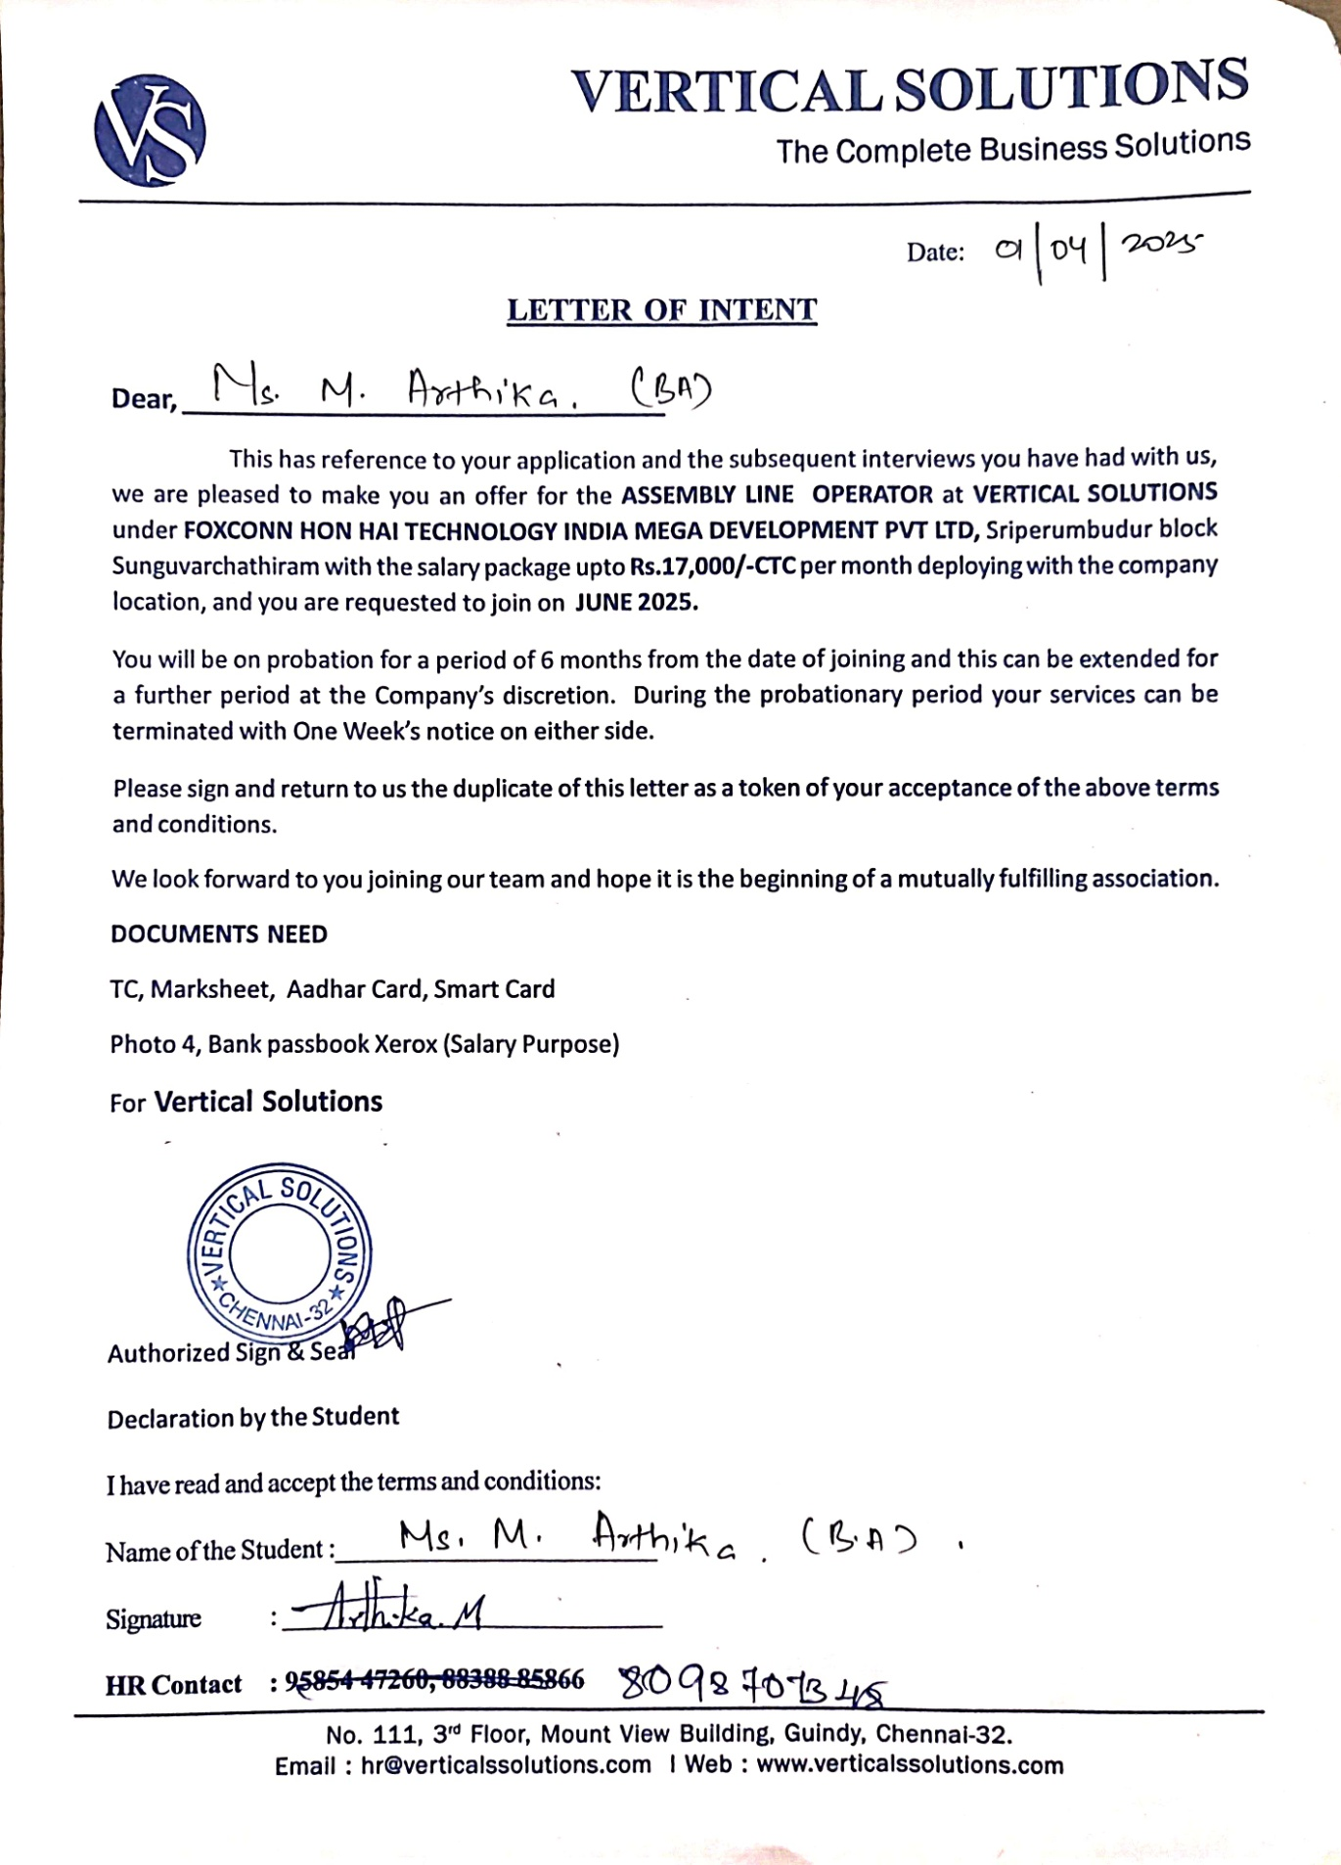

PHOTOS OF THE PROGRAMME :

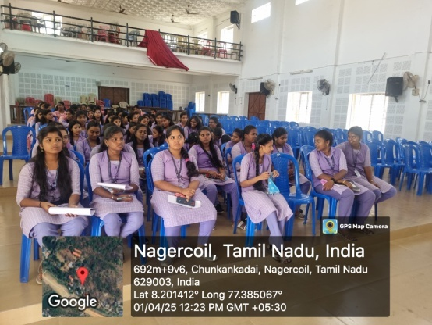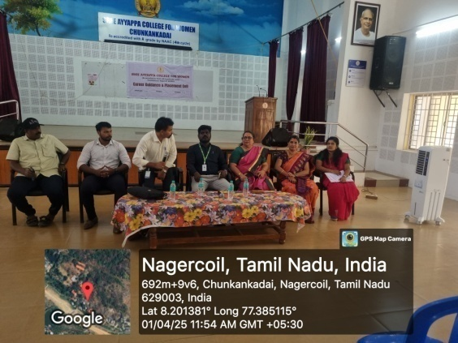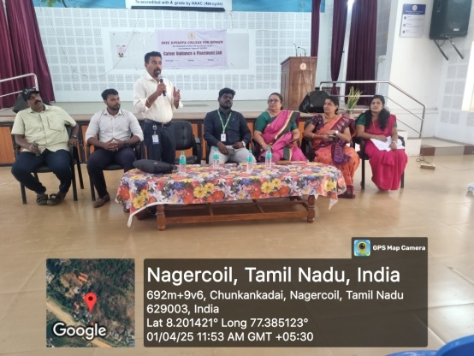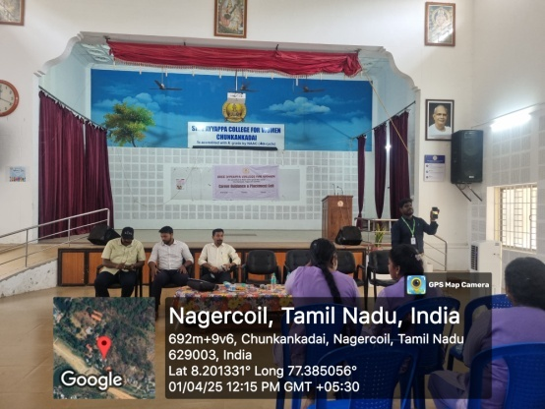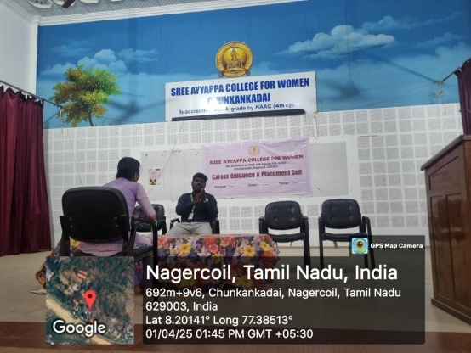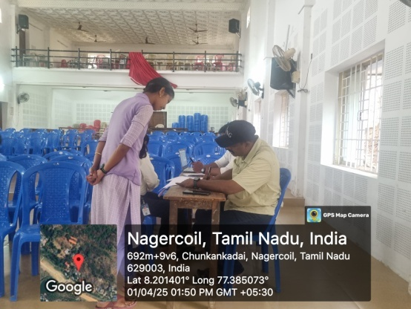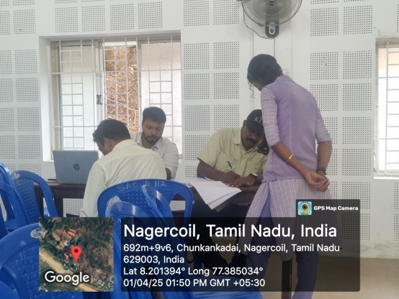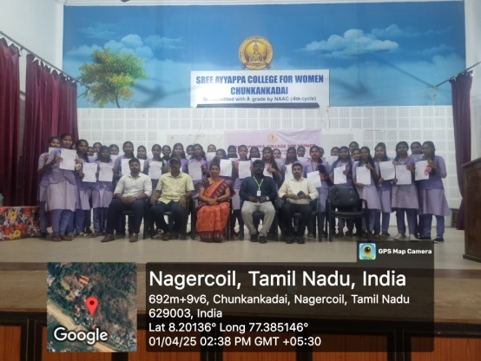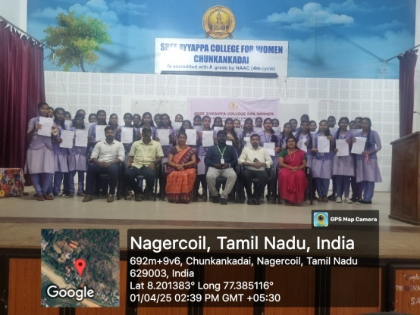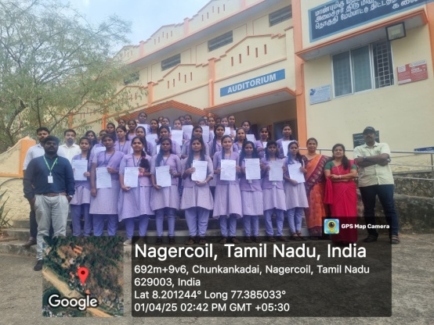

BROCHURE :
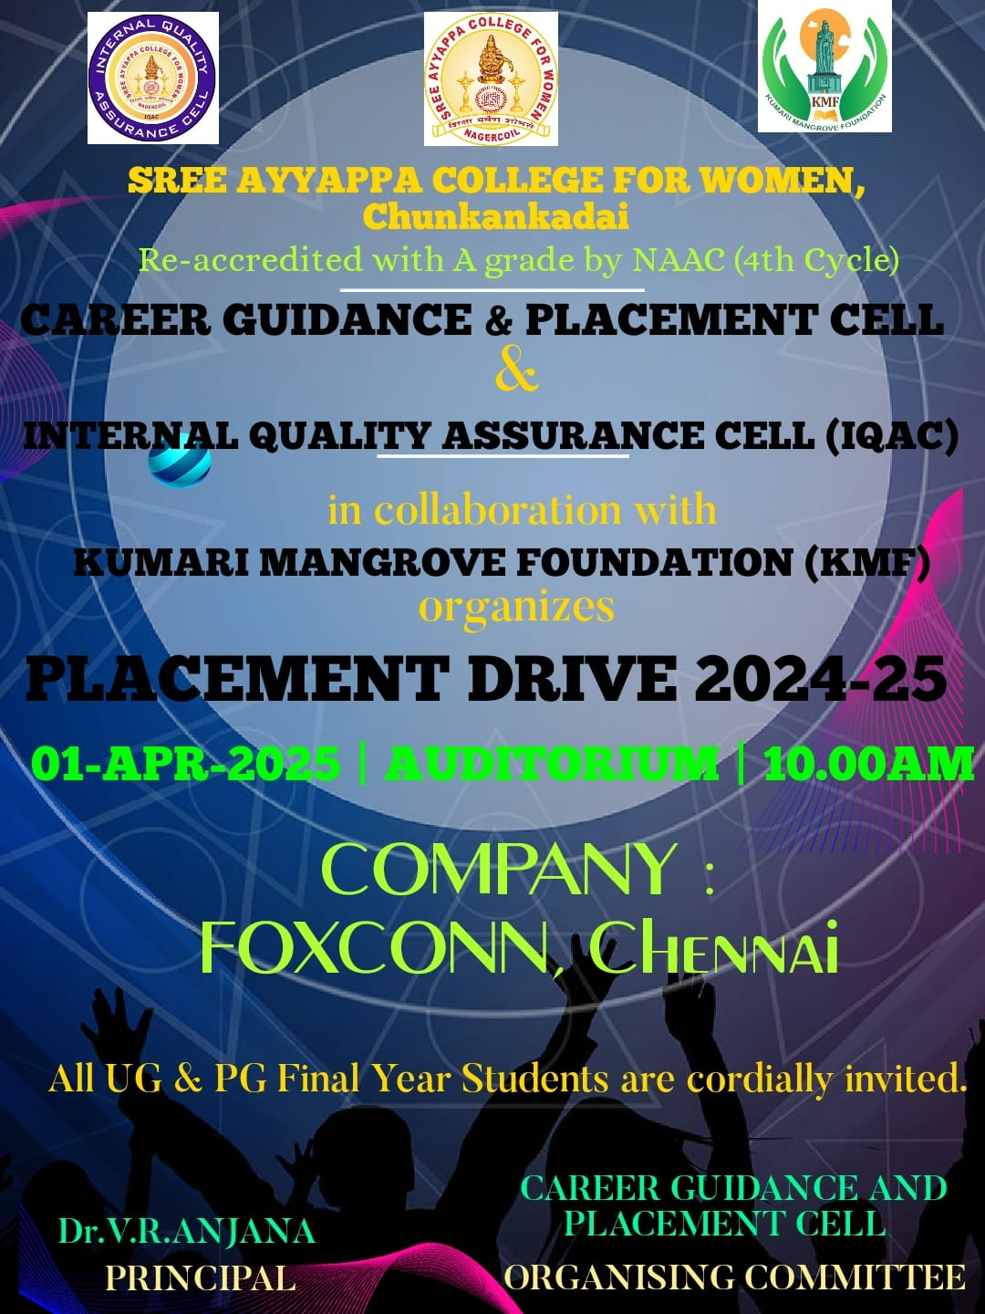
NAME OF THE ORGANIZING COMMITTEE : Career Guidance and Placement Cell & Internal Quality Assurance Cell (IQAC) in collaboration with Kumari Mangrove Foundation (KMF).

