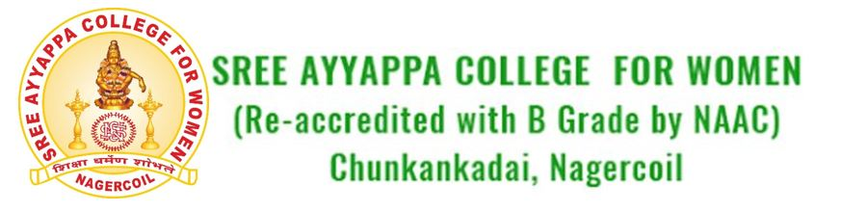
Department of Mathematics
GANITHOLSAV-‘24
Ganitholsav-’24 was conducted in regard of National Mathematics Day on 19 and 20 January 2024 in collaboration with Kanniyakumari Academy of Arts and Sciences (KAAS). Various intercollegiate competitions and paper presentations were held. The intercollegiate competitions were held with the objective of aiding the young generations to explore their talents and invoke interest in the subject. We received proactive response form Arts and Science colleges in Tirunelveli and Kanyakumari district. More than 100 participants inclusive of students from TDMNS college, Kallikulam in Tirunelveli and furthermore 12 Arts and Science colleges in Kanyakumari, competed in 5 events. Competitions including Poster Presentation, Mathematical Modelling and Quiz were conducted on 19/01/2024. To invoke research ideas in young minds paper presentation was held on 20/01/2024.
On the first day, the inaugural function was presided over by Dr. V. R. Anjana (Principal, Sree Ayyappa College for Women) and was inaugurated by Dr. R. Kala (Professor, Department of Mathematics and Syndicate Member, Manonmaniam Sundaranar University). The Keynote address was delivered by Dr. E. James R. Daniel (General Secretary, KAAS) and felicitation by Mr. Subodh Kumar (Branch Manager, Central Bank of India, Aloor).
Inaugural session was followed by Quiz, Poster Presentation, Mathematical Modelling competitions. A total of 16 teams enrolled for quiz competition, out of which 5 teams were selected by a preliminary test. The quiz master was Dr. R. Kala. Paper presentations were held on 20-01-2024. 19 students presented their findings. It was followed by Valedictory function in the afternoon session. The valedictory address was delivered by Dr. V. R. Anjana (Principal, SAC). Mr. M. Harish (Branch Manager, Dhanlaxmi Bank, Nagercoil), Dr. N. Sam Raj (Vice-president, KAAS) and Mr. M. G. Prakash (Director, BITS Information Technology) felicitated. Prizes were distributed to the winners of the competitions and participants and best paper award was given to UG and PG separately. Trophy was awarded to the overall champions. The two-day programme was concluded by collecting feedback from students of various colleges who were inspired and impressed by Ganitholsav-’24. We thank Principal and the management for permitting us to organise the event.
List of Colleges Participated
- Holy Cross college (Autonomous), Nagercoil
- Women’s Christian College, Nagercoil
- Sree Devi Kumari Women’s College, Kuzhiturai
- Nanjil Catholic College, Kaliyakavilai
- St. Alphonsa College of Arts and Science, Karungal
- Scott Christian College, Nagercoil
- Pioneer Kumaraswamy College, Nagercoil
- Annai Velankanni College, Tholaiyavattam
- TDMNS College, Kallikulam
- ST. Jude’s College, Thuthoor
- Govt Arts and Science College, Konam
- St. John’s College of Arts and Science, Ammandivilai
Number of Participants
 | Holy Cross college (Autonomous) | : | 26
 | Women’s Christian College | : | 25
 | Sree Devi Kumari Women’s College | : | 4
 | Nanjil Catholic College, Kaliyakavilai | : | 5
 | St. Alphonsa College of Arts and Science, Karungal | : | 6
 | Scott Christian College, Nagercoil | : | 11
 | Pioneer Kumaraswamy College, Nagercoil | : | 3
 | Annai Velankanni College, Tholaiyavattam | : | 7
 | TDMNS College, Kallikulam | : | 5
 | ST. Jude’s College, Thuthoor | : | 4
 | Govt Arts and Science College, Konam | : | 5
 | St. John’s College of Arts and Science, Ammandivilai | : | 2

Prize Winners
Quiz Competition
1st prize | Holy Cross College | - Starlin Mini. S  - Bama. M  - Amala Binisha. C
2nd prize | Holy Cross College | - Asmin Serlin. P  - Deva Thibiksha  - Carolin Jonna. U.S
3rd Prize | Nanjil Catholic College, Kaliyakavilai | - Jenifa. K.S  - Shijo. S  - Afin. R.S

Poster Presentation
1st prize | Scott Christian College, Nagercoil | - Sowmiya. T  - Rama Dhevi. S.V
2nd prize | Holy Cross college (Autonomous) | - Ashly. X.L  - Dhanya. M.R
3rd prize | Women’s Christian College | - Abinaya. R  - Abisha Bemi. C

Mathematical Modelling
1st prize | Women’s Christian College | - Ameena Bevi. S  - Jessica Jannet. S.R
2nd prize | Holy Cross college (Autonomous) | - Ashly. X.L  - Dhanya. M.R
3rd prize | St. Alphonsa College of Arts and Science, Karungal | - Joshika. J  - Asmiya. M

Best Paper Presenter
- R. Thillai Raj, Women’s Christian College (UG)
- Jenifa. R.S, Scott Christian College (PG)

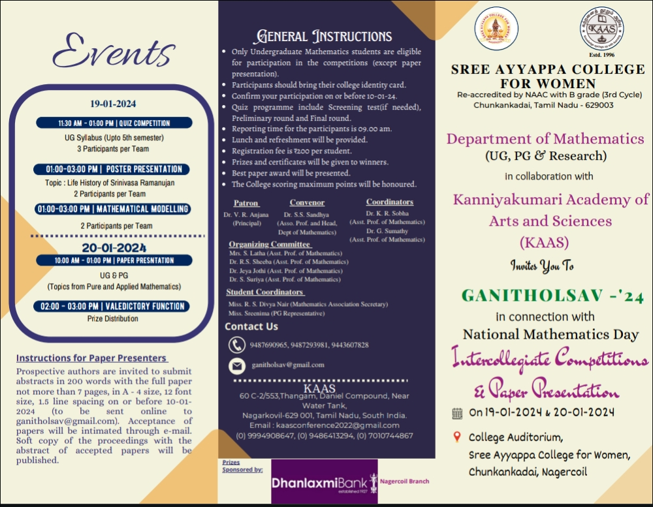
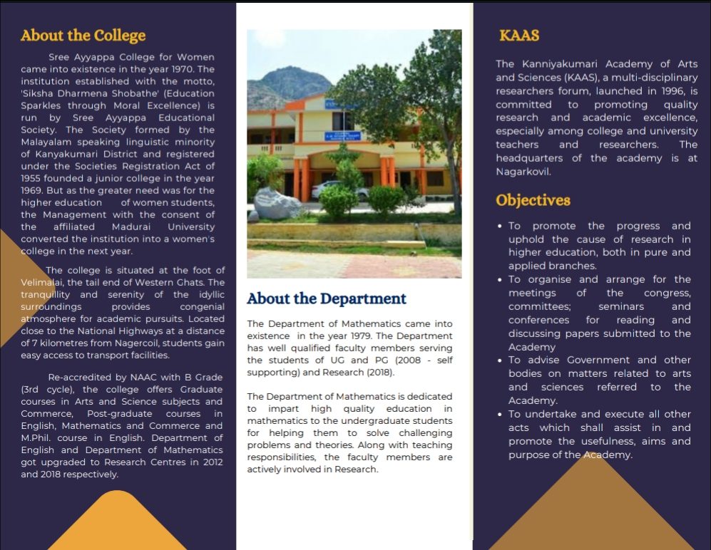
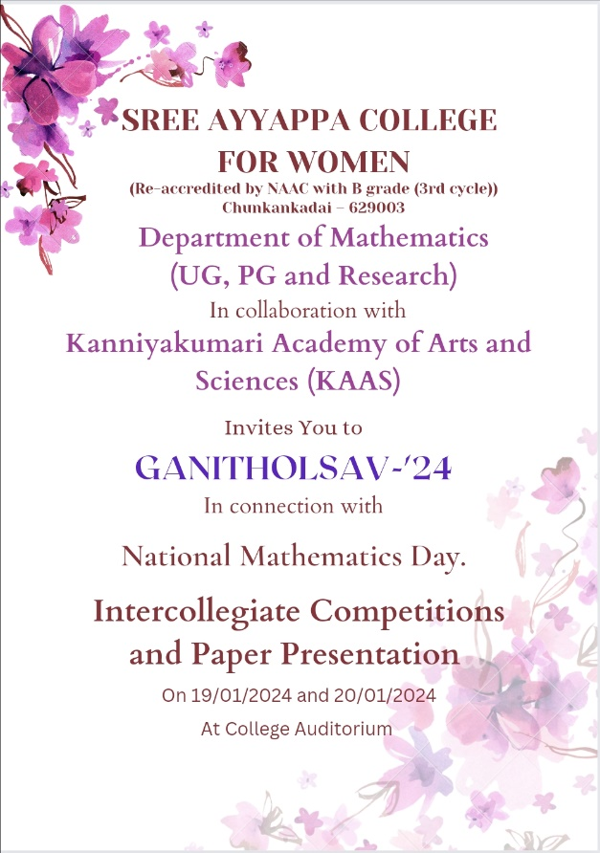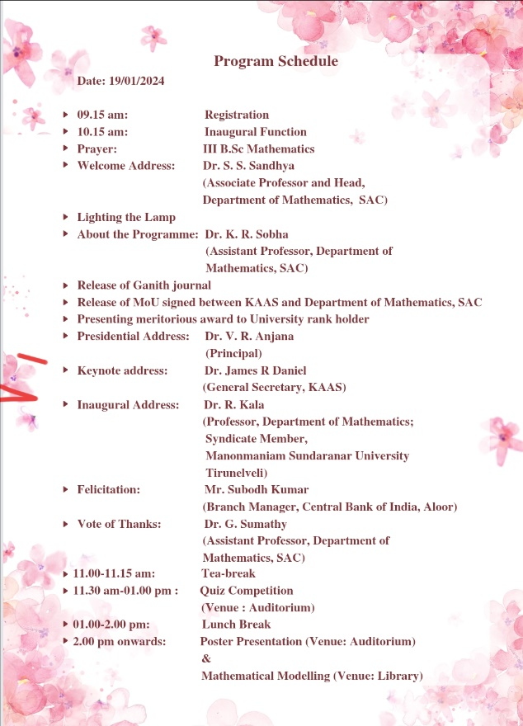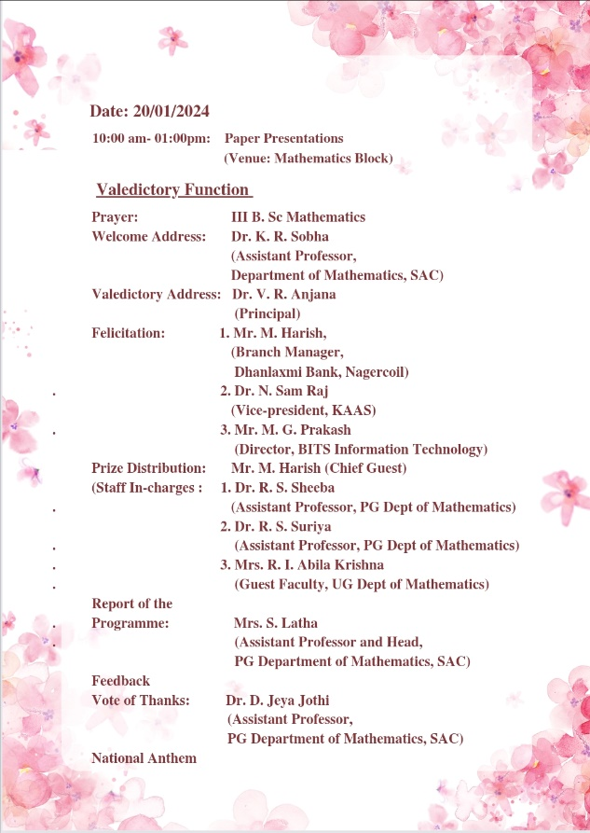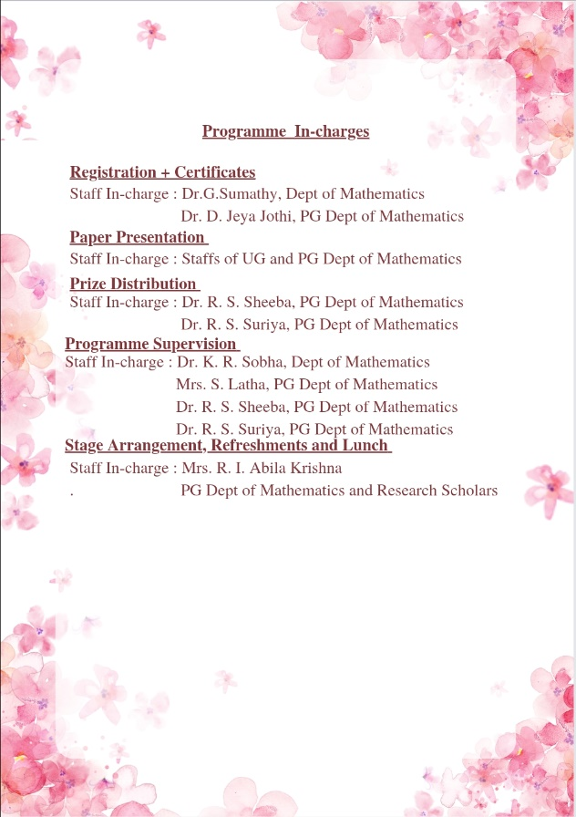

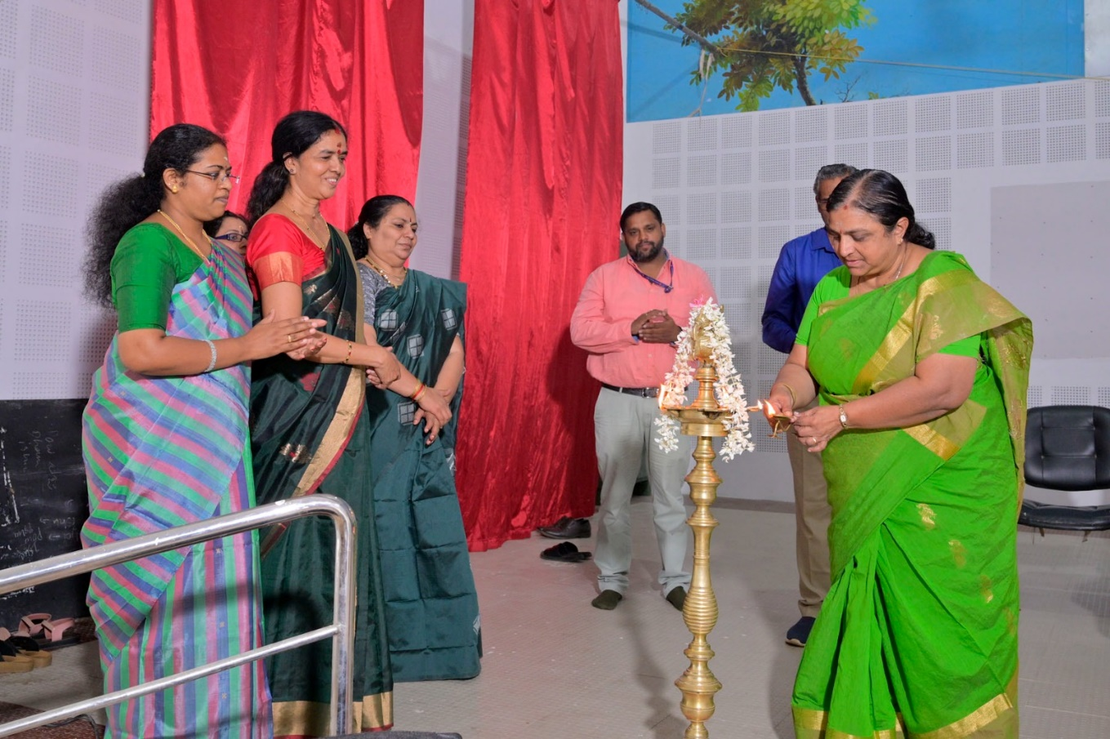
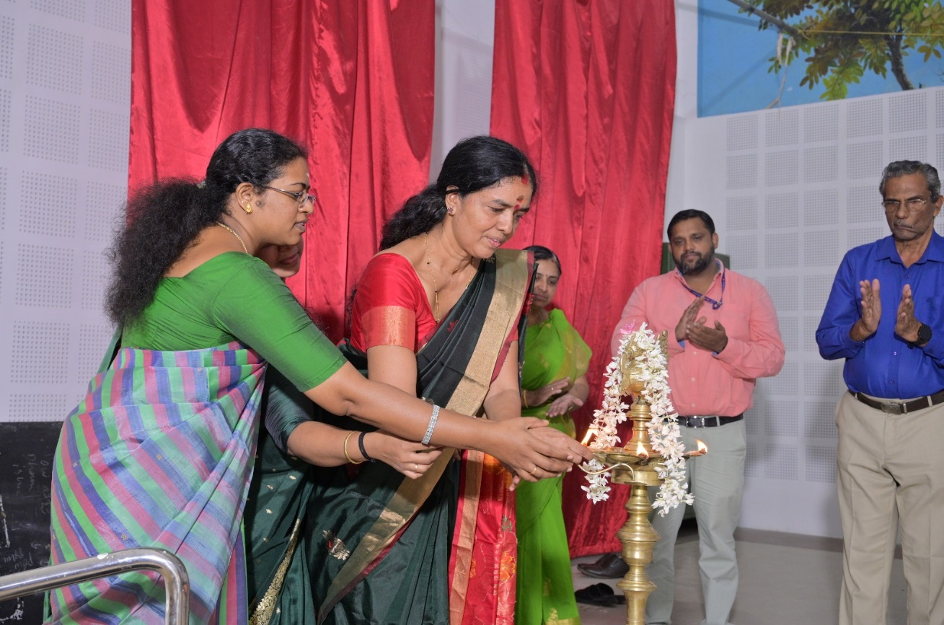
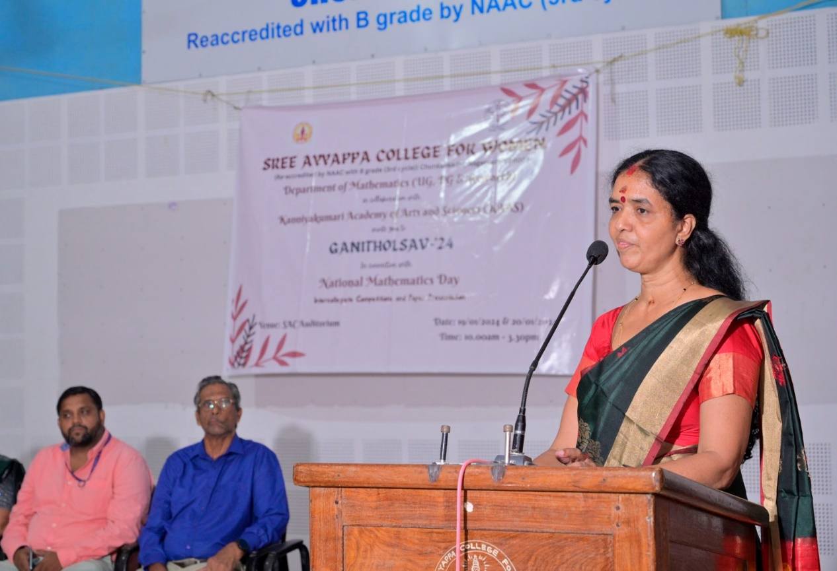
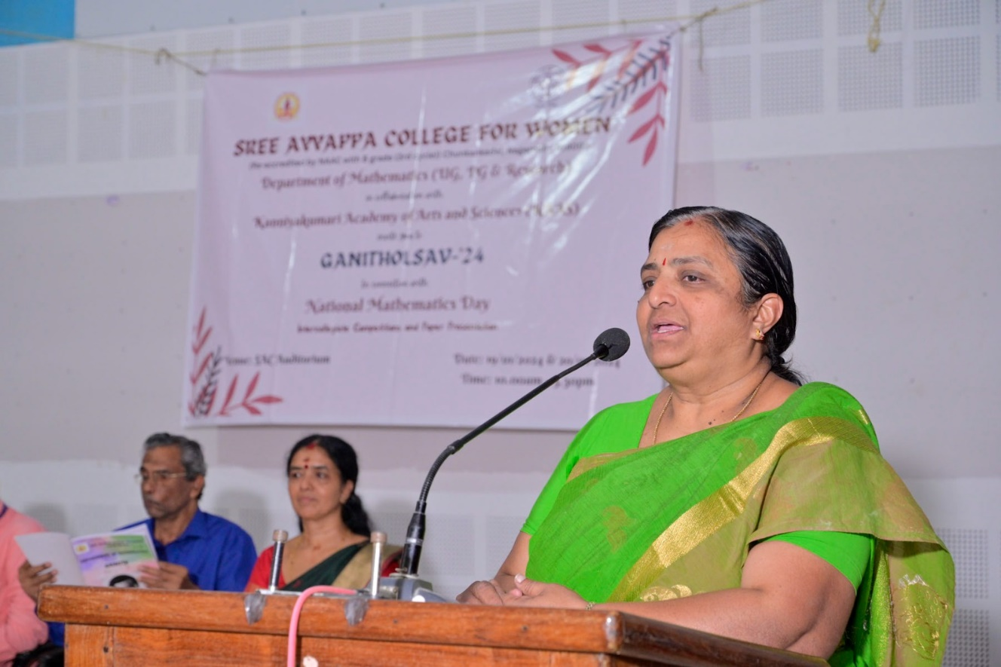
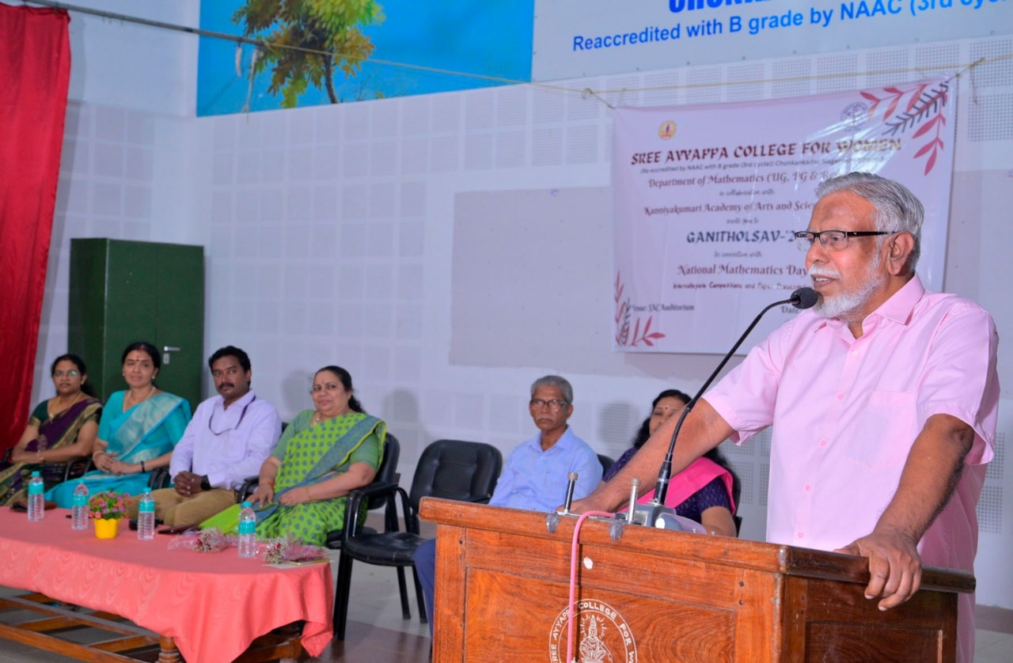
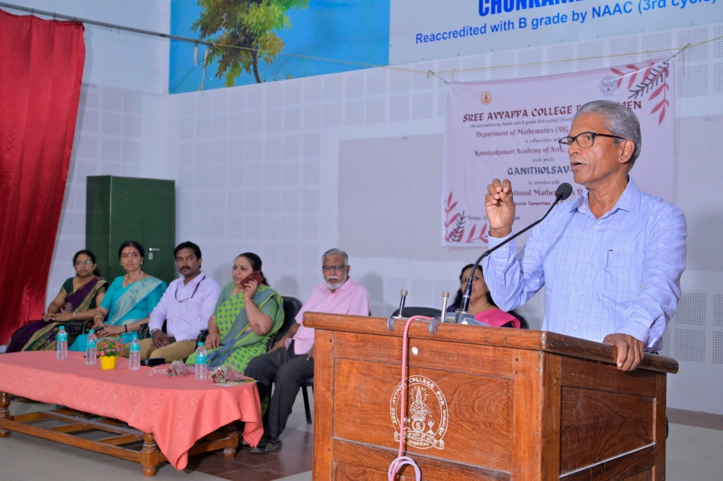
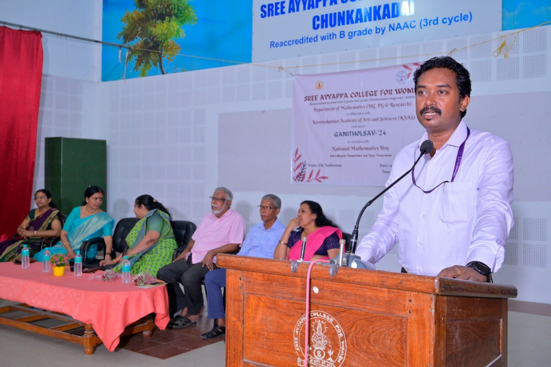
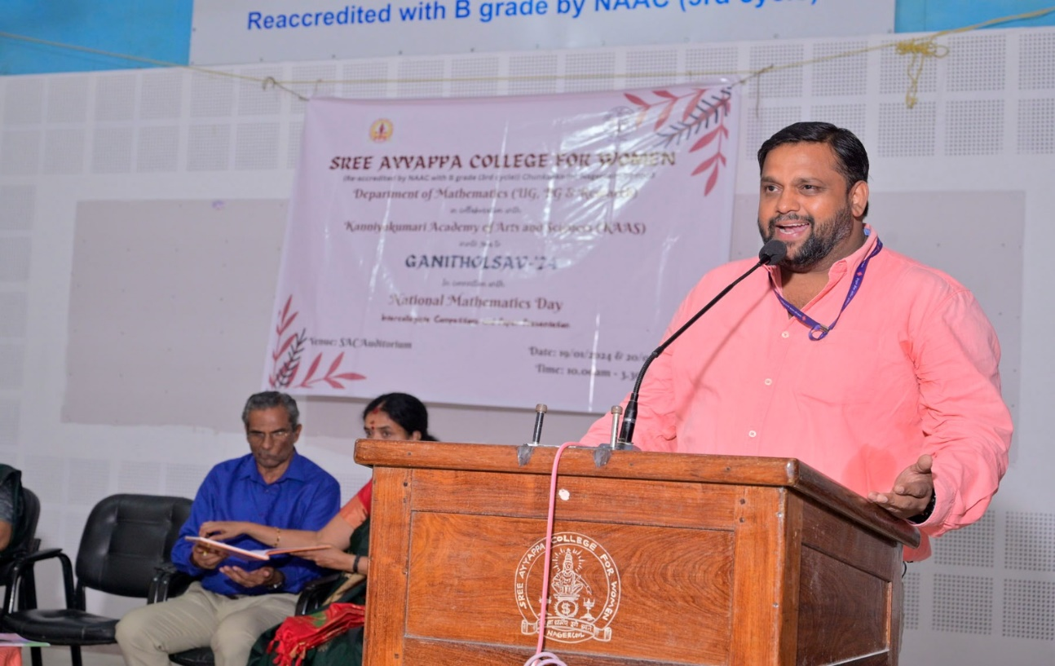
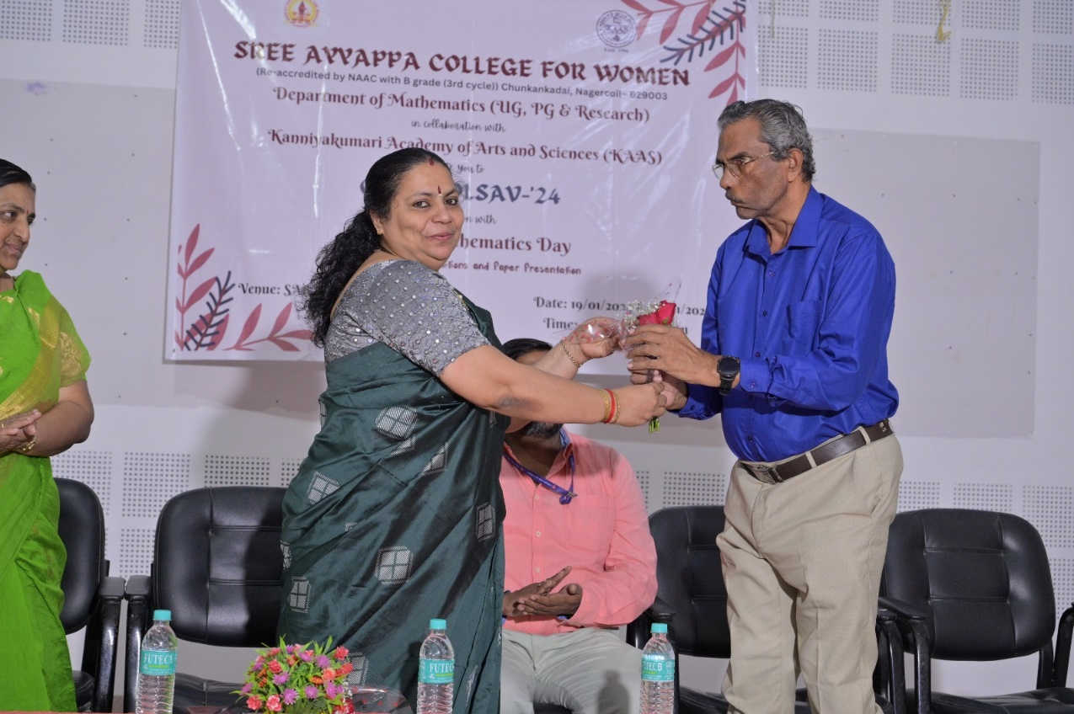
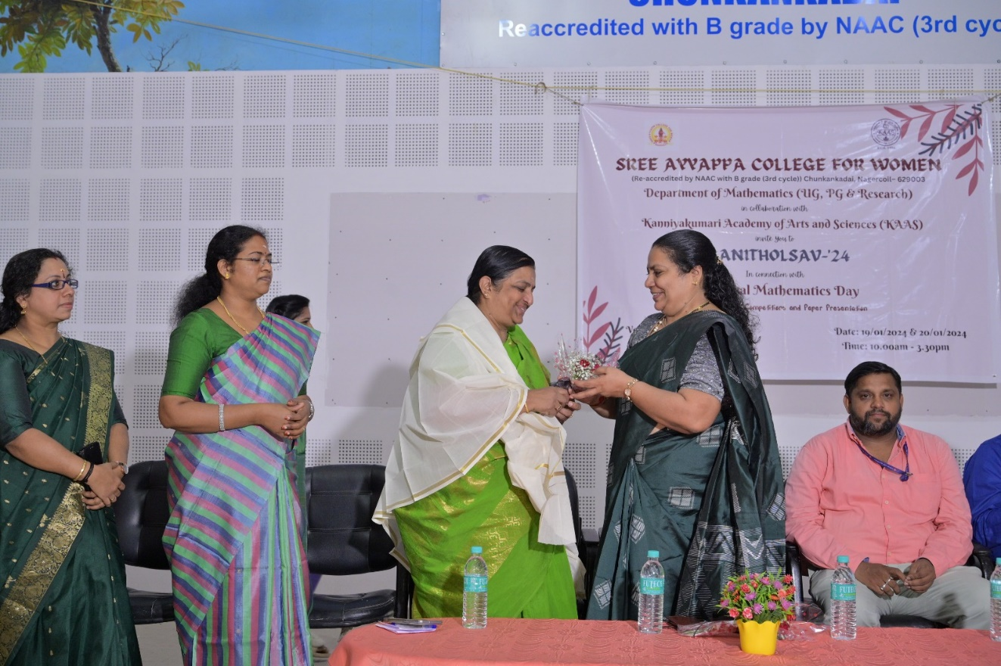
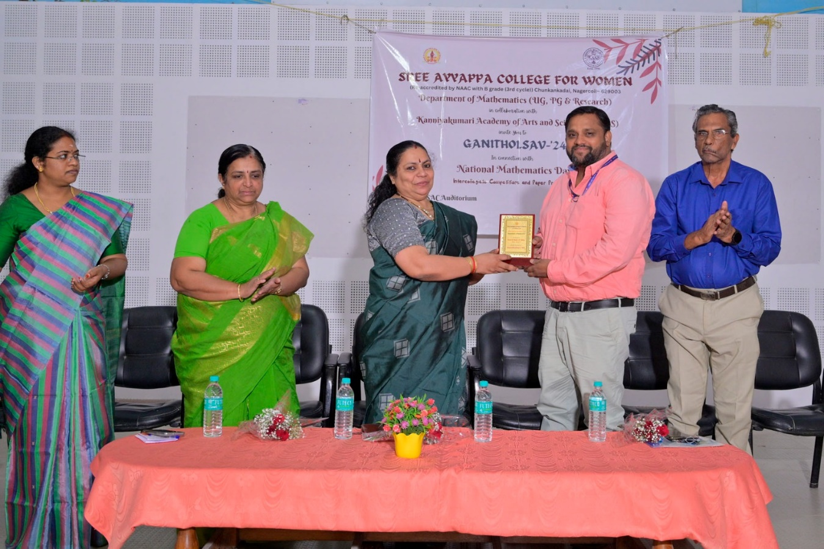
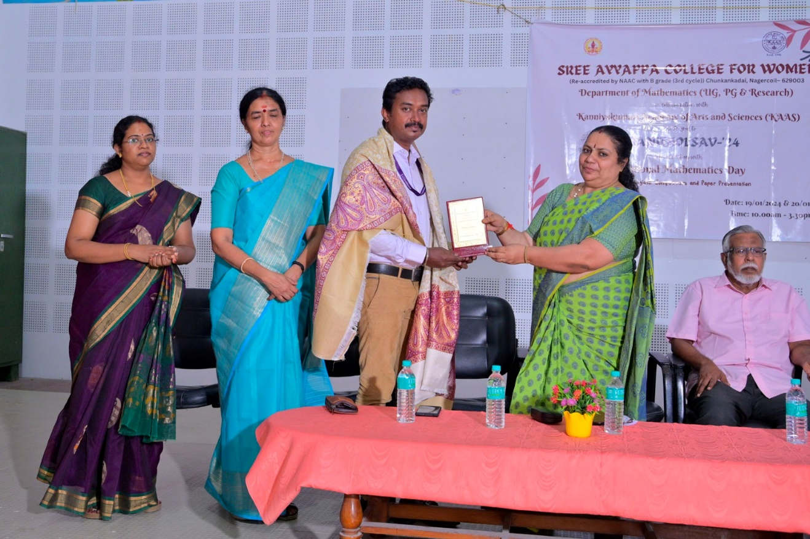
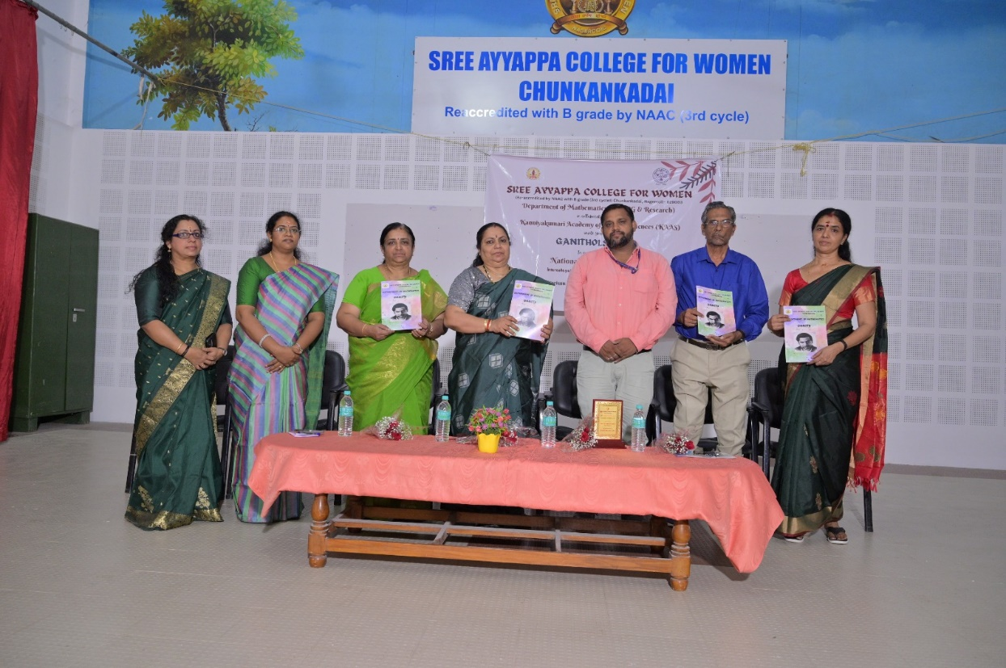
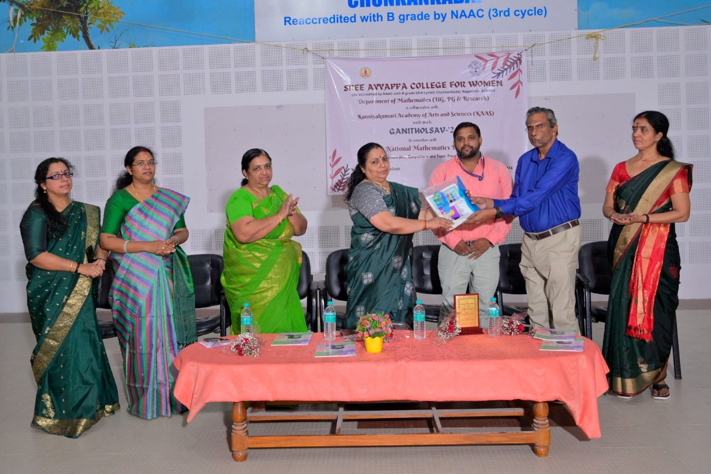
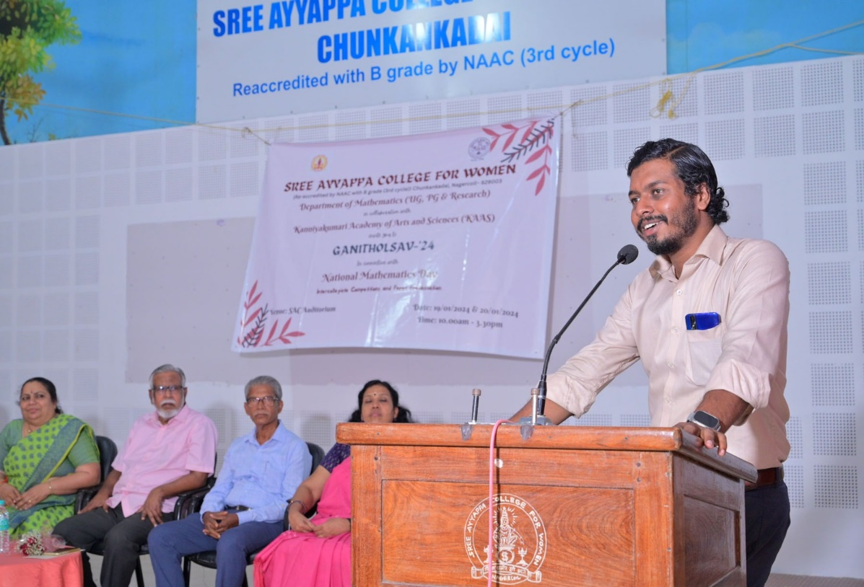
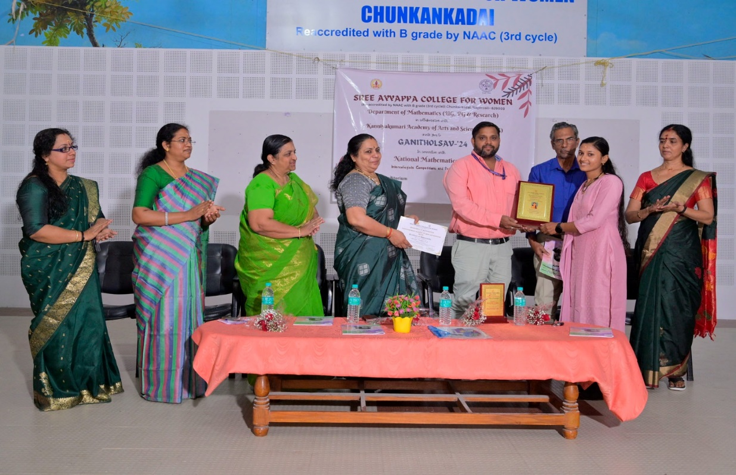

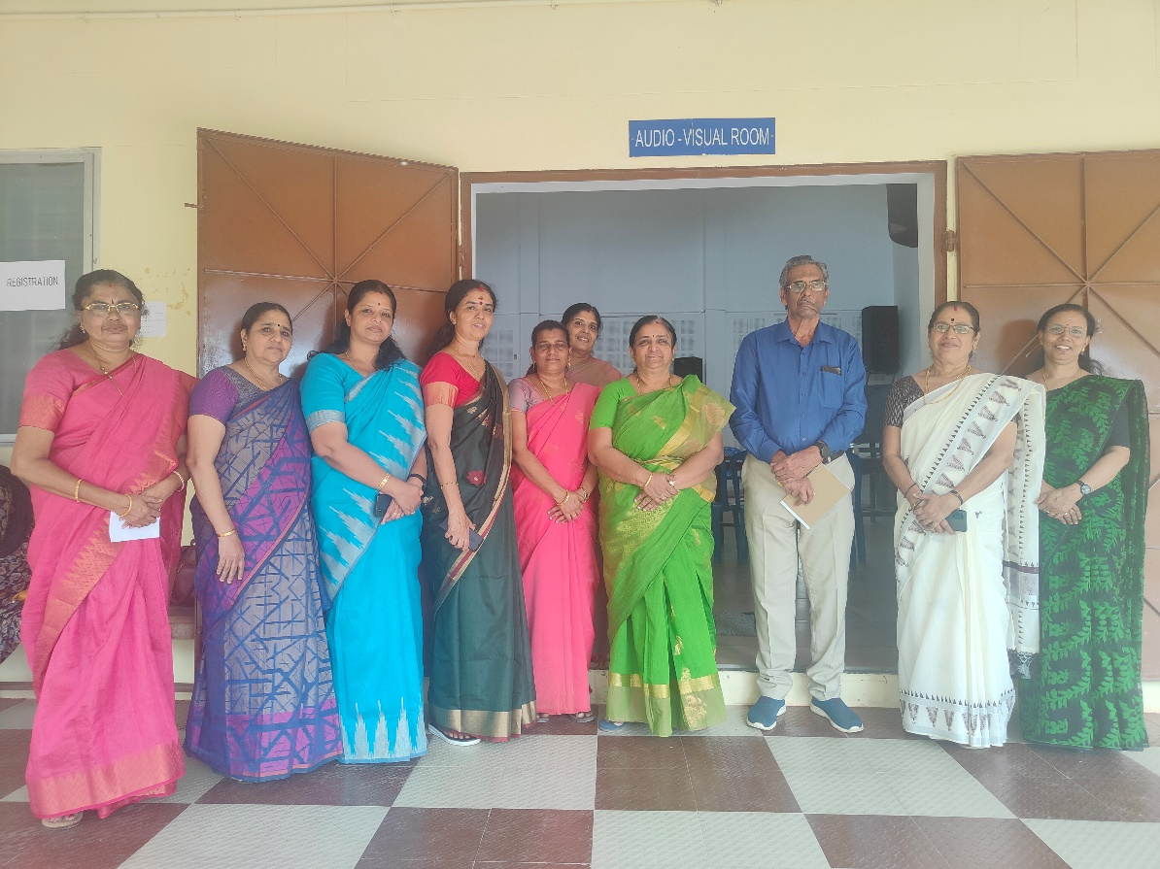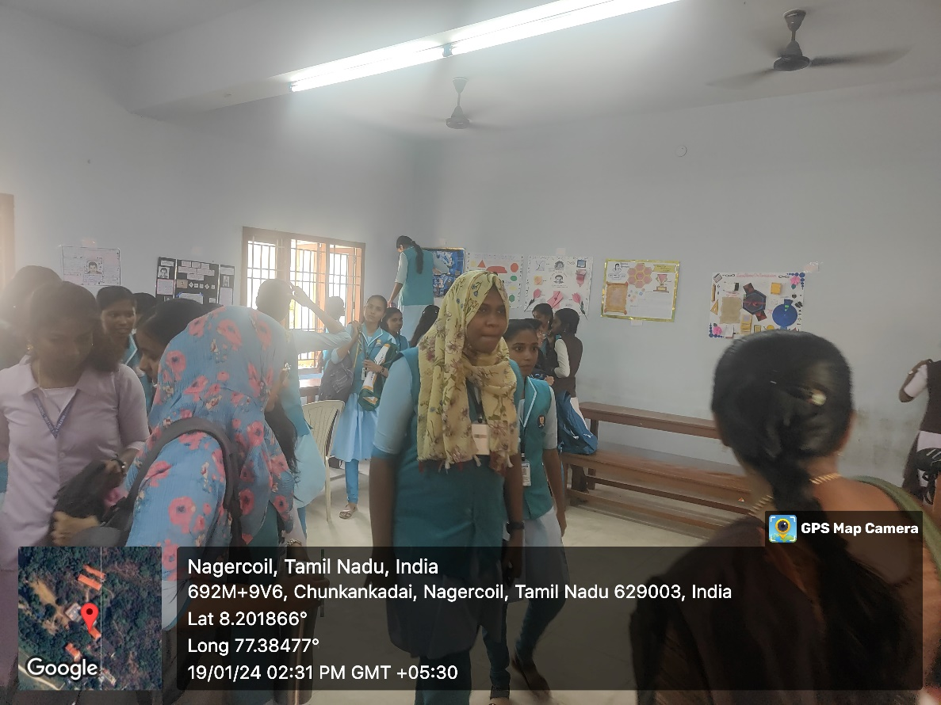Poster Presentation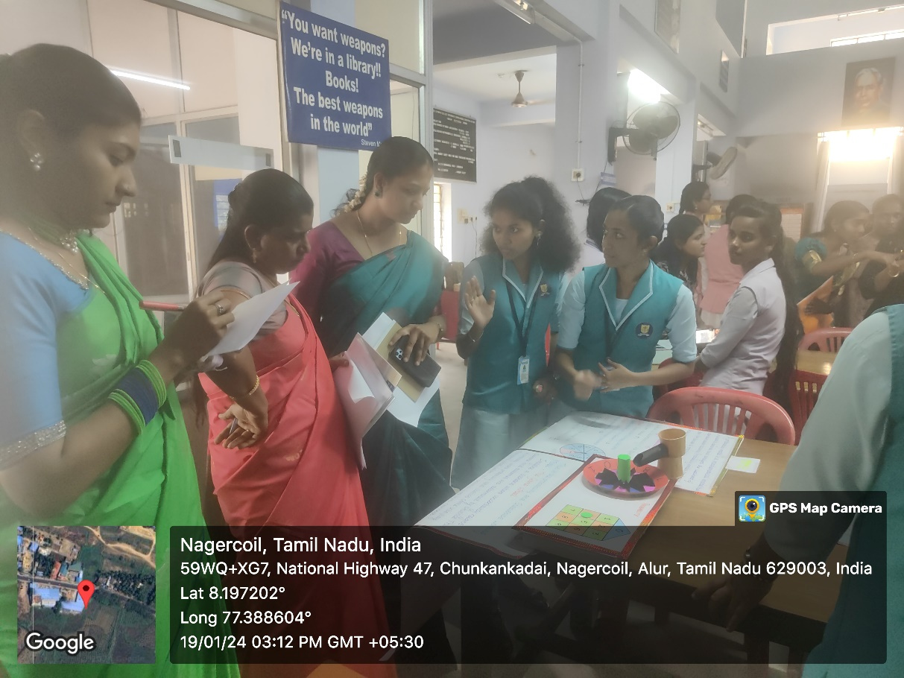 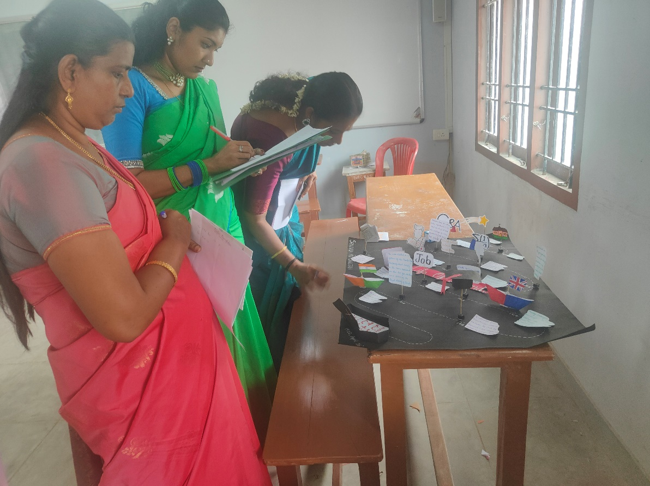Mathematical Modelling
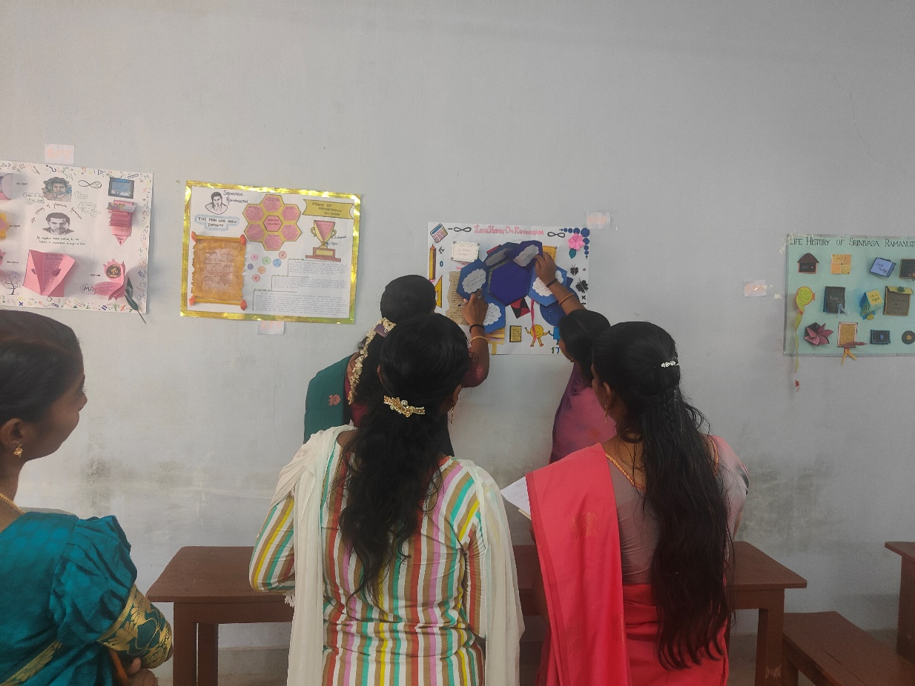Poster Presentation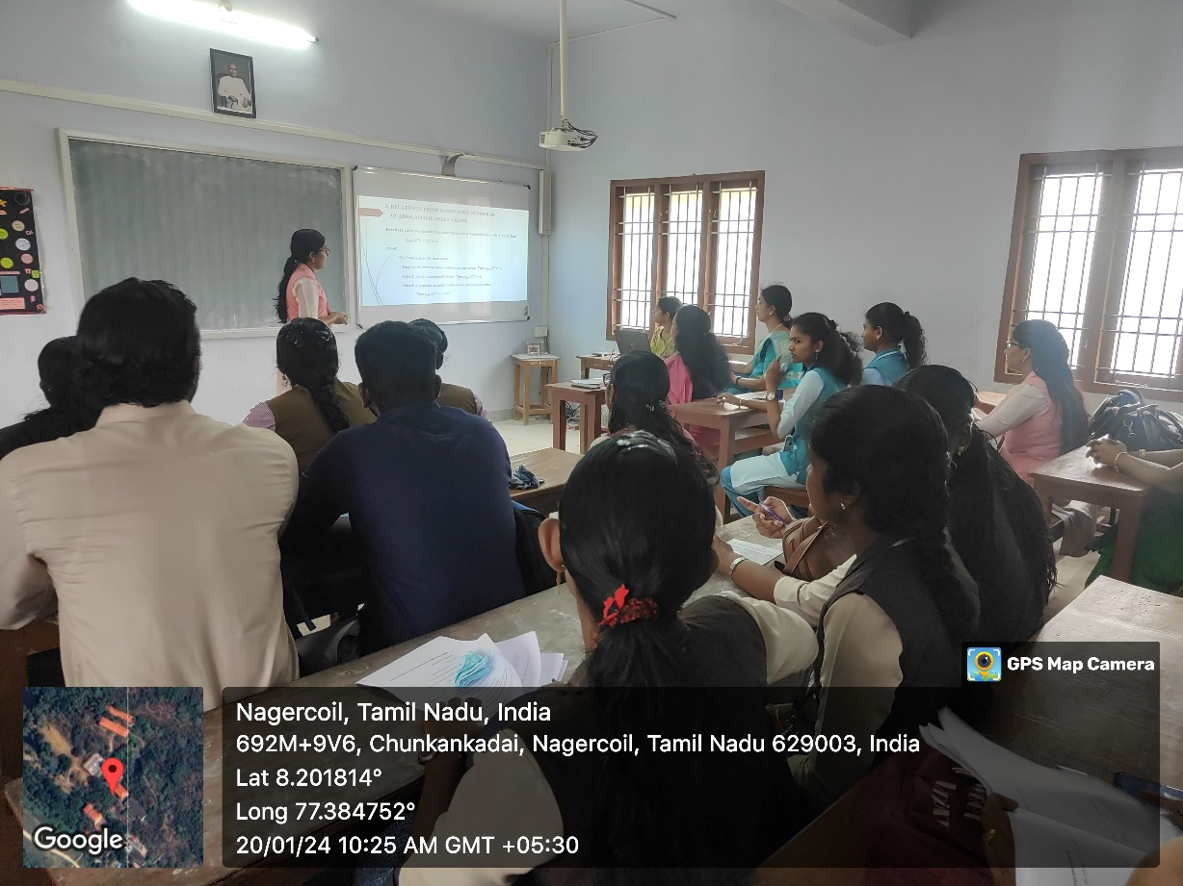Paper Presentation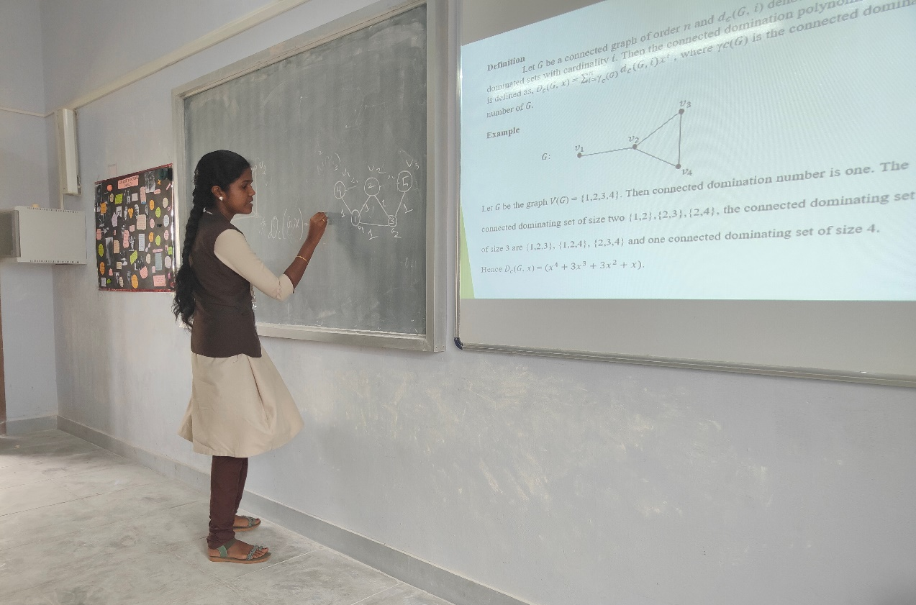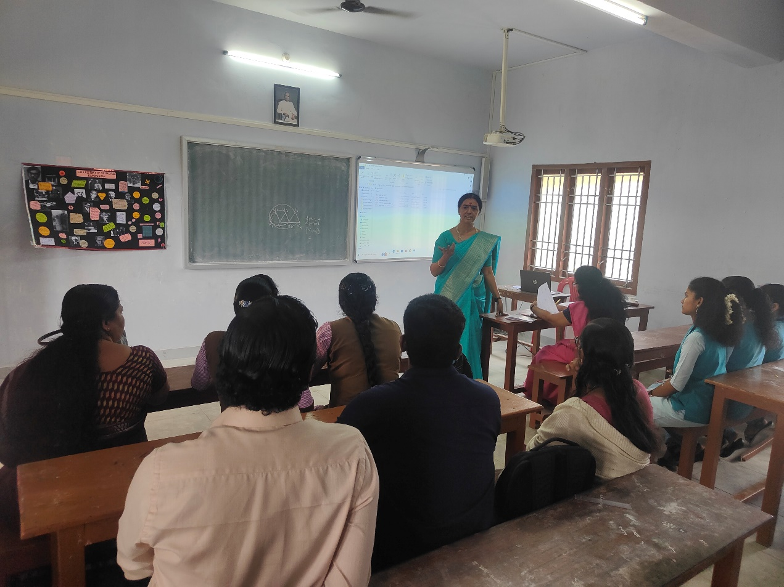Paper Presentations

