SREE AYYAPPA COLLEGE FOR WOMEN CHUNKANKADAI, NAGERCOIL-629003

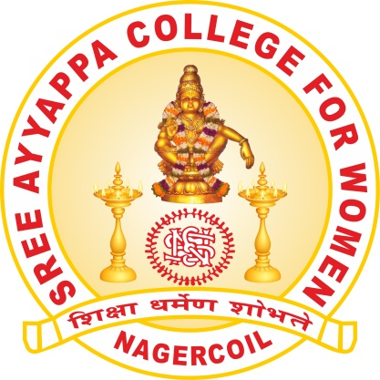

NAAC CRITERIA- V (5.1.3)

CAPACITY BUILDING AND SKILL ENHANCEMENT INITIATIVES

SEMINAR ON YOGA IN CONNECTION WITH YOGA DAY CELEBRATIONS
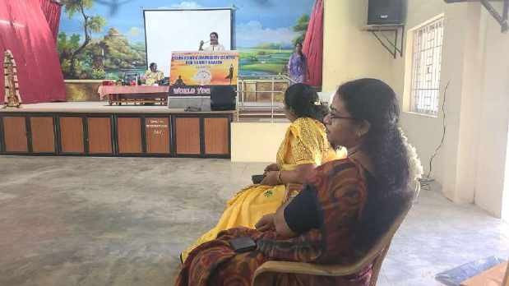
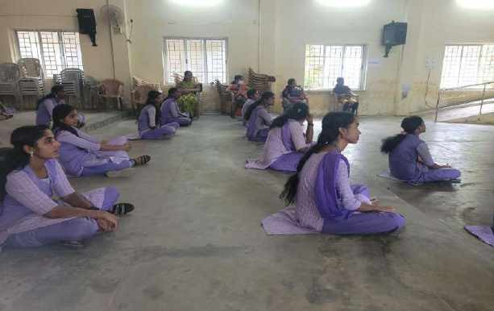
Department of Zoology organised a seminar on 27-6-2022 as a part of on International Yoga Day which is celebrated all over the world.The Resource persons were Dr.Swarnalatha Raju ,Vice chairman ,Suraksha Committes and Dr.Geetha,Member,Suraksha committe .In connection with International Yoga Day celebration our students participated and performed sitting and standing asanas .Yoga has earned the respect of being a discipline that has been passed down for generations and has proved to be beneficial to those who practice it on daily basis.The resource persons encouraged the students to practice regular yoga to remain fit and improve concentration.

.WORKSHOP ON ICT TECHNOLOGY
A one day workshop on ICT Technology and computer applications was organised for III B.Sc Zoology on 12-3-2023.Ms .Arathy explained the students about the computer applications and the students were made to undergo practical sessions.The session proved very useful for the students who participated in the workshop.
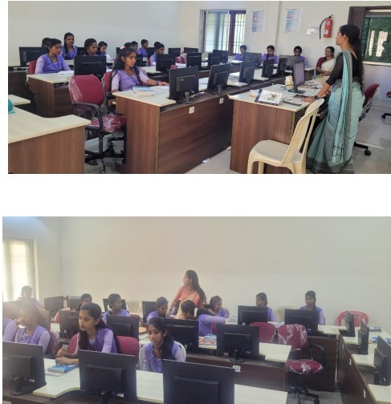
AWARENESS PROGRAMME ON NATIONAL NUTRITIONAL MONTH
On celebrating National nutritional month of 2022 on September 13, an awareness programme was organized by NSS Unit No 97 of Sree Ayyappa College for Women in the Government Primary School of Villukuri A. Our volunteers have prepared charts that explains the importance of nutritional diet. They gave the students some knowledge about the national nutritional month and some of the government schemes related to it

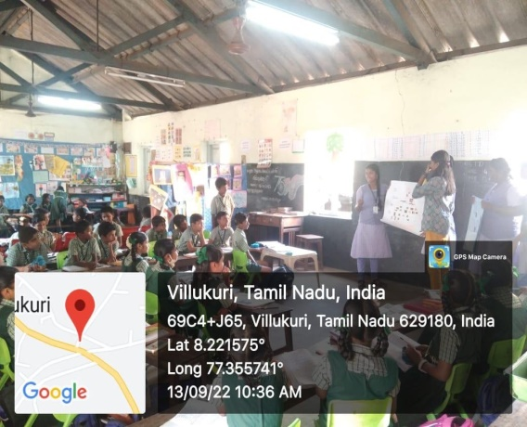
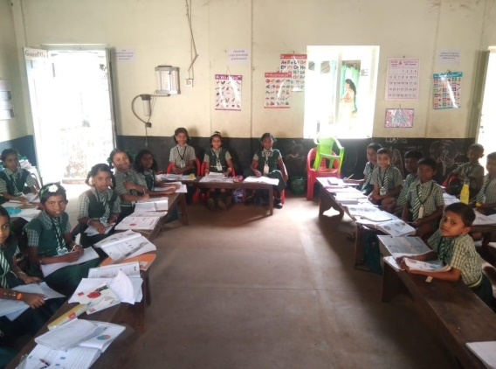

BREAST CANCER AWARENESS PROGRAMME

“BREAST CANCER AWARENESS PROGRAMME -CLOSE THE GAPS IN
CANCER CARE” was organized by National Service Scheme Units 97 and 162 of
Sree Ayyappa College for Women on the theme ‘Lets unite to make the world aware to close the gap in cancer care’. The session started with a prayer song . Respected Principal Dr K V Jayashree gave the presidential address .The resource person Dr. K I Jayakumar, Professor and Senior Consultant Oncologist, Sree Mookambika Medical College,Kulasekharam has created awareness on breast cancer, its causes and preventive measures. He demonstrated how to carry out Self Breast Examination (SBE) and advised the girl students and faculties on the measures to be taken to protect themselves from the dreadful disease .the program was well received by all and was very useful. About 150 volunteers took part in this programme. The session was concluded with the vote of thanks proposed by Ms Vasavi from 2nd BA History.

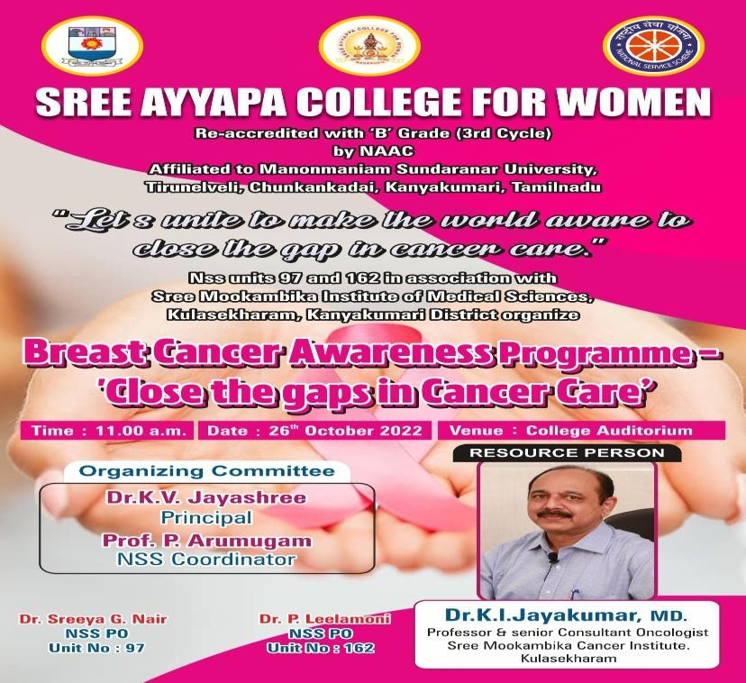

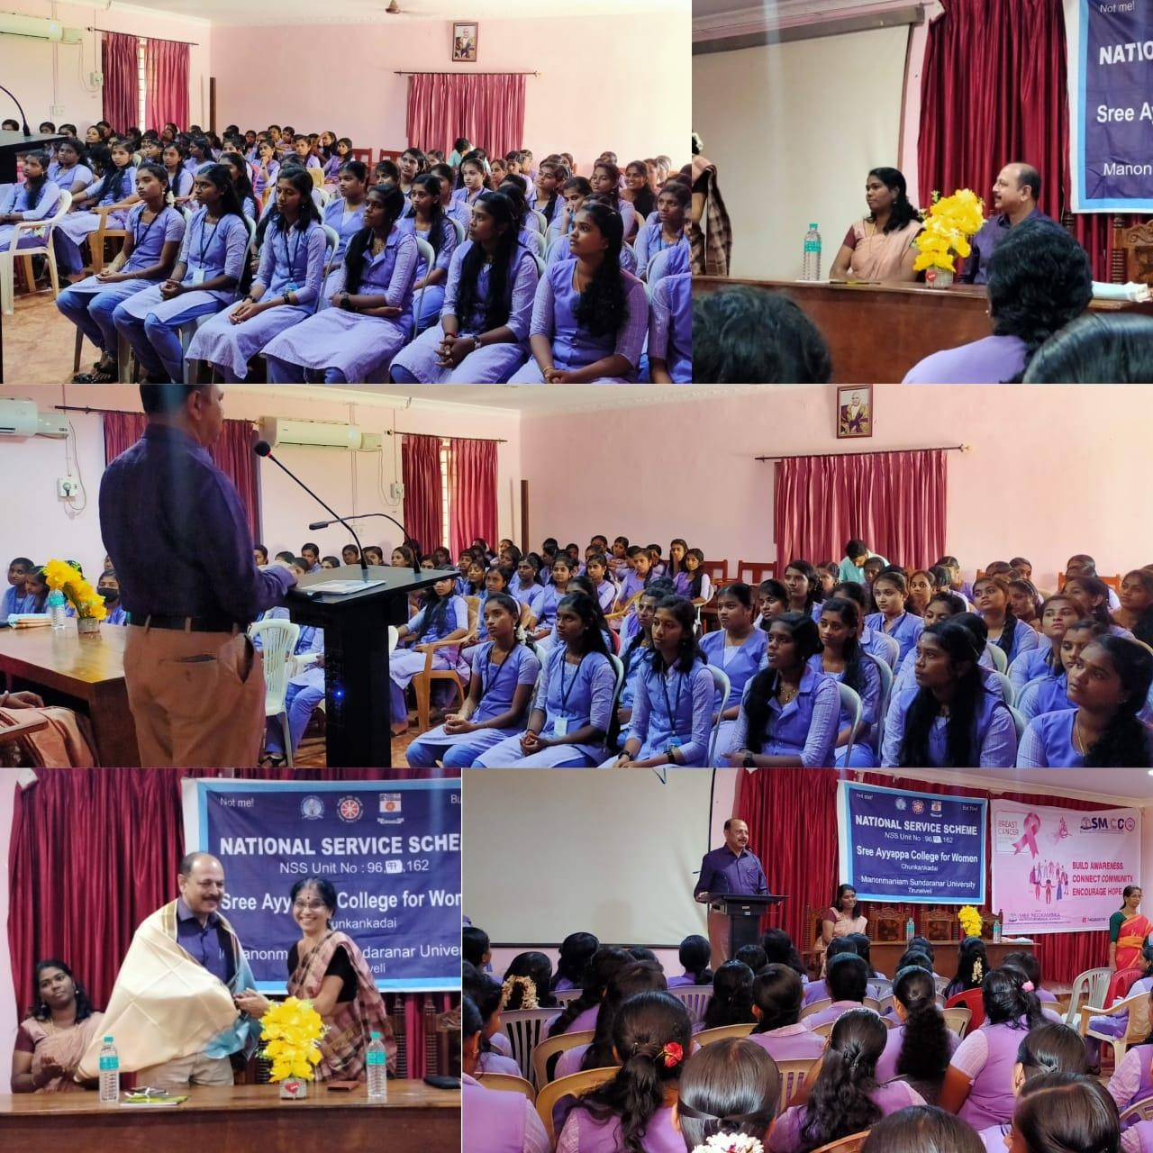

NATIONAL WEBINAR ON WORLD AIDS DAY
NSS Unit No 97 and Red Ribbon Club of Sree Ayyappa College for Women organized a webinar on "Equalize - a call to action to aid in the eradication of AIDS" on 5th December 2022 from 10.30 am to 1130 a.m. In view of the ongoing Semester Examinations, the Programme could be organized only on virtual mode. A total number of 75 NSS volunteers from Unit No.97 and a few Faculty Members of our esteemed institution and other institutions actively participated in the Programme. Prof.Dr. A.Veliappan, Programme Coordinator, RRC/NSS of Manonmaniam Sundaranar University in his address highlighted the fact that NSS and RRC are the major student forces which has the potentials to transform the society for ensuring a better and more peaceful co-existence. He lauded the efforts of the NSS volunteers of Unit No.97 in promoting environment enrichment activities and health awareness Programmes. Dr.J.Nivil Simon MBBS, Assistant Professor of Sree Mookambika Institute of Medical Sciences, Kulasekharam has clearly explained the current situation of HIV/AIDS and also dispelled myths and misconceptions. The participants were richly benefited through the same.cannot spread HIV, sharing clothes as well cannot spread HIV etc.

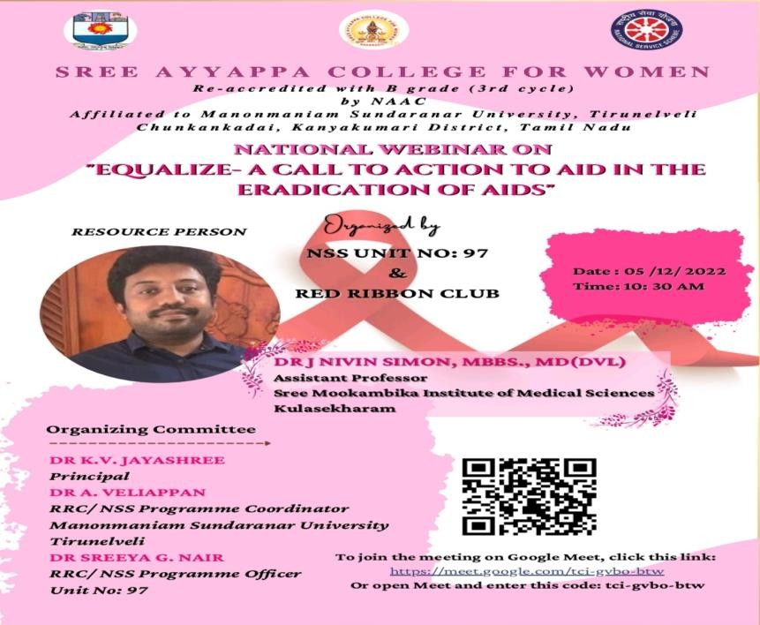
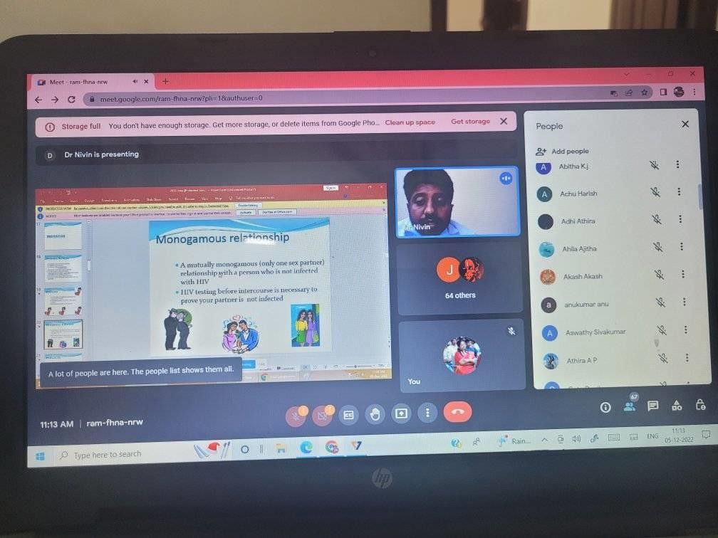

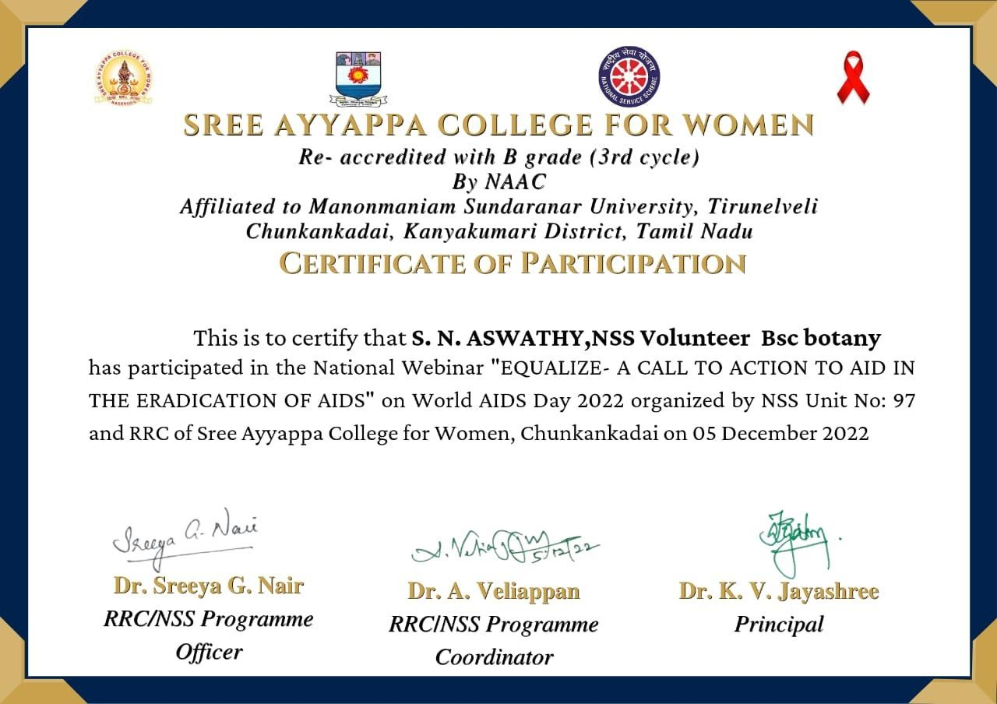

SEMINAR ON DRUG ABUSE
A Seminar on THE EVIL IMPACT OF DRUG ABUSE ON THE LIVES OF
YOUNG PEPOLE IN INDIA was organized by the National Service Scheme Unit No 97 and Anti Drug Club on January 18 2023. Dr .R Radha ,Assistant Professor of Zoology handled the session effectively. She spread awareness among the volunteers about what are the drugs thats getting abused , who abuses drugs , what causes people to abuse drug ,how do drug abusers actions affect themselves,their families,and their communities and concluded with the tratment and resources that are available to drug abusers with a clear Power Point Presentation. The session was very informative. Ms Santhiya and Ms Remi have formally welcomed the gathering and proposed the vote of thanks respectively.150 volunteers were benifitted.

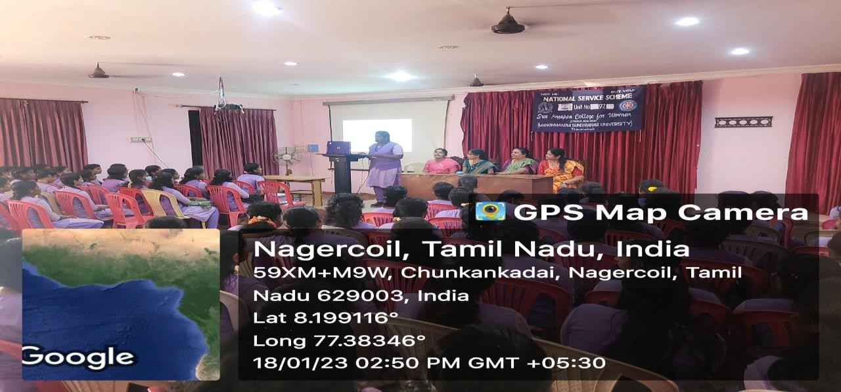

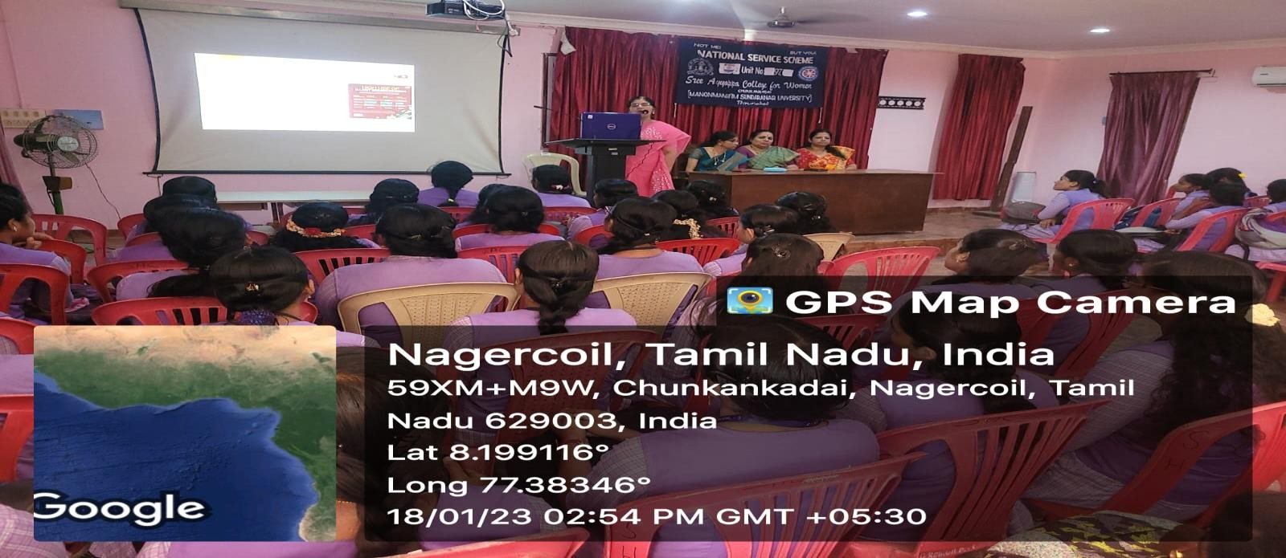

ONE DAY PREVENTIVE HEALTH CARE CAMP
Everyone needs to stay healthy, particularly women who are prone to many peculiar and frequently attacking ailments. Young Women irrespective of the fact that they have access to updated information on health issues and how to prevent the same choose to remain ignorant. Keeping this critical point in view, the NSS Units 96, 97 and 162 of Sree Ayyappa College for Women, Chunkankadai, Kanyakumari District in collaboration with Sree Mookambika Institute of Medical Sciences, Kulasekharam, Kanyakumari District organised One Day Preventive Health Care Camp in the College Seminar Hall on 10th February 2023.A total No. Of 300 Students and NSS volunteers attended the camp. Dr. M.Venkatesh and Dr.R. Aalathi supervised the entire diagnostic procedures. It was alarming to note that more than 60% of them were found to be anaemic due to intake of non-nutritious food. Similarly students who required further check-ups and medical attention were given proper advice by the medical team.

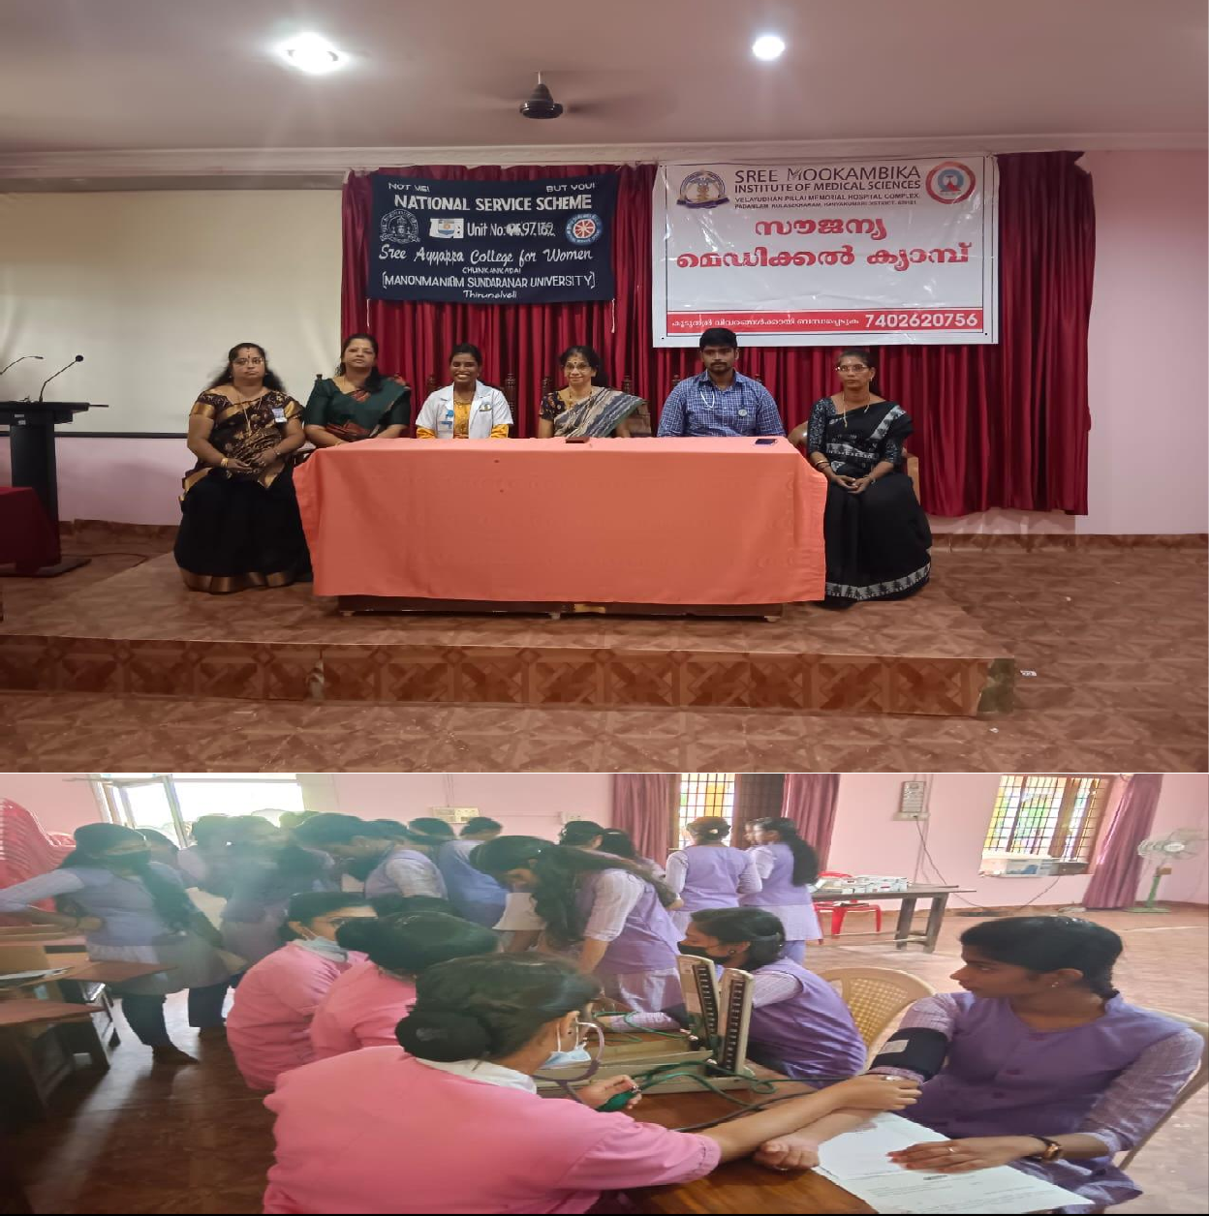

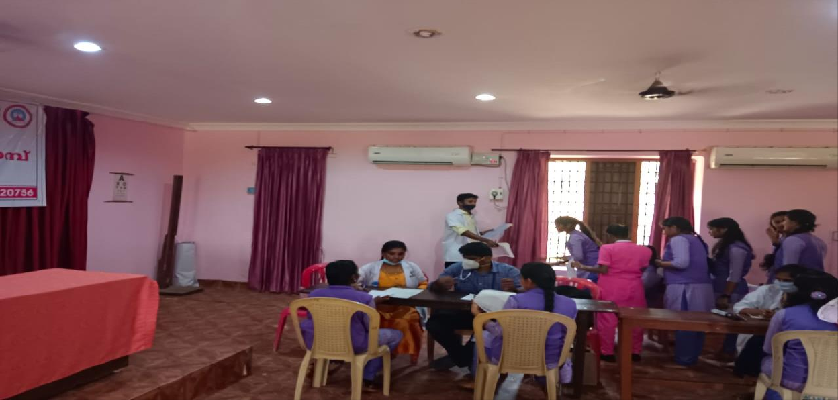

BLOOD DONATION CAMP
The NSS Units 96, 97, 162 and Red Ribbon Club of Sree Ayyappa College for Women, Chunkankadai in collaboration with Sree Mookambika Institute of Medical Sciences, Kulasekharam, Kanyakumari District organized a Blood Donation Camp on 20th February 2023 at 10.00am in Seminar Hall. Dr.Sithara,MD,Associate Professor of the Hospital in her Special Address highlighted that one unit of Blood can save a precious life. She also advised that more students should come forward to donate blood frequently as there has been an increased demand for Blood in Kanyakumari District as patients from adjoining State of Kerala also come to the Hospital for specialized medical treatment. 50 units of blood were donated.

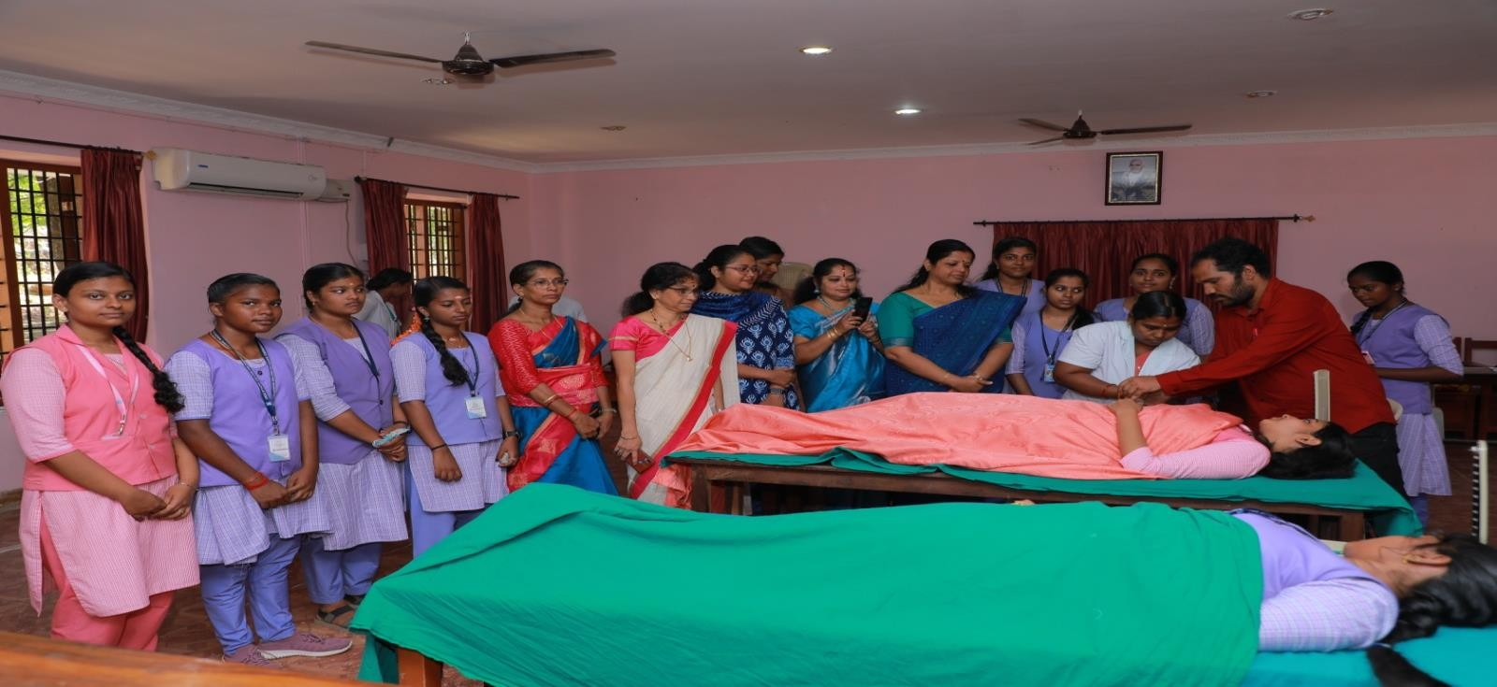

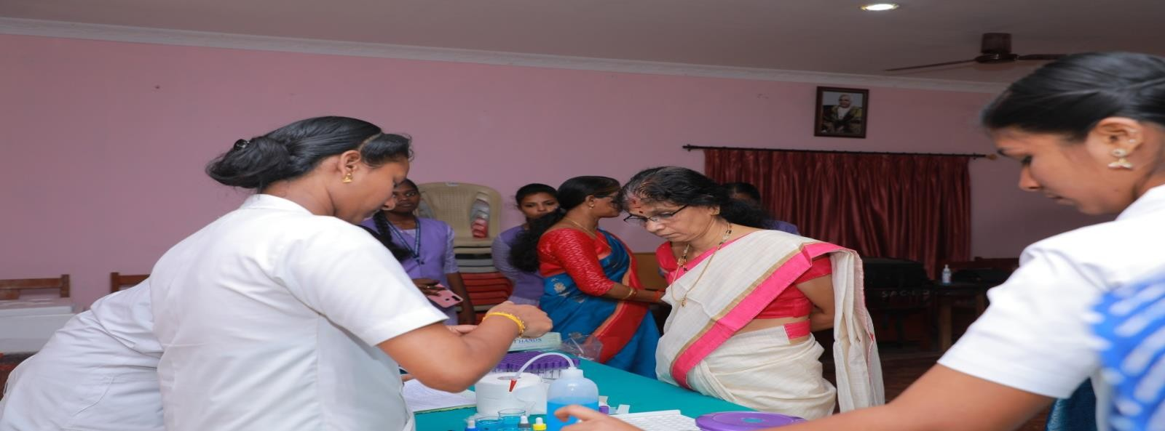

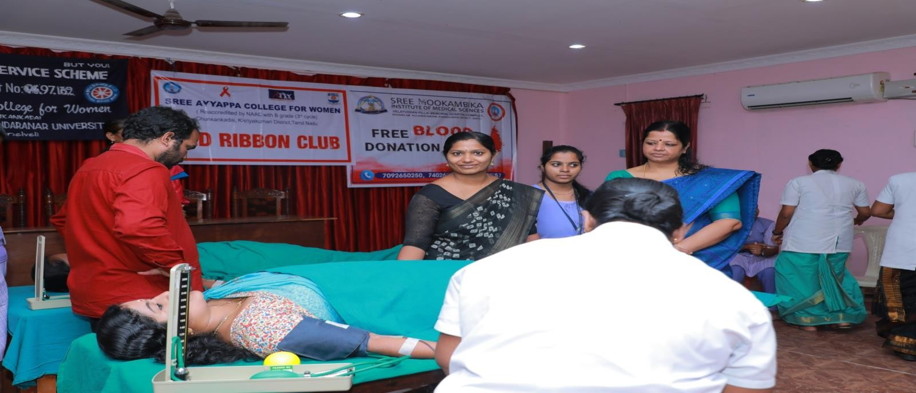
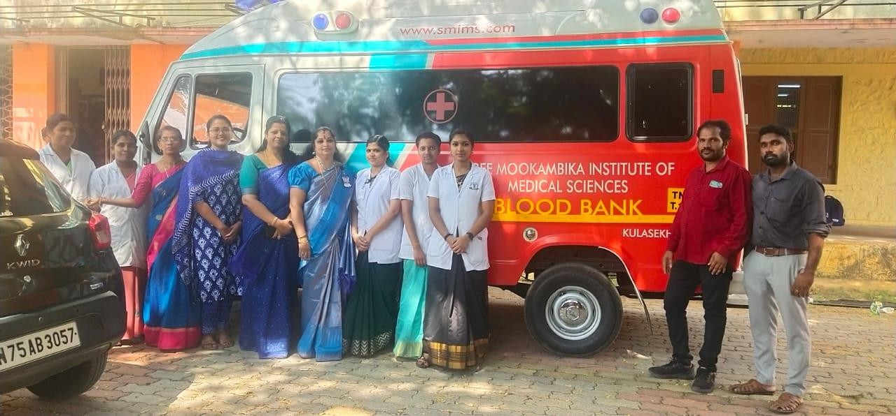

AWARENESS CAMPAIGN ON DRUG AND ALCOHOL DEPENDENCE
The NSS Units of Sree Ayyappa College for Women, Chunkankadai has been organising various programmes aimed at raising the awareness levels of both NSS volunteers and general students on Drug Abuse. As a part of the drive against Drug/Substance Abuse, an Awareness Campaign on Drug and Alcohol Dependence was organized on 23rd February 2023 in the college in collaboration with Anti-Drug

Club. Adv.Jerush delivered a meaningful talk on how to stay away from Drugs and what would be its negative impact on the abusers. Dr.Anusha pointed out that of late, young girls are increasingly becoming drug addicts because of peer pressure which is dangerous for them, their family and society. The Principal Dr.K.V.Jayashree delivered the Special Address.As a part of the Awareness Campaign on Drug Abuse, saplings were also donated to NSS volunteers.300 students were benefitted.
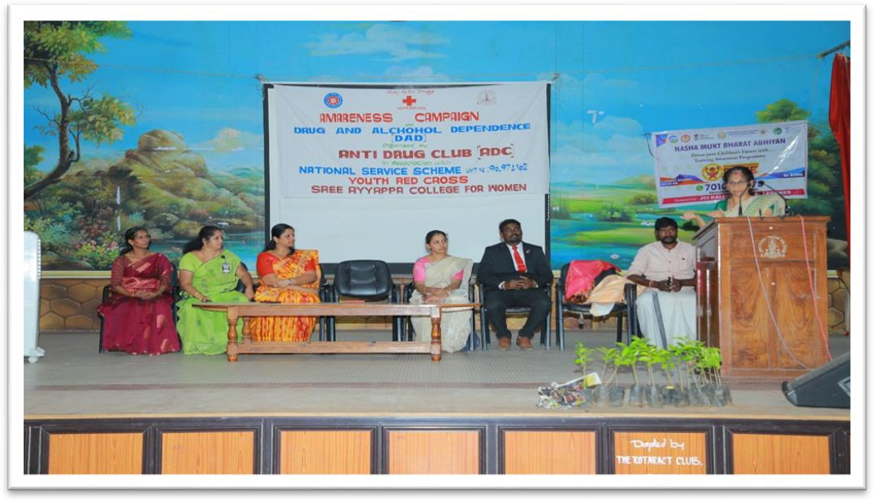

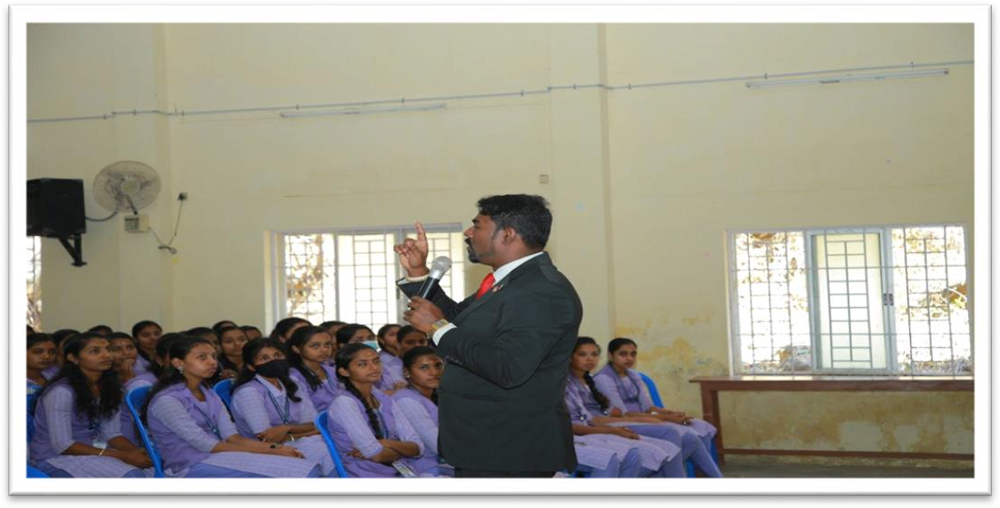

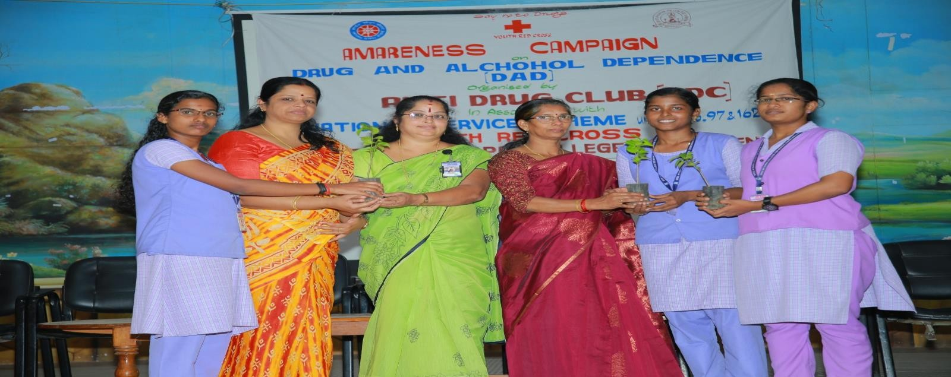

YOGA SESSION AT NSS SPECIAL CAMP –March 29,2023
A special yoga session was organized by NSS Units of Sree Ayyappa collge for Women on March 29,2023 as a part of NSS special camp-2023. Dr Akhila R B, Physical Education Directress, Sree Ayyappa College for Women, Chunkankadai was the resource person. The session began by seeking the blessings of the Almighty by chanting the Gayatri Mantra. Asanas starting with warming up and stretching were followed by a Padmasanas, Sukhasan, Tadasana, Bhujang Asana and ending with Shavasana. Exercises for relieving stress, reducing joint pain and enhancing the flexibility of the back were also done for the benefit of the volunteers. In the present day when students face stress, tension, fear, etc., simple ‘asanas’can help dispel these.
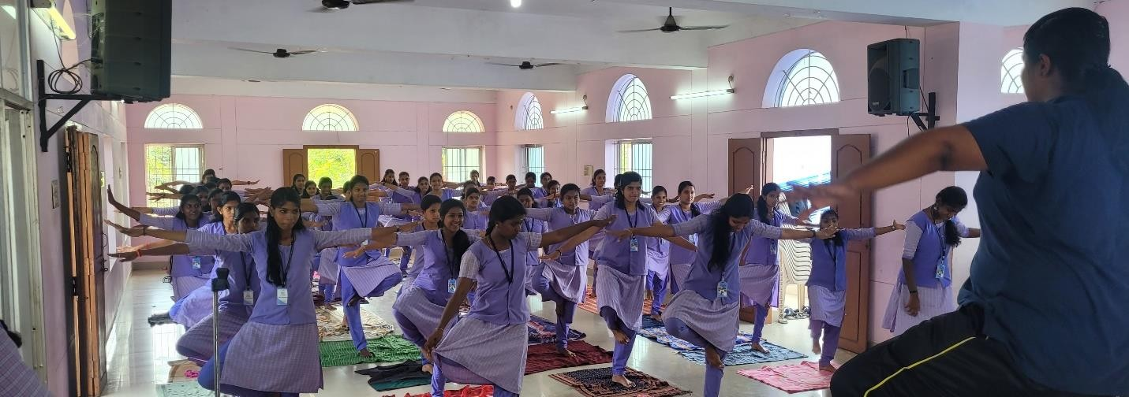

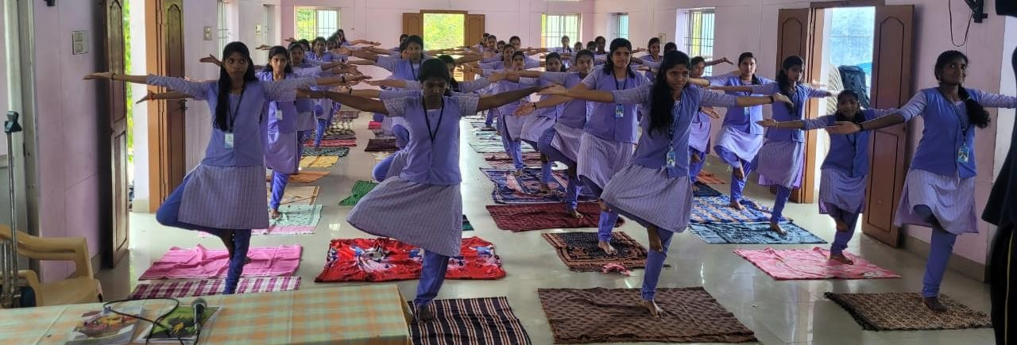
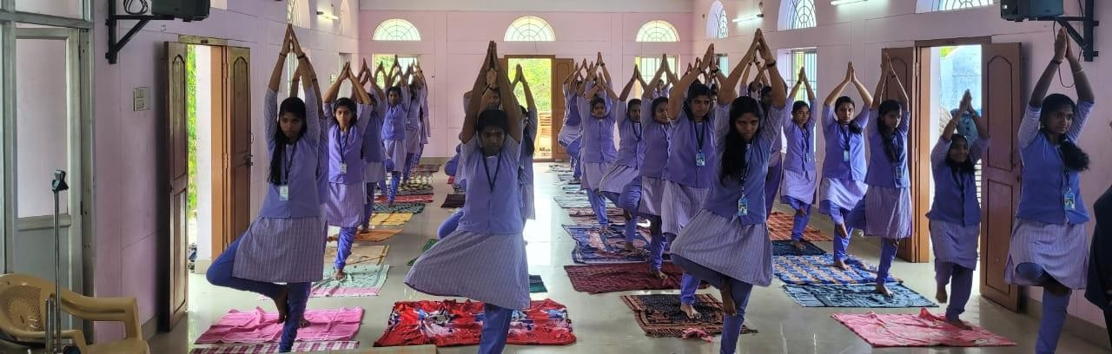
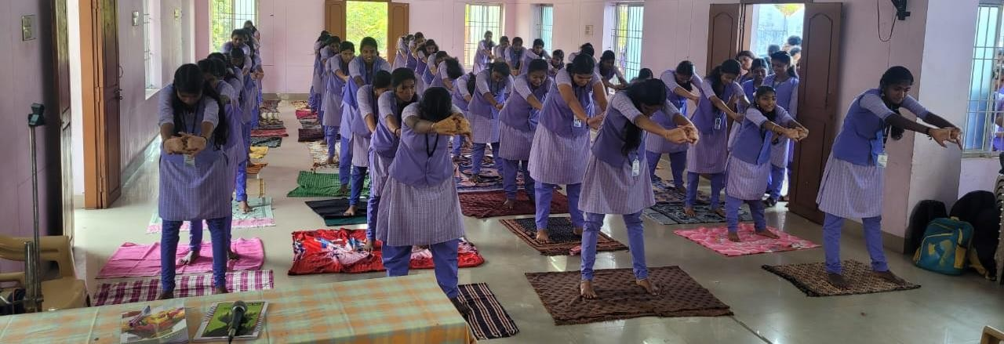
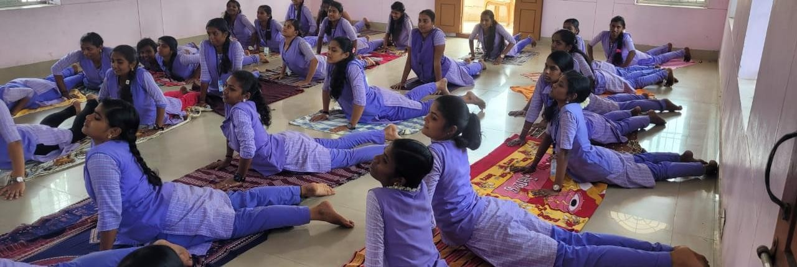

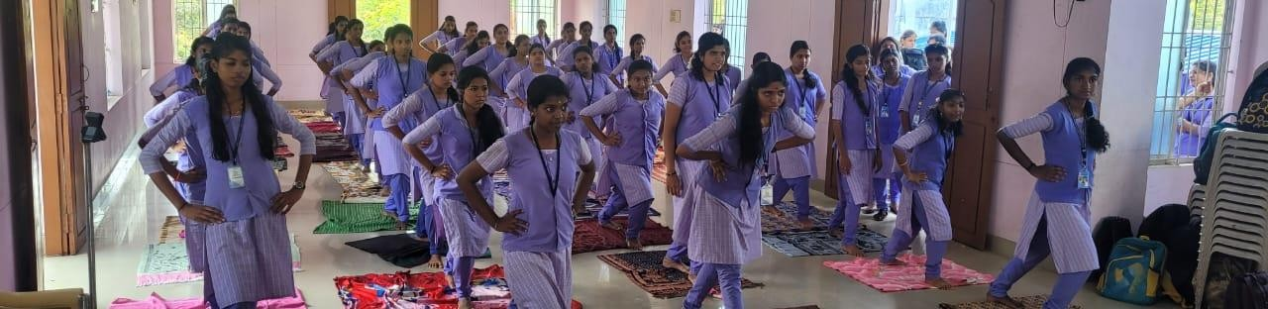

SESSION ON DRUG ABUSE AND PREVENTION –March 31,2023
A lecture on Drug abuse and Prevention handled by Dr V R Anjana, Head of Department of Zoology, Sree Ayyappa College for Women, Chunkankadai. Onmarch 31,2023 at NSS special camp. The session was so interactive. She had started the session with a quote on Bhaghavat Gita and spread awareness among the volunteers about the ill effects of drug abuse and the social problems caused by them. She adds some of the rehabilitation centers which provide good counseling for those who are abused by the drugs.
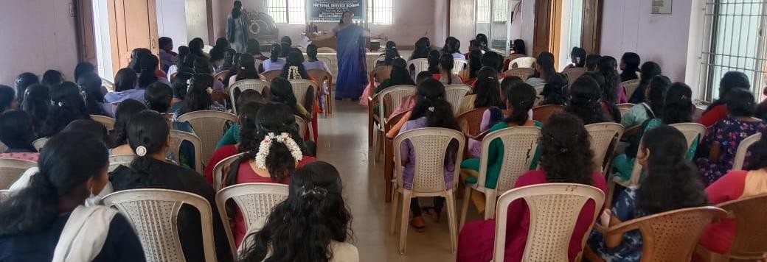
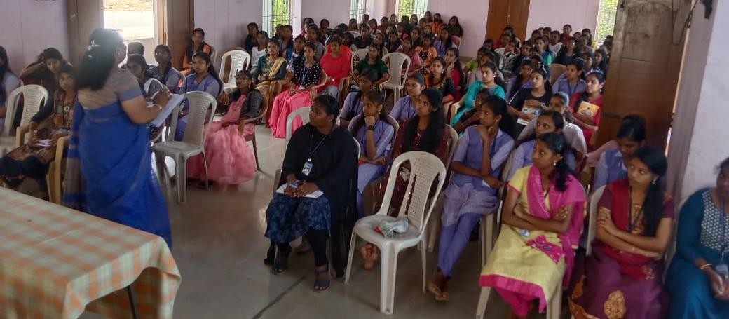

ONE DAY FREE MEDICAL CAMP

Tthe National Service Scheme Units 96, 97, 162 in hands with Sree Mookambika Institute of Medical Sciences, Kulasekaram organized a one day free medical camp for the benefit of public in our adopted villages Villukuri A, B and C. The medical team arrived the location at 11 am, Many villagers participated in the camp and thanked our volunteers for their wide publicity about the medical camp. A total number of 90 people were treated as outpatients. Out of this , the following 35 cases were referred to specialists.

- GM – 9
- GS – 4
- ENT – 2
- DVL- 2
- Cataract -6
- Ortho- 5
- Pediatrics- 1
- Cardio- 6
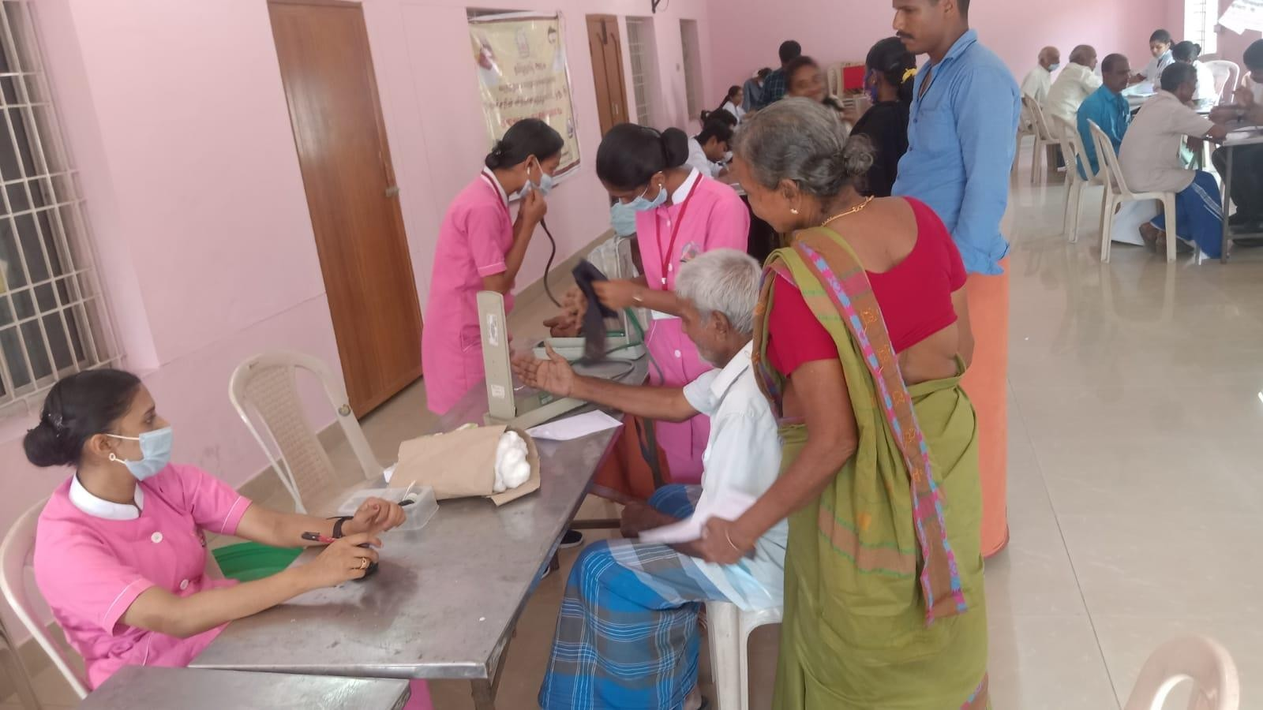

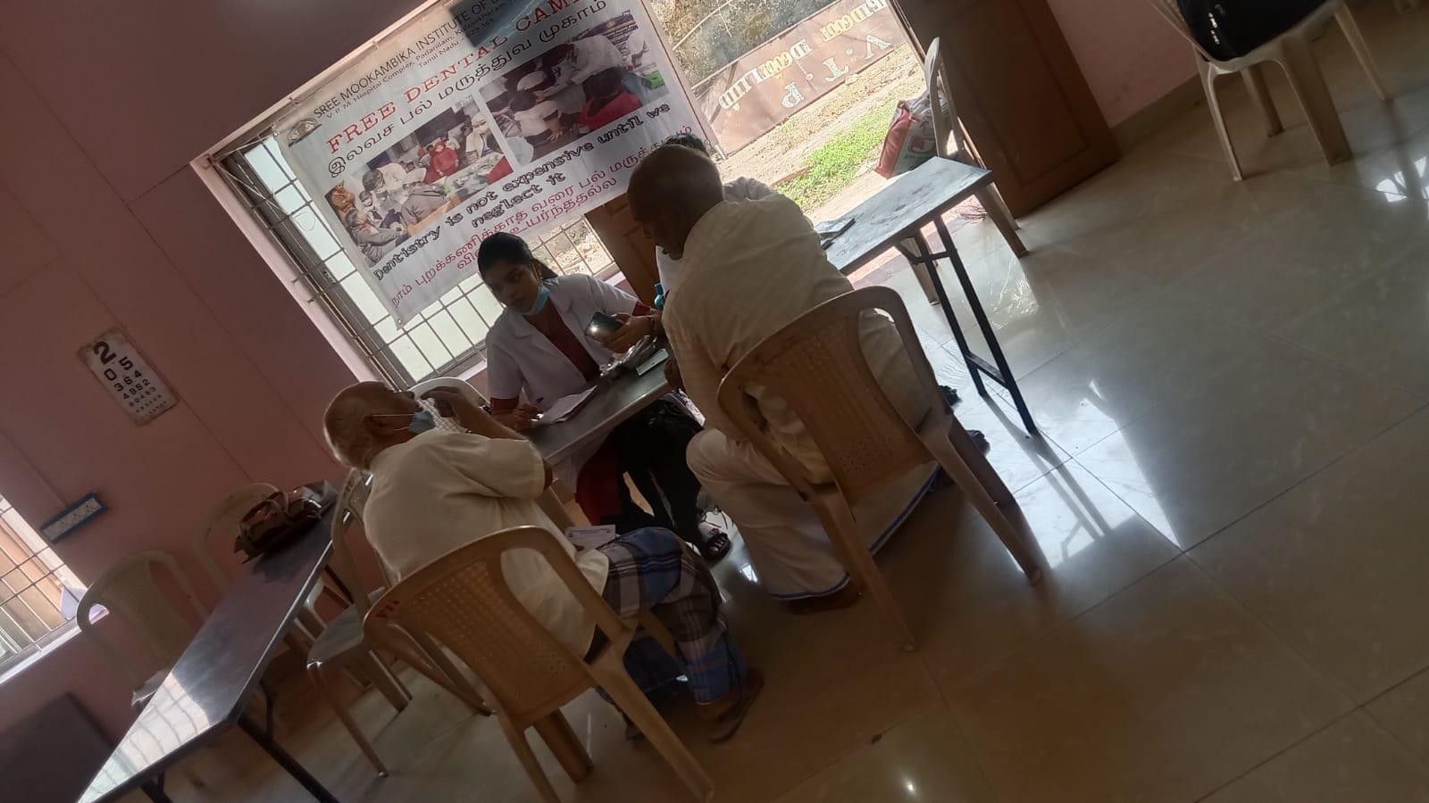
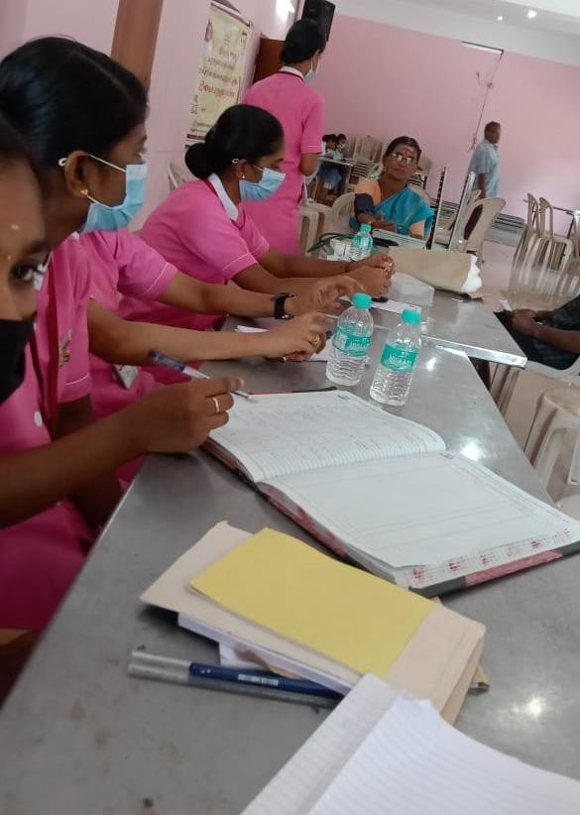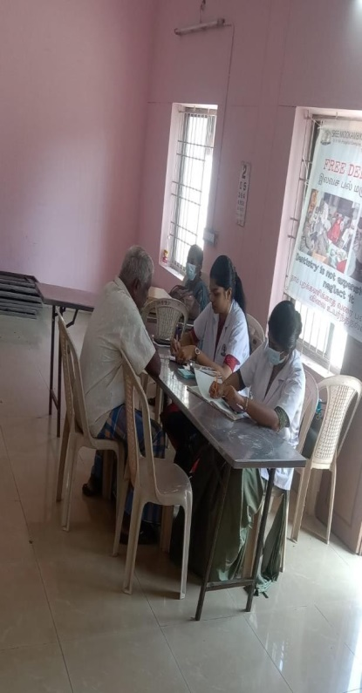

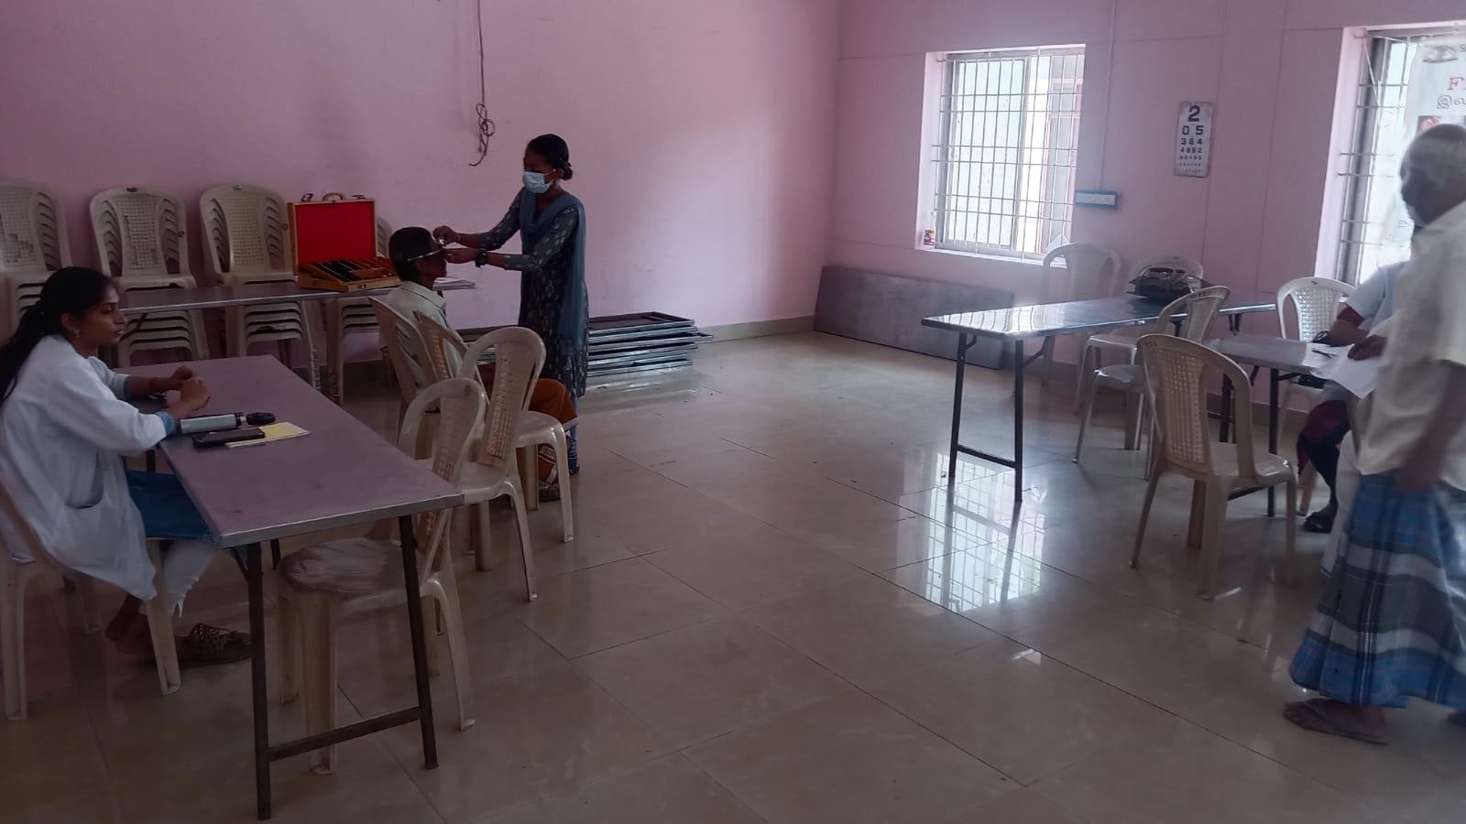
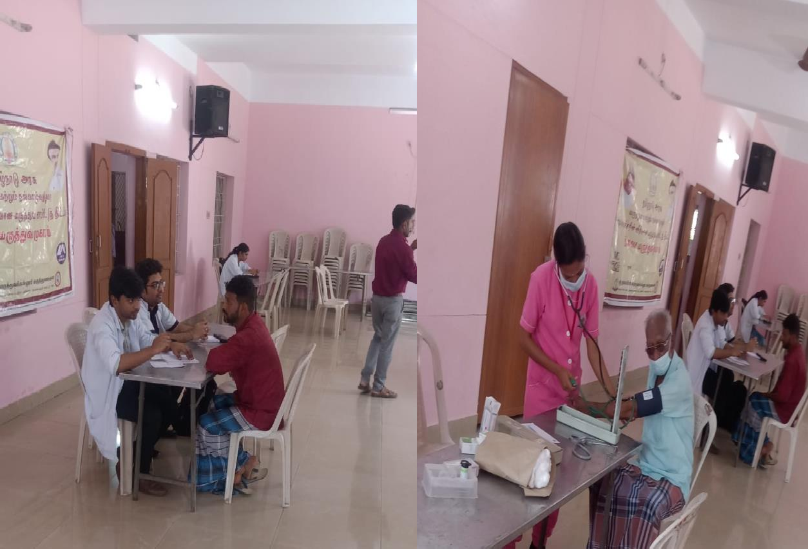

SESSION ON SKILL DEVELOPMENT PROGRAM ON MEDICAL CODING
Date :03-02-2023
Resource Person: Dr.Jenisha,Transorze Solution,Nagercoil
No: of participants:65
Objective of the programme: To provide participants with practical skills and knowledge related to medical coding, including understanding medical terminology, anatomy, and coding guidelines and to encourage participants to continue their education and professional development in the field of medical coding to stay current with evolving practices and regulations.The session aims to equip participants with the skills and knowledge required to pursue a career in medical coding and contribute to the healthcare industry by ensuring accurate and efficient coding of medical records.
Programme outcome-The Institution Innovation Council of Sree Ayyappa College for Women in collaboration with Library Committee organised a Session on Skill Development program on Medical Coding on 3-2-2023.Dr.Jenisha,TransorzeSolution,Nagercoil was the resource person. The resource person gave a clear cut awareness about medical coding and told that this course will help students convert healthcare diagnosis, procedures, medical services, and equipment into universal medical alphanumeric codes. The diagnoses and procedure codes are taken from medical record documentation, such as a transcription of physician's notes, laboratory and radiologic results, etc. She also emphasised that Medical coding is the process of translating diagnoses, procedures and supply information from patient records into universal medical codes, which are used by billers to submit claims. Medical coders must be knowledgeable in medical terminology and anatomy to code procedures and diagnoses accurately. They should also understand billing practices and follow the appropriate guidelines so they can effectively collaborate with medical billers. She also said that Medical coding is highly in demand- Graduates opting to study this vocation stand a big chance of landing into a good job in a reputed company.Furthermore, individuals choosing this career will experience faster growth as the integration of technology and data is increasing in the healthcare industry. She summarised the talk by pointing that Medical coding as a career can truly be a lucrative option in the healthcare sector. At the end of the session, aptitude test was conducted to test the IQ of students.The session was interesting and productive and participants really enjoyed the session.
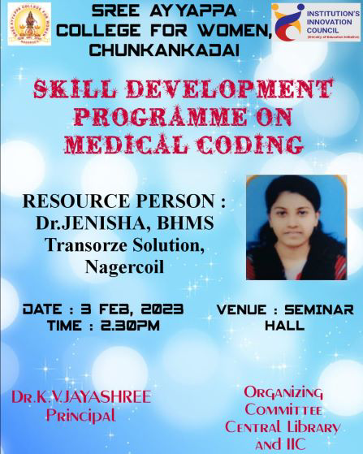
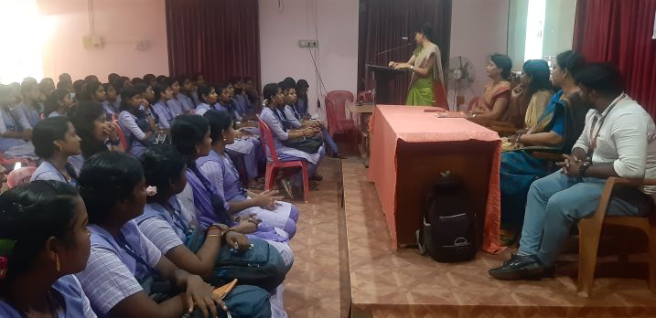
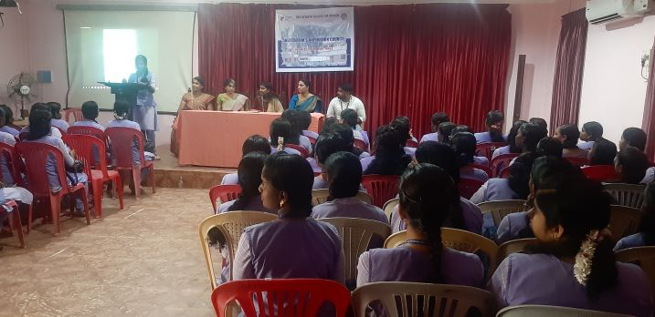

SDG INNOVATION BOOT CAMP FOR GIRL STUDENTS
Date :13-02-2023 to 15-02-2023
No: of participants:100
Objective of the programme: To provide girl students with an understanding of the United Nations Sustainable Development Goals and their importance in addressing global challenges and to equip participants with essential skills such as critical thinking, problem-solving, innovation, and teamwork.The boot camp aims to empower girl students to become leaders and innovators in the pursuit of sustainable development, while fostering a sense of social responsibility and the ability to create positive change.
Programme outcome-The Institution Innovation Council of Sree Ayyappa College for Women and Start-up TN Tirunelveli Hub organised a Three Day Experiential Boot Camp for Girl Students and Faculty to create an opportunity to learn insights and work on sustainable development goals for a better future from 13-02-2023 to 15-02-2023. Mr.Rahul, Project Lead, Tamilnadu start-up and innovation Mission ,Govt of Tamilnadu was the chief guest of the boot camp with Dr.Dhiliban Kumar,Associate Vice president, Nellai circle,Tamilnadu start-up and innovation Mission ,Govt of Tamilnadu a sthe trainer f the boot camp. The objective of the boot camp was to create awareness about IPRs, especially patents, designs and copy rights among faculties, students, researchers/inventors in respect of patenting their inventions and to provide insight into practical applications of IP such as patent drafting, patentability search and freedom to operate search, validity/invalidity search, and evidence of use analysis. The chief guest ,Mr.Rahul explained about innovation, design thinking, entrepreneurship, startup ecosystem in India, procedure for registering start-up, types of funding etc. He also explained the role of IIC in developing start-up culture in campus. The three day camp held series of learning oriented workshops cum sessions to help students learn basic concepts of marketing, finance, product development and company formation. Through Boot-Camp the students got awareness about aspects of Innovation as well as Entrepreneurship. Students were made to face the situations similar to the problems faced by real life entrepreneurs, and help them to find proper solution to overcome the difficulty. This would help students to overcome mental pressure in their academic as well as professional life. Apart from the problem solution they also learned how to make Business Plans and to conduct Market Surveys about their idea. Hence, the Boot-Camp helped the student to develop an entrepreneurial mind and learn how real life pitching of ideas takes place. Thus the 3-day Boot Camp promised to be a constructive session of 1-many and 1-1 sessions by the teams with mentors and experts from the ecosystem. The teams got a chance to crystallize their ideas and bring out the best in themselves.The participants expressed excellent feedback about the session that it motivated them to think out of the box.
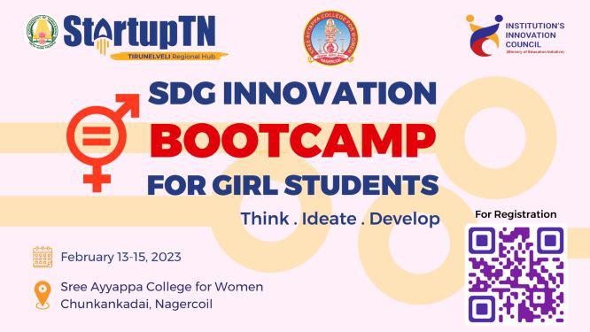
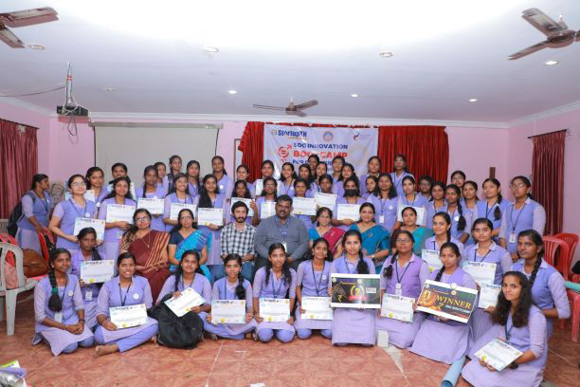
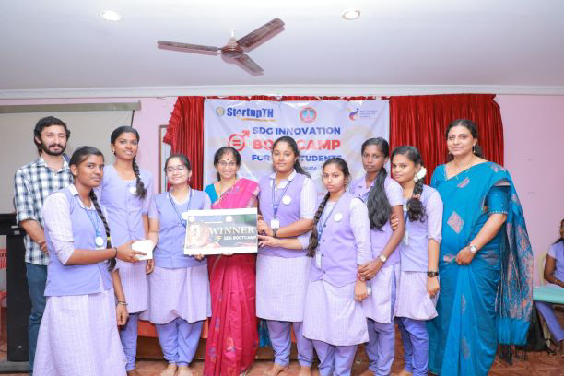
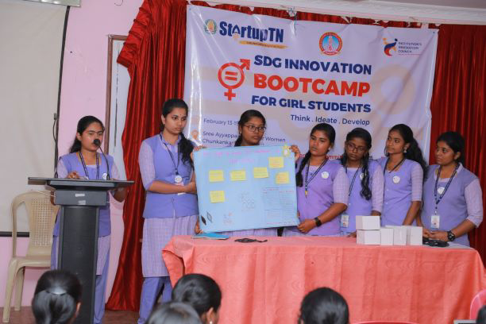
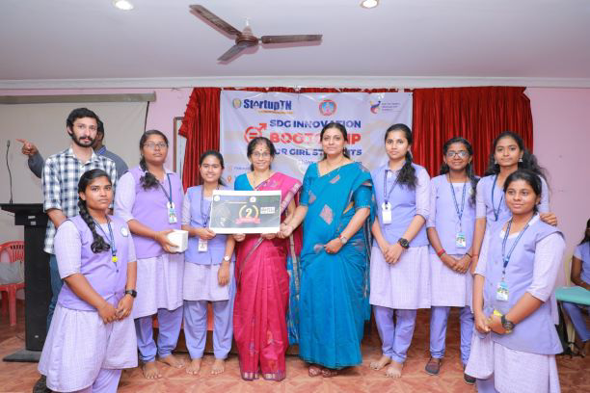
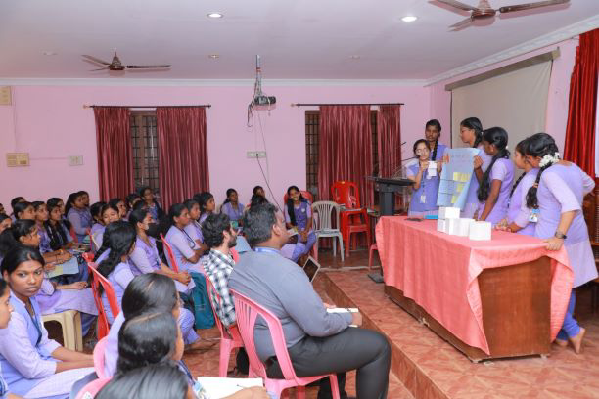
INTRA-INSTITUTIONAL SMART IDEA PRESENTATION COMPETITION
Date :10-03-2023
No: of participants: 20
Objective of the programme: To promote a culture of innovation and creativity within the institution and to encourage students, faculty, and staff to generate innovative and smart ideas that can address real-world challenges or improve existing processes.The competition aims to harness the innovative potential within the institution, recognize and support promising ideas, and contribute to the growth of an innovation ecosystem within the academic community.
Programme outcome-The Institution's Innovation Council (IIC) of Sree Ayyappa College for Women organised an Intra-Institutional Smart Idea Presentation Competition on 10-03-2023 .The main objective of idea competition was to create an atmosphere for social entrepreneurship among students to give back to society,to inculcate a culture for startups and innovation and to encourage a business mindsetamong students.Students participated in teams to present their ideas. They developed and delivered effective, professional business pitches for innovative and marketable business concepts that are both economically and technically feasible. The students participated with enthusiasm and passion by presenting their ideas. All the students expressed that it was a unique opportunity in their life and experiences gained throughout the development process since the launch of problem statements, until the declaration of the results was amazing. This kind of events will definitely aid in improving their intellectual capacity and developing a healthy innovation culture in the campus.

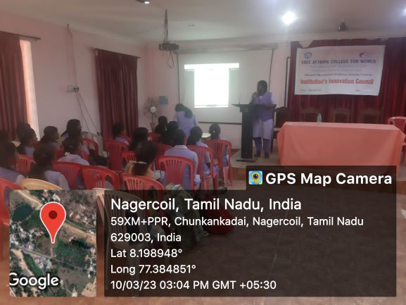

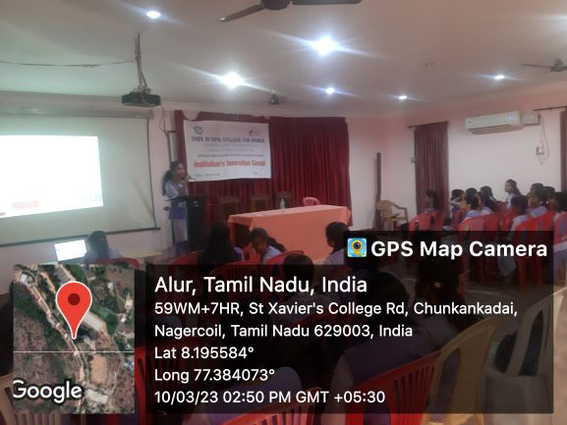
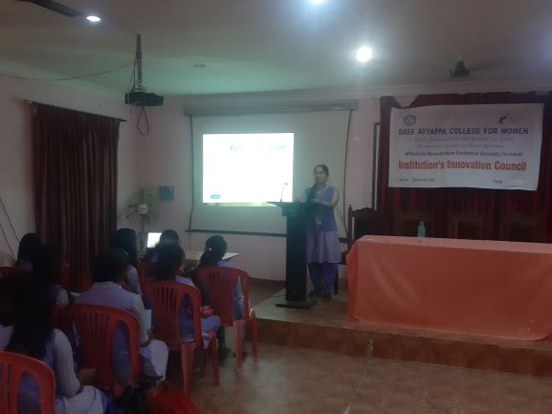

TWO DAY WORKSHOP ON ROBOTICS AND INDUSTRY 5.0
Date :16-03-2023 & 17-03-2023
No: of participants:40
Objective of the programme: To provide participants with comprehensive knowledge about the field of robotics and its applications in Industry and to equip participants with practical skills in robotics, automation, and Industry 5.0 technologies. The workshop aims to provide a deep understanding of the intersection of robotics and Industry 5.0, fostering a new generation of professionals who can contribute to the transformation of manufacturing and industrial processes.
Programme outcome-The Institution's Innovation Council (IIC) of Sree Ayyappa College for Women and Acutro Technologies jointly organised a Two Day workshop on Robotics and Industry 5.0 on 16-03-2023 and 17-03-23.The aim of the workshop was to acquaint the students with Industry 5.0 which is regarded as a fifth industrial revolution in which consumers could satisfy their individual requirements as per the tastes and expectations. The workshop was mainly focused on encouraging students in the field of robotics and automation. The students were introduced to different types of robots and their applications. The designing of wired robots with construction of new prototypes of robots has been discussed in detail by the experts from Acutro Technologies.In the first day of the session, overview of wireless and autonomous robots was elaborated by explaining the integration of external sensors and actuators in the designing of robots. Introduction to Robotics, components required for manually controlled robots and automatic robots were explained during the session.Hands on training session started in second day. The robotics workshop was well-received by the participants, students found the content engaging and informative. At the end, participants have completed the given assignment of making manually controlled robots and automatic robots.The students had shown their keen interest during the workshop by querying their doubts.The robotics workshop was a success, providing participants with a solid foundation in robotics and inspiring them to explore this exciting field further. Feedback from the participants indicated that they would like to see more advanced workshops in the future.
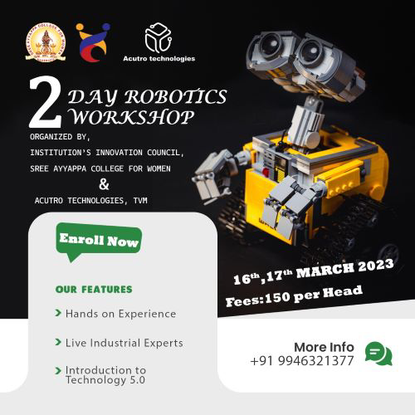
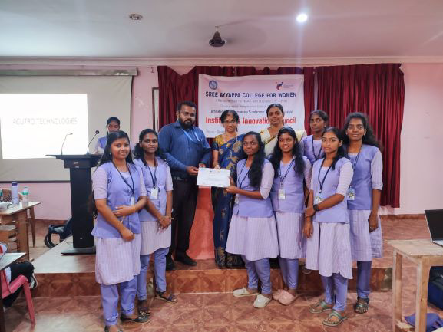
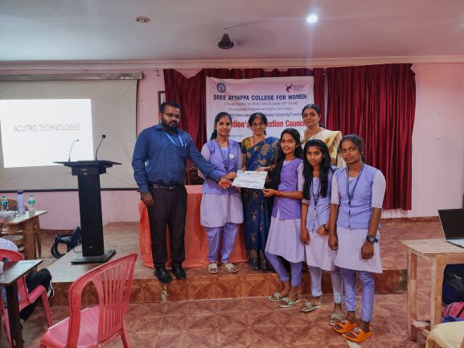

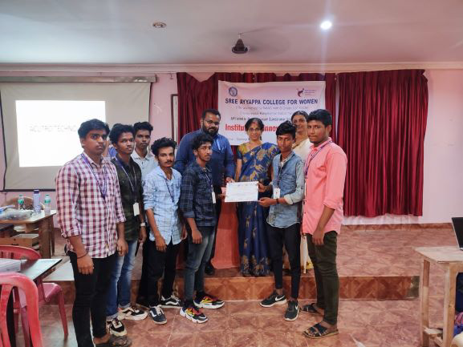
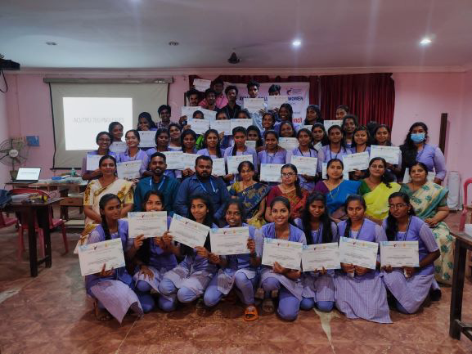F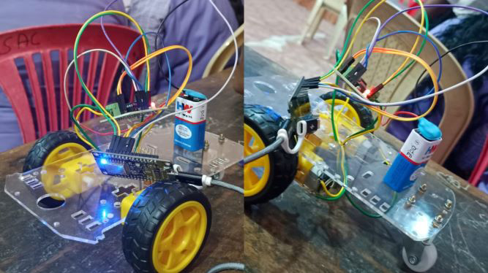
SESSION ON ENTREPRENEUR’S FUTURE WITH CHAT GPT
Date : 21-03-2023
Resource Person: Mr.Raghav Narayan,Chairperson,Voll Mond
Academy,Nagercoil
No: of participants:50
Objective of the programme: To educate entrepreneurs about the capabilities of AI-driven technologies like Chat GPT and their potential applications in business and entrepreneurship and to encourage entrepreneurs to explore innovative ways to incorporate AI and natural language processing into their business strategies.The session aims to provide entrepreneurs with insights into the possibilities and potential benefits of incorporating AI technologies like Chat GPT into their entrepreneurial endeavors, helping them stay competitive and innovative in the evolving business landscape.
Programme outcome-Institution’s Innovation Council and Central Library
jointly organised a session on Entrepreneur’s Future with Chat GPT on 21-03-
2023. Mr.Raghav Narayan,Chairperson, Voll Mond Academy,Nagercoil was the resource person for the session. He explained about ChatGPT which has created ripples across the younger generations and is also gradually taking several industries by storm. It has been trending on social media shortly after its November 2022 release. It has stirred the IT and AI industries, including tech
giants like Google and Microsoft. He added that Engineers, entrepreneurs, and
many social media users look at AI as a bold innovation that opens horizons for
services and solutions; the academic and creative industry stands both
concerned and threatened by the latest AI chatbot. New York Times author Ezra
Klein called ChatGPT an &#39;information warfare machine&#39; and even raised questions on the implications of releasing such a form of technology at a large scale. The soaring popularity of ChatGPT has caught the worries of social
scientists and scholars alike. The newly available tools like big data, analytics,
and information at our fingertips empowered professionals to find new ways of
providing value, mostly through adding context or expertise on how to use these
new tools. It famously reached its first 1 million users within 5 days of being
released. OpenAI, the developer of ChatGPT, ignites the imagination with the
endless possibilities of use cases that could be enabled by combining Chat GPT
Functionality with everyday applications that help us write and analyse documents in Word, convey our talking points and strategies via PowerPoint, or
decide the best approach to building models in Excel. It also could empower
environmental educators to make content more engaging and helpful and help
professionals understand how their businesses can be more sustainable or find
new opportunities in sustainable markets.He concluded the talk by saying that
the democratization of AI like Chat GPT will lead to a proliferation of new
startups, services, and products that make our economy more abundant from a
consumer perspective, but also for founders, creators, and prosumers. The
session was very informative and enabled the participants to gain knowledge
about Chat GPT.
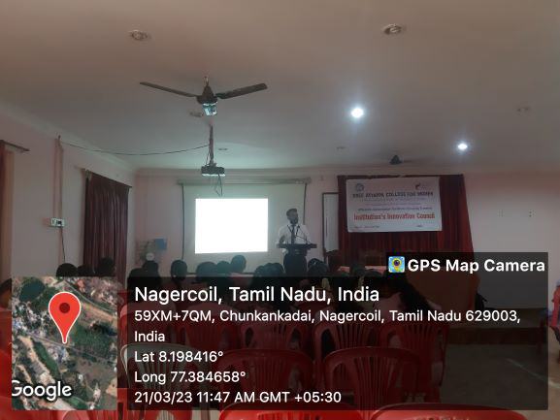
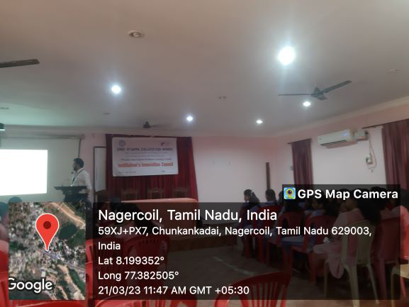
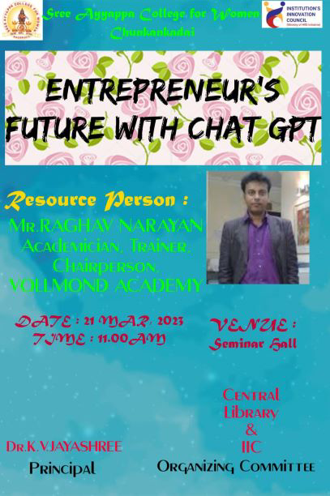
SKILL DEVELOPMENT-TRAINING PROGRAM(OCT26-NOV1 2022)
,Department of Physics of Sree Ayyappa College for Women organized one week ( October 26,2022 - November 1,2022) training program in employability skills to the female students conducted by Naandi Foundation and Mahindra Pride Classroom. Mr.Paul Ravichandran was our trainer.On the first day, the trainer Mr. Paul Ravichandran began the training program with a brief self introduction. He also dealt with the topic " I am Unique" and made every student prepare a shield describing everything about one's life. Also, the trainer introduced himself and spoke in detail about the naandi foundation.day 2 began with the topic "body language and professional grooming". he also helped the students about the importance and ways to create a first impression. the importance of english in communication was also explained in detail. several tips to improve grammar, pronunciation and vocabulary were also discussed in the class. students were made to learn new words every day by giving them work to be done at home.goal setting was another important topic that was discussed in class. group activity was also given in order to enhance teamwork. students were made to prepare a chart on the given topics and were made to explain them. Day 3 focused on the topic of "Time Management" and "Professional Communication".The format of an email was taught to the students and a group activity on money management was also explained in detail.Day 4 stressed on the topics "Critical Thinking" and "Conflicts in Communication and Management". The seven C's of effective communication was dealt with along with the qualities of problem solving.Day 5's topics were the impact of a good resume and how to do a good one. Students were made to perform in a group discussion that was conducted in the same manner as in a company.The final day of the training program began with a group activity on varied topics that were explained along with a PowerPoint presentation by the students. The session completed with an elaborate discussion on how to attend an interview, how to face it and answer common and expected questions. The trainer concluded by narrating his personal and professional experience and how to balance both in life. Above all, on a farewell note, he assured that the company would visit the students for recruitment in a few months and conveyed their wishes and blessings to the students.
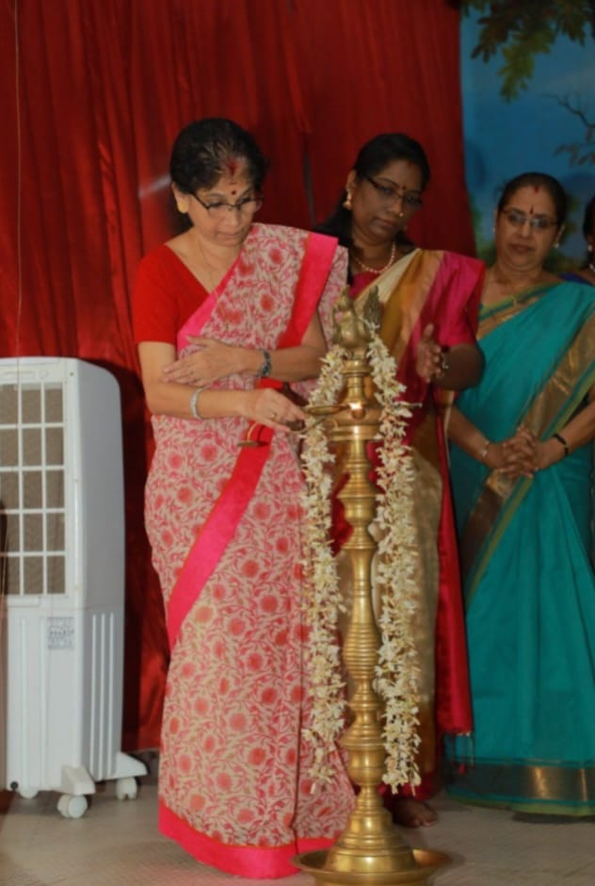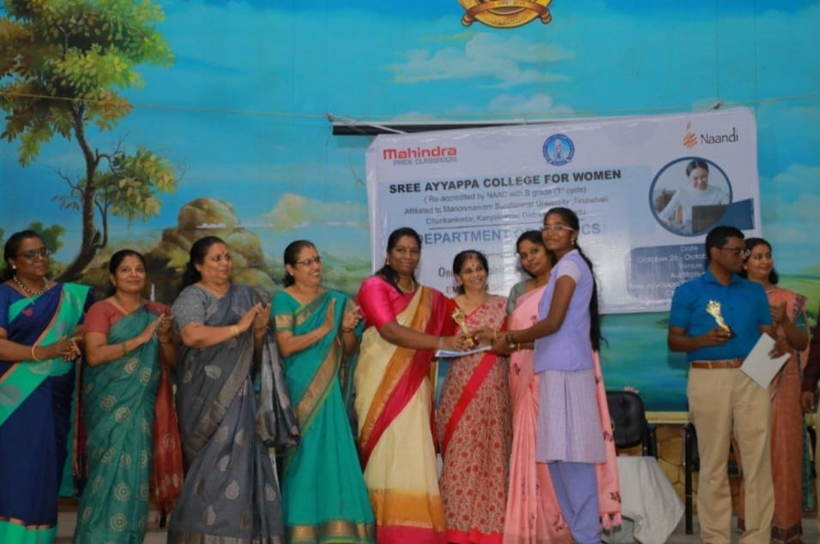

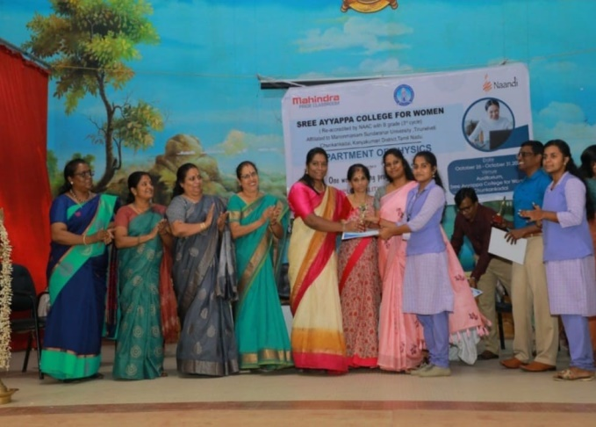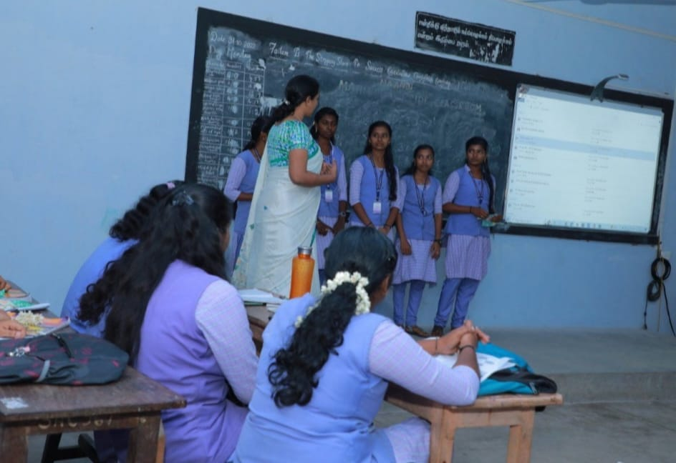

SESSION ON DATA ANALYTICS AND TABLEAU
A Session on the topic: Data analytics and Tableau was organised by the Department of Physics on 18th April 2023, 10 am. The resource person of the program was Dr.Rimal Isaac R S, Assistant Professor in Nanotechnology, Noorul Islam Centre for Higher Education, Tamilnadu. The resource person started the session by explaining about the need of datas in our daily life. He taught the students to extract data and connect it to the tableau software. He also explained how to work on the tableau app and demonstrated by conducting practical sessions on graphs,piecharts etc.
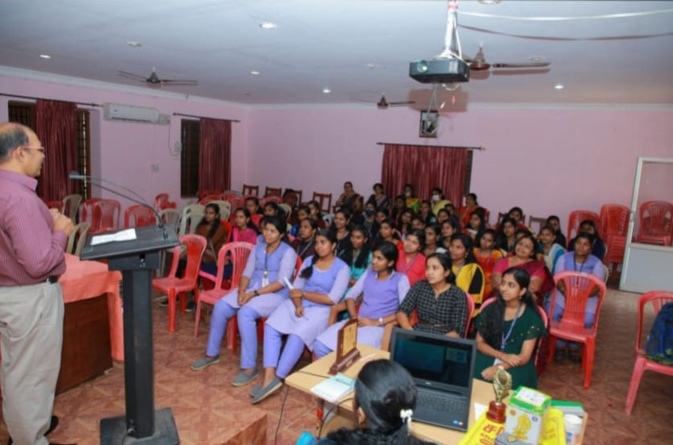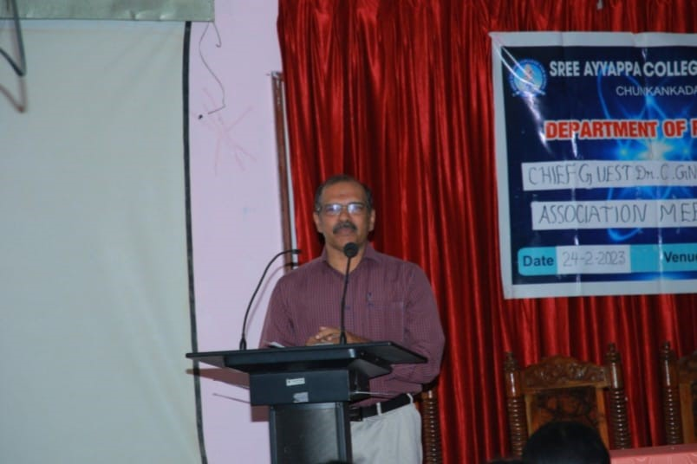
SKILL DEVELOPMENT PROGRAMME ON SOFTWARE TESTING AND CERTIFICATION
The Career Guidance and Placement Cell organised a skil development programme on software testing and certification on May 8,2023. Mr. Jose George Vachaparambil, Founder of TECH MASTERS Software Services Private Limited was the resource person.The objective of the programme was to validate the software's functionality, enhance its performance, and improve the overall user experience. The Resource Person had a good interactive session with students and many of our students were awarded with attractive prizes including cash awards.

