DEPARTMENT OF CHEMISTRY ACTIVITIES 2022- 2023
ASSOCIATION INAUGURATION
The Chemistry Association inauguration for the academic year 2022 -23 was held on June 12,2022. Dr. Abbs Fen Reji, Associate Professor, Department of Chemistry, was the chief guest. He has given an excellent talk on ‘Green Chemical approach to Photodynamic therapy’. The speaker discussed the use of plant-derived or bio-based materials as photosensitizers, exploring their efficacy in targeting cancer cells. Green solvents like water or benign organic alternatives might have been advocated for replacing traditional toxic solvents. Additionally, the talk covered strategies to optimize the synthesis process, focusing on sustainability and reduced waste generation. Overall, session on green chemical approach to photodynamic therapy aimed to advance medical treatments while prioritizing environmental responsibility." The students were motivated and gained insights through his enlightening lecture.
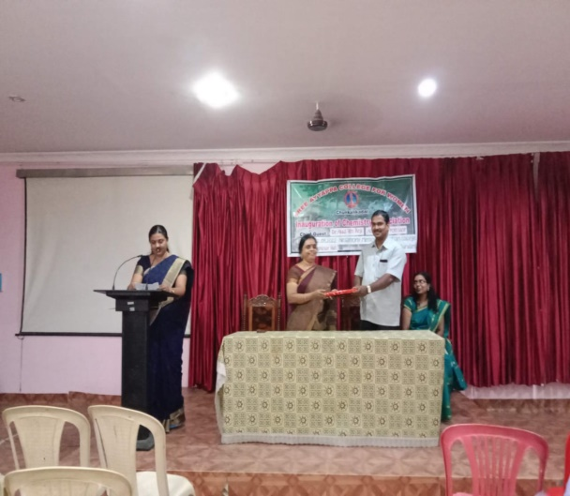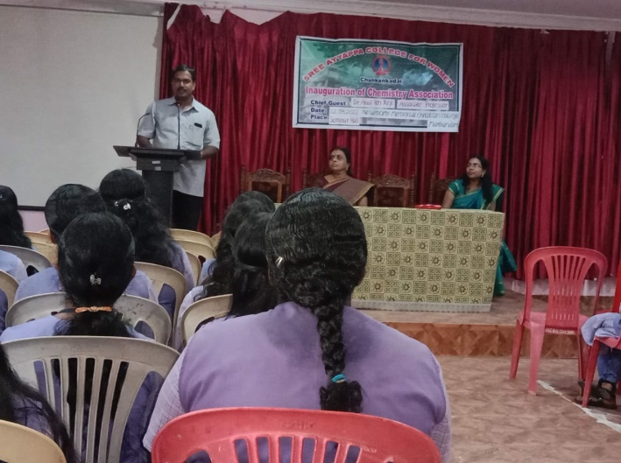
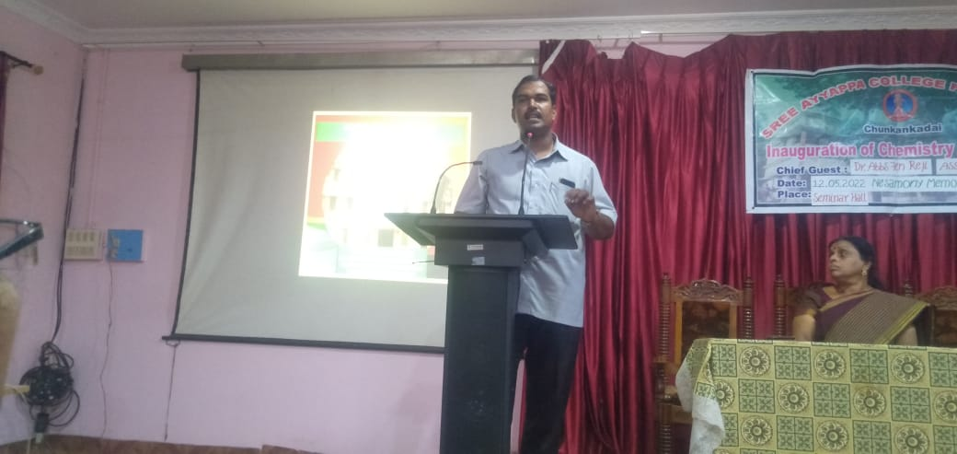

TALK ON CARBOHYDRATE METABOLISM
Dr.Smitha Nair,Associate Professor and Head, Department of Chemistry delivered a talk on Carbohydrate metabolism to the students on August 13,2022.An animated video about carbohydrate metabolism was shown to the students. The talk on carbohydrate metabolism covered key aspects such as glycolysis, gluconeogenesis, and the regulation of blood glucose levels. Enzymes like hexokinase and PFK play crucial roles, while hormones like insulin and glucagon help maintain homeostasis. Additionally, the importance of glycogen storage and breakdown was discussed in relation to energy needs. The talk emphasized the interconnected pathways that ensure a balanced and regulated carbohydrate metabolism in the body.

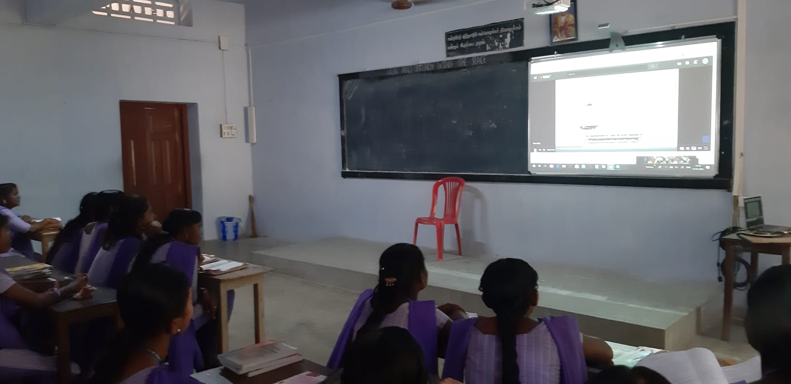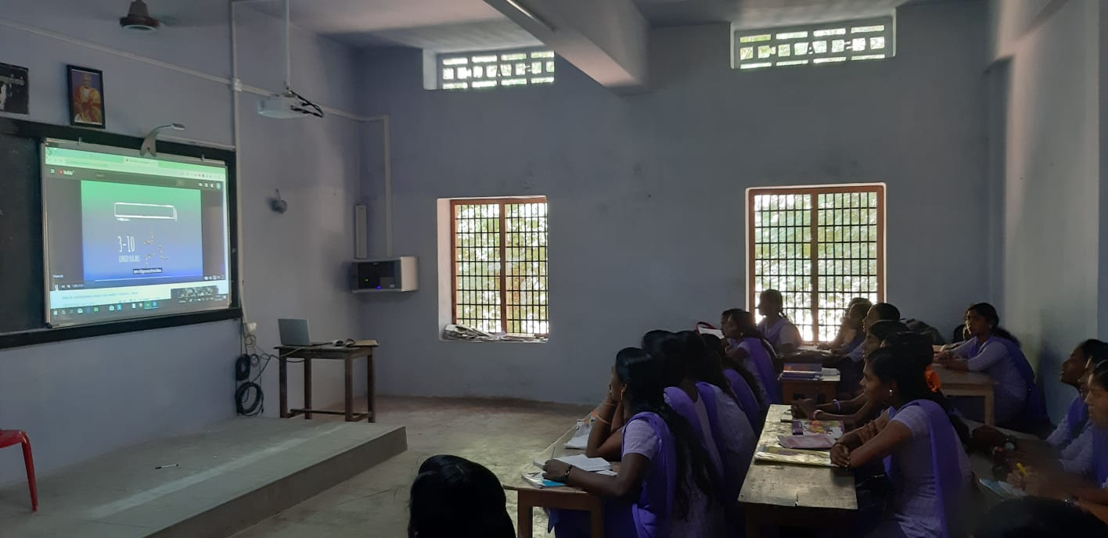
SESSION ON GREEN HOUSE EFFECT AND GLOBAL WARMING AS PART OF NATIONAL POLLUTION CONTROL DAY CELEBRATION
Department of Chemistry in collaboration with Institution Innovation Council of Sree Ayyappa College for Women organised a Session on Green House Effect and Global warming as part of National Pollution day Celebration on 31-1-2023. Dr.Prince.P.R, Assistant Professor of Physics, University College, Trivandrum was the resource person.The resource person explained the need for keeping the environment clean and green. He highlighted the effects of deforestation, depleting the non renewable sources etc., He stated that the climate change, green-house emissions, ozone layer depletion and global warming are the need for green technology. The speaker explained in detail about the green house effect and the gases responsible for the green house effect. Global warming was referred as the average increase in the earth’s temperature which in turn changes the climate. The speaker then gave a note on the ozone layer, the earth’s sunscreen which absorbs about 98% of the UV radiation. He explained that reducing pollution, consumption and waste, conserving resources and energy, protecting the earth’s ecological balance are the basic principles of going green. The speaker gave a note on the three R’s (reduce, reuse and recycle). Finally the session ended with a discussion regarding the initiatives to make the campus green. The session was interactive and interesting. The speaker gave some valuable suggestions to make a green campus like energy conservation, planting trees, avoiding plastics inside the campus, effective consumption of water, reducing the usage of paper etc.
